Karie Funk

11.15.2019

RESTFul API’s

Assignment 5.2

First part of request: Typed in ‘US’ where ‘?’ was

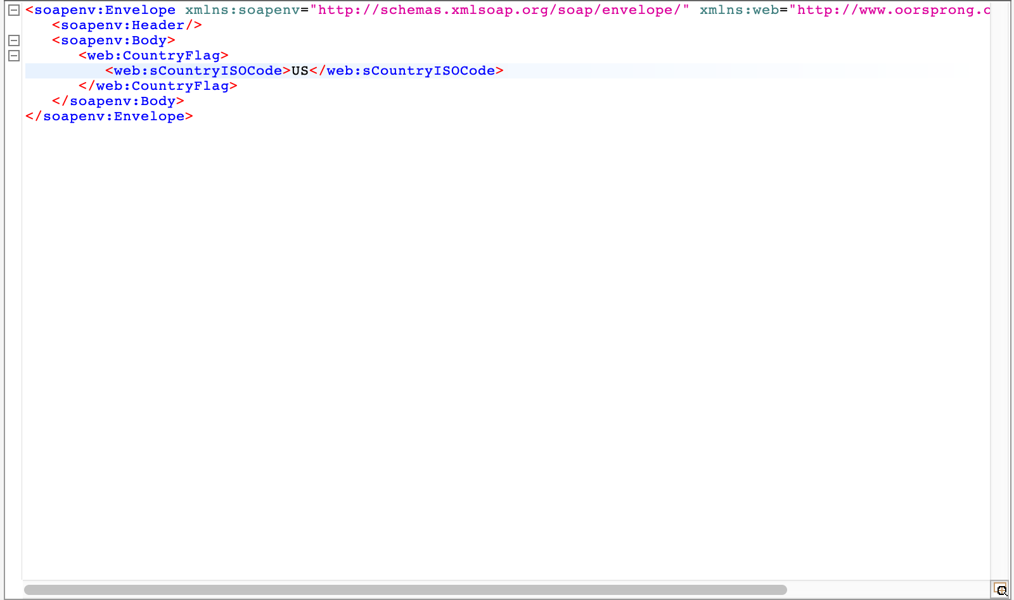

Second part of request finishing URL:

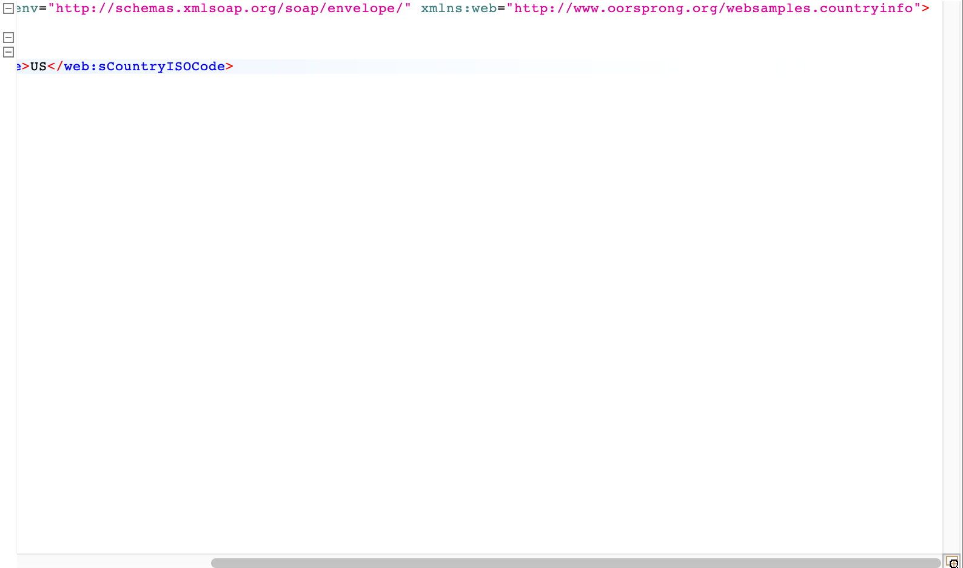

Response:

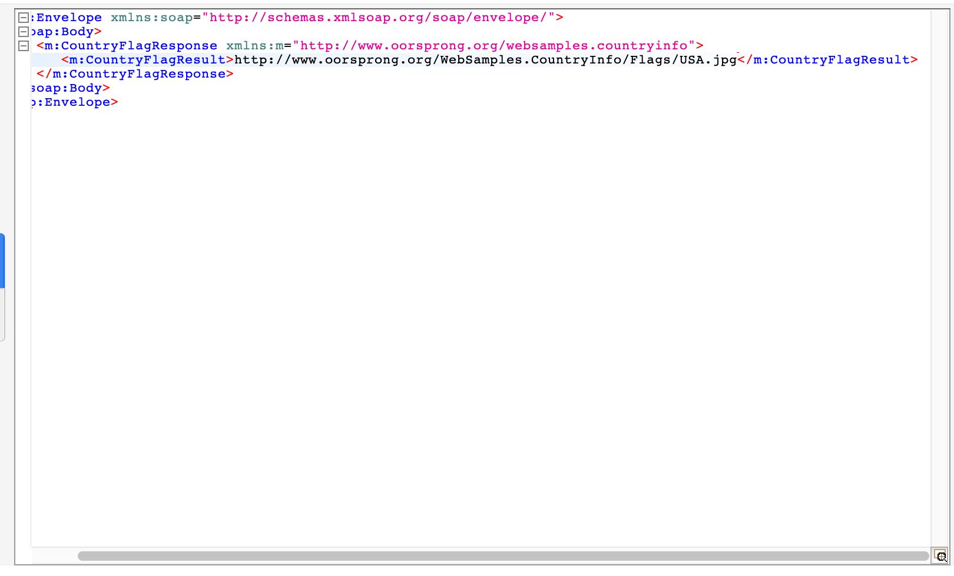

URL from response:

