Karie Funk

11.18.2019

RESTFul API’s

Assignment 5.4

CLI Window:

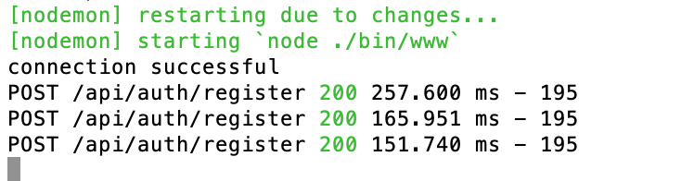

Token:

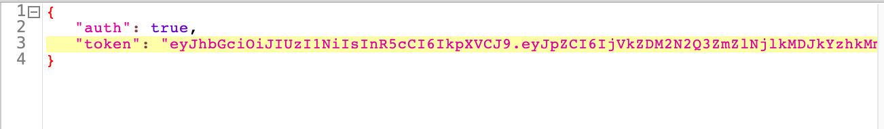

Response:

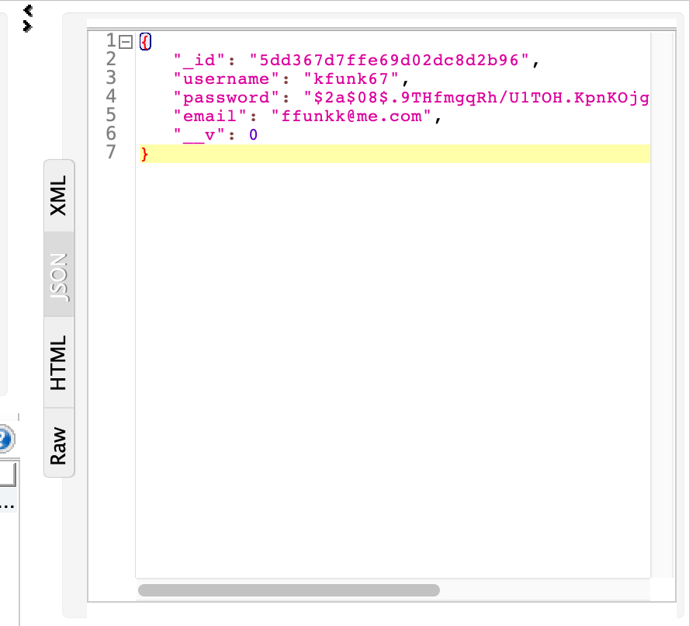

Record in mLab:

