SAP Integration Suite
Cloud Integration

Technical Specification Document

Foundation_BusinessDocumentPDF_Bravo_Subscriber

Version: 1.0
Author: Generated by AI
Date: May 13, 2026
Status: Draft

Table of Contents
1. Change History
1.1 Document Control
2. Overview
2.1 Executive Summary
2.2 Purpose
2.3 Interface Requirement
2.4 Functional Assumptions
2.5 Integration Snapshot
3. High level iFlow Design
3.1 Current Scenario
3.2 To-Be Scenario
3.3 High Level Design
3.4 Technical Dependencies
4. Message Flow
4.1 Process Flow
4.2 Message Flow Connections
4.3 Integration Flow Diagram
5. Technical Description
5.1 Main Integration Process
5.2 Local Integration Process
5.3 Sender
5.4 Receiver
5.5 Mappings
5.6 Security
5.7 Groovy Scripts
5.8 Error Handling & Logging
6. Version and Metadata
7. Appendix
7.1 Technical Artifacts
7.2 Schemas
7.3 Externalized Parameters

1. Change History
Version | Date | Author | Description
1.0 | 2026-05-13 | Generated by AI | Initial autogenerated version

1.1 Document Control
- Document ID: TS-Foundation_BusinessDocumentPDF_Bravo_Subscriber
- Integration Flow: Foundation_BusinessDocumentPDF_Bravo_Subscriber
- Generated On: 2026-05-13 12:53
- Generation Mode: Batch
- Diagrams Included: Yes
- Functional Spec Context: Provided

2. Overview

2.1 Executive Summary
This iFlow retrieves a business document in XML format from the Foundation system via HTTPS, extracts the Base64 encoded PDF content, and uploads it to an AWS S3 bucket. It also logs technical exceptions to a JDBC database and updates document metadata.

2.2 Purpose
This document provides the technical specification for the Foundation_BusinessDocumentPDF_Bravo_Subscriber iFlow, detailing its functionality, configuration, and integration points.

2.3 Interface Requirement
The interface is required to automatically archive business document PDFs from the Foundation system into AWS S3 for long-term storage and retrieval, as part of the VAT Integration project.

2.4 Functional Assumptions
Assumption | Value
Frequency | Real time
Volume | TBU
Processing Type | Async, XML
Performance | Not specified

2.5 Integration Snapshot
Metric | Value
Integration Processes | 2
Message Flows | 3
Sequence Flows | 14
Groovy Scripts | 1
Schemas | 2
Externalized Parameters | 4

3. High level iFlow Design

3.1 Current Scenario
No automated integration exists. The business document PDF is not automatically extracted and stored in AWS S3.

3.2 To-Be Scenario
The iFlow automates the process of receiving a business document from the Foundation system, extracting the PDF content, and storing it in a designated AWS S3 bucket. It also updates a database with document metadata and logs any technical exceptions encountered during processing.

3.3 High Level Design
The iFlow uses an HTTPS sender adapter to receive XML payloads from the Foundation system. It extracts the PDF content and uploads it to AWS S3 using the AmazonWebServices receiver adapter. A mapping transforms the data, and Groovy scripts are used for concatenation. JDBC receiver adapter is used to interact with SynLogisticsPlatform_Database.

3.4 Technical Dependencies
- Runtime platform: SAP CI integration flow 'Foundation_BusinessDocumentPDF_Bravo_Subscriber' orchestrates message exchange from Foundation to AWS-S3.
- Inbound interface dependency: path /businessDocument/IDT; HTTPS adapter using None over HTTPS; sender auth type RoleBased with role ESBMessaging.send.
- Outbound interface dependency: URL amazonaws.com; receiver authentication type Not configured with credential/security artifact LogisticsPlatform; operation write.
- Security dependency: sender auth type RoleBased with user role ESBMessaging.send; receiver authentication type Not configured with credential/security artifact LogisticsPlatform.
- Design-time artifacts: mappings src\main\resources\mapping\BusinessDocumentMapping.mmap.
- Custom script artifacts: concatenate.groovy.
- Externalized runtime dependencies: 4 parameter(s) supplied.

4. Message Flow
A message comes from Foundation into SAP CI through the configured sender channel.
SAP CI processes the payload and sends the final message to AWS-S3 through the receiver channel.

4.1 Process Flow
Step | Description
1 | Step 1: Foundation system sends a business document in XML format via HTTPS to the Integration Suite.
2 | Step 2: Integration Suite receives the XML payload.
3 | Step 3: The iFlow extracts the Base64 encoded PDF content, folder name, and file name from the XML payload.
4 | Step 4: The PDF is uploaded to the designated AWS S3 bucket.
5 | Step 5: A stored procedure is called to update document metadata in the SynLogisticsPlatform_Database.
6 | Step 6: Any exceptions are logged to the SynLogisticsPlatform_Database.

Flow Attribute | Value
Target System | AWS-S3
Trigger | HTTPS request

4.2 Message Flow Connections
Source | Target | Name
call to S3 | AWS-S3 | AmazonWebServices
Query JDBC | SynLogisticsPlatform_Database | JDBC
Foundation | Start | HTTPS

4.3 Integration Flow Diagram
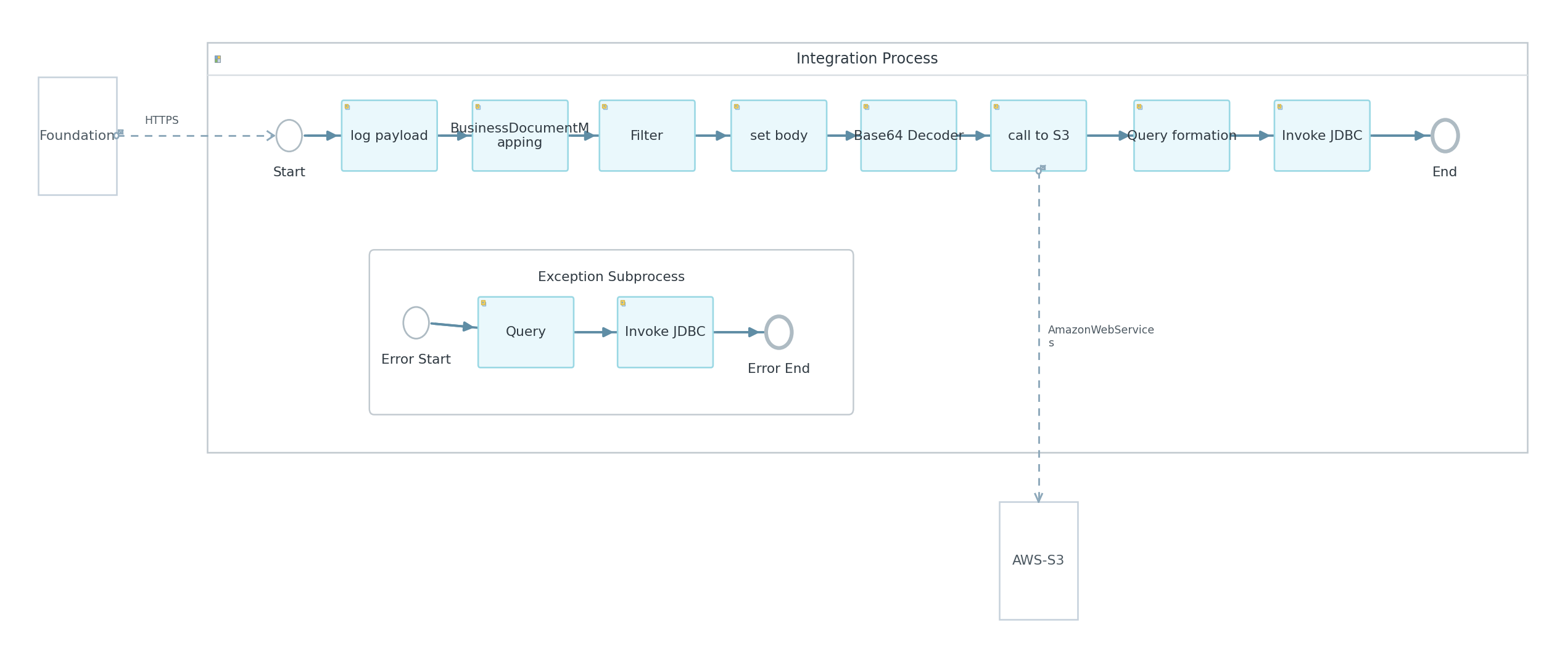
Figure: Integration Flow Diagram

5. Technical Description

5.1 Main Integration Process
Process Name | Sequence Flows | Flow Elements
Integration Process | 12 | 11

Integration Process
This is the main integration process that orchestrates the flow of data from the Foundation system to AWS S3 and the SynLogisticsPlatform_Database.
Key Activity
Enricher
Service Task
SubProcess

Step | Description
1 | Start Event
2 | log payload
3 | Filter
4 | set body
5 | call to S3
6 | Query formation
7 | End Event

Component Name | Key | Value
Integration Process | Transaction Timeout | 30
Integration Process | Transactional Handling | Not Required

callActivity Query formation Properties
Key | Value
Body Type | expression
Wrap Content | CALL sp_crud_dt_docfolder_and_documentlist('${property.FolderName}', '${property.IDENTIFIER}', NULL, NULL, NULL, NULL, '${property.FileName}.pdf', '1', '${property.DOC_NUMBER}', 'F');

callActivity set body Properties
Key | Value
Body Type | expression
Wrap Content | ${property.payload}

callActivity log payload Properties
Key | Value
Body Type | constant

callActivity Filter Properties
Key | Value
Body Type | constant

callActivity Invoke JDBC Properties
Key | Value
Process Id | Process_40623567
Sub Activity Type | NonLoopingProcess

callActivity Base64 Decoder Properties
Key | Value
Encoder Type | Base64 Decode

5.2 Local Integration Process
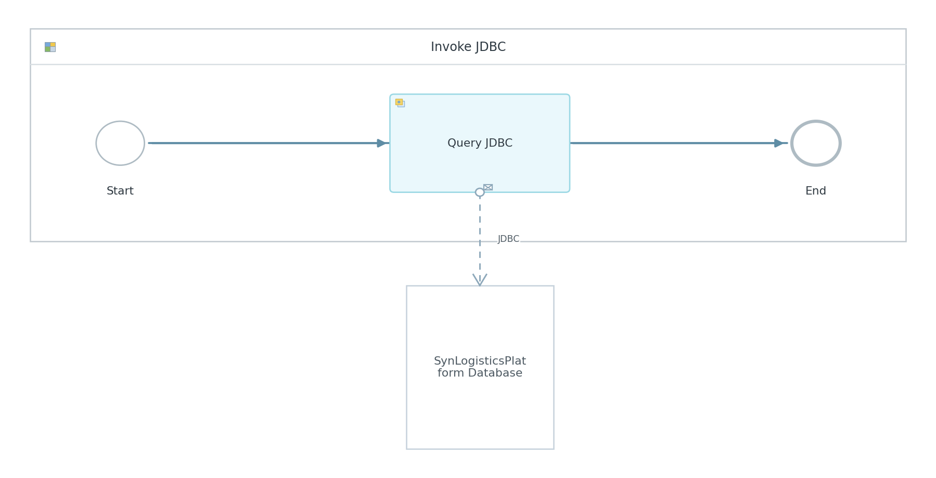
Figure: Invoke JDBC Diagram

Process Name | Sequence Flows | Flow Elements
Invoke JDBC | 2 | 3

Invoke JDBC
This process is a local integration process that calls the JDBC receiver adapter to execute a database query.
Key Activity
ExternalCall to JDBC receiver adapter

Step | Description
1 | Step 1: Start Event
2 | Step 2: Query JDBC Service Task
3 | Step 3: End Event

Component Name | Key | Value
Invoke JDBC | Transaction Timeout | 30
Invoke JDBC | Process Type | directCall
Invoke JDBC | Transactional Handling | From Calling Process

5.3 Sender
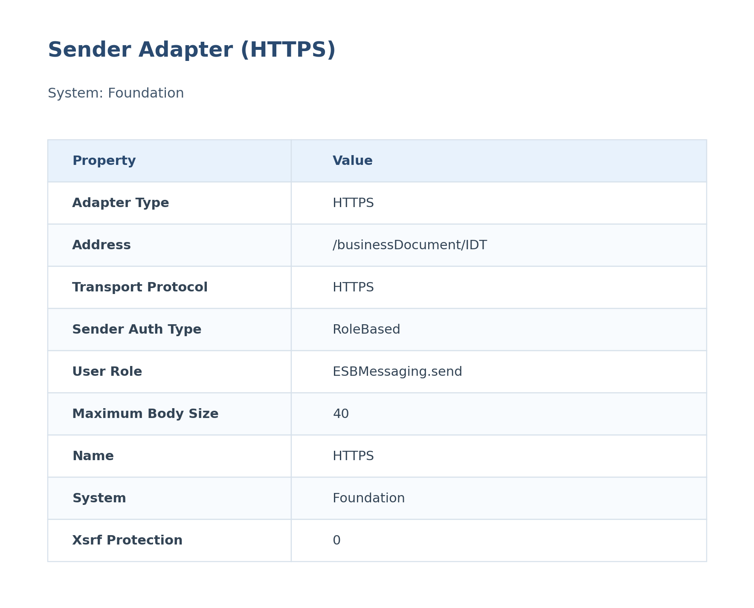
Figure: Sender Configuration

The HTTPS sender adapter receives the business document in XML format from the Foundation system. It uses role-based authentication, requiring the ESBMessaging.send role. The maximum body size is set to 40MB.
Attribute | Value
Path / Address | /businessDocument/IDT
Adapter Type | HTTPS
Protocol | HTTPS
Auth Type | RoleBased
User Role | ESBMessaging.send

Table: Detailed Sender Adapter Properties
Key | Value
Maximum Body Size | 40
System | Foundation
Xsrf Protection | 0

5.4 Receiver
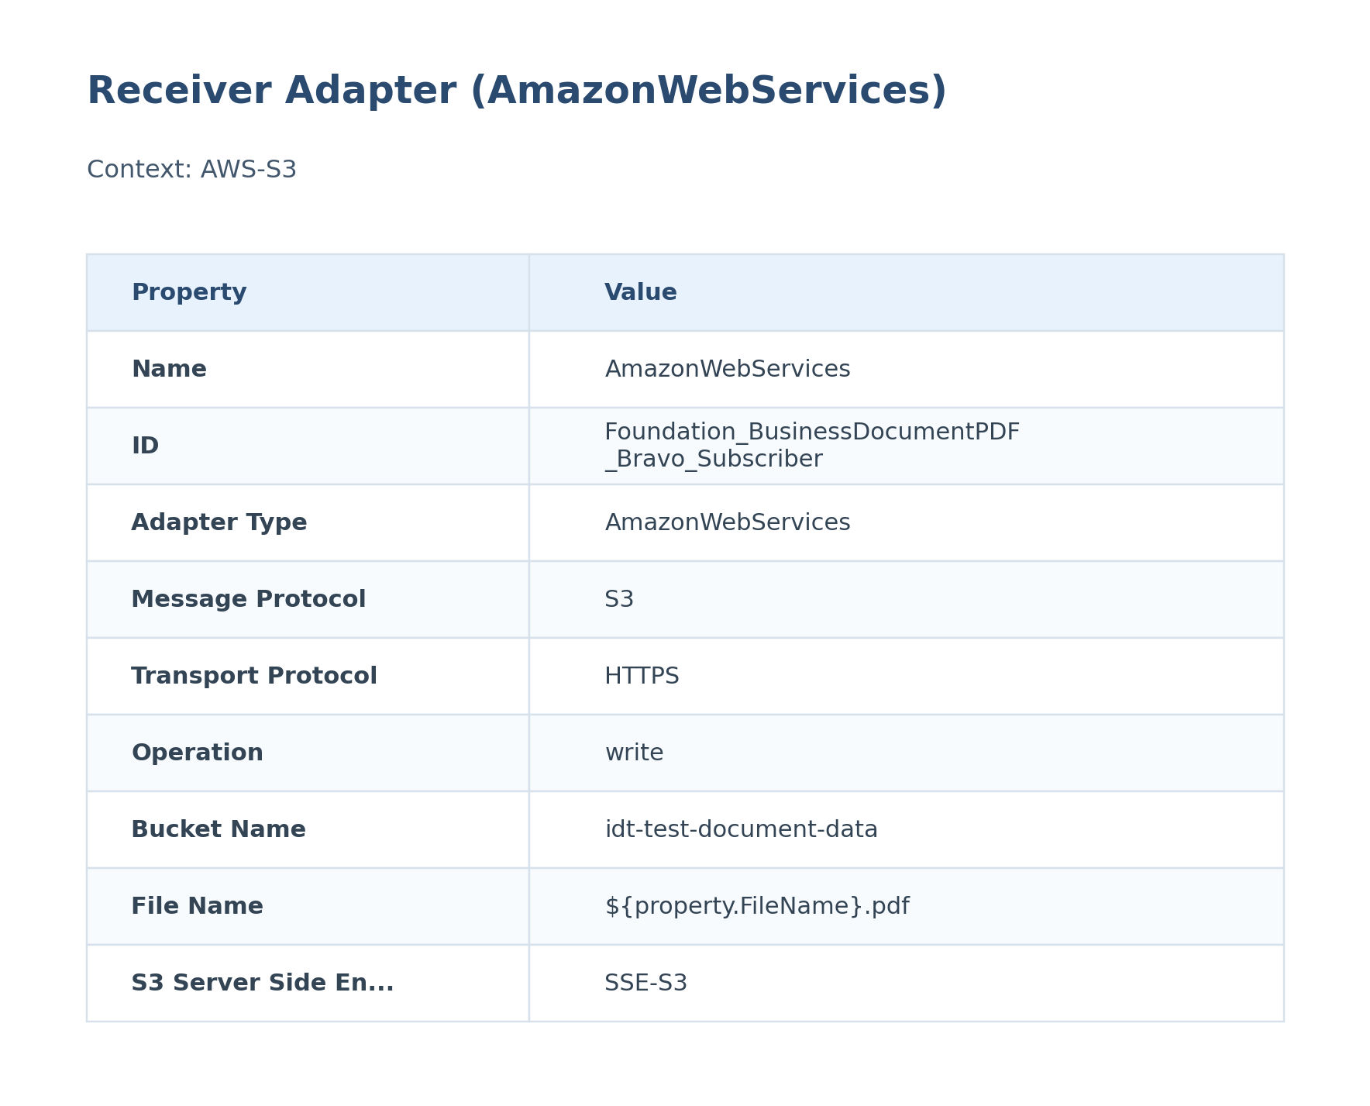
Figure: Receiver Configuration

The AmazonWebServices receiver adapter uploads the PDF document to the specified S3 bucket. It uses the provided Access Key and Secret Key for authentication. Server-side encryption (SSE-S3) is enabled.
Attribute | Value
URL / Address | amazonaws.com
Adapter Type | AmazonWebServices
Authentication Type | Not configured
Credential / Security Artifact | LogisticsPlatform
Operation Name | write

Table: Detailed Receiver Adapter Properties
Key | Value
Bucket Name | idt-test-document-data
File Name | ${property.FileName}.pdf
S3 Server Side Encryption For Archive | SSE-S3
Empty File Handling | proceedWithEmptyFile
S3 Receiver Post Processing | delete
Content Type | application/pdf
Exist File Handling | overwrite
Upload Message Attachments | false
System | AWS-S3
Transport Protocol | HTTPS
Folder Name | ${property.FolderName}
Region Name | eu-central-1
Storage Class | STANDARD
Requester Pays | false
Message Protocol | S3
S3 Append Message Id | false
S3 Append Timestamp | false
Vendor | rojoconsultancy.com
List Operation Include Sub Directories | false
Connect Via Sdk | false
Apply Encryption When Archiving | false
Sorting For List Operation | none
Query Timeout | 3
Page Size | 100000
Vendor | SAP
Batch Operation | atomic
System | SynLogisticsPlatform_Database
Batch Mode | false
Transport Protocol | JDBC
Connection Timeout | 3
Message Protocol | JDBC

5.5 Mappings
Name | 2-Line Summary | Mapping File Link
BusinessDocumentMapping | This mapping applies the configured transformation logic for BusinessDocumentMapping within SAP CI.  It is executed during message processing to reshape the payload before the next handoff. | src\main\resources\mapping\BusinessDocumentMapping.mmap

BusinessDocumentMapping
Attribute | Value
Source Message / Object | BusinessDocumentMapping
Target Message / Object | Not identified

5.6 Security
Security Aspect | Details
Authentication | RoleBased authentication for the HTTPS sender adapter.
Authorization | User role ESBMessaging.send is required.
Encryption | HTTPS for transport security to Foundation system; SSE-S3 for AWS S3 server-side encryption.

Key | Value
Http Session Handling | None
Return Exception To Sender | false
Log | All events
Cors Enabled | false
Server Trace | false
Access Control Allow Credentials | false

5.7 Groovy Scripts
Groovy scripts are used in this iFlow to perform custom data transformations within the mapping. Specifically, the 'concatenate' script is used to concatenate string values.

concatenate.groovy
This script concatenates multiple input strings into a single string.
[Groovy]
import com.sap.it.api.mapping.*;
/*Add MappingContext parameter to read or set headers and properties
def String customFunc1(String P1,String P2,MappingContext context) {
String value1 = context.getHeader(P1);
String value2 = context.getProperty(P2);
return value1+value2;
}
Add Output parameter to assign the output value.
def void custFunc2(String[] is,String[] ps, Output output, MappingContext context) {
String value1 = context.getHeader(is[0]);
String value2 = context.getProperty(ps[0]);
output.addValue(value1);
output.addValue(value2);
}*/
def void concatenate(String[] is, Output output, MappingContext context) {
String str="";
for(int i=0;i<is.length;i++){
str=str+is[i];
}
output.addValue(str);
}

5.8 Error Handling & Logging
Aspect | Details
Description | The iFlow includes an exception subprocess to handle errors. When an error occurs, the exception details are logged to the SynLogisticsPlatform_Database.
Exception Handling | The exception subprocess captures errors, sets a timestamp property, and calls a stored procedure (sp_crud_bravo_order_technical_exception_log) to log the exception details to the database. It then invokes the 'Invoke JDBC' process to execute the database query.
Alerting | Not configured
Retry Logic | Not configured

Exception SubProcess Diagram
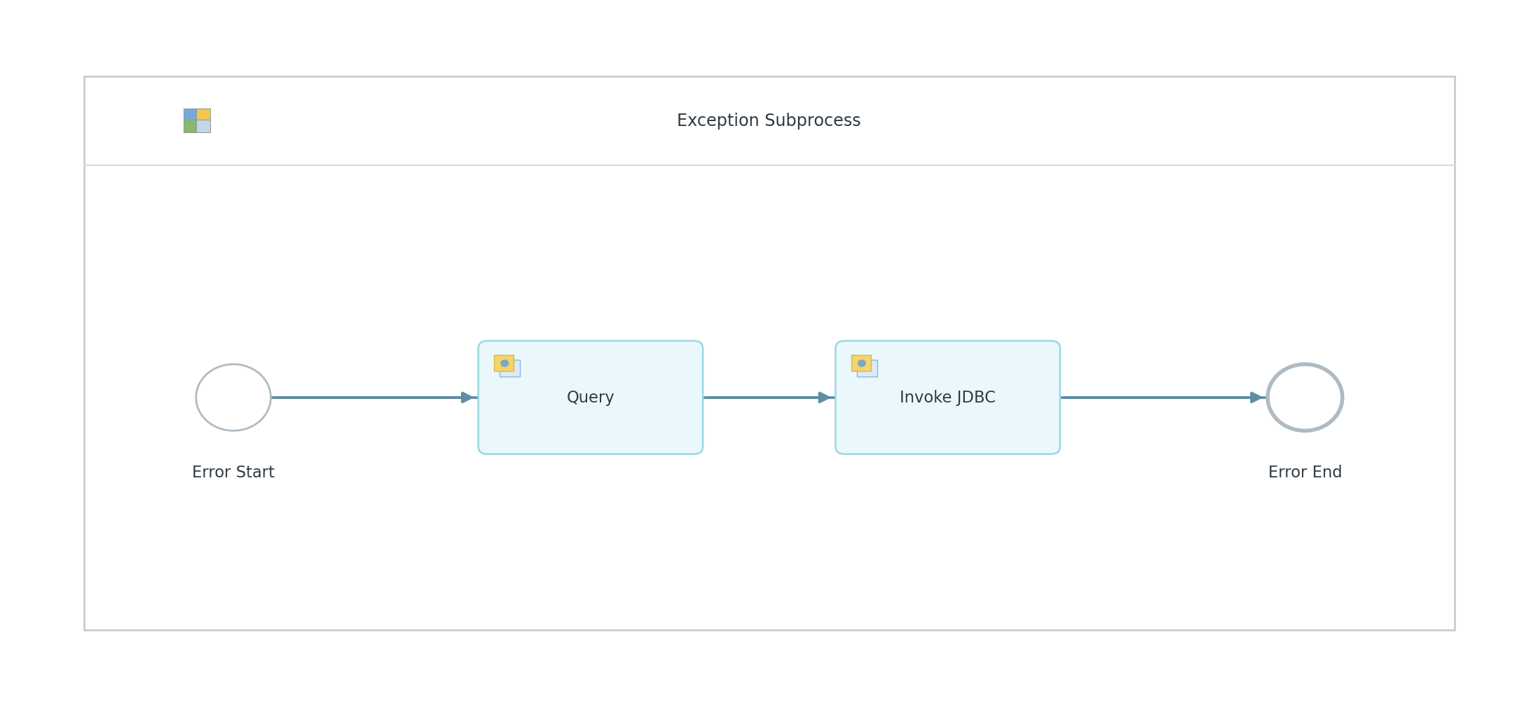
Figure: Exception SubProcess Diagram

Exception SubProcess 1 Properties

Child Element: callActivity Query
Key | Value
bodyType | expression
wrapContent | call public.sp_crud_bravo_order_technical_exception_log( 'F${property.DOC_NUMBER}','${property.FolderName}','FSAP', '', 'Foundation_BusinessDocumentPDF_Bravo_Subscriber','${exception.message}','${property.DOC_CREATION_DATE}', '${property.ExceptionSubProcessTimeStamp}');

Child Element: callActivity Invoke JDBC
Key | Value
processId | Process_40623567
subActivityType | NonLoopingProcess

6. Version and Metadata
Key | Value
Componentversion | 1.0
Version | 1.2
Package | Not found in iFlow
Author | Not found in iFlow
Description | This interface is created as subscriber flow for AWS S3 bravo pdf's. Daisy chained from PO interface FoundationERP_GTNexus_BusinessDocumentPDF_Glovia

7. Appendix

7.1 Technical Artifacts
- iFlow: Foundation_BusinessDocumentPDF_Bravo_Subscriber.iflw
- Groovy Script: concatenate.groovy
- Schema: BusinessDocument.xsd
- Schema: Delivery_Returns_PDF.xsd
- Message Flows: 3
- Sequence Flows: 14
- Mapping Activities: 1
- src/main/resources/script/concatenate.groovy
- src/main/resources/xsd/BusinessDocument.xsd
- src/main/resources/xsd/Delivery_Returns_PDF.xsd
- src/main/resources/mapping/BusinessDocumentMapping.mmap
- src/main/resources/scenarioflows/integrationflow/Foundation_BusinessDocumentPDF_Bravo_Subscriber.iflw

7.2 Schemas
File | Namespace | Elements | Complex Types
BusinessDocument.xsd | urn:erp:o2c:s:global:business:document:100 | 8 | 5
Delivery_Returns_PDF.xsd |  | 5 | 2

7.3 Externalized Parameters
Parameter | Value | Used In
AccessKey | Access_Key_AWS_S3_Bravo | Receiver - Access Key
Bucket Name | idt-test-document-data | Receiver - Bucket Name
SecretKey | Secret_Key_AWS_S3_Bravo | Receiver - Secret Key
SynLogisticsPlatform_Database | LogisticsPlatform | Receiver - Alias

