SAP Integration Suite
Cloud Integration

Technical Specification Document

GSAP_MaterialMaster_DataPro

Version: 1.0
Author: Generated by AI
Date: May 13, 2026
Status: Draft

Table of Contents
1. Change History
1.1 Document Control
2. Overview
2.1 Executive Summary
2.2 Purpose
2.3 Interface Requirement
2.4 Functional Assumptions
2.5 Integration Snapshot
3. High level iFlow Design
3.1 Current Scenario
3.2 To-Be Scenario
3.3 High Level Design
3.4 Technical Dependencies
4. Message Flow
4.1 Process Flow
4.2 Message Flow Connections
4.3 Integration Flow Diagram
5. Technical Description
5.1 Main Integration Process
5.3 Sender
5.4 Receiver
5.5 Mappings
5.6 Security
5.7 Groovy Scripts
5.8 Error Handling & Logging
6. Version and Metadata
7. Appendix
7.1 Technical Artifacts
7.2 Schemas
7.3 Externalized Parameters

1. Change History
Version | Date | Author | Description
1.0 | 2026-05-13 | Generated by AI | Initial autogenerated version

1.1 Document Control
- Document ID: TS-GSAP_MaterialMaster_DataPro
- Integration Flow: GSAP_MaterialMaster_DataPro
- Generated On: 2026-05-13 12:53
- Generation Mode: Batch
- Diagrams Included: Yes
- Functional Spec Context: Provided

2. Overview

2.1 Executive Summary
The GSAP_MaterialMaster_DataPro iFlow integrates SAP (gSAP) with DataPro to transfer Material Master data. It receives Material Master data from gSAP via IDocs and inserts it into the DataPro system using JDBC.

2.2 Purpose
This document provides a technical specification for the GSAP_MaterialMaster_DataPro iFlow, detailing its functionality, configuration, and integration processes.

2.3 Interface Requirement
The business requirement driving this integration is to automate the transfer of Material Master data from GSAP to DataPro, ensuring data consistency and reducing manual effort. The functional specification mentions the need for GSAP-DataPro integration for Product Data.

2.4 Functional Assumptions
Assumption | Value
Frequency | Daily, based on the functional specification.
Volume | Not specified in iFlow, but the functional specification mentions initial load volumes.
Processing Type | Asynchronous, XML
Performance | No special performance considerations as data volume is not huge and no time bound data upload requirements into DB, according to the functional specification.

2.5 Integration Snapshot
Metric | Value
Integration Processes | 1
Message Flows | 2
Sequence Flows | 8
Groovy Scripts | 2
Schemas | 0
Externalized Parameters | 37

3. High level iFlow Design

3.1 Current Scenario
No automated integration. Material Master data is not automatically transferred from GSAP to DataPro.

3.2 To-Be Scenario
Material Master data is automatically extracted from GSAP via IDocs and loaded into DataPro using JDBC. The iFlow processes the IDoc, transforms the data, and inserts it into the DataPro database.

3.3 High Level Design
The iFlow uses a ProcessDirect sender adapter to receive IDocs from gSAP. A message mapping transforms the IDoc data into the DataPro format. The JDBC receiver adapter then inserts the transformed data into the DataPro database. An exception subprocess handles errors and logs payload.

3.4 Technical Dependencies
- Runtime platform: SAP CI integration flow 'GSAP_MaterialMaster_DataPro' orchestrates message exchange from gSAP to DataPro.
- Inbound interface dependency: path /GSAP/MATMAS_MATMAS05_ZX_MATMAS05; ProcessDirect adapter using Not Applicable over Not Applicable.
- Outbound interface dependency: URL DataPro_PricingCondition; receiver authentication type Not configured with credential/security artifact DataPro_PricingCondition.
- Security dependency: receiver authentication type Not configured with credential/security artifact DataPro_PricingCondition.
- Design-time artifacts: WSDLs src\main\resources\wsdl\MATMAS.MATMAS05.ZX_MATMAS05.wsdl; src\main\resources\wsdl\MT_Insert_MaterialMaster.wsdl | mappings src\main\resources\mapping\mm_MATMAS_MATMAS05_to_MaterialMaster.mmap.
- Custom script artifacts: Interface_Generic_Headers.groovy; Log_Payload.groovy.
- Externalized runtime dependencies: 37 parameter(s) supplied, including BusinessObject.

4. Message Flow
A message comes from gSAP into SAP CI through the configured sender channel.
SAP CI processes the payload and sends the final message to DataPro through the receiver channel.

4.1 Process Flow
Step | Description
1 | Step 1: gSAP triggers the iFlow by sending a Material Master IDoc.
2 | Step 2: Integration Suite receives the IDoc via the ProcessDirect adapter.
3 | Step 3: The IDoc data is mapped to the DataPro Material Master structure using a message mapping.
4 | Step 4: The transformed data is sent to DataPro via the JDBC adapter for insertion into the database.

Flow Attribute | Value
Target System | DataPro
Trigger | Event-triggered by IDoc from gSAP

4.2 Message Flow Connections
Source | Target | Name
End Message | DataPro | Datapro_MaterialMaster_JDBC_Receiver
gSAP | Start | ProcessDirect

4.3 Integration Flow Diagram
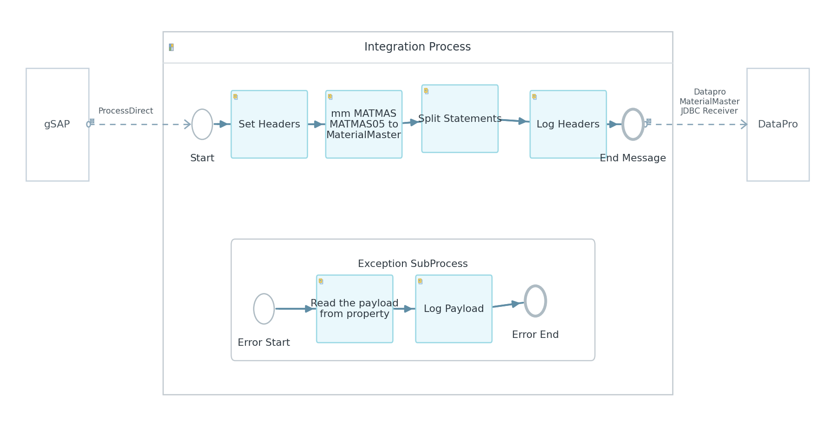
Figure: Integration Flow Diagram

5. Technical Description

5.1 Main Integration Process
Process Name | Sequence Flows | Flow Elements
Integration Process | 8 | 7

Integration Process
This process defines the main integration flow for transferring Material Master data from gSAP to DataPro. It includes steps for receiving the IDoc, transforming the data, and sending it to DataPro.
Key Activity
Enricher (Set Headers)
Mapping (mm_MATMAS_MATMAS05_to_MaterialMaster)
Splitter (Split Statements)
Script (Log Headers)
JDBC Adapter

Step | Description
1 | Receive IDoc from gSAP
2 | Set Headers
3 | Map IDoc to DataPro format
4 | Split Statements
5 | Log Headers
6 | Send data to DataPro via JDBC

Component Name | Key | Value
Integration Process | Transaction Timeout | 30
Integration Process | Transactional Handling | Not Required

callActivity Set Headers Properties
Key | Value
Body Type | constant

callActivity Split Statements Properties
Key | Value
Split Expr Value | //Statement

5.3 Sender
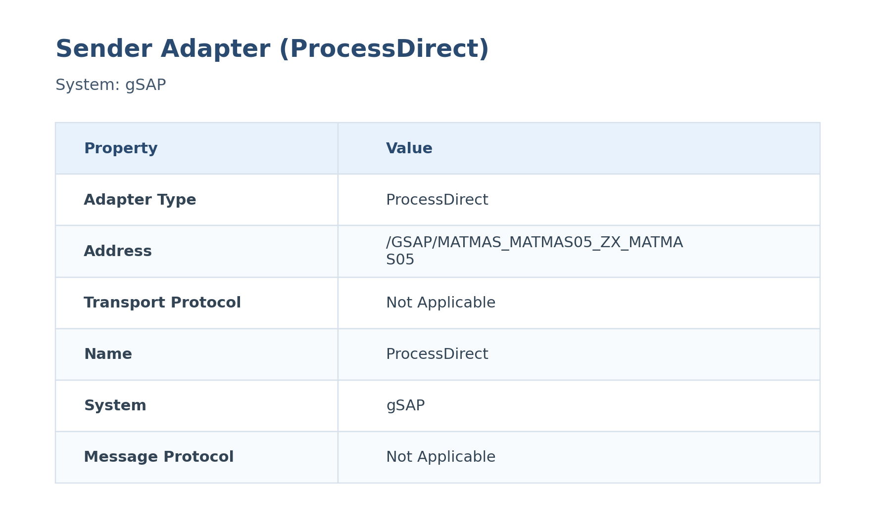
Figure: Sender Configuration

The sender is configured with the ProcessDirect adapter to receive IDocs from gSAP. No authentication is configured at the adapter level.
Attribute | Value
Path / Address | /GSAP/MATMAS_MATMAS05_ZX_MATMAS05
Adapter Type | ProcessDirect
Protocol | Not Applicable over Not Applicable
Auth Type | Not configured
User Role | Not configured

Table: Detailed Sender Adapter Properties
Key | Value
Vendor | SAP
System | gSAP

5.4 Receiver
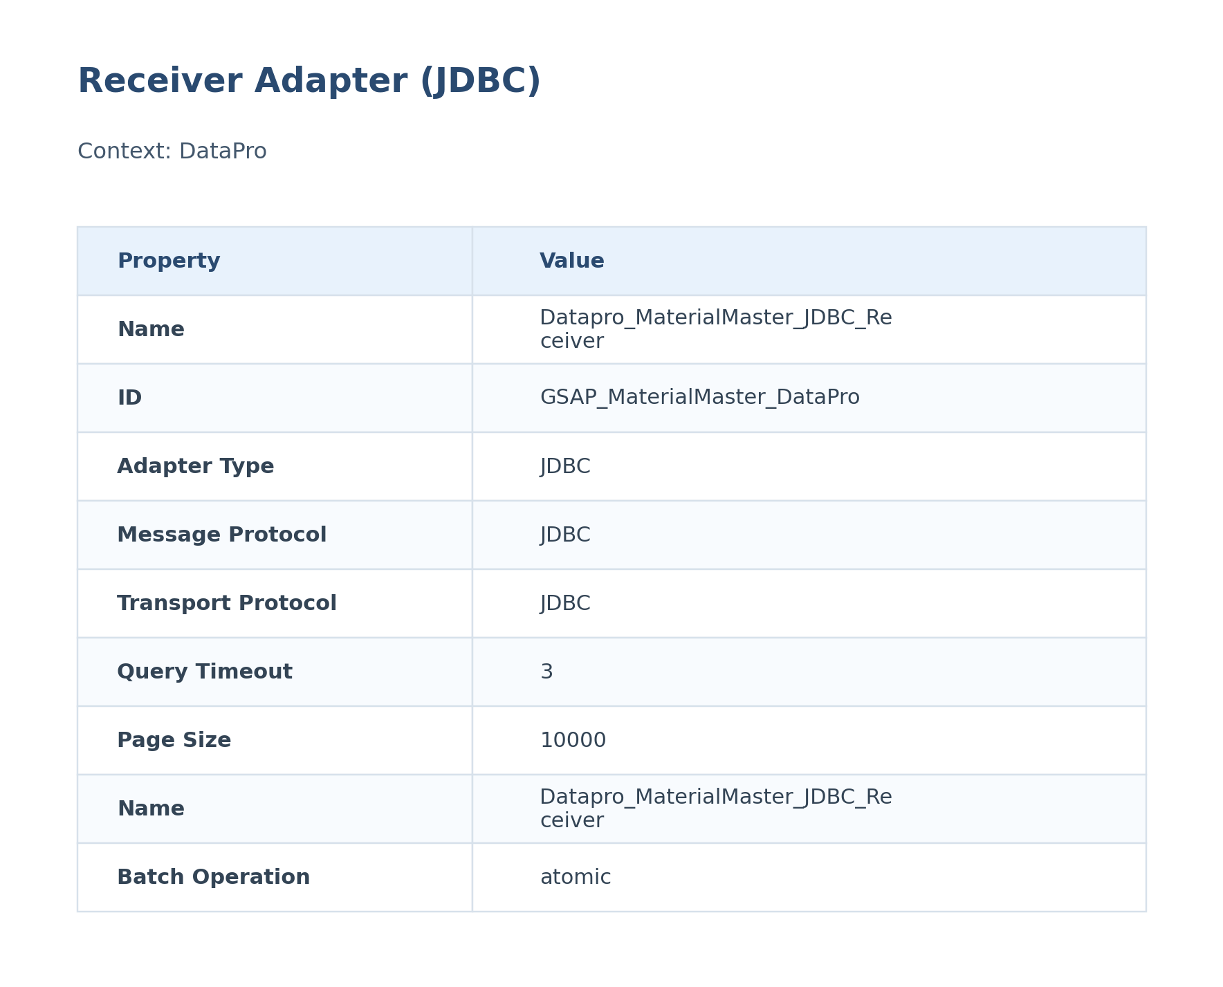
Figure: Receiver Configuration

The receiver is configured with the JDBC adapter to insert data into the DataPro database. The connection details are defined by the JDBC DataSource Alias.
Attribute | Value
URL / Address | DataPro_PricingCondition
Adapter Type | JDBC
Authentication Type | Not configured
Credential / Security Artifact | DataPro_PricingCondition
Operation Name | Not configured

Table: Detailed Receiver Adapter Properties
Key | Value
Query Timeout | 3
Page Size | 10000
Vendor | SAP
Batch Operation | atomic
System | DataPro
Batch Mode | false
Transport Protocol | JDBC
Connection Timeout | 3
Message Protocol | JDBC

5.5 Mappings
Name | 2-Line Summary | Mapping File Link
mm_MATMAS_MATMAS05_to_MaterialMaster | This mapping transforms MATMAS MATMAS05 data into the MaterialMaster structure used later in SAP CI.  It is executed during message processing to reshape the payload before the next handoff. | src\main\resources\mapping\mm_MATMAS_MATMAS05_to_MaterialMaster.mmap

mm_MATMAS_MATMAS05_to_MaterialMaster
Attribute | Value
Source Message / Object | MATMAS MATMAS05
Target Message / Object | MaterialMaster

5.6 Security
Security Aspect | Details
Authentication | Not configured for ProcessDirect sender. JDBC authentication depends on the JDBC DataSource Alias configuration.
Authorization | Not configured
Encryption | TLS/SSL depends on the JDBC DataSource Alias configuration.

Key | Value
Http Session Handling | None
Return Exception To Sender | false
Log | All events
Cors Enabled | false
Server Trace | false
Access Control Allow Credentials | false

5.7 Groovy Scripts
Groovy scripts are used for logging message headers and payloads. These scripts enhance the monitoring and debugging capabilities of the iFlow.

Interface_Generic_Headers.groovy
This script logs the values of specific message headers (Country, Region, BusinessObject, Sender, Receiver, TimeStamp, MaterialNumber, IDocNumber) to the message log for monitoring and auditing purposes.
[Groovy]
import com.sap.gateway.ip.core.customdev.util.Message;
def Message processData(Message message)
{
def messageLog = messageLogFactory.getMessageLog(message);
if(messageLog != null)
{
def Country = message.getHeaders().get("Country");
if(Country!=null)
{
messageLog.addCustomHeaderProperty("Country", Country);
}
def Region = message.getHeaders().get("Region");
if(Region!=null)
{
messageLog.addCustomHeaderProperty("Region", Region);
}
def BusinessObject = message.getHeaders().get("BusinessObject");
if(BusinessObject!=null)
{
messageLog.addCustomHeaderProperty("BusinessObject", BusinessObject);
}
def Sender = message.getHeaders().get("Sender");
if(Sender!=null)
{
messageLog.addCustomHeaderProperty("Sender", Sender);
}
def Receiver = message.getHeaders().get("Receiver");
if(Receiver!=null)
{
messageLog.addCustomHeaderProperty("Receiver", Receiver);
}
def TimeStamp = message.getHeaders().get("TimeStamp");
if(TimeStamp!=null)
{
messageLog.addCustomHeaderProperty("TimeStamp", TimeStamp);
}
def MaterialNumber = message.getHeaders().get("MaterialNumber");
if(MaterialNumber!=null)
{
messageLog.addCustomHeaderProperty("MaterialNumber", MaterialNumber);
}
def IDocNumber = message.getHeaders().get("IDocNumber");
if(IDocNumber!=null)
{
messageLog.addCustomHeaderProperty("IDocNumber", IDocNumber);
}
}
return message;
}

Log_Payload.groovy
This script logs the message payload as an attachment to the message log. This is useful for debugging and auditing purposes.
[Groovy]
import com.sap.gateway.ip.core.customdev.util.Message;
import java.util.HashMap;
def Message processData(Message message) {
def body = message.getBody(java.lang.String) as String;
def messageLog = messageLogFactory.getMessageLog(message);
messageLog.addAttachmentAsString("Output", body, "text/plain");
return message;
}

5.8 Error Handling & Logging
Aspect | Details
Description | The iFlow includes an exception subprocess to handle errors. This subprocess logs the payload and terminates the iFlow with an error.
Exception Handling | The exception subprocess captures errors, reads the payload from the 'InputPayload' property, logs the payload using the 'Log_Payload.groovy' script, and terminates the iFlow with an error end event.
Alerting | Not configured in iFlow
Retry Logic | Not configured in iFlow

Exception SubProcess Diagram
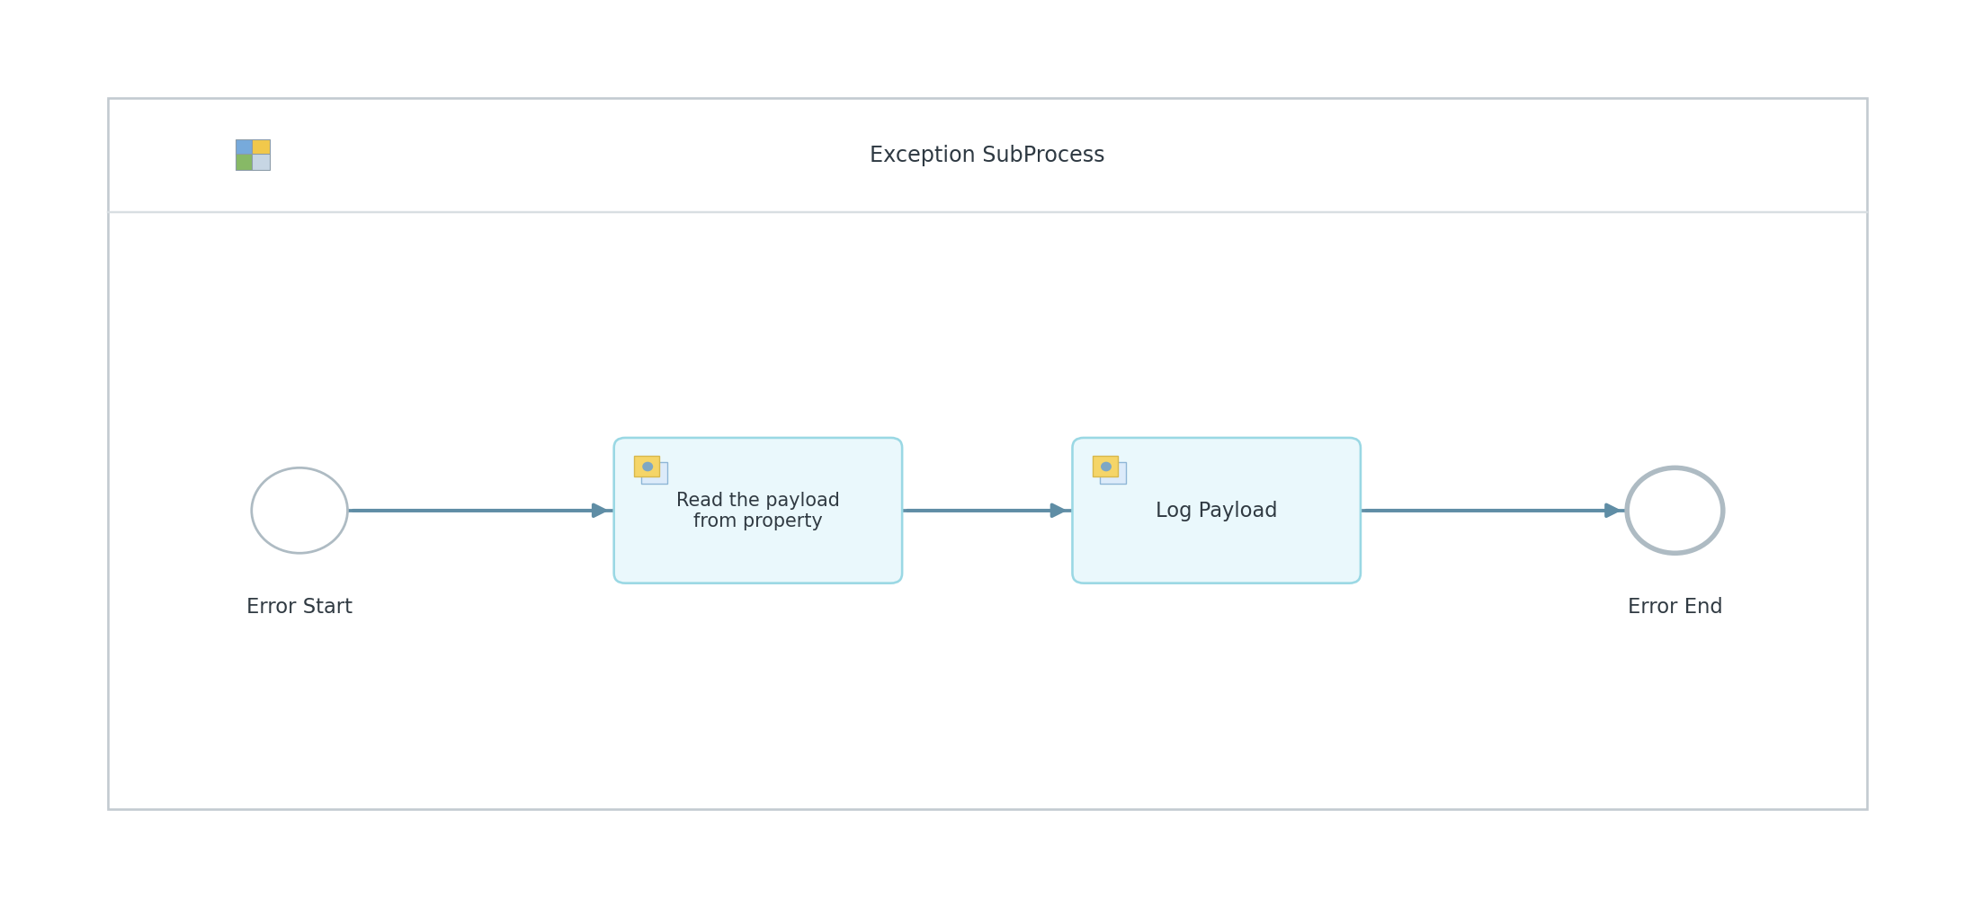
Figure: Exception SubProcess Diagram

Exception SubProcess 1 Properties

Child Element: callActivity Log Payload
Key | Value
subActivityType | GroovyScript
script | Log_Payload.groovy

Child Element: callActivity Read the payload from property
Key | Value
bodyType | expression
wrapContent | ${property.InputPayload}

6. Version and Metadata
Key | Value
Componentversion | 1.3
Version | 1.2
Package | Not found in iFlow
Author | Not found in iFlow
Description | Not found in iFlow

7. Appendix

7.1 Technical Artifacts
- iFlow: GSAP_MaterialMaster_DataPro.iflw
- Groovy Script: Interface_Generic_Headers.groovy
- Groovy Script: Log_Payload.groovy
- Message Flows: 2
- Sequence Flows: 8
- Mapping Activities: 1
- Log_Payload.groovy
- Interface_Generic_Headers.groovy
- mm_MATMAS_MATMAS05_to_MaterialMaster.mmap
- MATMAS.MATMAS05.ZX_MATMAS05.wsdl
- MT_Insert_MaterialMaster.wsdl

7.3 Externalized Parameters
Parameter | Value | Used In
BatchMode | false | Receiver - Batch Mode
ConnectionTimeout | 3 | Receiver - Connection Timeout
JDBCDataSourceAlias | DataPro_PricingCondition | Receiver - Alias
MaximumRecords | 10000 | Receiver - Page Size
Query/ResponseTimeout | 3 | Receiver - Query Timeout
Sender_Address | /GSAP/MATMAS_MATMAS05_ZX_MATMAS05 | Sender - Address

