SAP Integration Suite
Cloud Integration

Technical Specification Document

Foundation_BusinessDocumentPDF_Bravo_Subscriber

Version: | 1.0
Author: | Generated by AI
Date: | April 09, 2026
Status: | Draft

Table of Contents

1. Change History
Version | Date | Author | Description
1.0 | 2026-04-09 | Generated by AI | Initial autogenerated version

1.1 Document Control
Attribute | Value
Document ID | TS-Foundation_BusinessDocumentPDF_Bravo_Subscriber
Integration Flow | Foundation_BusinessDocumentPDF_Bravo_Subscriber
Generated On | 2026-04-09 21:15
Generation Mode | Batch
Diagrams Included | Yes
Functional Spec Context | Not Provided

2. Overview

2.1 Executive Summary
The iFlow 'Foundation_BusinessDocumentPDF_Bravo_Subscriber' receives a business document via HTTPS, extracts the Base64 encoded PDF content, and stores it in an AWS S3 bucket. It also logs exception information to a JDBC database. This integration automates the process of storing business documents in a central repository and tracking any errors encountered.

2.2 Purpose
This document provides a technical specification for the 'Foundation_BusinessDocumentPDF_Bravo_Subscriber' iFlow, outlining its functionality, configuration, and dependencies.

2.3 Interface Requirement
The business requires an automated solution to store business documents in a central repository (AWS S3) and track any errors encountered during the process.

2.4 Functional Assumptions
Assumption | Value
Frequency | Real-time
Volume | Not configured
Processing Type | Async, XML
Performance | Not configured

2.5 Integration Snapshot
Metric | Value
Integration Processes | 2
Message Flows | 3
Sequence Flows | 14
Groovy Scripts | 1
Schemas | 2
Runtime Parameters | 4

3. High level iFlow Design

3.1 Current Scenario
No automated integration

3.2 To-Be Scenario
The integration enables automated transfer of business document PDFs from the Foundation system to an AWS S3 bucket, with exception logging to a SynLogisticsPlatform database.

3.3 High Level Design
The iFlow uses an HTTPS sender adapter to receive the business document. It then uses content modifiers to extract properties and prepare the data for storage in AWS S3 via the AmazonWebServices adapter. An exception subprocess handles errors and logs them to a JDBC database.

3.4 Technical Dependencies
AWS S3 bucket name, AWS Access Key, AWS Secret Key, JDBC connection details for SynLogisticsPlatform_Database, ESBMessaging.send role for HTTPS sender.
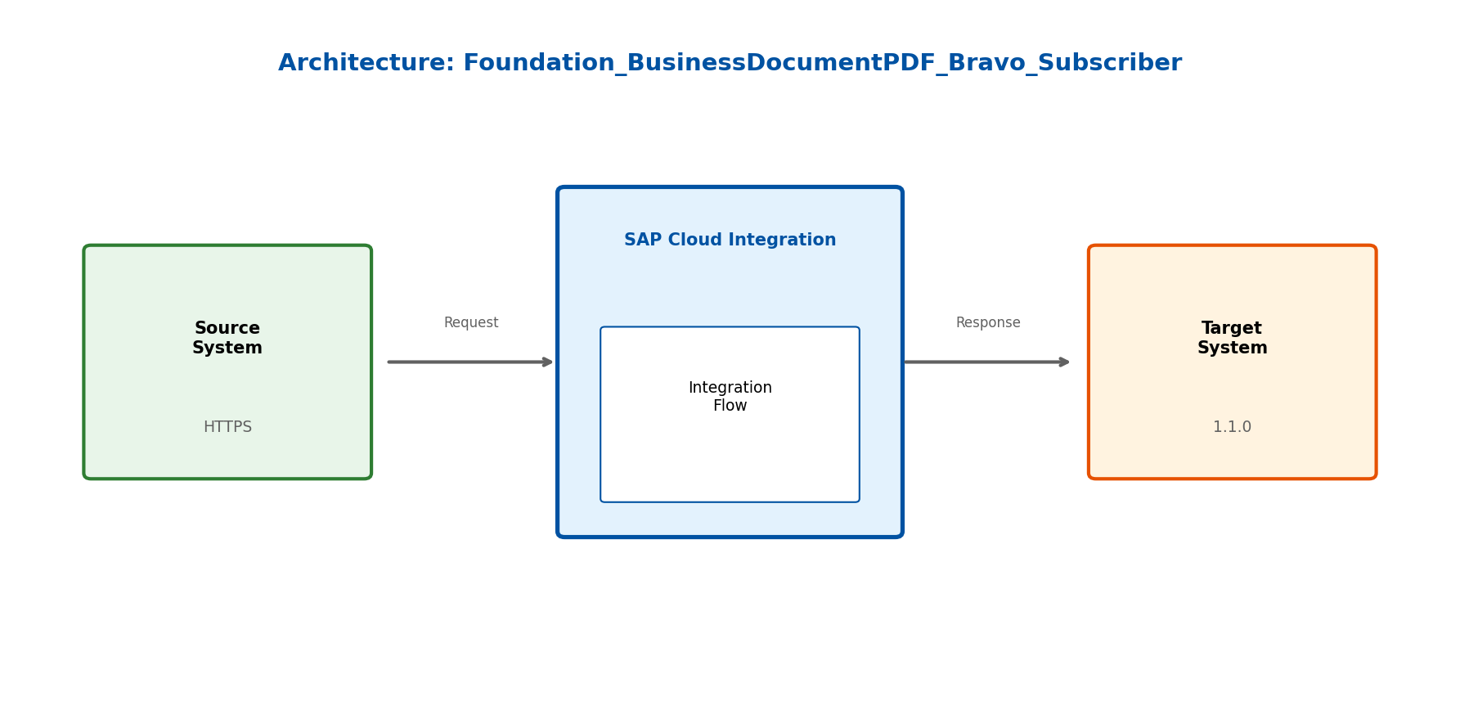
Figure: High-Level Architecture

4. Message Flow
- The iFlow starts with an HTTPS sender adapter, listening for requests on the '/businessDocument/IDT' endpoint.
- The 'log payload' Enricher extracts properties like DOC_NUMBER, DOC_TYPE, IDENTIFIER, and DOC_CREATION_DATE from the incoming XML payload using XPath expressions and stores the entire payload in the InputPayload property. It also sets SAP_MessageType and SAP_ApplicationID headers.
- The 'Filter' Enricher extracts the Base64 content, FolderName, and FileName from the payload using XPath and stores them as properties.
- The 'set body' Enricher sets the message body to the value of the 'payload' property.
- The 'call to S3' Service Task calls the AmazonWebServices receiver adapter to write the PDF content to the specified S3 bucket. The bucket name, folder name, and file name are dynamically determined using properties. Server-side encryption (SSE-S3) is enabled.
- The 'Query formation' Enricher calls the stored procedure `sp_crud_dt_docfolder_and_documentlist` in the database.
- The iFlow ends with a Message End Event.

4.1 Process Flow
Step | Description
1 | Step 1: Foundation system sends a business document via HTTPS to the Integration Suite.
2 | Step 2: Integration Suite receives the document and extracts relevant properties (payload, folder name, file name, document number, identifier, document creation date).
3 | Step 3: The PDF content is stored in an AWS S3 bucket.
4 | Step 4: Information about the document and any exceptions are logged to the SynLogisticsPlatform database.

Flow Attribute | Value
Source System | Foundation
Target System | AWS-S3
Trigger | HTTPS request

4.2 Message Flow Connections
Source | Target | Name
call to S3 | AWS-S3 | AmazonWebServices
Query JDBC | SynLogisticsPlatform_Database | JDBC
Foundation | Start | HTTPS

4.3 Integration Flow Diagram
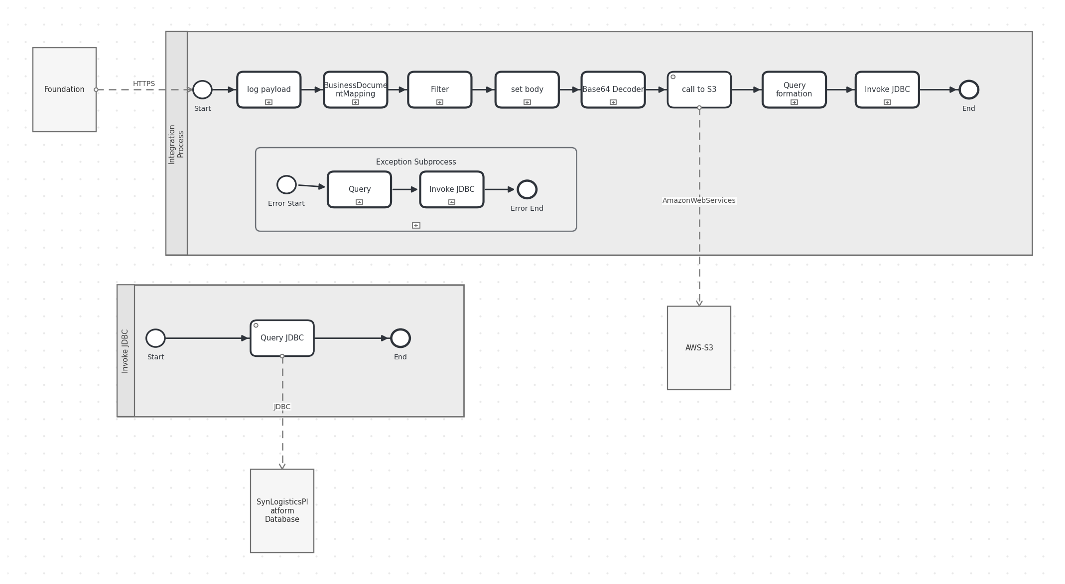
Figure: Integration Flow Diagram

5. Technical Description

5.1 Main Integration Process

Invoke JDBC
This process is a local integration process that executes a JDBC query. It is called from the exception subprocess to log error information to the database.
Key Activity
ExternalCall

Step | Description
1 | Start
2 | Query JDBC
3 | End

Component Name | Key | Value
Invoke JDBC | Transaction Timeout | 30
Invoke JDBC | Process Type | directCall
Invoke JDBC | Component Version | 1.1
Invoke JDBC | Cmd Variant Uri | ctype::FlowElementVariant/cname::LocalIntegrationProcess/version::1.1.3
Invoke JDBC | Transactional Handling | From Calling Process

serviceTask Query JDBC Properties
Key | Value
Component Version | 1.0
Activity Type | ExternalCall
Cmd Variant Uri | ctype::FlowstepVariant/cname::ExternalCall/version::1.0.4

endEvent End Properties
Key | Value
Cmd Variant Uri | ctype::FlowstepVariant/cname::EndEvent
Activity Type | EndEvent

startEvent Start Properties
Key | Value
Cmd Variant Uri | ctype::FlowstepVariant/cname::StartEvent
Activity Type | StartEvent

5.2 Local Integration Process

Integration Process
This is the main integration process that handles the overall flow of the iFlow, including receiving the message, processing the data, storing the PDF in S3, and handling exceptions.
Key Activity
Enricher
ExternalCall
SubProcess

Step | Description
1 | Start
2 | log payload
3 | Filter
4 | set body
5 | call to S3
6 | Query formation
7 | End

Component Name | Key | Value
Integration Process | Transaction Timeout | 30
Integration Process | Component Version | 1.2
Integration Process | Cmd Variant Uri | ctype::FlowElementVariant/cname::IntegrationProcess/version::1.2.1
Integration Process | Transactional Handling | Not Required

subProcess Exception Subprocess Properties
Key | Value
Component Version | 1.1
Activity Type | ErrorEventSubProcessTemplate
Cmd Variant Uri | ctype::FlowstepVariant/cname::ErrorEventSubProcessTemplate/version::1.1.0

serviceTask call to S3 Properties
Key | Value
Component Version | 1.0
Activity Type | ExternalCall
Cmd Variant Uri | ctype::FlowstepVariant/cname::ExternalCall/version::1.0.4

endEvent End Properties
Key | Value
Component Version | 1.1
Cmd Variant Uri | ctype::FlowstepVariant/cname::MessageEndEvent/version::1.1.0

callActivity Query formation Properties
Key | Value
Body Type | expression
Property Table
Header Table
Wrap Content | CALL sp_crud_dt_docfolder_and_documentlist('${property.FolderName}', '${property.IDENTIFIER}', NULL, NULL, NULL, NULL, '${property.FileName}.pdf', '1', '${property.DOC_NUMBER}', 'F');
Component Version | 1.6
Activity Type | Enricher
Cmd Variant Uri | ctype::FlowstepVariant/cname::Enricher/version::1.6.1

callActivity set body Properties
Key | Value
Body Type | expression
Property Table
Header Table
Wrap Content | ${property.payload}
Component Version | 1.6
Activity Type | Enricher
Cmd Variant Uri | ctype::FlowstepVariant/cname::Enricher/version::1.6.1

callActivity log payload Properties
Key | Value
Body Type | constant
Property Table | <row><cell id='Action'>Create</cell><cell id='Type'>xpath</cell><cell id='Value'>//Attribute[Type=&apos;DOC NUMBER&apos;]/Values/text()</cell><cell id='Default'></cell><cell id='Name'>DOC_NUMBER</cell><cell id='Datatype'>java.lang.String</cell></row><row><cell id='Action'>Create</cell><cell id='Type'>xpath</cell><cell id='Value'>//Attribute[Type=&apos;DOC TYPE&apos;]/Values/text()</cell><cell id='Default'></cell><cell id='Name'>DOC_TYPE</cell><cell id='Datatype'>java.lang.String</cell></row><row><cell id='Action'>Create</cell><cell id='Type'>xpath</cell><cell id='Value'>//Attribute[Type=&apos;IDENTIFIER&apos;]/Values/text()</cell><cell id='Default'></cell><cell id='Name'>IDENTIFIER</cell><cell id='Datatype'>java.lang.String</cell></row><row><cell id='Action'>Create</cell><cell id='Type'>xpath</cell><cell id='Value'>//Attribute[Type=&apos;DOC CREATION DATE&apos;]/Values/text()</cell><cell id='Default'></cell><cell id='Name'>DOC_CREATION_DATE</cell><cell id='Datatype'>java.lang.String</cell></row><row><cell id='Action'>Create</cell><cell id='Type'>expression</cell><cell id='Value'>${body}</cell><cell id='Default'></cell><cell id='Name'>InputPayload</cell><cell id='Datatype'>java.lang.String</cell></row>
Header Table | <row><cell id='Action'>Create</cell><cell id='Type'>xpath</cell><cell id='Value'>//Attribute[Type=&apos;IDENTIFIER&apos;]/Values/text()</cell><cell id='Default'></cell><cell id='Name'>SAP_MessageType</cell><cell id='Datatype'>java.lang.String</cell></row><row><cell id='Action'>Create</cell><cell id='Type'>xpath</cell><cell id='Value'>//Attribute[Type=&apos;DOC NUMBER&apos;]/Values/text()</cell><cell id='Default'></cell><cell id='Name'>SAP_ApplicationID</cell><cell id='Datatype'>java.lang.String</cell></row>
Wrap Content
Component Version | 1.6
Activity Type | Enricher
Cmd Variant Uri | ctype::FlowstepVariant/cname::Enricher/version::1.6.1

callActivity Filter Properties
Key | Value
Body Type | constant
Property Table | <row><cell id='Action'>Create</cell><cell id='Type'>xpath</cell><cell id='Value'>//Base64Content</cell><cell id='Default'></cell><cell id='Name'>payload</cell><cell id='Datatype'>java.lang.String</cell></row><row><cell id='Action'>Create</cell><cell id='Type'>xpath</cell><cell id='Value'>//Name</cell><cell id='Default'></cell><cell id='Name'>FolderName</cell><cell id='Datatype'>java.lang.String</cell></row><row><cell id='Action'>Create</cell><cell id='Type'>xpath</cell><cell id='Value'>//Type</cell><cell id='Default'></cell><cell id='Name'>FileName</cell><cell id='Datatype'>java.lang.String</cell></row>
Header Table
Wrap Content
Component Version | 1.6
Activity Type | Enricher
Cmd Variant Uri | ctype::FlowstepVariant/cname::Enricher/version::1.6.1

startEvent Start Properties
Key | Value
Component Version | 1.0
Cmd Variant Uri | ctype::FlowstepVariant/cname::MessageStartEvent/version::1.0

callActivity Invoke JDBC Properties
Key | Value
Process Id | Process_40623567
Component Version | 1.0
Activity Type | ProcessCallElement
Cmd Variant Uri | ctype::FlowstepVariant/cname::NonLoopingProcess/version::1.0.4
Sub Activity Type | NonLoopingProcess

callActivity BusinessDocumentMapping Properties
Key | Value
Mappinguri | dir://mmap/src/main/resources/mapping/BusinessDocumentMapping.mmap
Mappingname | BusinessDocumentMapping
Mapping Source Value
Mapping Type | MessageMapping
Mapping Reference | static
Mappingpath | src/main/resources/mapping/BusinessDocumentMapping
Component Version | 1.3
Activity Type | Mapping
Cmd Variant Uri | ctype::FlowstepVariant/cname::MessageMapping/version::1.3.1
Message Mapping Bundle Id

callActivity Base64 Decoder Properties
Key | Value
Component Version | 1.0
Activity Type | Decoder
Cmd Variant Uri | ctype::FlowstepVariant/cname::Base64 Decode/version::1.0.1
Encoder Type | Base64 Decode

5.3 Sender
Attribute | Value
System | Foundation
Adapter Type | HTTPS
Address | /businessDocument/IDT
Protocol | HTTPS
Authentication | RoleBased
Description | The HTTPS sender adapter receives the business document from the Foundation system. It is configured to use role-based authentication, requiring the 'ESBMessaging.send' role.

Key | Value
Component Type | HTTPS
Description
Maximum Body Size | 40
Component N S | sap
Component Version | 1.5
Url Path | /businessDocument/IDT
Name | HTTPS
Transport Protocol Version | 1.5.2
Component S W C V Name | external
System | Foundation
Xsrf Protection | 0
Transport Protocol | HTTPS
Cmd Variant Uri | ctype::AdapterVariant/cname::sap:HTTPS/tp::HTTPS/mp::None/direction::Sender/version::1.5.2
User Role | ESBMessaging.send
Sender Auth Type | RoleBased
Message Protocol | None
Message Protocol Version | 1.5.2
Component S W C V Id | 1.5.2
Direction | Sender
Client Certificates

5.4 Receiver
Attribute | Value
System | AWS-S3
Adapter Type | HTTPS
Address | amazonaws.com
Protocol | HTTPS
Authentication | Access Key / Secret Key
Description | The AmazonWebServices receiver adapter stores the PDF content in the specified S3 bucket. It uses HTTPS protocol and requires an Access Key and Secret Key for authentication. Server-side encryption (SSE-S3) is enabled.

Key | Value
Bucket Name | {{Bucket Name}}
File Name | ${property.FileName}.pdf
S3 Server Side Encryption For Archive | SSE-S3
Empty File Handling | proceedWithEmptyFile
S3 Server Side Encryption Customer Key
Name | AmazonWebServices
Transport Protocol Version | 1.1.0
S3 Server Side Encryption Customer Key For Archive
S3 Server Side Encryption Kms Key I D
Host | amazonaws.com
Content Encoding
S3 Receiver Post Processing | delete
Content Type | application/pdf
Component S W C V Id | 1.1.0
Exist File Handling | overwrite
Component Version | 1.1
Archive Folder
S3 Decryption Key
Upload Message Attachments | false
S3 Server Side Encryption
System | AWS-S3
List Operation Folder Name
Archive Bucket
Access Key | {{AccessKey}}
Transport Protocol | HTTPS
Folder Name | ${property.FolderName}
Cmd Variant Uri | ctype::AdapterVariant/cname::AmazonWebServices/vendor::rojoconsultancy.com/tp::HTTPS/mp::S3/direction::Receiver/version::1.1.0
Message Protocol Version | 1.1.0
Description
Component N S | sap
Region Name | eu-central-1
Component S W C V Name | external
Storage Class | STANDARD
Requester Pays | false
S3 Custom Metadata Table For Archive
S3 Server Side Encryption Kms Key I D For Archive
Message Protocol | S3
Direction | Receiver
S3 Append Message Id | false
Component Type | AmazonWebServices
Secret Key | {{SecretKey}}
S3 Append Timestamp | false
Vendor | rojoconsultancy.com
Read Operation Folder Name
List Operation Include Sub Directories | false
Connect Via Sdk | false
Apply Encryption When Archiving | false
S3 Custom Metadata Table
Sorting For List Operation | none
S3 Receiver Operation | write
Read Operation File Name
List Operation File Name
Query Timeout | 3
Component Type | JDBC
Description
Component N S | sap
Page Size | 100000
Vendor | SAP
Component Version | 1.5
Name | JDBC
Transport Protocol Version | 1.5.3
Component S W C V Name | external
Batch Operation | atomic
System | SynLogisticsPlatform_Database
Batch Mode | false
Alias | {{SynLogisticsPlatform_Database}}
Transport Protocol | JDBC
Cmd Variant Uri | ctype::AdapterVariant/cname::JDBC/vendor::SAP/tp::JDBC/mp::JDBC/direction::Receiver/version::1.5.3
Connection Timeout | 3
Message Protocol | JDBC
Message Protocol Version | 1.5.3
Component S W C V Id | 1.5.3
Direction | Receiver

5.5 Mappings
Attribute | Value
Description | The iFlow uses Enrichers to extract data from the incoming XML payload and set properties. XPath expressions are used to identify and extract specific elements.
Source Format | XML
Target Format | application/pdf
Transformations | Extracting Base64 content from XML, Setting file name and folder name properties, Calling stored procedure

Mapping Activity 1 Properties
Key | Value
mappinguri | dir://mmap/src/main/resources/mapping/BusinessDocumentMapping.mmap
mappingname | BusinessDocumentMapping
mappingSourceValue
mappingType | MessageMapping
mappingReference | static
mappingpath | src/main/resources/mapping/BusinessDocumentMapping
componentVersion | 1.3
activityType | Mapping
cmdVariantUri | ctype::FlowstepVariant/cname::MessageMapping/version::1.3.1
messageMappingBundleId

5.6 Security
Security Aspect | Details
Authentication | RoleBased for HTTPS sender
Authorization | ESBMessaging.send role is required to send messages to the iFlow.
Encryption | TLS/SSL for HTTPS and potentially for S3 (SSE-S3)

Key | Value
Namespace Mapping
Http Session Handling | None
Access Control Max Age
Return Exception To Sender | false
Log | All events
Cors Enabled | false
Exposed Headers
Component Version | 1.2
Allowed Header List
Server Trace | false
Allowed Origins
Access Control Allow Credentials | false
Allowed Headers
Allowed Methods
Cmd Variant Uri | ctype::IFlowVariant/cname::IFlowConfiguration/version::1.2.4

5.7 Groovy Scripts
The iFlow uses a Groovy script named 'concatenate.groovy'. This script is used to concatenate strings.

Script: concatenate.groovy
Key | Value
Line Count | 24
Imports | com.sap.it.api.mapping.*
File Path | D:\Hackathon\SYNGENTAILFW\sample\Sample 1\Foundation_BusinessDocumentPDF_IDT_Subscriber (2)\src\main\resources\script\concatenate.groovy

[Groovy]
import com.sap.it.api.mapping.*;
/*Add MappingContext parameter to read or set headers and properties
def String customFunc1(String P1,String P2,MappingContext context) {
String value1 = context.getHeader(P1);
String value2 = context.getProperty(P2);
return value1+value2;
}
Add Output parameter to assign the output value.
def void custFunc2(String[] is,String[] ps, Output output, MappingContext context) {
String value1 = context.getHeader(is[0]);
String value2 = context.getProperty(ps[0]);
output.addValue(value1);
output.addValue(value2);
}*/
def void concatenate(String[] is, Output output, MappingContext context) {
String str="";
for(int i=0;i<is.length;i++){
str=str+is[i];
}
output.addValue(str);
}

5.8 Error Handling & Logging
Aspect | Details
Description | The iFlow includes an exception subprocess to handle errors. When an error occurs, the exception subprocess logs the error message and other relevant information to a JDBC database.
Exception Handling | The exception subprocess captures errors, sets a timestamp, and calls a stored procedure (`sp_crud_bravo_order_technical_exception_log`) to log the error details to the SynLogisticsPlatform database. It then calls the 'Invoke JDBC' process to execute the query.
Alerting | Not configured
Retry Logic | Not configured

Exception SubProcess 1 Properties
Key | Value
componentVersion | 1.1
activityType | ErrorEventSubProcessTemplate
cmdVariantUri | ctype::FlowstepVariant/cname::ErrorEventSubProcessTemplate/version::1.1.0

Child Element: callActivity Query
Key | Value
bodyType | expression
propertyTable | <row><cell id='Action'>Create</cell><cell id='Type'>expression</cell><cell id='Value'>${date:now:yyyy-MM-dd&apos;T&apos;HH:mm:ss&apos;Z&apos;}</cell><cell id='Default'></cell><cell id='Name'>ExceptionSubProcessTimeStamp</cell><cell id='Datatype'>java.lang.String</cell></row>
headerTable
wrapContent | call public.sp_crud_bravo_order_technical_exception_log( 'F${property.DOC_NUMBER}','${property.FolderName}','FSAP', '', 'Foundation_BusinessDocumentPDF_Bravo_Subscriber','${exception.message}','${property.DOC_CREATION_DATE}', '${property.ExceptionSubProcessTimeStamp}');
componentVersion | 1.6
activityType | Enricher
cmdVariantUri | ctype::FlowstepVariant/cname::Enricher/version::1.6.1

Child Element: callActivity Invoke JDBC
Key | Value
processId | Process_40623567
componentVersion | 1.0
activityType | ProcessCallElement
cmdVariantUri | ctype::FlowstepVariant/cname::NonLoopingProcess/version::1.0.4
subActivityType | NonLoopingProcess

6. Version and Metadata
Key | Value
Componentversion | 1.0
Componentswcvid | 1.5.2
Componentns | sap
Componentswcvname | external
Version | 1.2
Package | Not found in iFlow
Author | Not found in iFlow
Description | Not found in iFlow

7. Appendix

7.1 Technical Artifacts
- iFlow: Foundation_BusinessDocumentPDF_Bravo_Subscriber.iflw
- Groovy Script: concatenate.groovy
- Schema: BusinessDocument.xsd
- Schema: Delivery_Returns_PDF.xsd
- Message Flows: 3
- Sequence Flows: 14
- Mapping Activities: 1
- concatenate.groovy
- XML Schema for input message
- Mapping configurations in Enrichers

7.2 Schemas
File | Namespace | Elements | Complex Types
BusinessDocument.xsd | urn:erp:o2c:s:global:business:document:100 | 8 | 5
Delivery_Returns_PDF.xsd |  | 5 | 2

7.3 Runtime Parameters
Parameter | Value
SecretKey | Secret_Key_AWS_S3_Bravo
SynLogisticsPlatform_Database | LogisticsPlatform
Bucket Name | idt-test-document-data
AccessKey | Access_Key_AWS_S3_Bravo

7.4 Parameter Definitions
Parameter | Definition
<?xml version | "1.0" encoding="UTF-8" standalone="no"?><parameters><parameter>
</parameter><param_references><reference attribute_category | "AWS-S3" attribute_id="ctype::Adapter/cname::AmazonWebServices/vendor::rojoconsultancy.com/version::1.1.0/attrId::bucketName" attribute_uilabel="Bucket Name" param_key="Bucket Name"/><reference attribute_category="AWS-S3" attribute_id="ctype::Adapter/cname::AmazonWebServices/vendor::rojoconsultancy.com/version::1.1.0/attrId::secretKey" attribute_uilabel="Secret Key Alias" param_key="SecretKey"/><reference attribute_category="AWS-S3" attribute_id="ctype::Adapter/cname::AmazonWebServices/vendor::rojoconsultancy.com/version::1.1.0/attrId::accessKey" attribute_uilabel="Access Key Alias" param_key="AccessKey"/><reference attribute_category="SynLogisticsPlatform_Database.Auth" attribute_id="ctype::Adapter/cname::JDBC/vendor::SAP/version::1.5.3/attrId::alias" attribute_uilabel="JDBC Data Source Alias" param_key="SynLogisticsPlatform_Database"/></param_references></parameters>

7.5 Glossary
- iFlow: Integration Flow
- S3: Amazon Simple Storage Service
- JDBC: Java Database Connectivity
- XPath: XML Path Language

7.6 References
SAP Cloud Integration Documentation, AWS S3 Documentation, JDBC Adapter Documentation

7.7 Generation Statistics
Statistic | Value
API Calls | 1
Batch Calls | 1
Cache Hits | 0
Cache Hit Rate | 0.0%
Failures | 0

