|  |  |  |  |
| --- | --- | --- | --- |
|  |  | | |
|  |
| **Students Names:** |  |  | **Group No:** |
|  |  |  |  |
|  |  |  |  |
| Due Date: Tuesday December 4, 2018 or December 5, 2018 (split class)    **Labs are due at the end of class on the date specified above (End of class)** | | | |

# Lab Instructions:

* Place your name in the location provided above on this page, then print page 1 (this page)
* Page 1 (this page) is the only page that is submitted to your professor
* Before submitting your lab for evaluation make sure you have demo’ed the required steps to your professor and

it has been initialed by your professor

* Review your lab and make sure all questions/points have been answered before submitting your lab
* When you have completed this lab please rename the lab to the appropriate name as shown below

### o comp203-lab06-name

* **Submit the lab through blackboard**

**Verifications**

**Memory display Student 1: Verified:**

**“tree” command Student 1: Verified:**

**Professor’s Comments**

**Professor Signature:**

**Apple’s Operating System**

Use an Internet search engine to answer the following questions regarding “**Mac OS X**”

What (approximate) year did Apple introduce the Macintosh PC?

What is Mac OS X “**Mojave**”?

### Answer:

What Operating System is Mac OS X based upon?

### Answer:

What is the purpose of “**Gatekeeper**” in Mac OS?

### Answer:

What is “**AirDrop**” and what network medium is used by this technology?

### Answer:

What Operating System is used on the Apple iPhone 8 Plus?

**RFC (Requests for Comments)**

Document written to help ensure network standards and conventions are provided so one network can talk to another.

### Use the following URL and research the indicated RFC’s below

[**http://www.rfc-editor.org/search/rfc_search.php**](http://www.rfc-editor.org/search/rfc_search.php)

Review the following RFC’s and record the required information.

### RFC2549

Date Written:

Author:

In the “**Overview and Rational**” Section

What is a benefit of this technology? **Please read this carefully**☺ **Answer**:

### RFC6409

Date Written:

In the “**Introduction**” Section

What is it saying about “**SMTP**”?

### Answer:

**Class Addresses for IPv4**

**Use the Windows 10 Virtual Machine to do the following:**

# IPv4 and Class addresses

Ping the following hosts and record the IP address and the Class address of each site How to determine the Class Address from an IP address:

* + Find the IP Address of a site, address example: **143.55.101.10**
  + Using all 8 bits of the **first octet**, convert the first octet “**143**” to binary:

|  |  |  |  |  |  |  |  |
| --- | --- | --- | --- | --- | --- | --- | --- |
| **128** | **64** | **32** | **16** | **8** | **4** | **2** | **1** |
| 1 | 0 | 0 | 0 | 1 | 1 | 1 | 1 |

* + From the binary value above use the following chart to determine the class
  + Include all leading zeros

|  |  |  |  |
| --- | --- | --- | --- |
| **128** | **64** | **32** |  |
| 0 |  |  | 1st high-order bit = **0** - then it is a Class A |
| 1 | 0 |  | First two high-order bits = **10** - then it is a Class B |
| 1 | 1 | 0 | First three high-order bits = **110** then it is a Class C |

(**Note**: Some hosts may timeout, this is okay you can still obtain their IP address)

|  |  |  |  |  |  |  |  |  |  |  |
| --- | --- | --- | --- | --- | --- | --- | --- | --- | --- | --- |
| **Address** | **IP Address** | **Class** | **Binary Value of 1st Octet** | | | | | | | |
|  |  |  | 128 | 64 | 32 | 16 | 8 | 4 | 2 | 1 |
| [www.utoronto.ca](http://www.utoronto.ca/) |  |  |  |  |  |  |  |  |  |  |
| [www.ucalgary.ca](http://www.ucalgary.ca/) |  |  |  |  |  |  |  |  |  |  |
| [www.apple.com](http://www.apple.com/) |  |  |  |  |  |  |  |  |  |  |
| [www.ibm.com](http://www.ibm.com/) |  |  |  |  |  |  |  |  |  |  |
| [www.nbc.com](http://www.rim.com/) |  |  |  |  |  |  |  |  |  |  |
| [www.google.ca](http://www.google.ca/) |  |  |  |  |  |  |  |  |  |  |
| [www.facebook.com](http://www.facebook.com/) |  |  |  |  |  |  |  |  |  |  |
| [www.youtube.com](http://www.youtube.com/) |  |  |  |  |  |  |  |  |  |  |

# Note:

**In the above chart make sure you record all 8 bits for the Binary value of the 1st Octet Start at the right side. Fill in high order zeros.**

**Whois Lookup**

## The following exercise you will:

* find the IP address of each site
* then use the web site [www.whois.sc](http://www.whois.sc/) to determine who owns the IP address

## Use the “**ping**” command for each site below and fill in their IPv4 address in the appropriate column

* Once all IPv4 addresses have been recorded use a web browser and go to: [www.whois.sc](http://www.whois.sc/)
* Use the web site: “[**www.whois.sc**](http://www.whois.sc/)” to determine the “**OrgName**” of each IP Address

|  |  |  |  |
| --- | --- | --- | --- |
| **Site** | **IP Address** | **OrgName** | **City** |
| [www.microsoft.com](http://www.microsoft.com/) |  |  |  |
| [www.youtube.com](http://www.youtube.com/) |  |  |  |
| [www.twitter.com](http://www.twitter.com/) |  |  |  |
| [www.gov.ca](http://www.gov.ca/) |  |  |  |
| [www.cisco.com](http://www.cisco.com/) |  |  |  |
| [www.hp.com](http://www.hp.com/) |  |  |  |
| [www.ctv.ca](http://www.ctv.ca/) |  |  |  |

### MAC Exercise:

The first part of every “**MAC**” address will determine the manufacture of the NIC card.

Determining the Company name for OUI (Organizational Unique IDs) in MAC Addresses Go to the following site using the URL listed below:

<http://standards.ieee.org/develop/regauth/oui/public.html>

* In the drop-down list choose: MAC Address Block Large (MA-L) (as shown below)
* Then click on the Magnifying glass

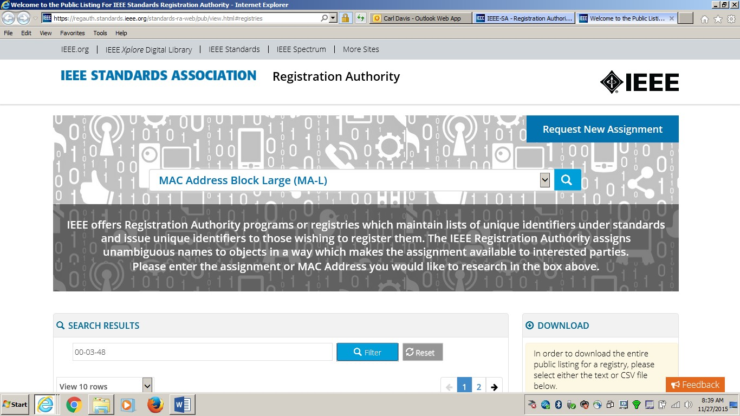

* Enter the following values in the “**Search Results**” box, then click on “**Filter**”
* To see the organization, look in the “**Assignment**” column (you may have to scroll down the page to find this box)
* Make sure you enter the exact value as shown next (include the dashes)

### Value Company Name

**00-03-48**

**00-04-50**

**00-06-21**

**00-02-02**

* Click **Start**, type in **cmd** and hit **Enter**, then type “**ipconfig /all**” command to determine the MAC address of the

following network interfaces: (once found record the MAC address in the space below)

### Interface MAC Address

Ethernet Adapter Ethernet0:

* Determining the Company name for OUI (Organizational Unique IDs) in MAC Address above using the site:<http://standards.ieee.org/develop/regauth/oui/public.html>

### MAC Address Company Name

**netstat command**

* “**netstat**” command is a command used by Network Administers to gather information on:

Protocol statistics

TCP/IP Network connections

* Start a “**command prompt**” (click **Start**, type in **cmd** and hit **Enter**)
* Enter the command (to receive help) **netstat /?**
* What information does the “**-a**” switch provide?

### Answer:

* Run the command: **netstat –e**

How many bytes have been received? How many bytes have been sent?

How many errors have been sent?

* Run the command: **netstat –n**

### Note: This will display addresses and port numbers in numerical form

* Approximately how many “**Established**” states are being displayed? **Answer**:

Use the following command to count the “**Established**” connections:

### Netstat –n | find –i “establish” /c

The solid bar in the above command can be found on the right side of the keyboard above the “**\**” key

\

**Find more Network configuration information**

* Go to “**Command Prompt**”

Run the command: **IPCONFIG /ALL**

* Find “**Ethernet adapter Ethernet0**”

Record the following:

DNS Suffix

DHCP Server Address DNS Server Address(es)

WINS Server Address(es)

* Close “**command prompt**”
* Go to “**Control Panel**” (click **Start**, type in **Control Panel** and hit **Enter**)
* Find and select “**Network and Sharing Center**”
* Select “**Change Adapter Settings**”
* **Right click** on “**Ethernet0**” and select “**Status**” and record the following:

Connection speed: Connection Duration: Bytes sent: Bytes received:

Select “**Details**”

Record the description of the NIC: When does the Lease expire: Is “DHCP” enabled?

Click on “**Close**”

* Click on the “**Windows 10 Start Button**”
* Type in **Computer Management** and hit Enter
* You will see a display open called “**Computer Management**”
* In the “left pane section named “**Storage**” find and click on “**Disk Management**”
* List the “**Volumes**” that are shown with File System type (there may be only one)

### Volume File System Type

* Go the “**Left Pane**” (left area)
* Select “**Performance**” and record the following information:

How much memory is available?

What is the “**average disk queue length**”?

* Find and select “**Open Resource Monitor**” link
* A system resource system should be displayed
* Select the “**Memory**” tab and answer the following:

How much memory is installed? MB

How much memory is in use? MB

How much memory is free? MB

### ***** Have your professor verify this above exercise *****

**Introduction to PowerShell**

**Each member of the group will be required to complete the following exercise**

* Click on the “**Windows 10 Start Button**”
* Type in **Powershell ISE** and hit Enter, this will start the session The remainder of this exercise will be done using **PowerShell Note**: “” is your section number

Move to the “**c:**” drive: **c:** press enter

Move to the “**root**” folder: **cd \** press enter Create the following directory: **mkdir comp203-lab06** press enter Move to the following folder **cd \comp203-lab06** press enter To ensure you are in the correct folder: **pwd** press enter

Next you will create folders within the “**comp203-lab06**” folder ( is your section number) Issue the following commands (press enter after each command):

### mkdir main mkdir secondary mkdir bones

Move to the “**main**” folder and create the following folders within “**main**”

### cd main mkdir alpha mkdir beta mkdir gamma

Move to the “**comp203-lab06**” folder: **cd \comp203-lab06**

Run the “**tree**” command: **tree**

You should have the following results:

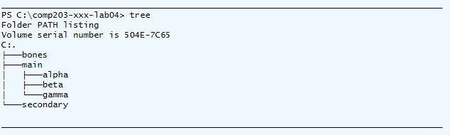

Issue the command: **get-childitem**

Issue the command: **dir**

Issue the command: **ls**

You should have the same results from each of the above commands (see below):

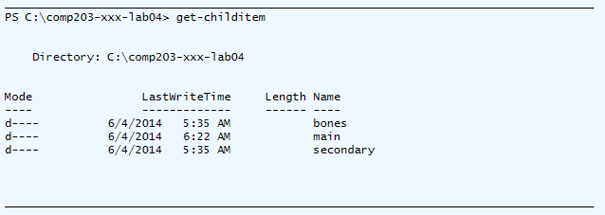

Next you will create a file named “**testfile.txt**” in the “**bones**” folder Move to the “**bones**” folder” **cd bones**

Launch “**notepad**” as follows: **notepad testfile**

If “**notepad**” asks you to create the file respond: **yes**

Once “**notepad**” opens enter your name in this file as text

Then select “**File**” then “**Save**”

Now “**Exit**” notepad, you will be returned to “**PowerShell**” Now make a copy of the file you created in “**Notepad**”

Issue the command: **copy testfile.txt newfile.txt**

Issue the command: **get-childitem**

You should have the following results (see below):

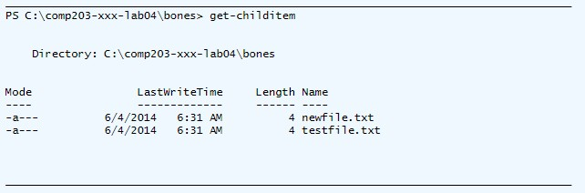

* To view the content of a file issue the command: **get-content testfile.txt**
* To view the “**ACL**” of an object issue the command: **get-acl testfile.txt**

### “ACL” Access Control List

* Move to “**comp203-lab06**” folder **set-location \comp203-lab06**

Notice the above command performs the same as the “**cd**” command

You created a file named: **newfile.txt** in the folder **bones**

Create copies of this file in the following directories: **alpha beta** and **gamma**

See the next step for an example of the “**copy**” command

* Set your current working directory to **cd \comp203-lab06\bones**
* Copy the file to alpha: c**opy newfile.txt \comp203-lab06\main\alpha**

Repeat the above copy command to have the file placed in “**beta**” and “**gamma**”

(you will have to change the path in the copy command) Once you have the above completed

* Move to the root of the file system **cd \**
* Run the command: **tree \comp203-lab06 /F**

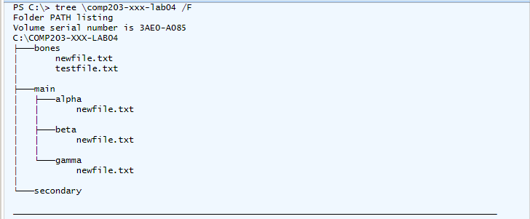

### ***** Have your professor verify this above exercise *****

Next you will experiment with other “**PowerShell**” cmdlet’s:

Run the following:

**get-process** This cmdlet will display all processes currently running

**get-date** Get the current date and time

**get-host** Get host information (PowerShell version etc)

**get-location** Shows your current working directory (same results as “**pwd**” command)

**Note**: There are many more “**PowerShell**” cmdlets some of which are very complex End of “**PowerShell**” exercise

To end the “**Powershell**” session end the command: **exit**

End of Lab