**Mobile Applications and IOT**

**PROJECT REPORT**

B.Tech - SEMESTER-VI

**Topic: Location Tracking System using Arduino**

**Submitted To: Mrs. Arpita Jadhav Mam**

**and Mrs. Rajalakshmi mam**

Group Member Details:

1. Amol Mathur 20104040 B15
2. Kartik Gupta 20104025 B14
3. Harshit Chopra 20104013 B14

**ABSTRACT**

Real-time tracking system on valuable items and assets has the potential to resolve a number of global issues. The Global Positioning System, or GPS, offers position in any situation utilizing both offline and online methods. There are several different kinds of GPS tracking systems on the market. When a device has GPS turned on, GPS satellites send out signals, which GPS receivers then utilize to calculate the latitude, longitude, and altitude as well as the time. In the contemporary world, GPS has shown to be one of the greatest tracking technologies. When it comes to security, it has shown to be a useful tool.

Any device with a sim card can utilize the GPS tracker gadget, an offline GPS system. An encryption method is used to encrypt the location. With the help of this technology, a user can locate the target people and see their whereabouts on a map of the web application. By using concepts from business intelligence and predictive analytics to improve the efficiency of vehicle tracking systems. Generally speaking, tracking is a technique in which we keep tabs on a location using latitude and longitude (GPS coordinates).

Track the users' locations is one of the study's goals.

Monitor a vehicle's whereabouts.

Improve the efficiency and performance of fleet business owners.

The majority of commercially available vehicle tracking technologies are prohibitively expensive. So, we made the decision to create a simple, affordable tracking system on our own. Users have the option to demand a location. The site is safe and encrypted. The client side performs the decryption.

**ABBREVIATIONS AND NOMENCLATURE**

GPS: Global Positioning System

GSM: Global System for Mobile communication

IDE: Integrated development environment

**INTRODUCTION**

When a device has GPS turned on, GPS satellites send out signals, which GPS receivers then use to calculate the latitude, longitude, and altitude as well as the time. There are many different location-tracking tools available, including GPS watches, GPS devices, and mobile phones. It retrieves the device's location information with the aid of middleware services, uploads it to a cloud database, and then automatically updates the location at predetermined intervals.

Any device with a sim card can use the GPS tracker device, an offline GPS system. An encryption algorithm is used to encrypt the location. With the help of this system, a user can locate the target users and see their locations on a map of the web application. By using concepts from business intelligence and predictive analytics to improve the efficiency of vehicle tracking systems. Generally speaking, tracking is a process in which we keep tabs on a location using latitude and longitude (GPS coordinates).

The majority of commercially available vehicle tracking systems are too expensive. So, we made the decision to create a simple, affordable tracking system on our own. Users have the option to demand a location. The location is encrypted and secure. The client side performs the decryption.

**BACKGROUND STUDY**

Many researchers have been interested in the real-time management and tracking of cars, and a lot of study has been done on tracking systems. Numerous anti-theft devices, including steering wheel locks, network tracking systems, and conventional electronic alarms, have been recently developed.

A tracking system employing a GPS, GSM modem, and a microcontroller is represented by the work of Pradip V. Mistary and R. H. Chile. The task is carried out to keep track of any equipped vehicle's movement at all times. In this system, a GPS receiver collects location information and continually translates it into a data string in the NMEA 0183 format. The receiver at the operator station gets this reading and inputs it into the GUI programme created in MATLAB. The application includes an algorithm that, when called, obtains the NMEA reading and converts it into a degree format appropriate for Google Earth.

The work done by Stephen Teang Soo Thong, Chua Tien Han and Tharek Abdul Rahman proposed front-end intelligent and web-based FMS to manage vehicle fleet efficiently and effectively.

The Global Positioning System (GPS) in this system will obtain the coordinates from the satellites as well as other vital data. In the current world, tracking systems are crucial. This has a number of uses, including military monitoring and vehicle theft tracking. The system uses a microcontroller and includes a worldwide system for mobile communication (GSM) and a GPS (GSM).

This system is simple to use, simple to install, simple to access, and useful for a number of other things. After installation, the system will use a Web application in Google Maps to find the target. The device enables tracking of the target at any time, anywhere, and in any weather.

**REQUIREMENT ANALYSIS**

Any device with a sim card can utilize the GPS tracker gadget, an offline GPS system. An encryption method is used to encrypt the location. With the help of this technology, a user can locate the target people and see their whereabouts on a map of the web application. By using concepts from business intelligence and predictive analytics to improve the efficiency of vehicle tracking systems. Generally speaking, tracking is a technique in which we keep tabs on a location using latitude and longitude (GPS coordinates)..

The majority of commercially available vehicle tracking technologies are prohibitively expensive. So, we made the decision to create a simple, affordable tracking system on our own. Users have the option to demand a location. The site is safe and encrypted. The client side performs the decryption.

GPS in our today’s modern world has proved to be one of the best tracking device.It has proved to be a fruitful device in terms of security.

**COMPONENTS**

Arduino UNO

SIM800L GSM/GPRS Module

GPS Module

LM2596S DC-DC Buck Converter Power Supply

Connecting Wires

Arduino IDE

Android Studio

**DETAILED DESIGN**

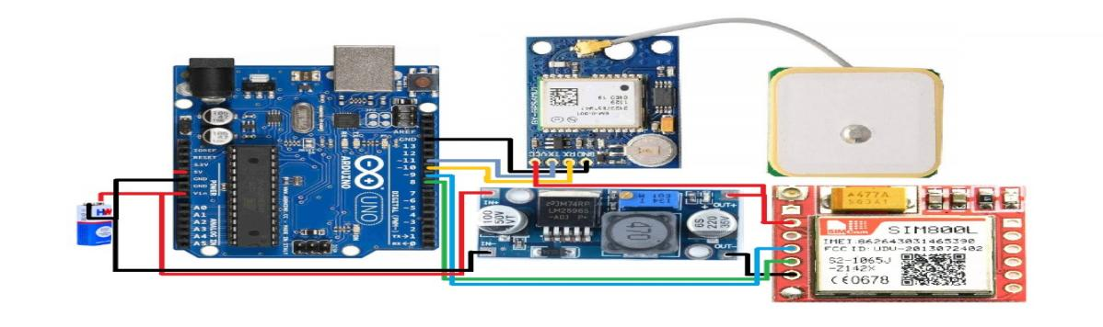

Fig. 1 (Circuit Design)

Arduino UNO: a module-connected programmable open-source microcontroller board.

SIM800L GSM/GPRS: An extremely small GSM modem that can convey the position via SMS is theModule. The operational voltage of the chip is between 3.4V and 4.4V.

GPS Module: The NEO-6M GPS module has the highest level of tracking sensitivity in the industry and can track 22 satellites across 50 channels. The latitude and longitude are sent through SMS.

LM2596S DC-DC Buck Converter Power Supply: The high-precision potentiometer converter step-down the voltage.

Jumper wire: Tie together distant electric circuits used to make printed circuit boards.

9-volt battery: Power source

Arduino IDE: A text editor for writing code, a message area, a text console, a toolbar with buttons for commonly used operations, and a number of menus are all included in the Arduino Integrated Development Environment (IDE). In order to upload programmes and communicate with them, it connects to the hardware.

Android Studio: To create a decryption application used in mobile devices.

**IMPLEMENTATION**

First, we have made a hardware system using a few modules and a microcontroller which can send the location to the desired device.

To fetch the location, we used the GPS module which can give longitude and latitude details to the microcontroller.

Microcontroller sends the longitude and latitude information to the desired device using the GSM Module via the 2G network through the sim card installed in the GSM Module.

The device receives the location information in the SMS form.

To send the location information link directly in the SMS app of the device can be read or misused by another one easily.

For that reason, we have sent the encrypted information to the device in the form of SMS and the encryption is done on the side of the Arduino.

We have made an android app to see the correct location of the user, In the application first user has to login with the credentials set when registering. This ensures that only authenticate person will login.

For that we have used SQLite Database to store the details of the user, then user must enter the phone number to ensure that coordinates from that number can only be extracted. Next page have the encrypted and decrypted text view in which message from a specific number (having coordinates) will auto read and set to the encrypted text and then user can click on the button Decrypted and original coordinates will be set in the decrypt text box and user will click on the go to map button to show the actual location in the google maps. for that we have integrated google maps with its API key,

For Auto Read Functionality, we have used Broadcast Receiver to listen the incoming messages.

**EXPERIMENTAL RESULTS AND ANALYSIS**

The message is sent in an encrypted form. Encryption is done on the Arduino side.

Decryption is done on the client side through the Decrypting application.

The location is shown on google maps integrated on the android app.

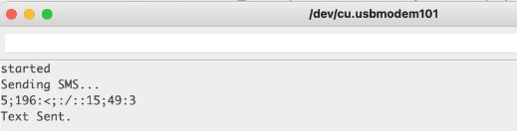

Fig. 2 (Sending message from arduino side and giving this information of sending in serial monitor or Arduino IDE)



Fig. 3 (Encrypted message received on the sms app of the mobile

Fig 4 The first activity of the android app where user can login using login credentials and also can redirect to the sign-up page

Fig 5 After successful sign-up user can enter the phone number whose location he/she want to get.

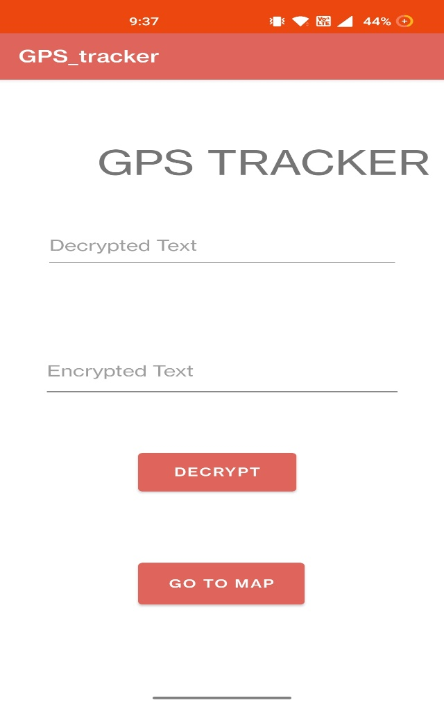

Fig 6. Where user get Decrypted message by own and can decrypt and can see the location by clicking on the Go to map button.

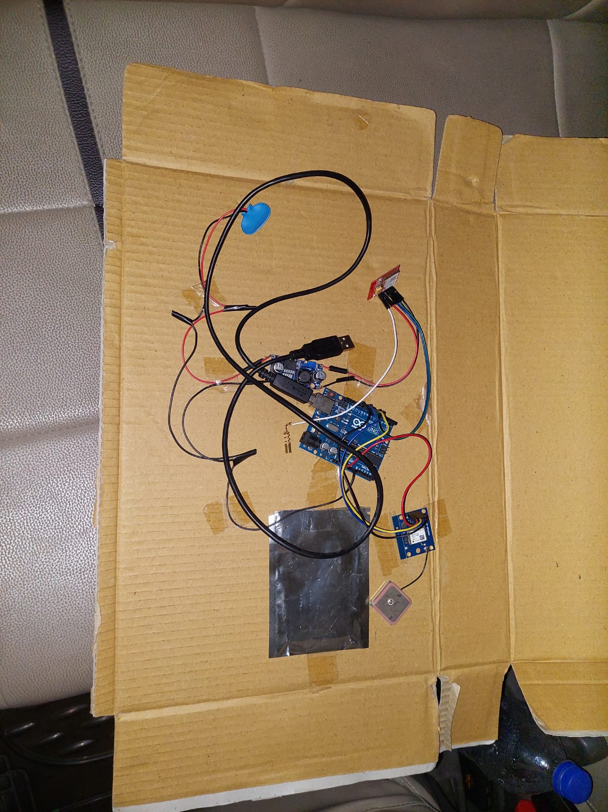

**Future Scope**

Any device with a sim card can utilize the GPS tracker gadget, an offline GPS system. The majority of commercially available vehicle tracking technologies are prohibitively expensive. Our project is small and affordable. Users have the option to demand a location. The site is safe and encrypted. The client side performs the decryption.

In the contemporary world, GPS has shown to be one of the greatest tracking technologies. When it comes to security, it has shown to be a useful tool. The system's goal is to increase car security through the use of GPS, GSM, and a web application.

In addition, it can help:

1. Parents who look after their kids.
2. tracking wildlife in jungles

3. Services for delivery.

4. The police and fire departments.

The usage of cameras and the creation of a mobile-based application to obtain a real-time view of the car rather than viewing it on a computer could further improve this project and make it more comfortable for the user to monitor the target.

Since memory card functionality is used, it can be challenging to follow our vehicle if it is in a border region where range is limited. When our vehicle approaches the range, the memory card contains all the dimensions, which are displayed.

**REFERENCES**

Hu Jian-ming; Li Jie; Li Guang-Hui, "Automobile Anti-theft System Based on GSM and GPS Module," Intelligent Networks and Intelligent Systems (ICINIS), 2012 Fifth International Conference on , vol., no., pp.199,201, 1-3 Nov. 2012

Nagaraja, B. G.; Rayappa, R.; Mahesh, M.; Patil, C.M.; Manjunath, T. C., "Design & Development of a

GSM Based Vehicle Theft Control System," Advanced Computer Control, 2009. ICACC '09. International

Fleischer, P.B.; Nelson, A.Y.; Sowah, R.A.; Bremang, A., "Design and development of GPS/GSM based vehicle tracking and alert system for commercial intercity buses," Adaptive Science & Technology

(ICAST), 2012 IEEE 4th International Conference on , vol., no., pp.1,6, 25-27 Oct. 2012

Interfacing SIM800L GSM/GPRS Module with ESP32

(https://circuitdigest.com/microcontroller-projects/interfacing-sim800l-module-with-esp32)