Infinite possibilities - endless opportunities

**INFINITY MESH d.o.o.**

Robot 7a ul. Zmaja od Bosne bb Sarajevo 71000 [http://www.infinitymesh.com](http://www.infinitymesh.com/) | [info@infinitymesh.com](mailto:info@infinitymesh.com)

Tasks Description and Requirements

# General Notes

All stories must be completed with an appropriate level of testing. No actual database implementation is required, for this you could for example use In Memory Database provided by EF Core. Your code should tend towards being SOLID (DDD, TDD). Once when you finish your project, please commit and upload your code on your GitHub1 account.

# Tasks

Create a simple single page CRUD application using jQuery or Angular >=2. The application should allow to see a list of users, blogs, create/edit a blog and link it to a user. You may use Bootstrap for styling and responsiveness.

## Story 1

As a **User**, I want to see a list of users available in the system and number of blogs they had created. Users should be pre-populated (up to 15 persons). Use a general field for a person like a Name, Age, and E-mail. You could use ASP.NET Identity Framework2 to achieve membership and authentication (it’s nice to have), which would be a big plus. Use a simple HTML table to display the users. Table columns: Name, Age, Email, Blogs (number of written blogs) and View Profile (link to user’s profile page).

### Acceptance criteria:

Must:

* The user table should display 5 user per page ordered by name.
* The user table can be filtered by search criteria (Name and Email) in the same input box.
* Clicking on Profile link should lead to user’s profile page.

Nice to have:

* Pagination
* Items per page can be configured in configuration file.
* Filter is implemented on Server Side.
* Login screen with the ability to login with credentials **admin** / **admin3**

1 <http://www.github.com/>

2 <https://github.com/aspnet/Identity>

3 Username / Password

Login is nice to have

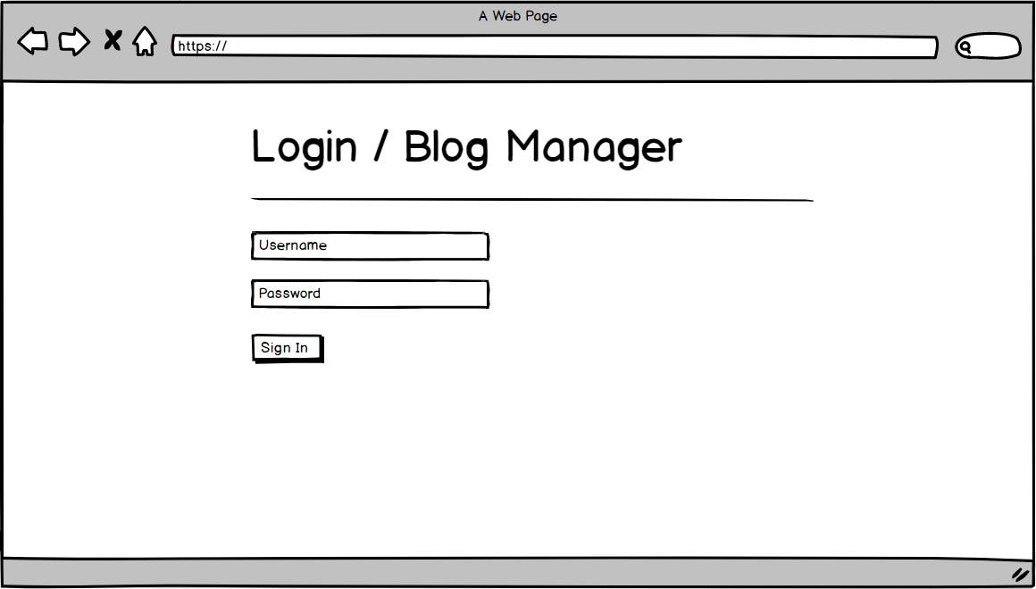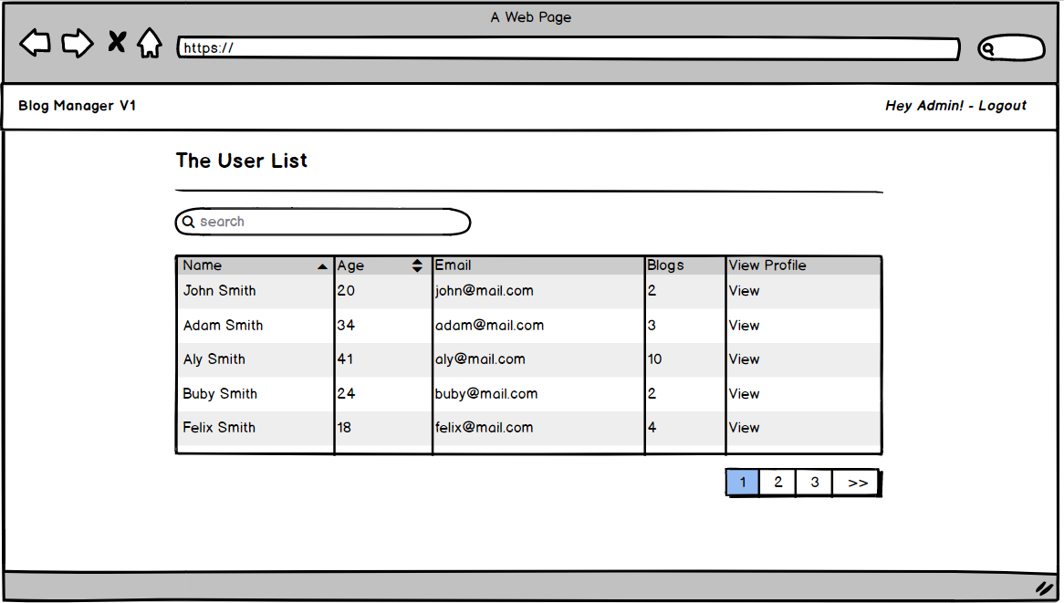

## Story 2

As a **User** I want to see user details on the profile page.

### Acceptance criteria:

Must:

* The page should display user details and list of blogs what user have created.
* Blog list should be in format “Title, Summary, Publishing Date Time (hh:mm, DD MMM YYYY)”, i.e. “Very Nice Blog – 13:30, 09 Mar 2018”.
* The list of user blogs need to be sorted by publishing date/time ascending Nice to have:
* Filtered blogs by created date/time (User can select date range, like 01.01.2018 10:00 - 01.03.2018 12:00)
* During pulling data by EF (or similar ORM) try to avoid N+14 issue
* Try to ensure the best performance during executing the query.

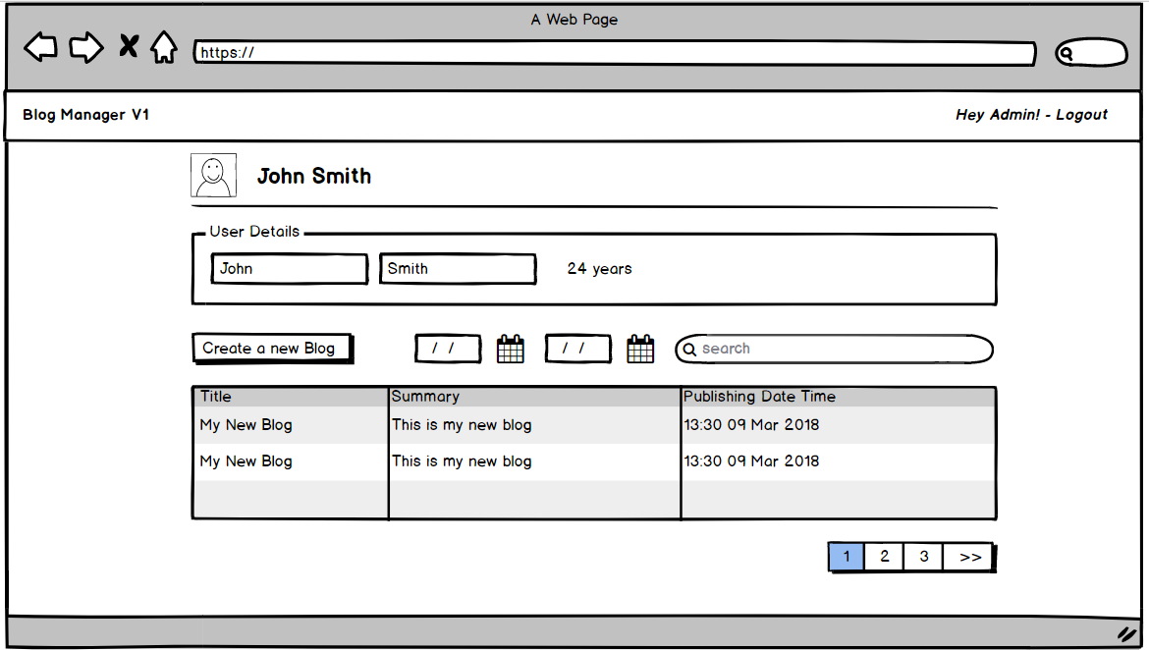

## Story 3

4 <https://secure.phabricator.com/book/phabcontrib/article/n_plus_one/>

As a **User** I want to be able to create new and update existing blog. Blog fields:

* **Title** – required, maximum length 64 characters.
* **Summary** – required, maximum length 350 characters.
* **Content** – required, maximum length 3500 characters. (Support HTML Rich Text Editor)
* **Published Date & Time** – required, cannot be in the past. You are allowed to use date and time pickers for convenience.

### Acceptance criteria:

Must:

* The page should allow me to update existing or create new blog.
* Blog should not be saved if any of the fields is not valid.
* Invalid fields should be visually indicated so I can correct them.
* Error handling. Nice to have:
* Create only one endpoint for update and create blog.
* Backend validation
* Handling Concurrency Conflicts
* DI (Native ASP.NET Core or Autofac)
* Implementation and Demonstration Design Patterns in action like:
  + Command
  + Mediator
  + Builder
  + Iterator
  + Null Object

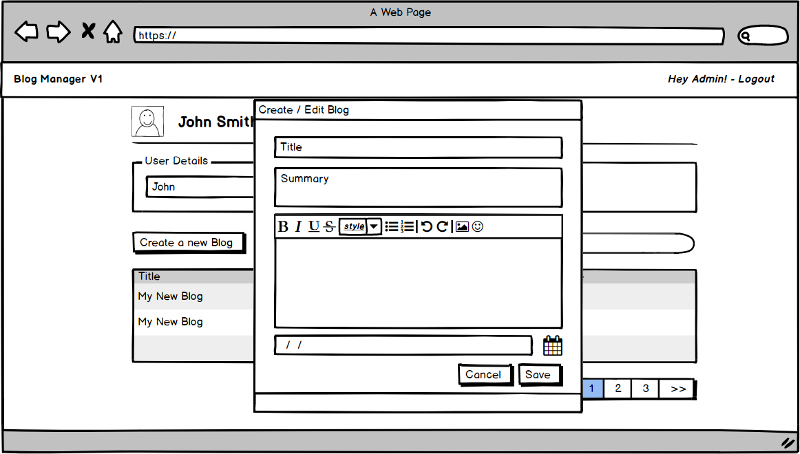

***Please keep in mind that all mockups are representing only suggestion, please free feel if you have an idea in order to improve UX.***