23 Nov aux dcsc explanation
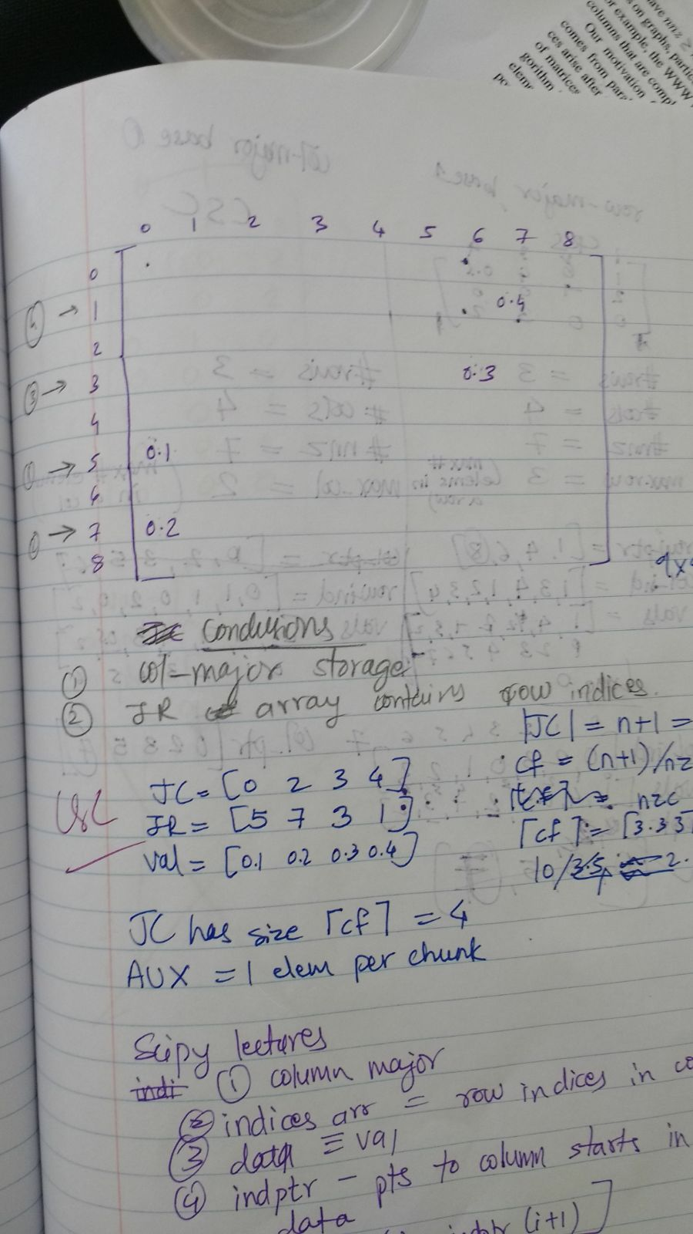
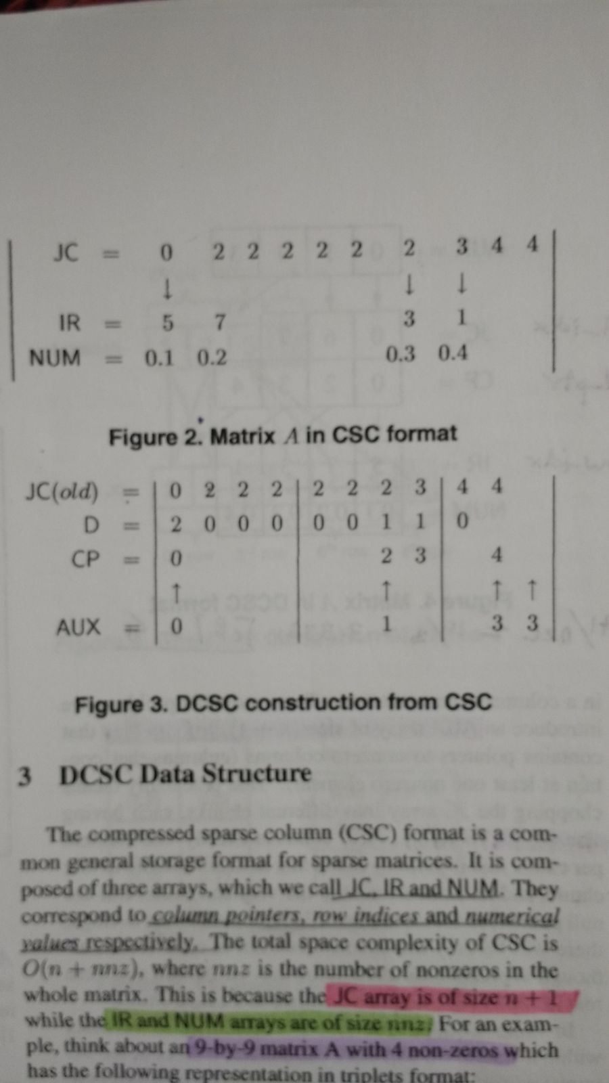

I think I got where AUX comes from
You're right about old JC having those 2's for zero columns.
So I have 10 elements in JC
But I want to compress that because of redundant info. So I chunk up the values. Size of each chunk is 4. So JC is split into three parts having 4,4 and 2 values each. Shown in fig 3
Aux needs only one value per chunk. Starts indexing at 0.
If you see the difference matrix, D, that indicates the redundancy. You'll see a change at the first element and then when value changes from 2 to 3 and then 3 to 4
But the next two changes are in the second chunk so we store only one value for them. Which is an increment of the previous. So 1.
The second change is incremented but not stored. So value goes to 2. But 2 not stored. Third chunk, only one change so value 3 which is again stored in AUX. and terminal element to indicate how many chunks.

26Nov
till date, started on sparse matrix storage formats, csr implemented, dcsr working on. Originally started with full matrix and parsing it into csr. Now, function to convert from triples to csr (works) and to dcsr (aux array reqd).

Do I need this new storage format, how does it benefit me? Does the complexity get better?

12/11/17 03:25:49 PM
- Case 1
block_sparse/
|
|- - > bin
|- - > text_exec
|- - > include
|- - > test.h
|- - > src
|- - > test.cpp

g++ -o bin/test_exec include/test.h src/test.cpp
this test.h has function declaration and definition in the header (header-only).
Works.

- Case 2
block_sparse/
|
|- - > bin
|- - > text_exec
|- - > include
|- - > test.h
|- - > src
|- - > test_func.cpp
|- - > test.cpp (main)

g++ -o bin/test_exec src/test_func.cpp include/test.h src/test.cpp
this has function declaration in test.h, function definition in test_func.cpp and main in test.cpp.
Works when #include<iostream> in either header or test_func.cpp but not when it is only in test.cpp where main is.

Test.h file
/*test h file*/
#include <iostream>
#include <vector>

void func1(int m);

test_func.cpp
#include <iostream>
#include </home/feynmann/block_sparse/include/test.h>

void func1(int m) {
std::cout << "hello world " << std::endl;
}

test.cpp
#include </home/feynmann/block_sparse/include/test.h>
int main () {
func1(5);
}

Typedefs need to be in the header file?

5pm
Converted original code directly to a header file. Simply include the header file. Has all the globally declared variables.

Include_directories path in cmake file explicitly.
Better way to do it is using $ENV{HOME}/block_sparse/include

