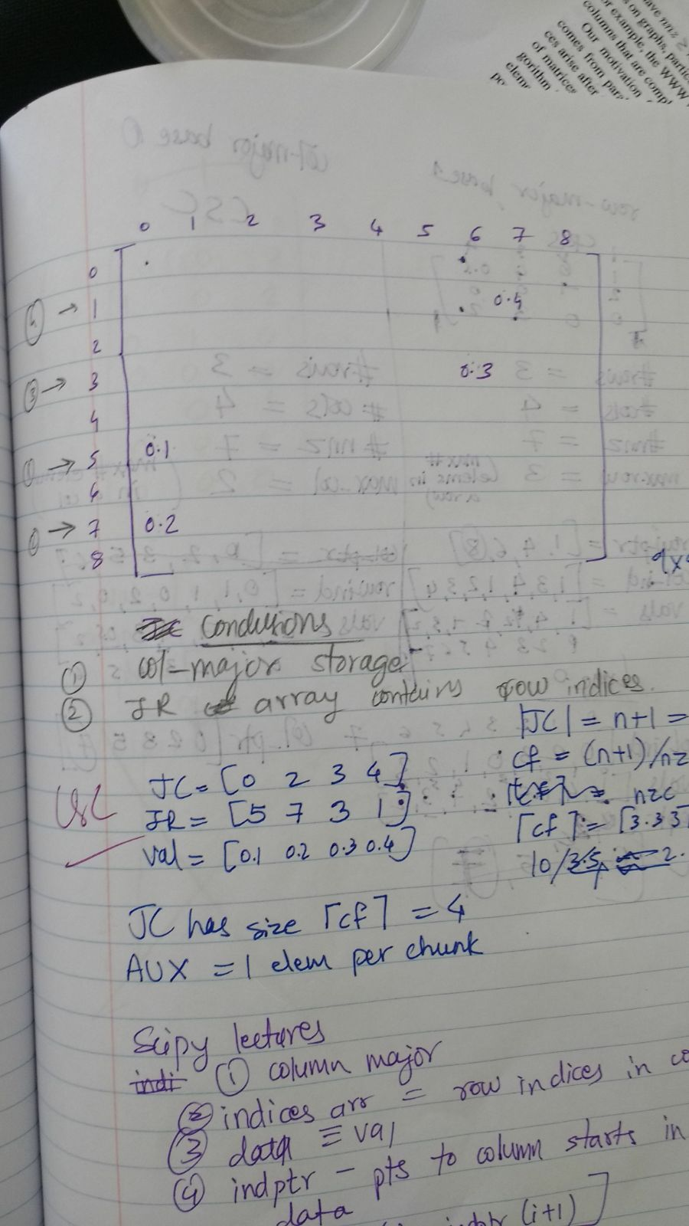
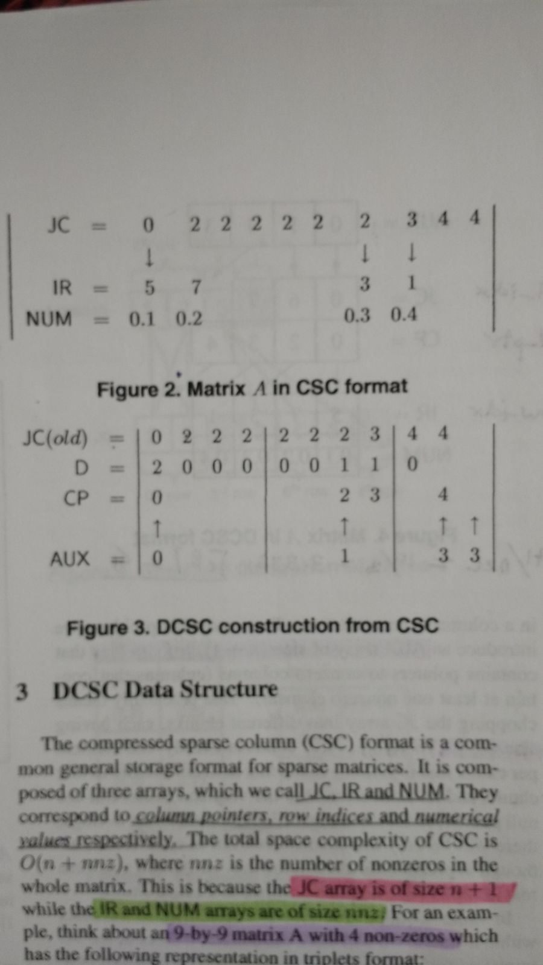

I think I got where AUX comes from
You're right about old JC having those 2's for zero columns.
So I have 10 elements in JC
But I want to compress that because of redundant info. So I chunk up the values. Size of each chunk is 4. So JC is split into three parts having 4,4 and 2 values each. Shown in fig 3
Aux needs only one value per chunk. Starts indexing at 0.
If you see the difference matrix, D, that indicates the redundancy. You'll see a change at the first element and then when value changes from 2 to 3 and then 3 to 4
But the next two changes are in the second chunk so we store only one value for them. Which is an increment of the previous. So 1.
The second change is incremented but not stored. So value goes to 2. But 2 not stored. Third chunk, only one change so value 3 which is again stored in AUX. and terminal element to indicate how many chunks.

