DIVE ANALYSIS by DN9 Team

## DIVE Journey (1 page)

### D: Surface discovery

1. **Strong Weekly Seasonality**
   1. **Weekend peaks:** Sales surge on **Saturdays** (~1.02 M units on 8/5; ~0.99 M on 8/12) and **Sundays** (~1.12 M on 8/6; ~1.08 M on 8/13).
   2. **Mid‑week troughs:** The lowest forecasts occur on **Thursdays** (~0.73 M on 8/3; ~0.62 M on 8/10), about **30% below** weekend highs.

### I: Deeper investigation findings

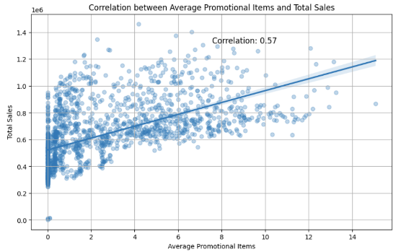The primarily drivers for seasonal variations are – Grocery I (41%), Beverages (33%), cleaning (11%), dairy (8%) and produce (6%), as shown in the Fourier analysis of the weekly seasonality on timeseries sales data.

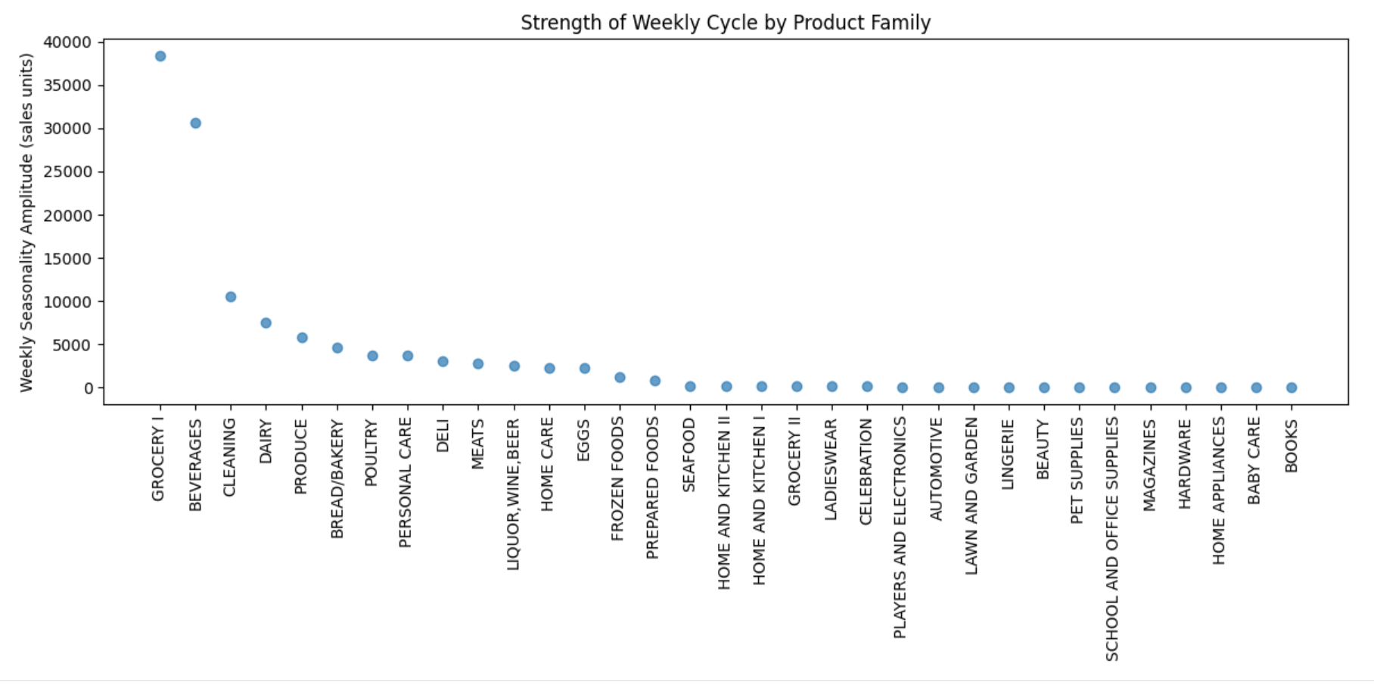

Add comments on Correlation

### V: Model limitations and risks

ARIMA weekly seasonality assumes stable historical patterns, ignores sudden demand, external shocks (holidays, promotions), fails to model inventory constraints or local heterogeneity, and degrades over longer horizons; FFT amplitudes may be noisy for low‑volume families, risking over‑/under‑estimation.

### E: Strategic recommendations

Adopt adaptive forecasting algorithms and integrated demand sensing. Implement dynamic assortment optimization, customer‑centric promotion planning, cross‑channel inventory orchestration, predictive labor scheduling, supplier flexibility agreements, real‑time performance dashboards, and a culture of experimentation. These data‑driven initiatives automate operations, foster agility, sustain seasonal gains, enhance accuracy, and drive scalable and consistent profitability.

## Action Plan (1 page)

### 3 specific actions for store managers with success Metric

|  |  |  |
| --- | --- | --- |
| Objective | Action | Success Metric |
| Forecast Accuracy | 1. Boost Grocery I & Beverages stock by 30% on weekends | Weekend stock‑out rate ≤ 5%; actual weekend sales ≥ 95% of forecast |
| Promotion Effectiveness | 2. Increase mid‑week promo spend by 20% to buffer Thursday dips | Thursday sales lift ≥ 15% vs. baseline; dip reduced from –18% to ≤ –10% |
| Labor Efficiency | 3. Add 15% extra staff Fri–Sun | Average checkout wait time ≤ 3 min; weekend conversion rate ↑ 5 pts |
| Inventory Availability | 4. Restock Cleaning & Dairy shelves every Thursday | Shelf‑availability ≥ 99% on Fridays; stock‑out incidents < 1% |
| Promotion Effectiveness | 5. Monitor daily sales and trigger promos if 2‑day drop > 10% below forecast | Promo deployed within 24 h of trigger; daily sales variance held within ± 5% of forecast |

### Risk mitigation strategies

* **Inventory Overstock (Grocery I & Beverages):**  
  • Negotiate “return-to-vendor” clauses for any unsold surplus  
  • Implement rolling 7‑day safety‑stock reviews to adjust ordering in real‑time.
* **Margin Erosion (Mid‑week Promotions):**  
  • Cap promotional budgets per family and channel; run small‑scale A/B tests before full rollout  
  • Track incremental lift vs. cost to ensure each promo yields ≥ 2× ROI
* **Labor Cost Overruns (Extra Weekend Staff):**  
  • Maintain an on‑call pool of part‑timers and cross‑trained staff to flex up/down  
  • Review weekend labor productivity daily; reallocate hours to peak checkout lanes only
* **Supply Disruptions (Thursday Restocking):**  
  • Establish dual sourcing for Cleaning & Dairy SKUs with 48 h lead‑time backups  
  • Automate reorder triggers at 20% below par‑stock to avoid last‑minute rush orders