0. Install azd and azd cli to execute commands in local for infra creation in azure
1. Create resources in azure using azd and bicep files in infra folder
2. Get keys of resources created and store them in .env file
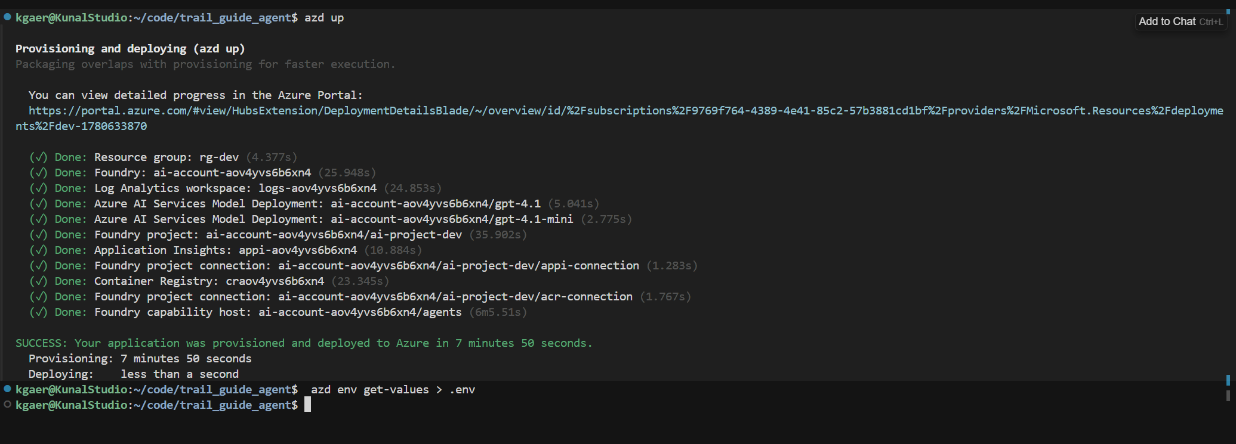

3. Install venv locally and install all packages
4. Create Agent in Foundry
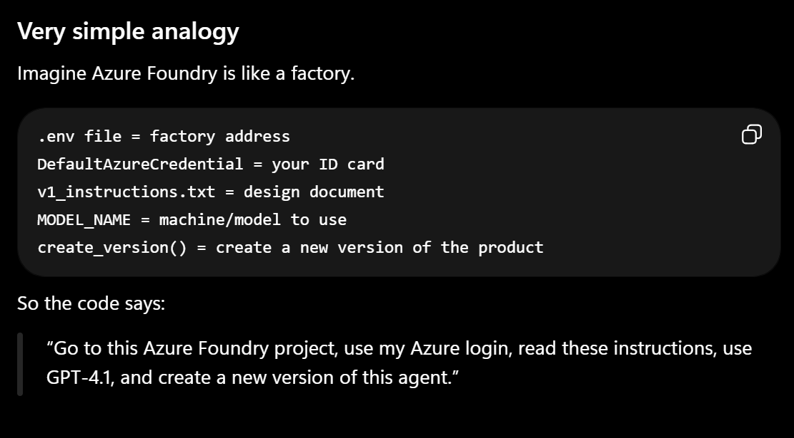

5. Azure Foundry New interface
6. Create branch
7. run evals cases in that branch
8. compare evals across multiple branches
9. Merge the branch that has highest eval

10. Create Automated evals
- Write Eval Questions
- Generate responses
- Create Evals to evaluate the model responses
- Github Actions to provision trigger condition, infra, install code, run evals and generate PR comment

