PlantProcess IQ
Customer Proposal: AI-Based Process-to-Quality Intelligence for Manufacturing
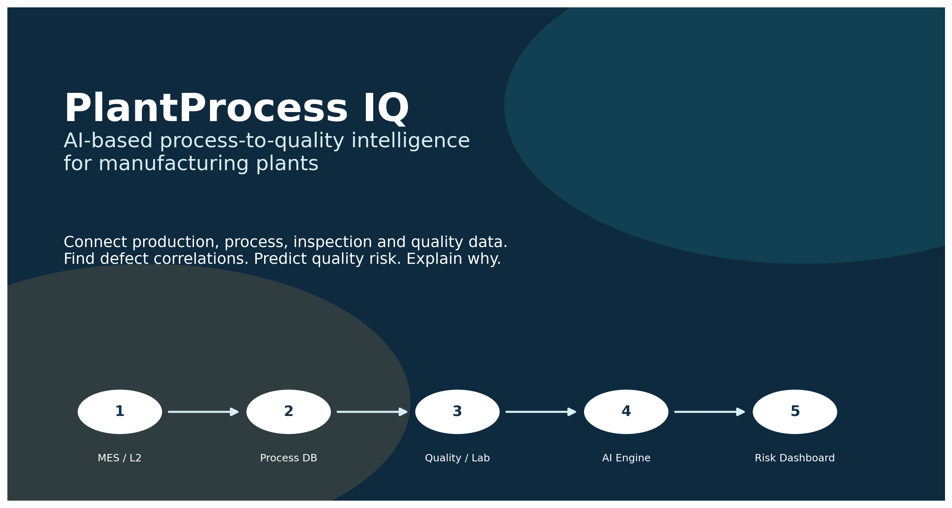

Prepared for: Karim Gamal Elsayed
Version 1.0 | 2026

1. Proposal Summary
PlantProcess IQ helps manufacturing companies connect production, process, inspection and quality data across the plant to understand why defects happen, predict quality risk earlier, and reduce manual investigation time. The solution is generic by design and can be configured for steel, aluminum, pharma, tire, paper, automotive, food, chemicals and other manufacturing domains.
Customer promise
Connect your plant data. Discover defect correlations. Predict quality risk. Explain suspected causes. Act earlier.

2. The Problem We Solve
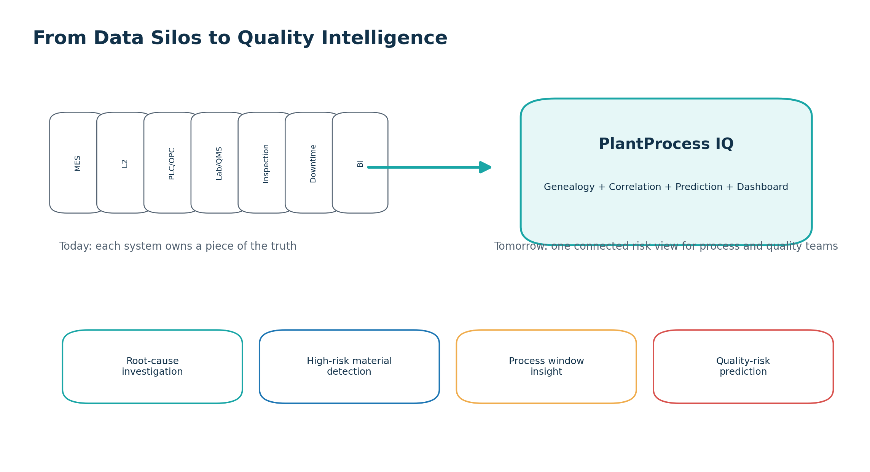
Figure 1 - Moving from fragmented data silos to connected quality intelligence.
- Plant data is spread across MES, Level 2, SCADA/PLC/OPC, historian, lab, inspection, downtime and ERP systems.
- Quality teams often investigate defects manually using Excel, screenshots, SQL queries and tribal process knowledge.
- Dashboards show what happened, but often do not explain which process parameters are linked to defects.
- Production teams need earlier warning when a material/batch is likely to create quality issues in the next process step.
- Management needs a repeatable method to learn from historical data and reduce scrap, rework, downgrade and claims.

3. What We Offer
Offer | Customer Outcome | Typical Duration
Data Readiness Assessment | Understand available data, gaps, quality, source systems and feasibility. | 1-2 weeks
Quality Correlation Diagnostic | Identify which process parameters, equipment, route, shift or material conditions are linked to defects. | 3-6 weeks
Quality Risk Prediction Pilot | Build an MVP model that predicts risk for a selected defect or quality KPI. | 6-10 weeks
Dashboard & AI Explanation Pack | Provide dashboards, risk views, material genealogy and AI-assisted explanations. | 2-6 weeks
Production Deployment | Install on-prem or private cloud with connectors, security, reports and support. | 3-6 months

4. Solution Overview
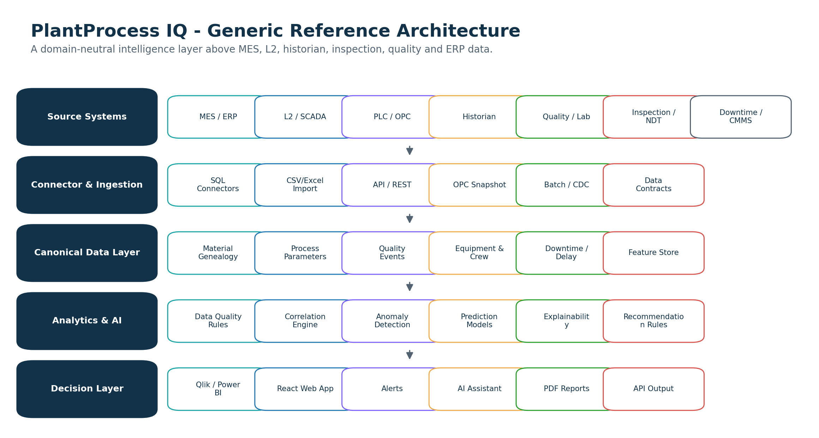
Figure 2 - High-level solution architecture.
Capability | Description
Data connectors | Connect to SQL Server, Oracle, PostgreSQL, CSV/Excel exports, MES/L2, inspection, quality and downtime sources.
Genealogy engine | Trace product/batch/material across process steps and link it to process and quality history.
Data quality checks | Find missing, duplicated, delayed or inconsistent production and quality records.
Correlation engine | Discover parameter ranges, equipment, routes or operating patterns linked to defects.
Prediction models | Score active or historical materials by quality-risk probability.
Dashboard and reports | Visualize quality KPIs, risk drivers, high-risk materials, process windows and investigation reports.

5. Generic Across Manufacturing Industries
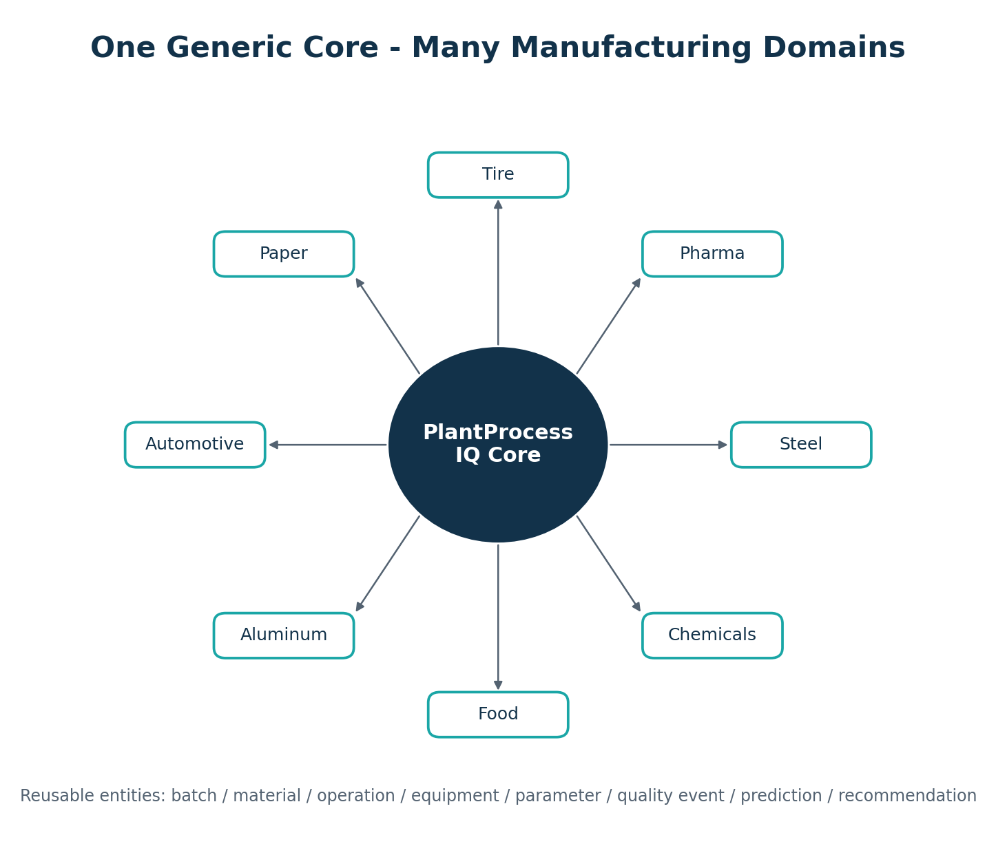
Figure 3 - The same platform core can be configured for multiple industries.
Industry | Example Data Sources | Example Quality Outcomes
Steel / Aluminum | EAF, LF, caster, rolling, inspection, quality lab | Cracks, inclusions, surface defects, profile/flatness, downgrade
Pharma | Batch records, lab results, equipment parameters, environmental monitoring | Out-of-specification, contamination risk, batch release delay
Tire | Mixing, curing, temperature/pressure, inspection | Uniformity issues, curing defects, dimensional defects
Paper | Machine speed, moisture, coating, web breaks, lab tests | Breaks, coating defects, moisture issues, roll defects
Automotive | Assembly parameters, torque, inspection, rework, supplier lot data | Rework, dimensional defects, warranty risk
Food / Chemicals | Batch process, temperature, pressure, recipe, lab/QA | Quality deviation, contamination risk, process instability

6. Example Dashboard Experience
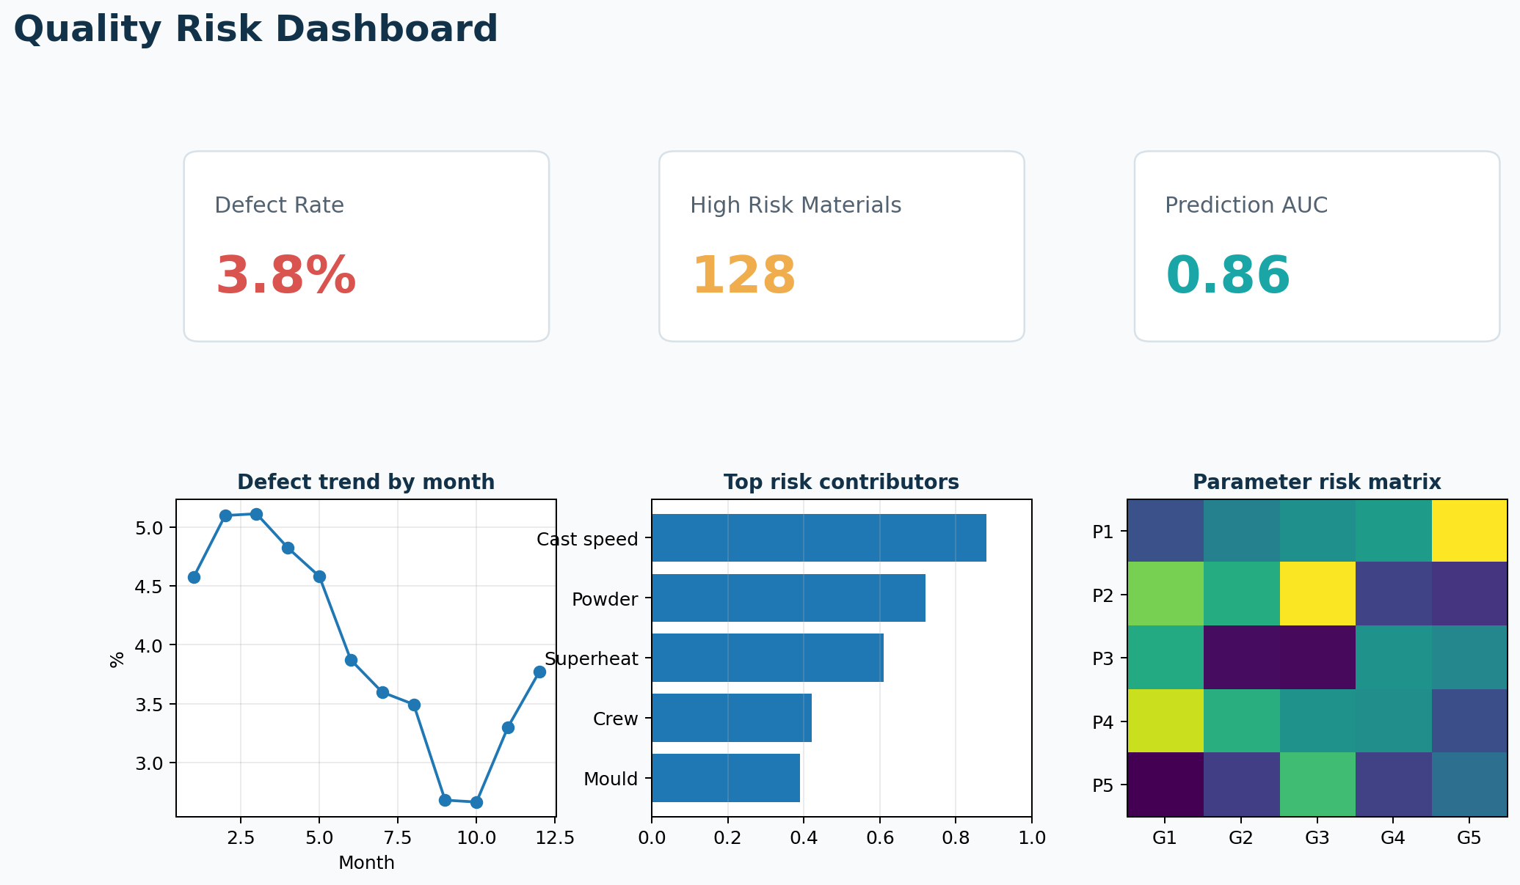
Figure 4 - Example quality-risk dashboard mockup.
- Quality overview: production volume, defect rate, rejection/downgrade and trend over time.
- Correlation analysis: defect rate by parameter range, equipment, route, grade, shift and material family.
- Material genealogy: search one product/batch and see its full process history.
- High-risk materials: list of products/batches with risk score and suspected contributors.
- AI explanation: plain-language answer to “why is this material high risk?”
- Recommended action: investigation or process-window suggestions validated by process experts.

7. Pilot Packages and Pricing Direction
Package | Scope | Output | Indicative Price
Data Readiness Assessment | Review data availability, sample tables, quality labels, genealogy feasibility. | Data readiness report + pilot scope. | EUR 3k-7k
Correlation Diagnostic Pilot | One process route + one quality topic using historical data. | Dashboard + correlation report + suspected contributors. | EUR 10k-25k
Prediction Model Pilot | Feature engineering + baseline ML model + risk dashboard. | Risk model + validation + dashboard + report. | EUR 25k-60k
Annual License / Support | Repeatable tool, connectors, dashboards, model updates and support. | On-prem or private-cloud product package. | EUR 50k-150k+/year

Final pricing depends on scope, number of data sources, data quality, deployment model, number of users, security requirements and support expectations.

8. Why This Is Different from a Normal BI Dashboard
Normal Dashboard | PlantProcess IQ
Shows KPIs after the fact. | Connects process history with quality outcomes and predicts risk.
Usually depends on manual interpretation. | Ranks suspected contributors and explains high-risk cases.
Often works per system or report. | Builds cross-system material/batch genealogy.
Shows defect count and trend. | Finds parameter windows and operating patterns linked to defects.
Designed mainly for reporting. | Designed for diagnosis, learning, prediction and prevention.

9. Steel Plant Example - End-to-End Quality Intelligence
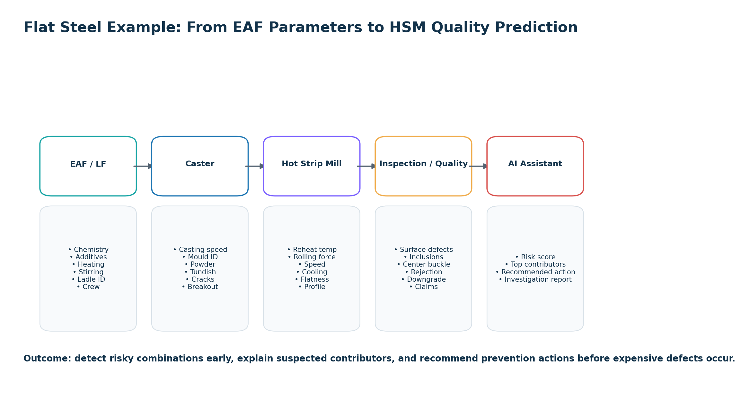
Figure 5 - Flat steel example from EAF/LF to Caster, HSM and Quality.
In a flat steel scenario, the system can combine EAF/LF chemistry, additives, heating and stirring time with caster speed, powder, mould, tundish and breakout/crack events, then link them to hot rolling parameters and final quality outcomes. The result is a risk model that can detect high-risk slabs or coils and recommend investigation or process adjustments before the defect becomes expensive.

10. Final Visual Sales Pages
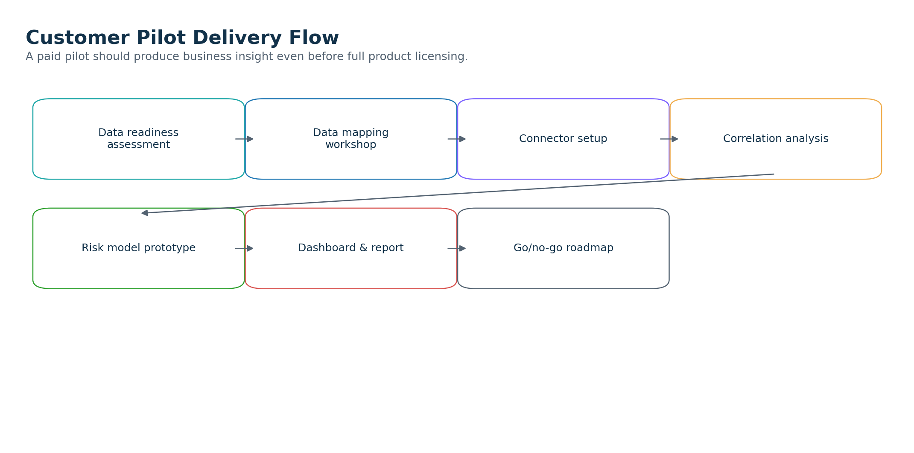
Figure 6 - Customer pilot delivery flow.
Page 1 - Start small, prove value fast
A pilot does not require replacing MES or connecting the whole plant. Start with one route, one defect family and one historical dataset. The first deliverable is business insight: what parameters appear linked to quality risk?

Page 2 - From historical learning to active prediction
Once historical correlation is proven, the same model can score active materials or batches before the next process step. This creates early warning for quality teams and process engineers.

Page 3 - Generic platform, industry-specific value
The same platform works across industries because the core model is generic: material/batch, operation, equipment, parameter, quality event and prediction. Each industry gets its own configuration pack.

11. Next Step
Recommended next step is a data readiness workshop. The workshop identifies available source systems, data quality, material genealogy feasibility, target quality topic, and the best pilot scope. After the workshop, the customer receives a fixed-scope proposal for the first correlation diagnostic pilot.

12. References
- Microsoft .NET support policy and release lifecycle: https://dotnet.microsoft.com/en-us/platform/support/policy
- ML.NET documentation: https://learn.microsoft.com/en-us/dotnet/machine-learning/
- scikit-learn documentation: https://scikit-learn.org/
- Qlik Sense analytic connections / Server-Side Extension: https://help.qlik.com/en-US/sense-developer/November2025/Content/Sense_Helpsites/AnalyticConnections.htm
- PostgreSQL declarative partitioning: https://www.postgresql.org/docs/current/ddl-partitioning.html
- PostgreSQL JSON/JSONB types: https://www.postgresql.org/docs/current/datatype-json.html
- ONNX Runtime documentation: https://onnxruntime.ai/docs/

