PlantProcess IQ
Full Product Plan: From Scratch to Demo, Pilot and V1
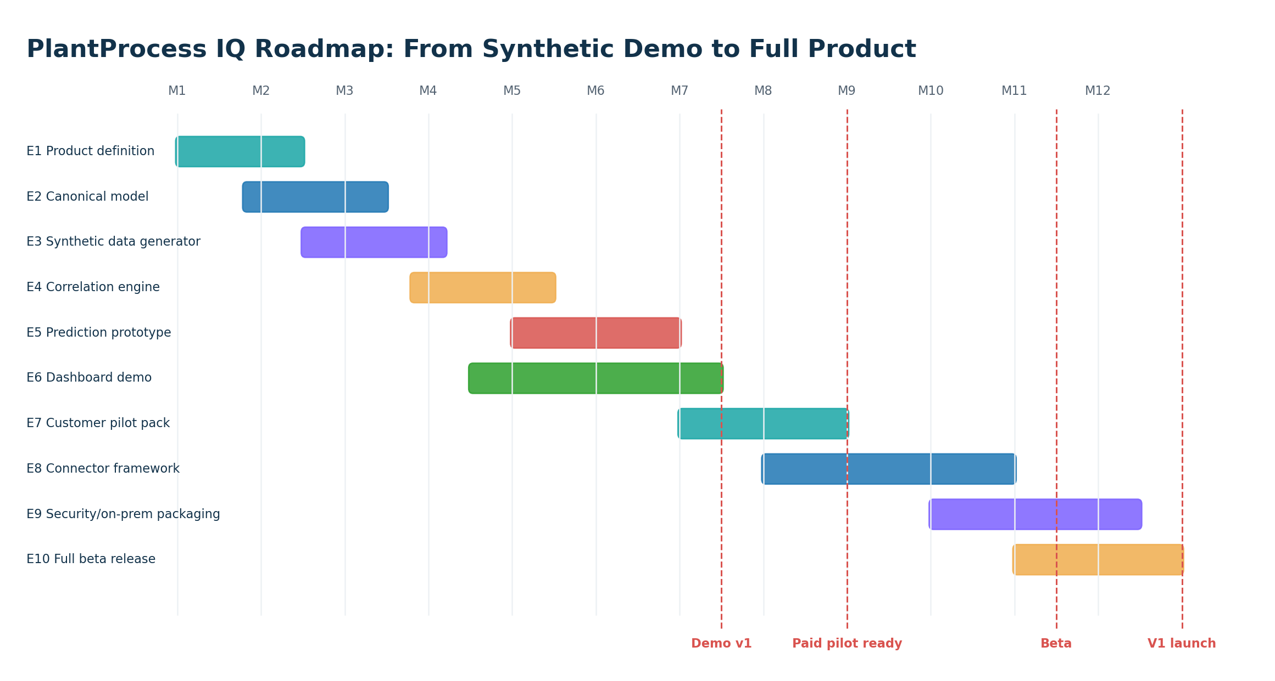

Prepared for: Karim Gamal Elsayed
Version 1.0 | 2026

1. Planning Objective
This plan converts the PlantProcess IQ concept into a practical roadmap. The goal is to build a demo and pilot-ready product without using any confidential employer/customer data. The first 12 months should focus on synthetic data, a generic model, one strong steel-inspired example, and customer validation before any full product commitment.
Planning rule
Do not build the full platform before selling the problem. Build a credible synthetic demo, run discovery calls, sell a data readiness assessment, then sell a pilot.

2. Roadmap Overview

Figure 1 - Roadmap from product definition to V1 launch.

3. Milestones
Milestone | Target Timing | Definition of Done
M0 - Concept locked | Week 1 | Product name, target customer, first use case, value proposition and non-goals defined.
M1 - Technical blueprint ready | Week 2 | Architecture, data model, stack, MVP scope and demo story finalized.
M2 - Synthetic data generator ready | Week 4-6 | 100k+ synthetic records generated for process, quality, defects and genealogy.
M3 - Data model and ETL ready | Week 6-8 | Canonical schema implemented and synthetic source data mapped into it.
M4 - Correlation demo ready | Week 10-12 | Dashboard shows top risk contributors and defect correlations.
M5 - Prediction demo ready | Month 4 | Baseline ML model predicts risk on synthetic test set and explains top drivers.
M6 - Customer demo pack ready | Month 5-6 | Proposal, demo script, sample report and dashboard screenshots ready.
M7 - First discovery calls | Month 6-7 | 10-20 customer/recruiter/domain conversations completed.
M8 - Pilot-ready product | Month 8-9 | Can accept customer sample data and run data readiness/correlation pilot.
M9 - Beta V1 | Month 10-12 | Connector framework, security baseline, reporting and deployment package ready.

4. Epic Map
Epic ID | Epic Name | Goal
E1 | Product Definition & Positioning | Define product boundary, target industries, target personas and first offer.
E2 | Generic Manufacturing Data Model | Build domain-neutral entities and configuration strategy.
E3 | Synthetic Data Generator | Generate realistic manufacturing data without confidential information.
E4 | Data Ingestion & Mapping | Load source tables and map them to canonical entities.
E5 | Data Quality & Genealogy Engine | Detect broken data and build material/batch genealogy.
E6 | Correlation & Analytics Engine | Find relationships between process parameters and quality outcomes.
E7 | Prediction & Explainability | Train baseline ML models and explain high-risk cases.
E8 | Dashboard & Frontend | Create Qlik/Power BI dashboard and later React product UI.
E9 | Reporting & AI Assistant | Generate investigation reports and natural-language explanations.
E10 | Security, Packaging & Deployment | Prepare on-prem/private deployment and customer data controls.
E11 | Sales Assets & Customer Validation | Create proposal, demo script, one-page offer and discovery process.

5. Jira-Style Backlog
Ticket | Area | Task | Priority | Estimate
E1-01 | Product | Define product name and positioning statement | High | 1 day
E1-02 | Product | Define first industry-neutral use case and steel-specific demo story | High | 2 days
E1-03 | Product | Define non-goals: no MES replacement, no full Level 2, no confidential data | High | 1 day
E2-01 | Data Model | Create ERD for plant, line, operation, material unit, equipment, parameter, quality event | High | 3 days
E2-02 | Data Model | Design material genealogy table and parent-child relationships | High | 3 days
E2-03 | Data Model | Design configurable parameter catalog and defect catalog | High | 2 days
E3-01 | Synthetic Data | Generate steel route: EAF/LF -> Caster -> HSM -> Quality | High | 5 days
E3-02 | Synthetic Data | Add hidden defect patterns for ML validation | High | 3 days
E3-03 | Synthetic Data | Add generic manufacturing examples: batch, equipment, quality result | Medium | 3 days
E4-01 | Ingestion | Create source import format for CSV/Excel/SQL export | High | 4 days
E4-02 | Ingestion | Implement mapping configuration from source columns to canonical model | High | 5 days
E5-01 | Data Quality | Implement missing ID, duplicate event and timestamp gap checks | High | 4 days
E5-02 | Genealogy | Build material genealogy search API | High | 5 days
E6-01 | Analytics | Build correlation matrix by defect and parameter | High | 4 days
E6-02 | Analytics | Build defect-rate-by-parameter-bin analysis | High | 3 days
E7-01 | ML | Train baseline random forest/gradient boosting model | High | 5 days
E7-02 | ML | Add feature importance and explanation text | High | 4 days
E8-01 | Dashboard | Create Qlik/Power BI dashboard mockup | High | 5 days
E8-02 | Frontend | Create React UI skeleton for material risk and genealogy | Medium | 7 days
E9-01 | Reports | Generate PDF investigation report | Medium | 4 days
E10-01 | Security | Define roles, permissions, audit logs and on-prem deployment assumptions | High | 4 days
E11-01 | Sales | Create one-page offer and sales deck/doc | High | 3 days
E11-02 | Validation | Prepare 20 discovery questions and outreach target list | High | 2 days

6. Sprint Plan
Sprint | Duration | Goal | Demo Output
Sprint 1 | 2 weeks | Product scope, architecture, data model | Technical blueprint and ERD draft
Sprint 2 | 2 weeks | Synthetic data generator | Generated process/quality/genealogy dataset
Sprint 3 | 2 weeks | Database schema and ingestion | Data loaded into canonical model
Sprint 4 | 2 weeks | Data quality and genealogy | Search material and show process history
Sprint 5 | 2 weeks | Correlation engine | Correlation dashboard and top contributors
Sprint 6 | 2 weeks | Prediction model | Risk scoring and feature importance
Sprint 7 | 2 weeks | Dashboard/report pack | Demo dashboard and sample customer report
Sprint 8 | 2 weeks | Sales demo readiness | Recorded demo, proposal, discovery script

7. When Can You Show a Demo?
Earliest credible demo
After 8-12 weeks, you can show a synthetic demo: generated plant data, genealogy, defect correlation, risk dashboard and sample explanation. This is enough for discovery calls, not yet for a paid production pilot.

Demo Level | Timing | What It Includes | Can Show To
Concept demo | Week 2 | Architecture, mockups, value proposition | Trusted contacts / advisors
Synthetic data demo | Week 6 | Generated data and basic genealogy | Technical peers / recruiters
Analytics demo | Week 10-12 | Correlation dashboard and defect patterns | Potential customers
Prediction demo | Month 4 | Risk model and explanation | Potential pilot customers
Pilot-ready demo | Month 6-8 | Data readiness workflow and import template | Paying pilot prospects
Beta product | Month 10-12 | Connector framework, reports, deployment package | First paying customer

8. Customer Validation Plan
- Prepare a one-page offer: Process-to-Quality Correlation Diagnostic.
- Identify target personas: plant quality manager, MES manager, process engineer, manufacturing IT lead, digital manufacturing manager, system integrator.
- Send 50 focused outreach messages with one simple question: “Do you have difficulty linking process data to quality defects?”
- Run discovery calls without selling the full product.
- Ask for examples of their defect investigation process, data sources and pain points.
- Refine the product around repeated pain, not around personal assumptions.
- Only then offer a paid data readiness assessment or diagnostic pilot.

9. Risk Register
Risk | Impact | Mitigation
Scope becomes too broad | Product never finishes | Start with one route, one defect family, one dashboard.
No real customer data | Model cannot prove value | Use synthetic demo first, then sell data readiness assessment.
False correlation interpreted as root cause | Loss of trust | Use careful wording: suspected contributor, not guaranteed cause.
Security restrictions block access | Pilot delayed | Offer CSV/SQL export first, on-prem later.
Too much Qlik dependency | Product becomes only dashboard | Keep intelligence engine separate from BI layer.
Too much ML complexity | Hard to explain | Start with correlation and interpretable models.
Conflict with employer/client data | Legal risk | Use only synthetic data and customer-approved data; keep all work independent.
Customer expects full MES | Wrong expectation | Position as intelligence layer, not MES replacement.

10. Definition of Full Version
- Multi-source data ingestion: CSV/Excel, SQL Server, Oracle, PostgreSQL and API-based import.
- Configurable canonical model for different industries and material/batch types.
- Genealogy viewer for material/batch/product traceability.
- Data quality engine with reusable rules and issue reporting.
- Correlation engine for parameter-to-defect analysis.
- Prediction engine with model registry, validation, risk scoring and explainability.
- Dashboard layer with Qlik/Power BI export and React product UI.
- Investigation report generator with evidence, charts, suspected contributors and next actions.
- On-prem/private cloud deployment package with RBAC, audit logs and secure configuration.
- Sales/pilot kit: proposal, demo script, data readiness checklist and sample report.

11. Suggested First Repository Structure
Folder / Project | Purpose
src/PlantProcess.Api | .NET backend API for dashboard and product workflows
src/PlantProcess.Domain | Canonical domain model and business rules
src/PlantProcess.Infrastructure | Database, connectors, import jobs and external integrations
src/PlantProcess.Workers | Background ingestion, analytics and report jobs
ml/ | Python notebooks/scripts for correlation, feature engineering and model training
ui/ | React frontend product UI
dashboards/ | Qlik/Power BI dashboard prototypes and exported screenshots
data/synthetic/ | Generated synthetic datasets only
docs/ | Architecture, data dictionary, product proposal, pilot reports
deploy/ | Docker compose, local deployment and customer pilot setup

12. References
- Microsoft .NET support policy and release lifecycle: https://dotnet.microsoft.com/en-us/platform/support/policy
- ML.NET documentation: https://learn.microsoft.com/en-us/dotnet/machine-learning/
- scikit-learn documentation: https://scikit-learn.org/
- Qlik Sense analytic connections / Server-Side Extension: https://help.qlik.com/en-US/sense-developer/November2025/Content/Sense_Helpsites/AnalyticConnections.htm
- PostgreSQL declarative partitioning: https://www.postgresql.org/docs/current/ddl-partitioning.html
- PostgreSQL JSON/JSONB types: https://www.postgresql.org/docs/current/datatype-json.html
- ONNX Runtime documentation: https://onnxruntime.ai/docs/

