PlantProcess IQ
Technical Blueprint for a Generic Manufacturing Quality Intelligence & Prediction Platform
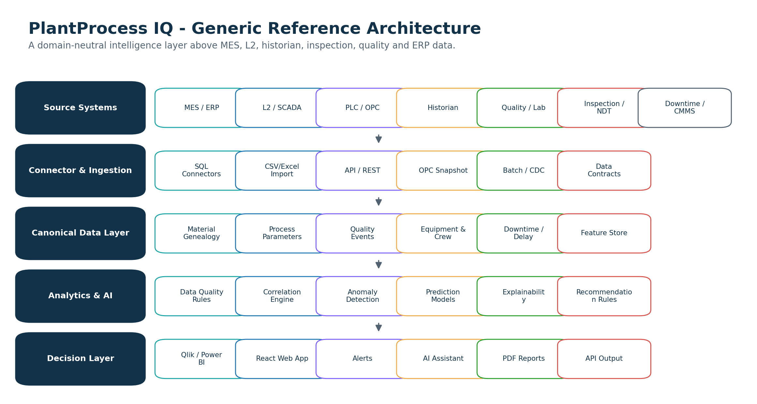

Prepared for: Karim Gamal Elsayed
Version 1.0 | 2026

1. Executive Technical Summary
PlantProcess IQ is designed as a generic intelligence layer above existing MES, Level 2, historian, quality, laboratory, inspection, downtime and ERP systems. It does not replace MES, SCADA or BI. It connects process and production data end-to-end, builds material genealogy, identifies correlations between process parameters and quality outcomes, predicts quality risk, and explains suspected contributors in a dashboard and AI-assisted report.
Core design principle
Build a domain-neutral manufacturing data model first. Industry-specific wording such as heat, coil, batch, tire, roll, lot, paper reel or aluminum billet must be configured as metadata, not hard-coded logic.

2. Product Objectives
- Connect fragmented production, process, inspection and quality data across the plant.
- Normalize data into a canonical manufacturing model that works for process and discrete manufacturing.
- Build genealogy from raw material, batch or order through process steps to final product and quality decision.
- Detect missing, duplicated, delayed or inconsistent production/quality records.
- Run statistical correlation and machine-learning models to identify risk contributors.
- Predict quality risk before the next process step and provide explainable recommendations.
- Offer dashboards in Qlik/Power BI for early MVP, and a React-based web application for a scalable product.

3. Recommended Product Architecture

Figure 1 - Reference architecture for a generic manufacturing quality intelligence platform.
The architecture should separate the product into layers. This avoids building a tool that only works for one plant or one industry. Each layer has a clear responsibility and can be replaced or extended later.
Layer | Purpose | Recommended Technology
Data connector layer | Read from MES, L2, PLC/OPC exports, historian, lab, inspection, downtime, ERP and BI data sources. | C#/.NET connectors, Python ingestion scripts, ODBC/JDBC, REST APIs, CSV/Excel import, OPC UA snapshots where permitted.
Staging layer | Store raw snapshots exactly as received for auditability and repeatable testing. | PostgreSQL or SQL Server; object storage/parquet later for large data.
Canonical data layer | Transform plant-specific source data into generic entities: material, operation, equipment, parameter, quality event and genealogy. | PostgreSQL/SQL Server relational model with JSONB/JSON columns for flexible attributes.
Analytics layer | Run data quality rules, correlation, anomaly detection and feature engineering. | Python/scikit-learn, SQL analytics, optional ML.NET for .NET-native models.
Prediction service | Serve trained models and calculate material risk scores. | Python FastAPI or .NET API; ONNX Runtime for framework-neutral inference later.
Decision layer | Dashboards, AI explanations, reports, recommendations and APIs. | React + .NET API for product; Qlik/Power BI for pilot dashboards.

4. Database Strategy

4.1 Recommended MVP database
For the first version, use PostgreSQL as the product database because it is open, strong for relational modeling, supports declarative table partitioning, and provides JSON/JSONB types for flexible attributes. PostgreSQL partitioning is useful for large time-based observation tables, and JSONB is useful for plant-specific parameters while the canonical model is still evolving.

4.2 Enterprise customer database support
- Support Microsoft SQL Server and Oracle as source systems because many MES/L2 environments already use them.
- Keep source connectors separate from the product storage layer.
- Never force a plant to change its existing MES/L2 databases.
- For pilots, accept database exports if direct connection is politically or technically difficult.
- For production, prefer read-only database users, API exports, or scheduled extracts approved by the customer IT/security team.

4.3 Core database schema
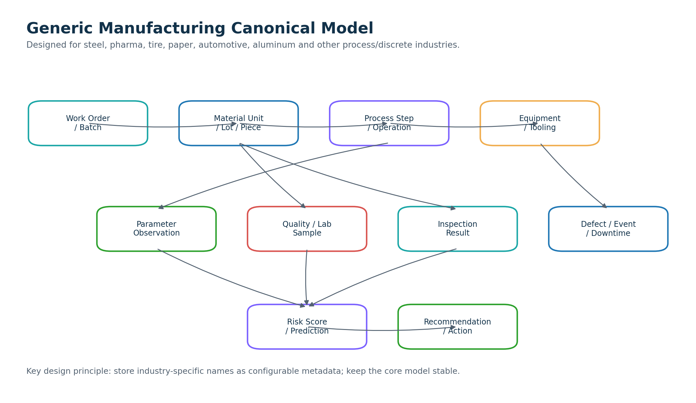
Figure 2 - Generic canonical model that supports multiple manufacturing domains.
Entity | Generic Meaning | Steel Example | Other Industry Example
Plant | Manufacturing site | Flat steel plant | Pharma factory / paper mill
Area / Line | Production area or process line | Caster, HSM, Cold Mill | Filling line, tire curing, paper machine
Work order / Batch | Planned production unit | Heat/order | Batch, lot, work order
Material unit | Traceable physical material | Slab, coil, rail, section | Tablet batch, tire, roll, car part
Operation | Manufacturing step | LF treatment, casting, rolling | Mixing, curing, coating, assembly
Parameter observation | Measured process value | Casting speed, temperature | Pressure, humidity, torque
Quality event | Defect/result/status | Crack, inclusion, flatness | Contamination, blister, dimension defect
Equipment context | Machine/tool/asset identity | Mould, tundish, stand | Mold, press, reactor, cutter
Crew/shift context | Operational context | Shift A / crew ID | Operator group / line team
Prediction | Risk model output | Surface defect risk | Reject probability / quality class

5. Generic Data Model Strategy
To make the platform generic across steel, pharma, tire, paper, automotive and aluminum, the product should use a graph-like genealogy model on top of a relational database. The central concept is not “coil” or “heat”; the central concept is a traceable material or batch unit that moves through operations and accumulates parameters, events and quality outcomes.
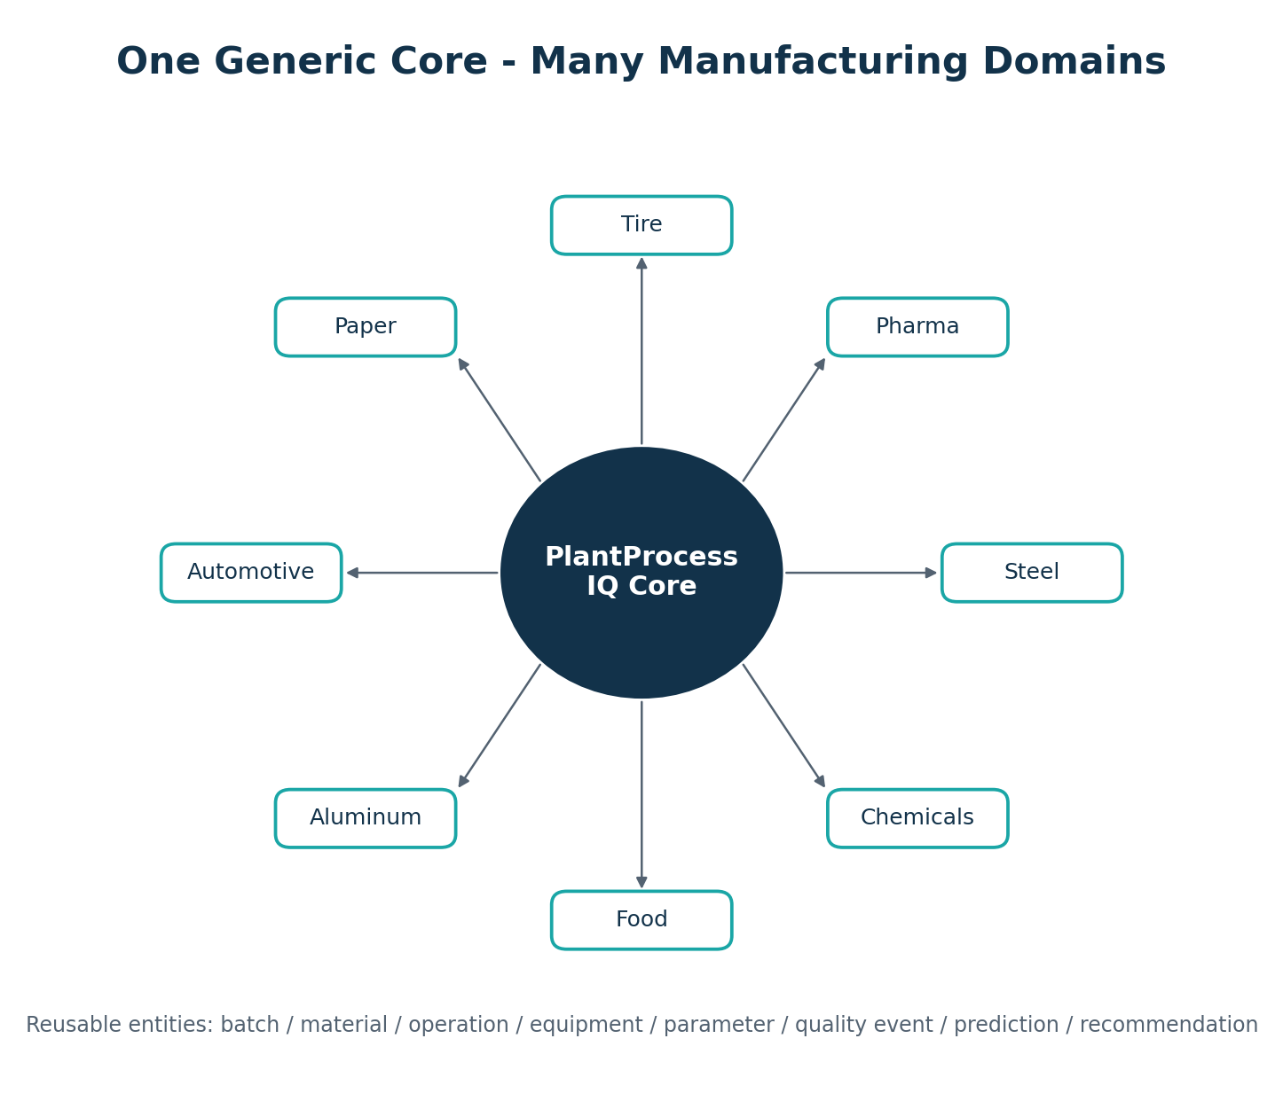
Figure 3 - Domain-neutral core with industry-specific configuration packs.
Generic Concept | Configuration Examples
Material unit types | Heat, slab, coil, rail, batch, tire, paper roll, aluminum billet, car component
Operation types | Melting, casting, rolling, coating, mixing, curing, assembly, inspection, packaging
Parameter catalog | Temperature, pressure, speed, force, chemistry, humidity, composition, delay duration
Quality event catalog | Crack, inclusion, center buckle, contamination, blister, dimension defect, surface defect
Equipment catalog | Furnace, ladle, mould, mill stand, reactor, press, cutter, inspection device
Domain rules | Steel grade rules, pharma batch release rules, tire curing rules, paper moisture rules

6. Data Ingestion and Integration
- Start with offline data import for MVP: CSV, Excel, SQL export, and synthetic datasets.
- Add read-only SQL connectors for pilot: SQL Server, Oracle, PostgreSQL.
- Add scheduled extraction jobs for production: nightly batch, shift-based load, or near-real-time incremental load.
- Add optional OPC/historian integration only when the customer has a secure approved method and clear data ownership.
- Use a source-system registry to track where each parameter came from and when it was loaded.
- Store raw data snapshots before transformations to make analysis reproducible.
Integration Mode | Use When | Risk Level | Recommendation
CSV/Excel import | First demo or customer data readiness assessment | Low | Best first step. Fast and safe.
Direct SQL read-only | Pilot with IT approval | Medium | Use read-only credentials and limit queries.
API/REST extraction | Modern MES/QMS/ERP systems | Medium | Good for controlled access.
CDC/replication | Large production deployment | High | Only after strong customer IT involvement.
OPC/historian stream | Near-real-time risk scoring | High | Later phase, not first MVP.

7. Backend and Service Design
Use a modular monolith first. Avoid microservices too early. The product needs fast iteration, a clean domain model and clear module boundaries more than distributed complexity. Later, the ML service, connector service and reporting service can be separated.
Module | Responsibility | Suggested Stack
Identity & tenant module | Users, roles, plant/site isolation, permissions | .NET API + PostgreSQL/SQL Server
Connector module | Source registrations, import jobs, mapping definitions | .NET workers + Python scripts where useful
Canonical model module | Material genealogy, operations, parameters and quality events | .NET domain model + EF Core
Analytics module | Data-quality checks, correlations, statistics | Python + SQL + background jobs
ML module | Training, validation, model registry, prediction | Python/scikit-learn first; ML.NET/ONNX for serving later
Dashboard API module | Expose KPIs, risk scores, genealogy and correlation outputs | ASP.NET Core Web API
Report module | PDF/Excel export and investigation reports | .NET document generation + templates

8. Frontend and Dashboard Strategy
Do not build everything in Qlik Sense only. Qlik is excellent for fast BI dashboards and first customer pilots, but the core product should remain independent. Build the data intelligence engine and expose it through APIs. Then offer multiple visualization options.
Option | Best Use | Advantages | Limitations
Qlik Sense dashboard | Fast pilot, business users, strong visual demo | Very fast dashboard delivery; good associative exploration; can connect to external analytic engines via SSE. | Not ideal as the full product core or complex workflow application.
Power BI dashboard | Customers already using Microsoft BI | Good adoption in many companies; strong enterprise reporting. | Can become report-heavy without product workflow.
React web application | Full product experience and workflows | Full control: genealogy search, risk review, approvals, AI explanations, reports. | More development effort than BI tools.
Hybrid: React + embedded BI | Best long-term strategy | Product controls the workflow; BI tools handle rich dashboards. | Needs clean API and licensing strategy.

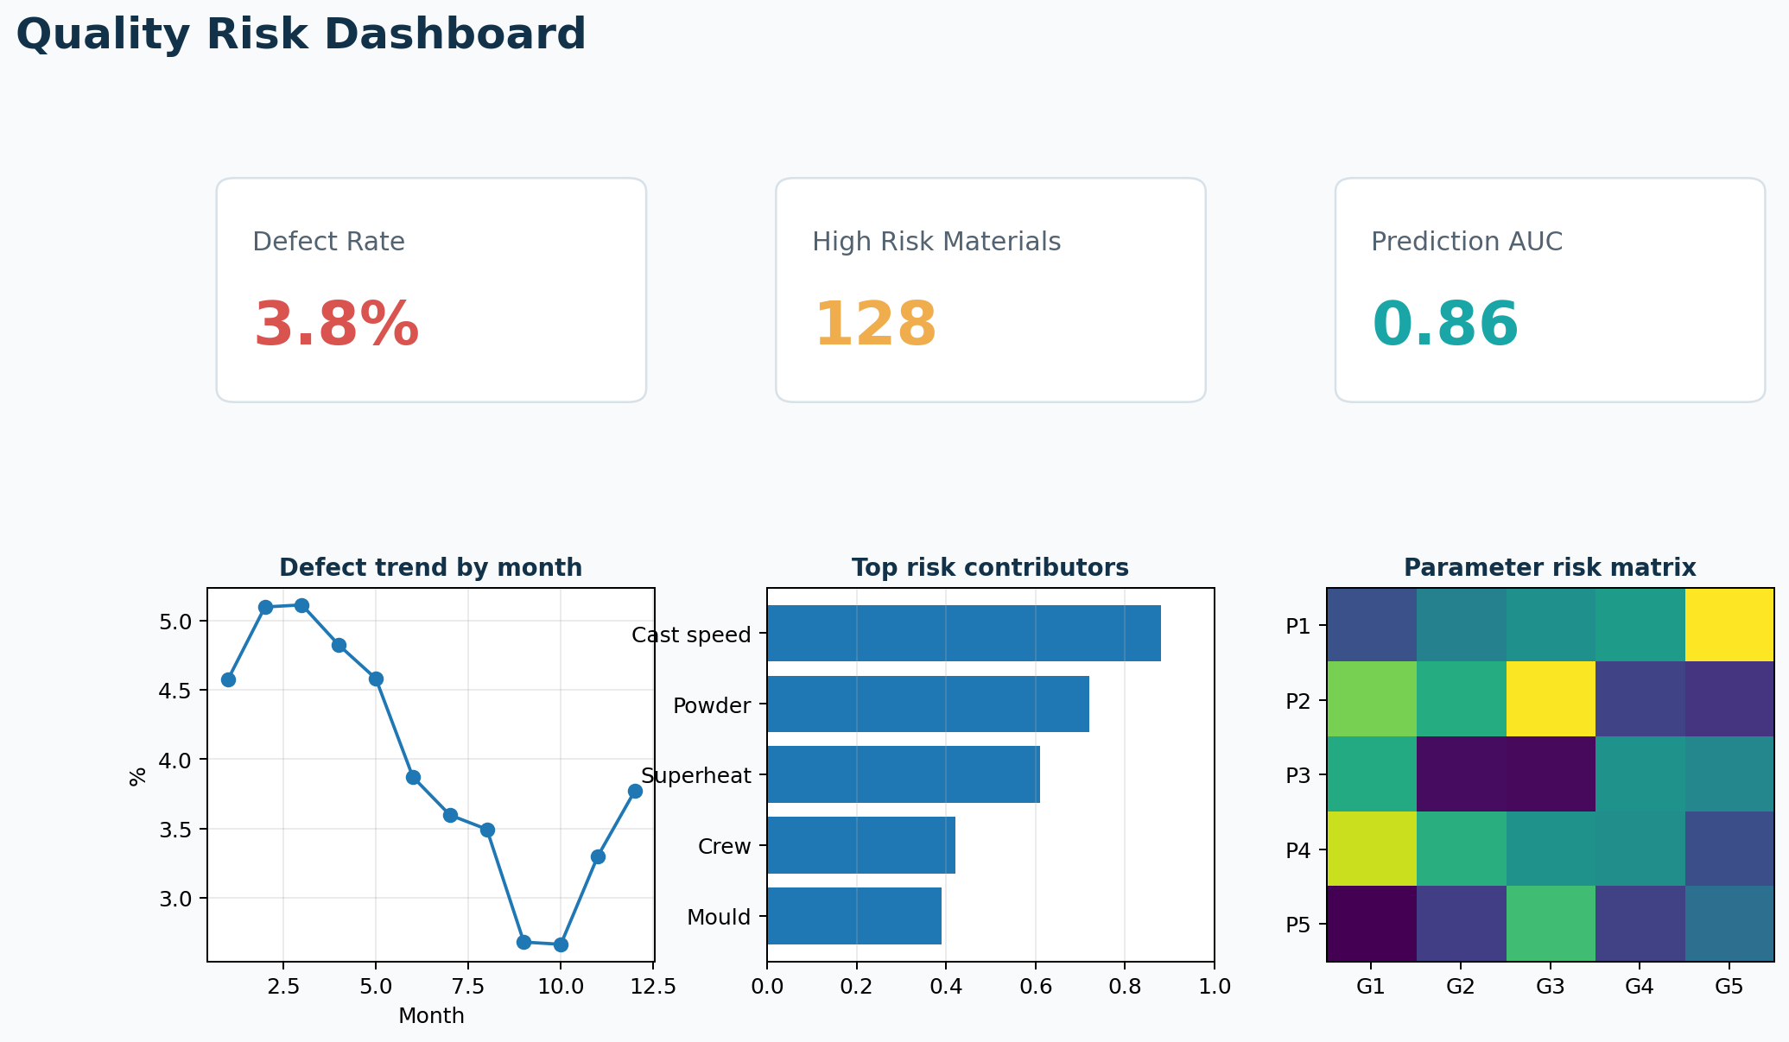
Figure 4 - Example dashboard mockup for quality risk and parameter correlation.

9. Qlik, Python, R, C# and React: Recommended Decision
Recommended stack decision
Use C#/.NET + React for the product platform, Python for machine learning, PostgreSQL/SQL Server for storage, and Qlik Sense/Power BI as optional dashboard layers. Do not make Qlik the core product database or workflow engine.

Capability | Recommended Tool | Why
Core backend | .NET 10 LTS or current enterprise LTS | Matches Karim’s C# strength and enterprise industrial environments.
Frontend product | React + TypeScript | Good for interactive product UI, genealogy search, risk review and admin tools.
Pilot dashboards | Qlik Sense first, Power BI optional | Fast visual delivery and customer-friendly analytics.
ML training | Python / scikit-learn | Strong ecosystem for correlation, preprocessing, classification and explainable models.
.NET-native ML | ML.NET | Useful when models need to run inside .NET environments or edge/server applications.
Model serving | FastAPI or .NET API; ONNX Runtime later | Keeps models accessible to the product and can support multiple frameworks.
Data storage | PostgreSQL for MVP; SQL Server for Windows-heavy customers | PostgreSQL is flexible; SQL Server may fit enterprise customers using Microsoft stack.

Qlik Sense can call external calculation engines through analytic connections / server-side extensions. This makes Qlik useful for advanced analytics pilots where Python or R performs calculations and Qlik presents the results. However, the product should keep the AI logic in a separate service so that the same intelligence can be consumed by Qlik, Power BI, React UI, APIs, and reports.

10. Analytics and Machine Learning Design
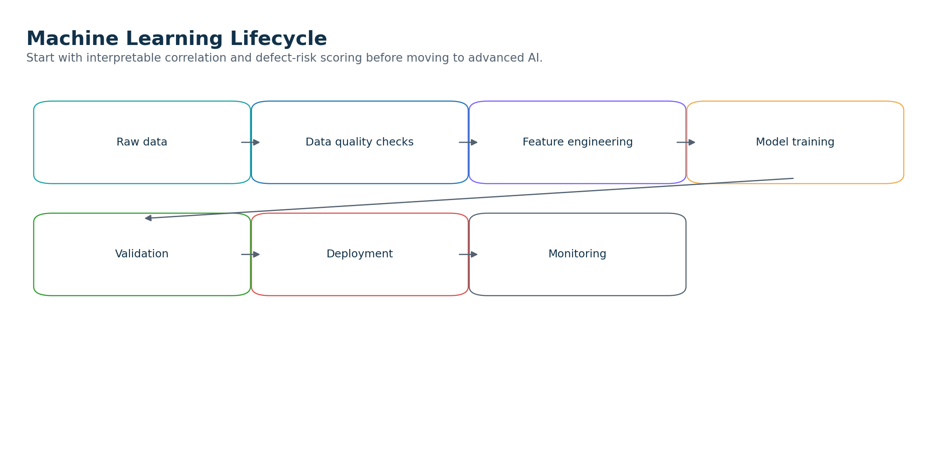
Figure 5 - ML lifecycle: start with correlation and explainability before advanced prediction.
Stage | Method | Purpose | Output
Data profiling | Missing values, duplicates, timestamp gaps, distribution checks | Know if the customer data is usable. | Data readiness report.
Correlation analysis | Pearson/Spearman, chi-square, group defect rates, parameter bins | Identify candidate relationships between parameters and quality outcomes. | Correlation matrix and risk contributors.
Feature engineering | Rolling windows, lag features, process-route aggregation, grade/equipment encoding | Convert raw process data into model-ready features. | Feature table per material/batch.
Baseline prediction | Logistic regression, random forest, gradient boosting | Predict probability of defect/rejection/high-risk quality event. | Risk score + feature importance.
Anomaly detection | Isolation Forest, robust z-score, clustering | Detect unusual process patterns even without labeled defects. | Anomaly score and abnormal cases.
Explainability | Feature importance, SHAP later, rule-based explanation templates | Make model output acceptable to process engineers. | Reason summary per material.
Recommendation | Rule engine + process windows + expert validation | Suggest action without pretending the model is process authority. | Recommended investigation/action list.

Important technical rule: the product should distinguish correlation from root cause. The dashboard should say “suspected contributor” or “risk indicator” unless process experts validate causality.

11. Security, Legal and Deployment Requirements
- For the MVP, use synthetic data only.
- For customer pilots, sign NDA and use customer-approved sample exports or read-only access.
- Never collect personal data such as operator names unless legally approved; prefer crew/shift codes and anonymized IDs.
- Prefer on-prem deployment for sensitive manufacturing customers.
- Add role-based access control, audit logs, encryption at rest/in transit, and clear data-retention rules.
- Create data-processing agreements and clarify ownership of trained models and derived insights.
- Avoid any use of SMS/client confidential data, internal documents, code or screenshots.
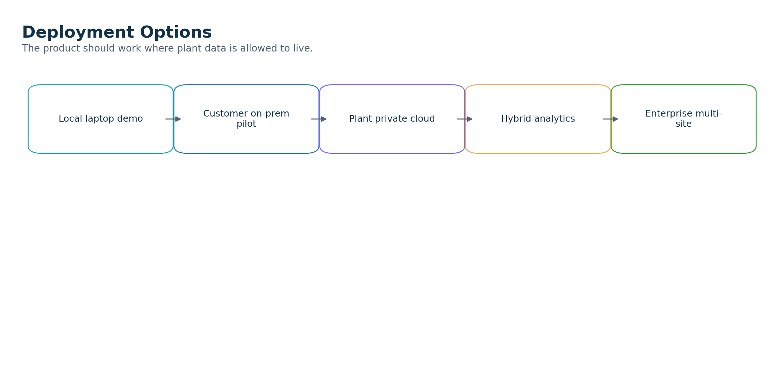
Figure 6 - Deployment options from demo to enterprise rollout.

12. MVP Implementation Steps
- Define one generic use case: process-to-quality correlation for one route and one defect family.
- Design canonical schema: material, operation, parameter observation, quality event, equipment, crew/shift, downtime and prediction.
- Build synthetic data generator with 100,000+ rows across multiple process steps.
- Implement PostgreSQL/SQL Server schema and import pipeline.
- Build ETL mapping layer from synthetic source tables to canonical model.
- Create data quality rules for missing IDs, duplicate events, missing timestamps and broken genealogy.
- Build correlation engine and first feature-importance report.
- Train baseline defect-risk model and validate with synthetic hidden patterns.
- Create dashboard in Qlik Sense or Power BI first, and later React UI for product workflow.
- Prepare customer pilot package: one-page offer, sample report, architecture diagram and demo dashboard.

13. References
- Microsoft .NET support policy and release lifecycle: https://dotnet.microsoft.com/en-us/platform/support/policy
- ML.NET documentation: https://learn.microsoft.com/en-us/dotnet/machine-learning/
- scikit-learn documentation: https://scikit-learn.org/
- Qlik Sense analytic connections / Server-Side Extension: https://help.qlik.com/en-US/sense-developer/November2025/Content/Sense_Helpsites/AnalyticConnections.htm
- PostgreSQL declarative partitioning: https://www.postgresql.org/docs/current/ddl-partitioning.html
- PostgreSQL JSON/JSONB types: https://www.postgresql.org/docs/current/datatype-json.html
- ONNX Runtime documentation: https://onnxruntime.ai/docs/

