# Design choices and structure

The start window of the application consists of a navigation feature, for lecturers that will be submitting claims and Programme coordinators Academic managers for verifications and approval features for the claims.

Features such as buttons should be clear and easy-to-read labels for a user-friendly design. With different specific colours used to describe the functionality of a feature, and common font styles to allow users to easily understand.

With a feature that stores user data as attributes, the stored data will be organised using functions and forms to label the grouped entities it belong to, with all entities of the database relating to each other.

Assumptions:

* Application might consist of redundant data
* Errors of application feature
* Information of data might be interpreted in many ways
* Delayed submittion of application

Constraints

* Data consistency feature
* Data accuracy feature
* Visual hierarchy to prevent ambiguity
* Planned work with timelines to avoid missing deadlines

# UML Diagram

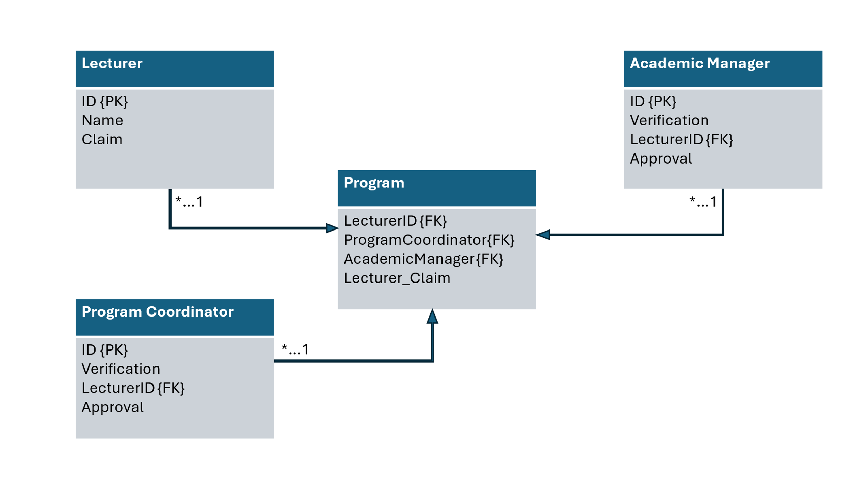

# Project plan

|  |  |  |  |  |
| --- | --- | --- | --- | --- |
| To-Do |  |  |  |  |
| Task | **Status** | **Due date** | **Timeline - Start** | **Timeline - End** |
| Project Planning | Done | 2025-09-09 |  |  |
| Project development | Done | 2025-09-09 |  |  |
| Submitting | Done | 2025-09-09 |  |  |
| Application building | Working on it | 2025-10-14 | 2025-09-12 | 2025-10-14 |
| Editing | Not Started | 2025-10-20 | 2025-10-14 | 2025-10-20 |
| Testing | Not Started | 2025-10-21 | 2025-10-20 | 2025-10-21 |
| Submitting | Not Started | 2025-10-24 |  |  |
| Resolving errors | Not Started | 2025-11-08 | 2025-10-31 | 2025-11-08 |
| Editing | Not Started | 2025-11-16 | 2025-11-08 | 2025-11-16 |
| Testing | Not Started | 2025-11-16 | 2025-11-15 | 2025-11-16 |
| Submitting | Not Started | 2025-11-21 |  |  |
|  |  | **2025-09-09 to 2025-11-21** | **2025-09-12** | **2025-11-16** |