***ASSIGNMENT-1***:

**Task-1:** Install Power BI Desktop and share the final screenshot of the report view page which appears when power desktop starts.

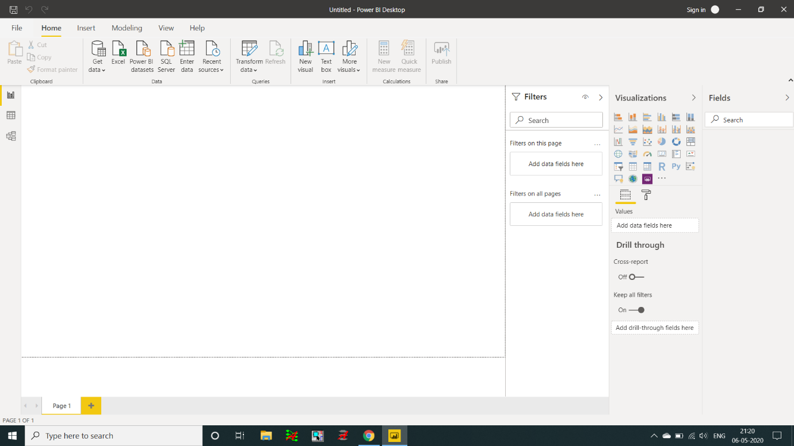

**Task-2:** Prepare a document and with the following screenshot:

* Report View
* Data View
* Model View
* Power Query Editor
* Advance Editor

1. Report View

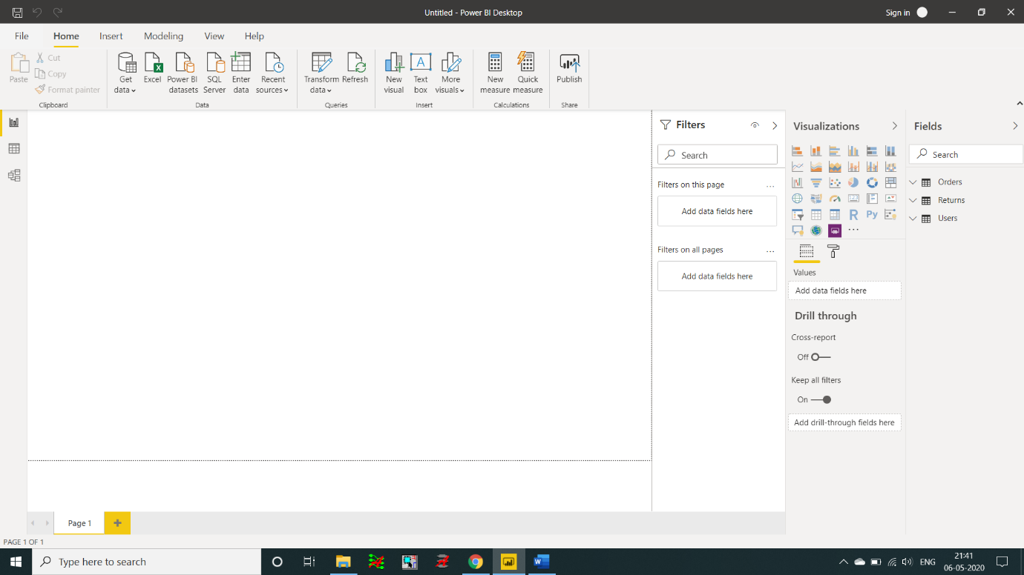

1. Data View

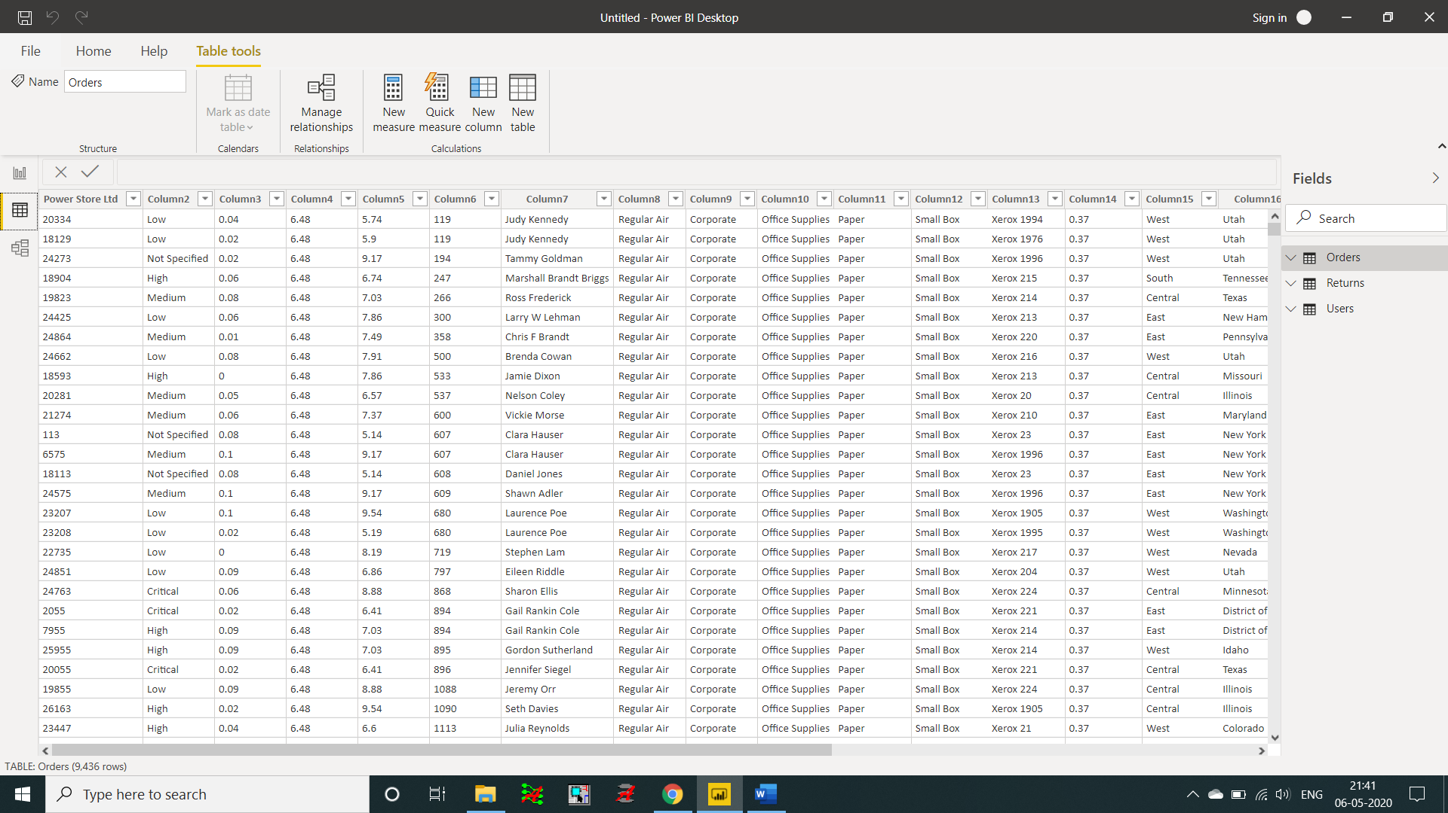

1. Model View

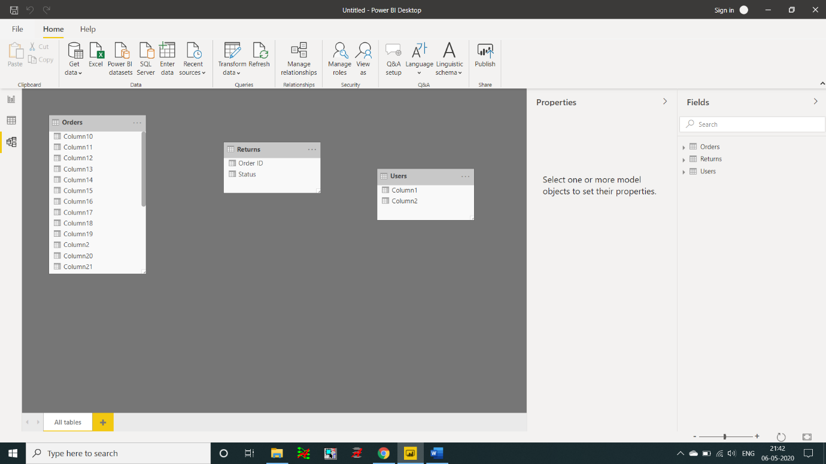

1. Power Query Editor

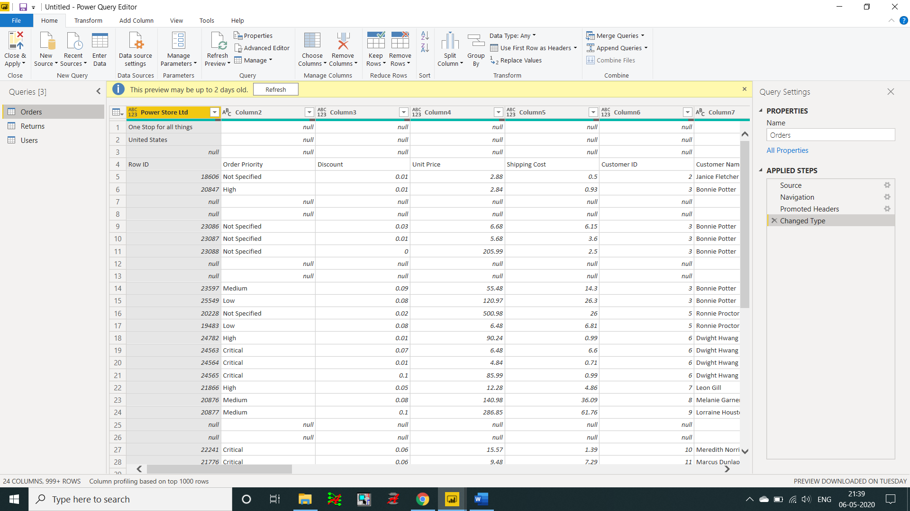

1. Advance Editor

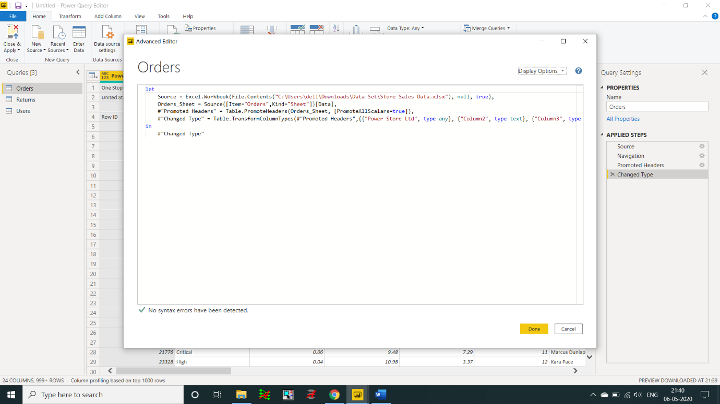

**Task-3:** Prepare a document with details of the following along with their price:

* Power BI Desktop
* Power BI Pro
* Power BI Premium

1)Power BI Desktop

* Connect to your data, wherever it is

### Prep and model your data with ease

### Provide advanced analytics with the familiarity of Office

### Deepen your data insights with AI-driven augmented analytics

### Create interactive reports customized for your business

### Author for everyone, anywhere

### Price: Free

2)Power BI Pro

* Discover insights quickly
* Get more done with familiar tools
* Govern your data securely
* Price: $9.99 user/month

3)Power BI Premium

* Accelerate decision making when everyone has access to insights
* Unlock big data with self-service data prep
* Simplify data management and access
* Improve publishing efficiency and accuracy of BI content
* View Power BI Premium content with the Power BI mobile app
* Price: $4,995 monthly price per dedicated cloud compute and storage resource with annual subscription.