Level 1 heading
This is a paragraph
And this is another one.

Level 2 heading
This is a sentence which appears in different fonts and sizes and has things like background colours and foreground colours all thrown in.

Level 3 heading
Here is an example of a bulletted list with formatting within the items:
- the first item
- the second item
- the third item

Level 4 heading
And here is an example of an enumerated list, maybe with wierd spacing between items and centre justified:
- item number one for joe.bloggs@abc.com
- item numero two
- the item after second item
- a fourth item that links to the BBC
This is just a short paragraph.

Level 5 heading
Here is an interesting item that should not show in the markdown:
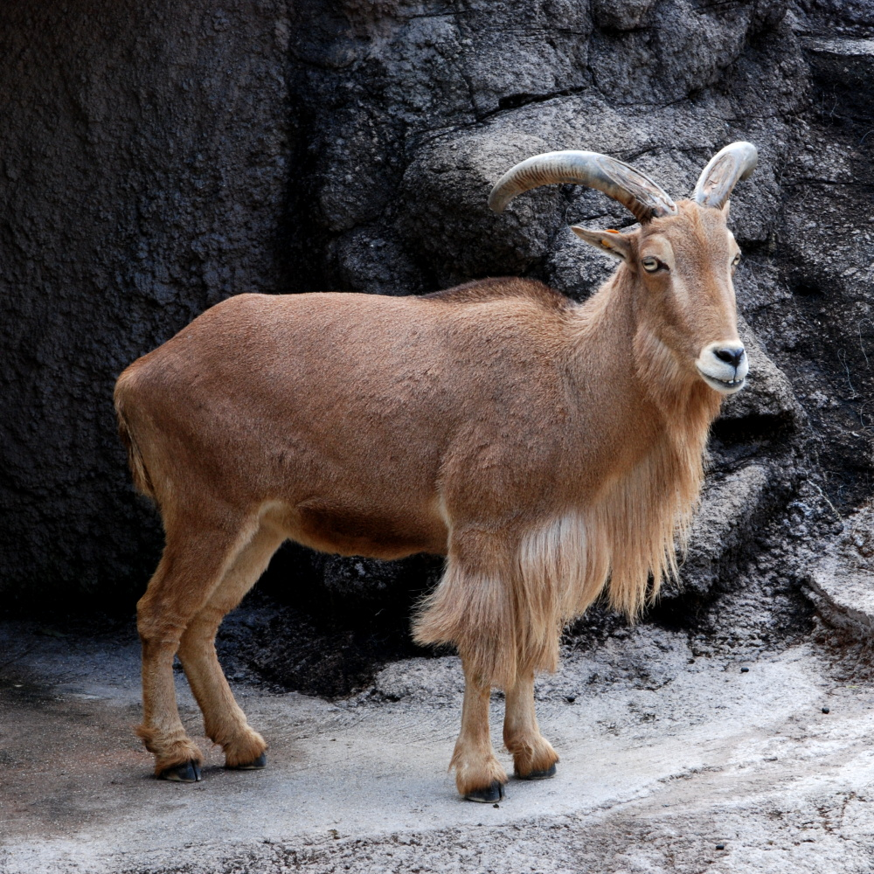

If you see anything about it, there is a problem.

Level 6 heading
The following block of text is meant to be a blockquote:
And now a few sentences about something that just goes on and on and maybe continues for enough lines to make it a substantive blockquote. It's still not as long as it could be. Here is another bit of text to make it an even taller and weightier bit of text. Oh and the line spacing is intentionally odd.

