# Systems & Networking: Arduino Adventure

Welcome to the Arduino Adventure! This guide will help you explore the world of Arduino with some cool LED projects. Ready to dive in? Let's get started!

## Table of Contents

Arduino Background

LED Matrix Magic

LED Wall Basic Operations

Communicating with the LED Wall

LED Wall WiFi Magic

Accessibility Notes - C - to be removed

* Using stylized headers and links to each in docs (technically should’ve used title to start…)
* Sans serif font for readability
* Images made bigger
* Alt text and titles added to all images
* TODO: Read for clarity and add descriptions for working with the physical Arduino
* TODO: increase contrast on boxes drawn on arduino render
* QUESTION: for “code” (i.e. file names, comments, etc.) is using a different font sufficient or is there a better way to indicate “special” phrases

## Arduino Background

The device we are using for the SUCCESS camp is an Arduino Uno R4 WiFi Board, as shown in the picture. An Arduino is a type of *microcontroller device*, similar to what you may find within everyday household items like your refrigerator, oven, smart home sprinkler system, or an automobile. While microcontrollers are usually created for a limited set of special functions, Arduinos are a bit more of a hobbyist general-purpose microcontroller. 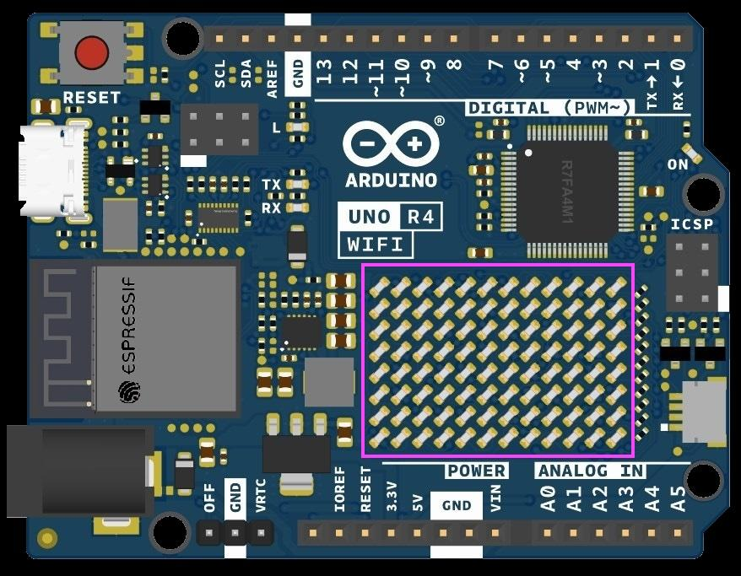

This Uno R4 we are using has several distinctive features:

* A set of “pin” connectors down each side (shown in the picture as the numbered holes going across the top and “Analog In” and “Power” holes across the bottom.
* USB-C connector (upper left just below the red button). The USB-C connection provides data transfer to a computer and power (if needed, an external power port is lower left).
* LED matrix (outlined in purple)
* Wireless WiFi capability
* Multiple other features and extension capabilities we won’t be using for this camp.

You make an Arduino “do something” by creating a program known as a *sketch* in the Arduino IDE (Integrated Development Environment) on your laptop, and uploading the sketch to the Arduino by connecting it to the laptop via the USB-C port with a cable. For our Arduino adventure, we will create a series of sketches that start with on-board features, and then connect to an external light wall and eventually integrate with other programs using the WiFi

## LED Matrix Magic

The Matrix Magic sketches use the LED matrix shown outlined in purple on the previous page.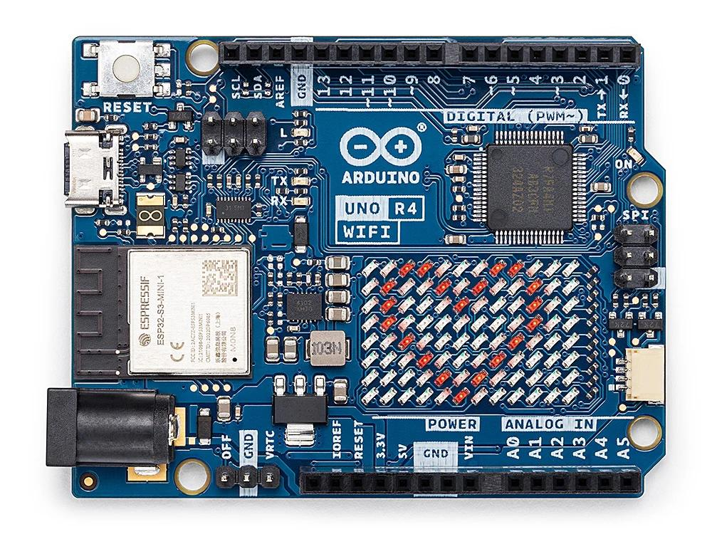

### Basic - ON, OFF, Happy, Heart

1. Open the Basic sketch.
2. Upload the code to your Arduino.
3. Watch as the LED Matrix shows different patterns:
   1. Lights turn on and off
   2. A happy face
   3. A heart (shown in the image)

/* Basic - ON, OFF, Happy, Heart code */

### Wink Animation

1. Open the Wink sketch.
2. Upload it and see the LED Matrix give you a wink, just like Eleven might give a cheeky wink to Mike!

/* Wink Animation code */

### GameOfLife Animation

1. Open the GameOfLife sketch.
2. Upload it and see a cool animation that looks like a living organism.

/* GameOfLife Animation code */

### TextWithArduinoGraphics

1. Open the TextWithArduinoGraphics sketch.
2. Enter any text you want in the "text" field in the code.
3. Upload it and watch your text scroll across the LED Matrix.

/* TextWithArduinoGraphics code */

*We will discuss some interesting manipulations of these scripts to do in camp, as well as some advanced challenges we have put in the code for those who are ready for more advanced coding experiences!*

## LED Basic Operations

For this activity, we will connect our Arduinos to a set of external programmable LED light strands (like ones you may see if you go around looking at Christmas lights during the holidays). The LED strands are programmable in that the Arduino, through a sketch, can tell it to light up individual or groups of lights at different times.

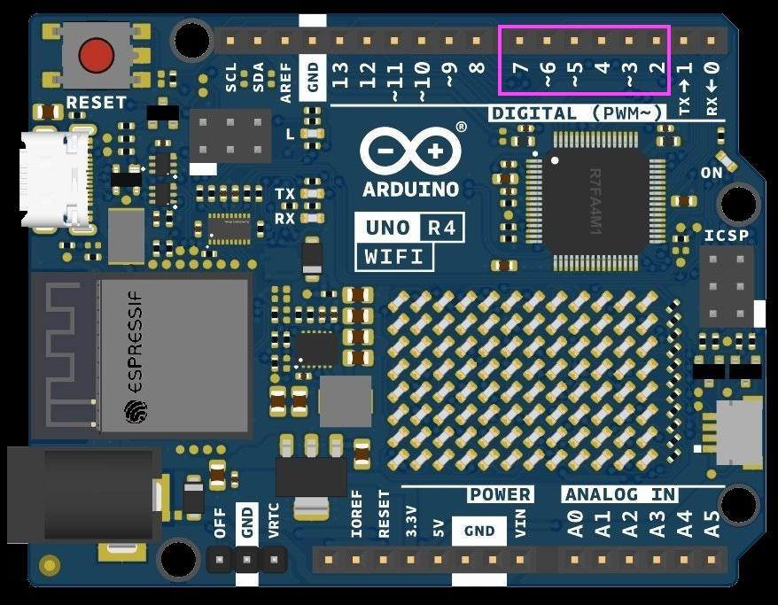

To connect the Arduino to the LED strands, we will use small wires whose ends are inserted into various pin connectors on the Arduino, and into a connector on one end of the LED strand.

First, note the pins labeled “GND” - there is one on the top and two on the bottom - it does not matter which you use. You need to connect a wire from that pin to the blue connector on the light strand. Next, you should use a wire to connect to pin 6 on the top (purple rectangle) with the white connector on the light strand. Finally, connect a wire to the red connector on the LED strand, with the other end going into the 3.5V power pin connector shown at the bottom center. This one goes last (after the blue GND one) as it supplies power from the Arduino to the LED light strand so the lights can go on!

### On, Off, Flicker, Sequence

1. Open the LEDWallBasic sketch.
2. Upload it to your Arduino.
3. Watch how the LEDs turn on, off, flicker, and sequence through, just like the lights on the wall in Stranger Things!

*This initial sketch can first be done with just the light strand laid out on your table. Play around with settings in the sketch that control the speed and length of the various patterns that turn on and off lights. When done, carefully disconnect the wires in reverse order (red, white, then blue).*

## Communicating with the LED Wall

The SUCCESS camp is a fan of the show Stranger Things, and Vecna is not pleased! If you have seen the show, particularly season 1, then you may have watched the “alphabet wall” scene: [Joyce Christmas Lights Scene (Winona Ryder) | Stranger Things | Netflix](https://youtu.be/jIQ9z2bxXyg?feature=shared)

*We are going to build our own alphabet walls with our Arduinos and LED strands!*

We will provide you with a foam board and materials to create your own alphabet wall, and encourage you to spice it up with stickers and drawings! Then we will mount the LED light strand onto the alphabet wall and use sketches to control what is spelled out on the wall!

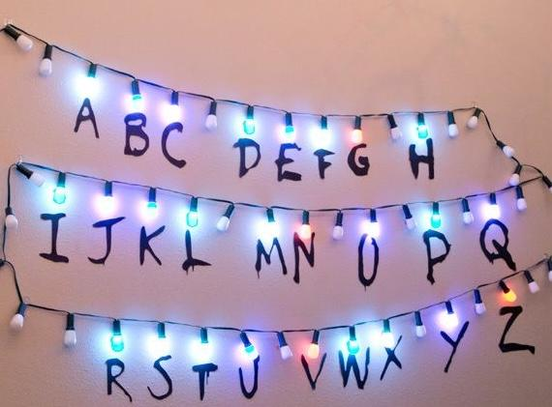

### Write Strings to LED Wall

1. Open the LEDWallWriteStrings sketch.
2. Upload it to your Arduino.
3. Attach an alphabet (A-Z) to each LED on your strip.
4. Use the serial monitor (in the ArduinoIDE Tools menu) to type messages and see them appear on the LED Wall. It’s like you’re talking to someone in the Upside Down!

This activity demonstrates serial communication. You’ve probably seen the acronym “USB”, we used it above (“USB-C”). USB stands for *Universal Serial Bus*, 1st introduced in 1996 and remains the most prevalent way of connecting external devices to computers. The technical details of serial communication are not important for this camp, other than to understand it is a standard form of *wired network communication* between computers and peripherals (devices).

*The challenge with this sketch is to match the letters on the wall to the representation of the LED strand within the sketch. Once you do that (with some trial and error) then you can see how the strings (“strings” is just a fancy computer term for “words”) are spelled out on your wall!*

## LED Wall WiFi Magic

In our previous example we use the *serial monitor* to type in words that are then sent to the Arduino over the USB-C cable, and then the sketch code determined what lights to turn on based on those words. This is fine and works, but it is somewhat inconvenient to have ity connected to a computer to provide our input words. What if we could …

1. Detach the USB-C cable and computer so we can put our wall wherever we want?
2. Communicate wirelessly with the Arduino, basically creating a remote control?
3. Allow any phone, computer, or tablet to control the board?

### Set Up Your Arduino with WiFi

1. Make sure your Arduino is connected to the LED strip.
2. Open the LEDWallWifi sketch and upload it to your Arduino.

### Start the Server

1. Open the terminal on your computer.
2. Navigate to the SysAndNetworking → LED WallWifi → server folder with server.js.
3. Run npm install to install the necessary packages.
4. Start the server by running npm start.

### Open in a Web Browser on your laptop.

1. Open wallwifiui.html in your browser.
2. Type messages, and the HTML page will talk to the backend server.
3. The server sends over WiFi the words to write on the wall.
4. To do this properly, you will first have to know the WiFi address of your Arduino board.

### How does this work?

So what is happening here? Well, we basically have multiple things going on here:

1. The HTML file you open in your browser has code in it that takes what you type in and sends it to your server. Your browser and HTML file in it are called the *client*
2. The server is called as such since it *serves* content to many clients, much in the way a waiter at a restaurant serves food to many customers. In this case we are sending to the server a request to write a word on the Arduino wall. This request is done in HTTP (HyperText Transfer Protocol), the standard networking protocol of the web (we will discuss more in camp).
3. The server receives the request, and then sends it to the Arduino over the WiFi connection (this replaces the USB-C cable we used previously). If you think about it, our “server” now acts as a “client” to the Arduino board!

browser

Arduino

server

Light wall

http WiFi pin connectors