**Clinician Home Visit Guide**

Aspira Asthma Monitoring System

# May 11, 2013**Before the First Visit**

The Aspira asthma monitoring system has been pre-provisioned on the tablet devices. As a result of this provisioning process several software programs are installed on the tablet:

1. Aspira tablet application (tablet app) – This is the tablet application the end user will use on a daily basis to collect spirometer readings.
2. Aspira monitoring service (Desktop Java service) – Start this application by double-clicking on the “Air Quality Status” shortcut on the Desktop (you get to the Desktop from the Windows Metro interface by tapping on the Desktop tile). When this application starts, a DOS command prompt window will appear as shown below; this window may be minimzed. This application should be running at all times.
3. Aspira configuration application (Desktop Java application) – Start this application by double clicking on the “Configure Aspira” shortcut on the Desktop. This application is only run bny the clinician during home visits. It has a graphical user interface (GUI) that is used to modofy configuration setting for the 2 programs above. After modifying settings, saving them, and exiting this program, you must go restart program #1 and #2.
4. Microlife PF100 Asthma Analyzer – This software will be used by the clinician each home visit to collect data from the memory of the spirometer devices used by the patients. You must connect the spirometer to the tablet using the USB cable before starting this software. When running this software you should not have programs #1 or #2 above running.
5. LogMeIn – LogMeIn allows remote access to the tablet. We will use this software for remote technical support in the case of unexpected errors. To enable, double-click on the Desktop icon for LogMeIn, then use the power button icon in the upper left to ensure it is accessible. Usually this software will be run while talking to technical support (someone from Dr. Cleary’s group or ASU). It should be disabled at all other times to minimize security risks.
6. Dylos Air Quality Monitor – This is provided by Dylos, the vendor that makes the air quality devices. It may be run to check the air quality levels of the home, and we will use it as a backup solution in case services within program #2 above fail. In general however, we should not have a need to use this software at this time.

As part of the pre-provisioning process, the software and devices have been configured with certain parameters to affect proper usage and data collection.

The configuration application is the main tool used to modify these parameters as needed. You (the clinician), need to understand how to use this application effectively. This guide explains how to use this application by describing what to do on each home visit.

# The First Home Visit

During the first home visit, you will setup the physical devices, configure the software, enable the programs #1 and #2, and check they are working properly.

### Setting up the physical devices

The physical devices are the air quality monitor, the spirometer, and the tablet itself. First, look for a location where the tablet and air quality monitor can be placed that is near power and minimizes the possibility they will need to be moved. Both the tablet and the air quality monitor need to be plugged in, so two outlets need to be available that are not controlled via a light switch. Attempt to avoid locations that would cause air quality readings to be skewed, like right next to an air intake or vent of the home’s heating and/or cooling system. Suggested locations might be an end table in a corner of a room or on top of a standup piano. Poor locations would be a coffee table cluttered with other items, a kitchen counter or table, or a child’s play table.

Put the tablet on the selected table and incline it in the provided cases to the lowest angle of display. The power will connect at of the bottom of the device and the USB cable at the top. The positioning of these cables at first seems awkward, particularly the power cable. Ensure you are drawing power by starting up the tablet and checking that the battery icon on the splash screen has a small “pitchfork” on the side of it meaning it is connected to power.

Place the air quality monitor next to the tablet, plug it in, and connect the 9-pin serial connector to the device on its left side (as it faces you). When the 9-pin connector (the fat side) is connected to the air quality monitor and the USB adapter (thin side) is connected to the tablet, the red LED should be illuminated indicating a valid connection. Turn the air quality monitor on (left button on front of the device) and you should hear its fan start and the green LED display will starting displaying small and large particulate numbers.

*It is important to ensure the tablet and air quality monitor are placed in a location where they will not need to be moved to decrease the chance they become disconnected*!

### Configure the Software

Each time you go into the home you will need to run the configuration application. First, shut down the air quality monitor, disconnect the power from the tablet, take the tablet out of the leather case, and place it in the keyboard dock. Run the configuration application by going to the Desktop and double-clicking on the Configure Application shortcut. You should see a screen like the following displayed:

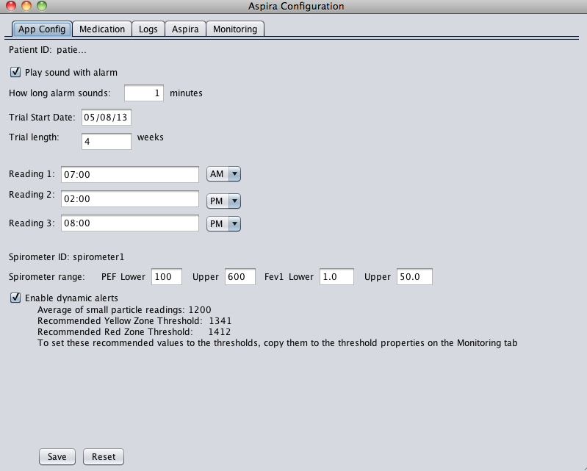

Note that these exact values will not be displayed. On the first visit, do the following on this tab:

1. Enter the trial start date
2. Enter the number of weeks the trial will run
3. Ask the family during what 3 times each day should readings be taken? Note that readings cannot be taken within 30 minutes of each other, and Reading 1 must be before Reading 2, which must be before Reading 3.
4. Enter the 3 reading times. Make AM and PM are properly selected.
5. The spirometer range values should be between 10 and 800 for PEF, and 1.0 and 50.0 for Fev1.
6. The “Enable dynamic alerts” checkbox should be de-selected.
7. Click Save to save the values to the config.json file.

Step 6 is important; dynamic alerts should not be enabled in the first week while air quality readings are collected.

Next, click on the Medication tab. You should see a screen that looks like this:

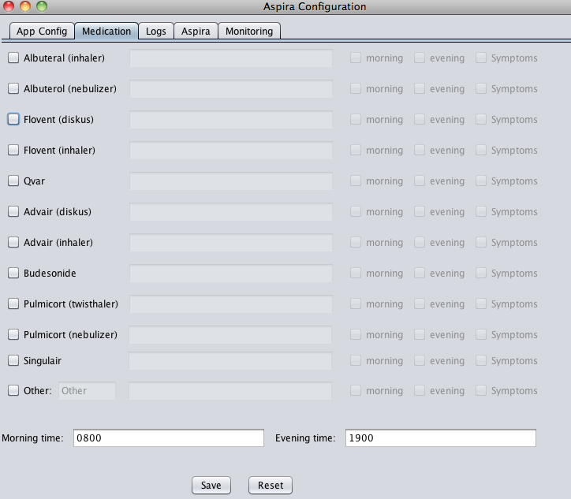

If the patient takes any medicines, check the checkbox next to the medicine, enter its description, and select whether the patient takes it in the morning, the evening, and/or while experiencing symptoms. Use the “Other:” checkbox at the bottom to enter a medication that is not listed. The default morning and evening times are listed at the bottom but may be changed. Click Save to save the readings (if no medications were entered you do not have to Save).

### Starting the Software

While the tablet is in the keydock, reconnect the air quality monitor and ensure it is on. Do the following:

1. Start the Aspira Monitoring Service. On the Desktop, double-click on the Air Quality Monitoring shortcut. In the black DOS command prompt window, type the letter “L” and hit return. You should see:

Current tasks:

MonitorTask3

MonitorTask1

MonitorTask4

MonitorTask2

Note that these tasks may be in numerical order, but there should be 4 of them. If there is not, see Troubleshooting below.

1. Start the tablet application by returning to the Metro screen (use the Windows button on the center border of the tablet) and tapping on the fish tile. After a splash screen you should see the familiar fishbowl and the time of the next scheduled reading, which should match the next closest future reading time you entered during the Configuration step. The traffic light will initially display no lights; this feature does not start until after a preset delay to ensure air quality readings are properly read from the device.

#### Troubleshooting

The most common error we anticipate is that the air quality monitor is not properly read by the Aspira monitoring service due to a Windows8 configuration. If only 3 tasks show after pressing “L” in step 1 above, then do the following:

1. Type “Q” in the DOS window and then close that window.
2. Ensure the air quality monitor is connected to the tablet.
3. Press the Windows key on the keyboard and at the same time press X. You should see a menu popup in the lower left. Select Device Manager. You can also get to the Device Manager by swiping in from the right to see the Charms menu, selecting Control Panel, then selecting Device Manager from the Control Panel.
4. Scroll down to “Ports (COM and LPT). Expand the item by selecting the carat just left of it. You should see a single entry with COMX next to it, where is a number from 1-6 (e.g. COM5). Make note of this entry.
5. Exit the Device Manager. Run the Aspira Configure application via the Desktop shortcut. Choose the Monitoring tab. Find the “aqmSerialPort” entry on the left. In the corresponding textbox to its right, type in the entry you noted (e.g. COM5). Click Save.
6. Close the Configuration Application and trying starting the Aspira Monitoring Service again. Verify all 4 tasks start by typing “L” in the DOS window again. If only 3 tasks show, repeat these troubleshooting steps or call technical support.

## The Second Home Visit

During the second home visit, you (the clinician), will export data to Excel, backup all data, set dynamic alerts, and verify settings and operation from the first visit. It is expected the second visit will occur about one week after the first visit.

Steps:

1. Shut down the Aspira Monitoring Service and the tablet fish application. Again, do this by typing Q then <return> in the DOS window for the Aspira Monitoring Service, and by type pressing Alt and F4 at the same time while focused n the tablet application.
2. Unplug the air quality monitor from the tablet, and place the tablet in the keyboard dock.
3. Extract data from the spirometer.
4. Import the data from step 3 into the Aspira application.
5. Export data to Excel.
6. Backup all files.
7. Enable dynamic alerts and confirm all patient settings.
8. Reconnect the tablet, air quality monitor, and power and place back in the leather case.

Step 3 is a new activity. To perform this activity, you need to plug the spirometer into the tablet using the USB cable that is in the spirometer case. Then run the Asthma Analyzer software to export the data:

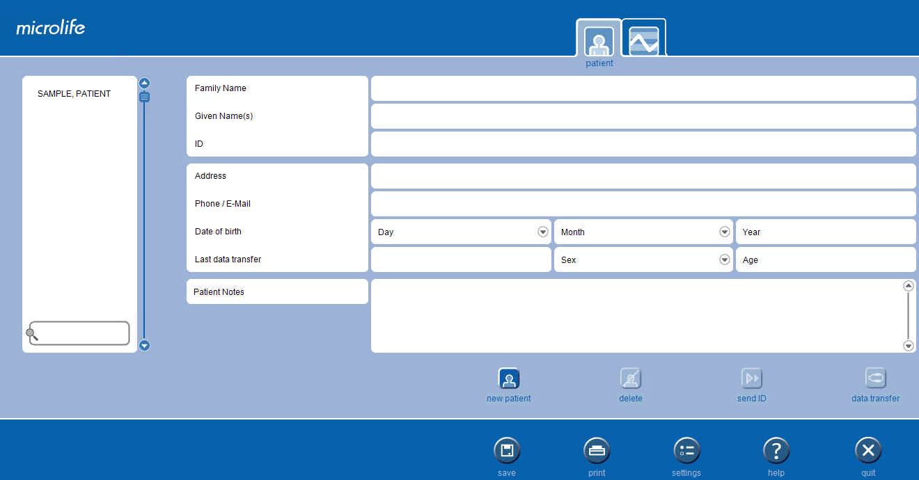

Make sure the patient profile is selected; the USB cable attached, and click on data transfer. You should then choose XML as the export file format and export. Make not of the export file.

For Step 4 run the Aspira Configuration Application. Select the “Logs” tab. You will see a screen like this:

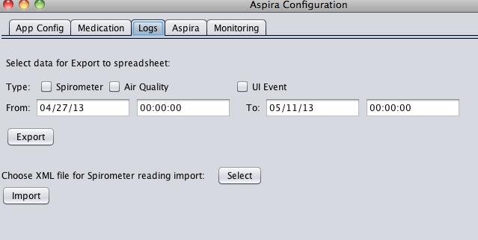

First, click the Select button and navigate on the filesystem to the XML file you just created in the Asthma Analyzer program. It should be under the My Documents folder. After selecting, click the Import button. The application will inform you if import is successful. If not, skip this step and inform technical support after you return to get help importing later.

For Step 5, decide what data you would like exported to an Excel spreadsheet: Spirometer data (what the Patient entered manually), Air Quality data extracted from the monitor, or User Interaction (UI) Event data, meaning every interaction the patient had with the tablet application. If you are not sure we recommending selecting all 3. Confirm the period of activity using the text areas underneath the checkboxes. Note the dates and time must be entered using the format shown exactly. After selecting the data types and date/time ranges, click the Export button. The application will save a file to the My Documents folder named export_<datetime>_TO_<datetime>.xls.

For step 6, you need to export all of the files from My Documents into a zip file. In your My Documents folder, create a zip file by right clicking and choosing New->Compressed (zipped) folder. Rename the zip to <username>_<timestamp>.zip (for example, aspira11_05092013.zip for a file created for patient aspira1 on May 9, 2013). Select all of the files from the My Documents folder and copy them over to the zip file you just created. Plug a USB stick into the full USB port on the tablet and copy the new zipfile to the USB stick.

For step 7, you will need to run the Aspira Configuration application as you did on the first visit. On the App Config tab (see figure page 3) check the Enable dynamic alerts checkbox. The application will pause a moment and then display the average air quality readings for the past week, and display recommended yellow and red air quality thresholds. Copy these values down to a piece of paper. Click on the Monitoring tab, and enter these values on the *yellowZoneThreshold* and *redZoneThreshold* values. Click Save.

While you have the Configure Application running, confirm with the patient and family that everything is operating OK. Ask them if the daily reading times are OK. Inform them that dynamic readings may now occur. Ask them if there have been any changes in medication. Use the Configuration Application as you did on the first visit to configure this information if any of it has changed.

After exiting the Configure Application, you may undock from the keydock, reconnect the tablet, power, and air quality monitor, and restart the Aspira Monitoring service and the Aspira tablet application.

# All Subsequent Visits

The first and second visits to the home have special steps to configure the applications. After these initial visits all subsequent visits only need to perform a subset of these steps as needed:

1. On each visit we recommend importing data off the spirometer using the Logs tab of the Aspira Configure application as you did on the second visit.
2. We also recommend taking a full export of data to Excel using the Logs tab functionality as you did in the second visit.
3. Take a full backup of all data in the My Documents folder to a zipfile as you did in the second visit and copy to an external USB stick as before.
4. Modify any configuration settings required such as medications or reading times as you did before.
5. Be sure to remember to reconnect the tablet, power, and air quality monitor, and to restart the Aspira Monitoring Service and Aspira tablet application before you leave the home.

The spirometer holds 240 readings in its memory. Assuming 4 readings per day (3 scheduled and 1 dynamic) and taking 3 readings per sitting (as recommended by Microlife), this means 20 days worth of data may be stored at a time. The spirometer automatically drops the oldest readings when its memory is full. We recommend visiting the home every 2 weeks, though it is possible data could be extracted remotely with the assistance of the family in the home.

# Getting Help

Please notify Kevin Cleary and Kevin Gary (6023127397) when you plan to visit the homes. If it is possible we will available by phone in case assistance is needed.

Skype has been left on the tablets in case it is needed to work with the families or technical support.

Keep in mind that LogMeIn can allow remote access to help us troubleshoot problems remotely.

If the system does not appear to be working or some other problem is causing confusion, then we recommend at a minimum doing 2 things before you leave the home:

1. Always backup the files under the My Documents folder. No matter what else happens, this ensures the data we are trying to collect is not lost.
2. Enable LogMeIn to allow ASU remote access to correct any issues. We are able to perform all software steps with remote access.