**Troubleshooting Guide**

Last updated: May 10, 2013

**A Quick Guide to Windows 8**

**Turning on the Tablet**

Press the power button on the back of the device. The device should turn on.

**Shutting Down the Tablet**

To turn off the tablet, hit the Windows key and C at the same time and then click the Settings icon. Click the Power icon and Choose Shut Down.

**Logging into your Account (Clinician)**

Once the tablet is on, click OK after the warning message appears. Then, click anywhere on the screen to begin. Enter the username ‘clinician’ in the username field and the password ‘aspira’ in the password field. Then hit Enter.

**Logging off**

Hit the Windows key to get to the Metro Start screen. On the upper right corner you should see the username you are logged under (clinician). Click on that and then click Sign out.

**Desktop**

To access the Desktop, hit the Windows key, right click on the bottom right corner of the screen and click on All Apps. You should see a list of all the Windows 8 apps that are accessible to you. Click on the app that says Desktop and it will take you to the Desktop.

**Accessing Libraries and Files**

To access File Explorer, click on the Folder icon at the bottom left of your screen (where the Start menu normally is) and you can access My Computer and other associated libraries on your machine.

**Metro Start screen**

There are three ways to open the Metro Start screen. One way is to point your mouse in the screen’s bottom-left corner and then click when the Start icon appears. You can also press the Windows key, or

slide your finger inward from your screen’s right edge and then tap the Start icon.

**DOS/Command Prompt**

To get to Command Prompt, hit the Windows key, right click on the bottom right corner of the screen and click on All Apps. You should see a list of all the Windows 8 apps that are accessible to you. Look under Windows System and click on Command Prompt.

**Starting the Tablet App**

After run the tablet app in Powershell, open the Start screen by hitting the Windows key.

**Closing the Tablet App**

To close the tablet app, simply hit ALT F4 when you are inside the app and it will close.

**Dumping Items into the Recycle Bin**

Unlike Windows 7, the desktop on Windows 8 does not have a Recycle Bin or a Start Menu. This functionality works differently on Windows 8. To move an item to the Recycle Bin, right-click on the unwanted item and choose Delete from the menu. Windows 8 asks cautiously if you are sure that you want to delete the item. Click Yes, and Windows 8 dumps it into the Recycle Bin, just as if you had dragged it there.

For further instructions on common Windows 8 features, view the Windows Dummy guide at: www.astro.umd.edu/~rauch/download/Windows8.pdf‎

**Patient**

**Q: I’m so frustrated, what do I do?**

A: See help guide or contact the clinician for assistance.

**Q: Why won’t the fish app run?**

A: You could be missing any of the following files:

* config.json
* airQualityStatus.json
* medicationReminders.txt
* SpirometerReadingLog.txt
* asthmaMonitoringLog.txt

Alternatively, you may have accidentally renamed the files to a different filename.

Check to be sure all the proper files are in the My Documents folder. If they are not there, copy them from the Downloads->Aspira-tablet->Aspira-tablet->AsthmaMonitoring.

**Q: The spirometer will not turn on.**

A: Is it plugged in? If not, plug it in. Check the status of the batteries and if they are dead, change them.

Repeatedly dropping the device can also have an impact on its condition. Refrain from dropping it as much as possible.

**Q: I am unable to read the recordings. What should I do?**

A: If you are unable to read the recordings, check the following:

Are you out of memory?

If so, delete any previous recordings to make room for new ones.

If not, consider the next question:

Is your battery low or dead?

If so, change your batteries.

If you scroll by too fast, use pencil and paper.

**Q: I cannot hear the sound go off when I do a measurement.**

A: Check to be sure that your volume is turned all the way up.

**Q: The next reading time is not updated. What should I do?**

A: Close the UI app using (ALT F4) when you are inside the app to make sure that the app updates the next reading time, then run it again. If it still does not work, call the clinician.

**Q: I cannot see the readings.**

A: Your serial cord might be disconnected. Reconnect the serial cord.

**Q: I cannot obtain any measurements when I am taking a reading.**

A: Did your child blow into the device properly? If you need clarification, please review the video help or textual guide for instructions on how to use the device.

**Q: The results look skewed and inaccurate.**

A: Did you clean the device with tapwater? Did you drop the device? Make sure that you clean the device properly and take care of the device when it is in use.

**Clinician**

**Q: The asthmaMonitoring log file is not updated.**

A: Are the SpirometerReadingLog file or the asthmaMonitoringLog file missing? Check to be sure that they are there. If they are not, copy them from the backup folder.

**Q: The USB tablet does not properly mount the spirometer device.**

A: Try mounting it again after you power cycle the tablet. If it still does not work, you could swap out the USB cable.

**Q: I cannot copy over the data files to the USB memory stick.**

A: Is the USB full? Did it get ejected safely? Those factors could be causing issues. Make sure you have enough space on your USB and that it is fully functional. Also, contact patient about the data.

**Q: I cannot export data to the server.**

A: Check your Internet connection. If the problem still isn’t solved, transfer the data to a USB stick

**Q: I cannot retrieve the measurements or receive connection to the USB port on the computer.**

A: Check to be sure that DylosLogger is on and the USB cable is properly connected on both ends. If readings are not being logged in the Aspira logfile, you may stop the Monitoring Service and run the Dylos Logger program to check connectivity, then restart the Monitoring Service. If you are certain the cables are properly connected, the air quality monitor is on, but neither the Aspira Monitoring Service nor the Dylos Logger program can capture values, then check the answer to the next question.

**Q: COM port for cable will not appear in DylosLogger port.**

A: In Desktop mode, go to Device Manager -> Ports(COM & LPT) , then click on the carrot symbol and expand it, then double click on USB Serial Port *(*it should be set to a default COM depending on your machine). A window should pop up with a dialog box indicating the status of the device. The device should be successfully connected. If it says “Unknown device” or shows a USB controller with a yellow exclamation mark, check to be sure that DylosLogger is on, the cable is seated and the DylosLog file is being written. (See screenshot below)

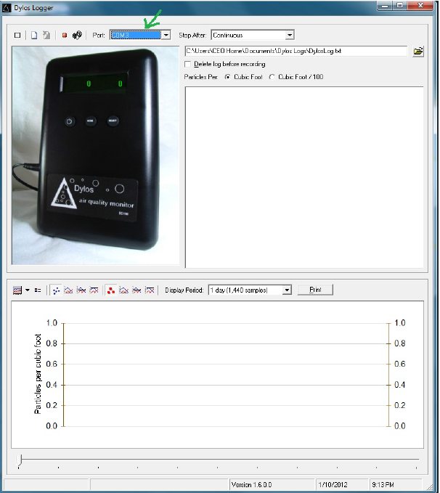

**Q: The monitor service crashed. What do I do?**

A: If the DOS window disappears, restart by double-clicking on the desktop shortcut. If the DOS window disappears again, contact the clinician or technical support.