SCRINCH User Manual
Table of contents
1 Main principles 4
1.1 The Team 4
1.2 The Task 4
1.3 The Project 4
1.4 The Sprint 4
1.5 The Scrum Master 5
1.6 The Scrum Planning meeting 5
1.7 The Daily Scrum 5
1.8 The Scrum Review 5
2 Getting started 6
2.1 Creating a team 6
2.2 Creating a project 6
2.3 Creating an item set 6
2.4 Creating a task 6
2.5 Managing the status of a task 6
2.6 Discovering the Sprint 7
2.7 Setting the sprint properties 7
2.8 Affecting a task to a sprint 8
2.9 Print your sprint 8
2.10 Finishing a task 8
2.11 Adding a target 8
2.12 Using the statistic tools 9
3 The user interface 10
3.1 Main menu 10
3.2 The projects 11
3.3 The project item set 12
3.4 The item 13
3.5 Status management 14
3.6 The Sprint 15
3.7 Sprint properties 16
3.8 The sprint meetings notes 17
3.9 Exporting and printing 18
3.10 Searching items 19
3.11 Members 20
3.12 Targets 21

Main principles
Mainly inherited from Scrum, here are the main principles you need to understand and follow to use SCRINCH in an efficient way :

The Team
The team is constituted only with the engineers involved in the daily work.

The Task
A task is a piece of work that has to be done. It is defined by at least two properties which are : the Business Value (BV) and the Workload (W). Its priority is then defined by dividing the BV by the W (priority = BV/W).
BV is defined by the customer of the project : he is the one who knows whether a task is more important than another one.
W is defined by engineers.
BV and W are not exact values, they do not represent hours or days, they are one of 1,2,3,5,8,13,21 (Fibonachi Never Ending Sequence). A bit disturbing at the beginning, but at last so usefull ! First, it is actually very difficult to find out an absolute evaluation for a task, so why should we keep on using hours ? Second, it is far more easier to say : "task A is easier than task B, as task B is set with a workload of 5, A will be with a W of 2".
That is how it works. Try it and you will see that it is pretty fine !
NB : very high BV is 21, very heavy workload is 21

The Project
A project is a group of tasks.
It can either be a never-ending project (we call it a maintenance project) or can have both a starting date and an end date.

The Sprint
The sprint is an iteration of work. Iterations can last 1, 2, 3 or 4 weeks, depending on the way you work. The principle is to define an amount of work that you will be able to deliver when the iteration comes to its end.
It can contain a mix of tasks coming from different projects. Before defining the content of a sprint, one should select a velocity (daily speed of the team). At the very first sprint, try with a velocity of 10. Ajust this velocity for each new sprint.

The Scrum Master
It is not mandatory for him to be the project manager as his main tasks will be to play as a refery during the scrum meetings (crouch - touch - Hold - Engage ;-)
He must be carrefull that scrum meetings timeframes are respected. He also has to be carrefull that the discussions are not away from the point. He finally has to make sure that everyone has talked.

The Scrum Planning meeting
The meeting where the team selects the tasks to be achieved during the sprint. In other words, this is the definition of the sprint.
It should last around 1h to max 3h (depending on the duration of your sprint)

The Daily Scrum
Each day, everyone has to say : what he did yesterday, what he will do today, and whether he encountered some troubles.
This should not last more than 15 min.

The Scrum Review
The meeting takes place at the end of the sprint, just to see what went right and what didn't (not to repeat the errors in the future)
This should not take more than an hour. (could even take just a few minutes if everything was OK)
For more information concerning the Scrum Principles, http://en.wikipedia.org/wiki/Scrum_%28development%29

Getting started
Launch SCRINCH and follow the next steps to see how it works.

Creating a team
First, we need to initialize your team. Go to the "Members" tab and create a new member by clicking on the "Add Member" button. You can then customize the member's attributes (leave the checkbox checked otherwise, the member will be inactive)

Creating a project
Then, we can go and fill in some work. Go to the "Projects" tab and create a new project by clicking on the "Add Project" button. You can then customize the project's attributes, especially the border dates of your project. (if it is not a real project, maintenance work for example, you can check the "Maintenance Project" checkbox which will lead to remove the date fields).

Creating an item set
A project can be constituted of several sets of items. You could be only using one. You could also have for example one dedicated to development stuff, another one to documentation. You could also separate the work you have to provide to 2 different customers into 2 different item sets. Let's start with creating one by clicking on the "Add Item Set" button. If you have no idea what name to give it, just call it "Work".

Creating a task
You then can create your tasks ! Click on the "Add" button inside the item set to create a new task. You can then fill in a title, a description, a request type, a work type, a business value (B.V) and an estimated workload (W). We did not set any target yet, so you will not be able to set any. If you are happy with your task definition, you could consider it is ready for implementation (set W to 21 for our example). You would therefore change its status : just click on the Status button.

Managing the status of a task
Yet, the status is SBY (Standby) which means that it is not ready to be implemented (workload estimation is not satisfying). As we said before, as we suppose that we are ready for implementation, we should update the status to EVAL (evaluated). (NB : A date and a member have to be associated with a status).
In the future, you will be able to set one of these statuses :
DONE (the work has been done, but not checked by the customer)
OK (the customer agrees with the result)
NOK (the customer does not agree with the result)
CNL (the task has been cancelled)
PP (the task has been postponed)
When the status has been set (should be to EVAL for our example), you can then close the window. The status button is now pink !

Discovering the Sprint
We can then go to the "Sprints" tab and create a new sprint clicking on the "Add Sprint" button after having chosen the duration of the sprint (set it to 1 week for our example)
The sprint comes with a set of properties :
the starting and end date
the possible velocity which is the velocity (daily speed of the team) set by the Scrum Master less the slow downs (people absence, holidays...)
the resulting velocity which is the result of the work achieved so far in the sprint (it is red when 20% lower than possible velocity, yellow if 20% to 10% lower than possible velocity and green if 10% lower or more than the possible velocity)
the required velocity which is the necessary speed to achieve all selected tasks
the number of working days (week-end days are automatically removed)
the total estimated work (sum of Workload values of all tasks that are in the sprint)
the excess of work allocated to the sprint (green if some work can still be affected to the sprint, red if the sprint is overloaded)

Setting the sprint properties
You can then click on the "Props" button. A dialog window appears. You can set all sprint parameters in there : the base velocity (which is the amount of work that you think your team will be able to achieve each day) (set it to 5 for our example), the start and end dates, the list of team members (a list of nicknames separated by a coma)
(Excess of work should now be -25F, which means that you can add tasks to the sprint which total workload does not exceed 25)
Managing slow downs
Slow downs are people absence, holidays or any other event that could slow down your normal velocity. For our example, let's say that one member of the team has to reach a 2-days conference : enter his nickname, choose 2 days, and set in a reason and press on the "Add" button. That's it ! The possible velocity has immediatly been impacted. (3 in our example, excess of work should now be -15F)

Affecting a task to a sprint
Go back to the project you created, check one task's checkbox and click on the "Affect to sprint" button. Choose the created sprint and click on the "OK" button. A label with the sprint name is displayed in the task. Go back to the sprint you created. Your task is there.
Now of course, you added to much workload in that sprint (you added a task with a W of 21, while the possible workload of the sprint was 15) Therefore, you can see that the field "Excess of field" is red and displays +6F. (In such a case, you can choose to leave it like that, or to remove some of the tasks in your sprint, or you can increase the velocity)

Print your sprint
Let's say that your sprint is now set correctly, and that you want to print the task lists and display it on the team's white-board. Then, just uncheck the "Editable view" checkbox : you will then be able to Export all DONE and NOK tasks to a pdf file (which you can easily print).
Check the "Editable view" checkbox.

Finishing a task
Provided you finished that task today, click on the status button of the task and set it to DONE. Resulting velocity turns to green (as in one day, you have achieved a workload of 21, though you initially expected to achieve only 3).
You can now click on the "See graph" button that will show you the picture of the situation (a bit more interesting when you have some more tasks in the sprint, of course).

Adding a target
Of course, you will have planned releases, and you would like to set them ! Go to the "Targets" tab and click on the "Add Target" button. Enter a label (let's say "v1.0"). Go back to the sprint or the project and select the new label in the task. Go to the "Search" tab and, among other possible prepared requests, in the "Search for target" combo box, choose the new target and click on the FIND button. All tasks with this label will be displayed. You can also generate your release notes by clicking on the "Produce release notes" button. (just copy and paste its content to your release-notes file)
You're now ready to work with Scrinch. To have a final full picture of Scrinch, you may want to see what it will look like when a lot of tasks are set, then please load the samples.scrinch file and play freely with it. (don't forget to check the "See also old projects and sprints")
(Of course, you can find the full description of each feature in the user manual part for more details)

Using the statistic tools
You can find on the main window 3 buttons : the global report (a customized Gant Chart graph), a velocity history graph and a Workload distribution graph.
You can also find a Workload distribution graph on each project.
The best way to test them is to load the samples.scrinch file that is already full of data that you can play with. (don't forget to check the "See also old projects and sprints")

The user interface

Main menu
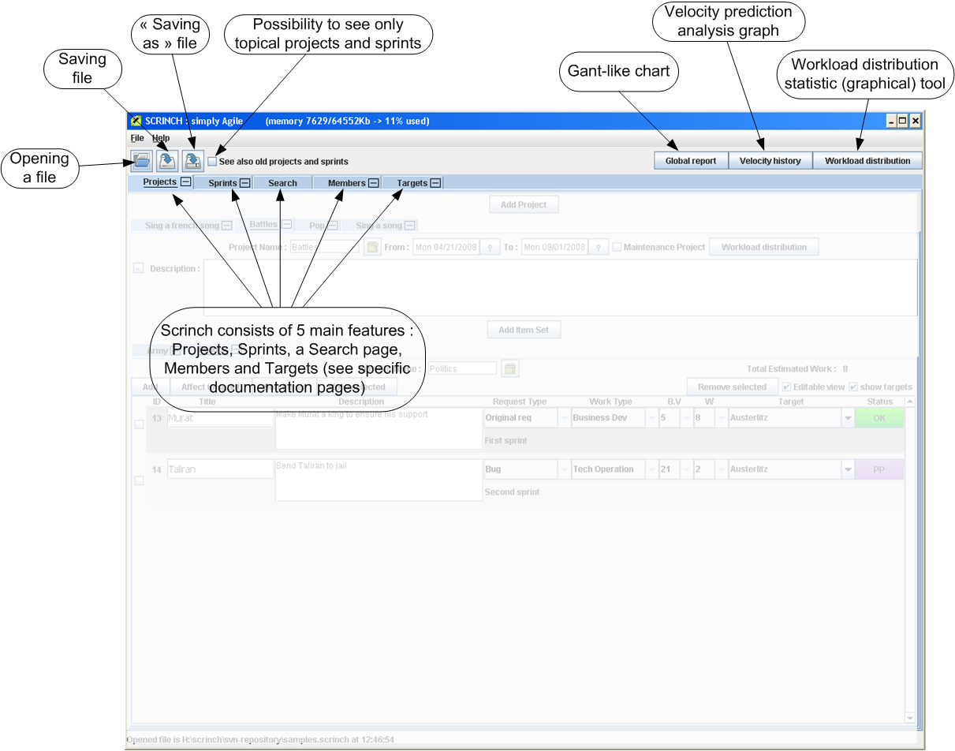

The projects
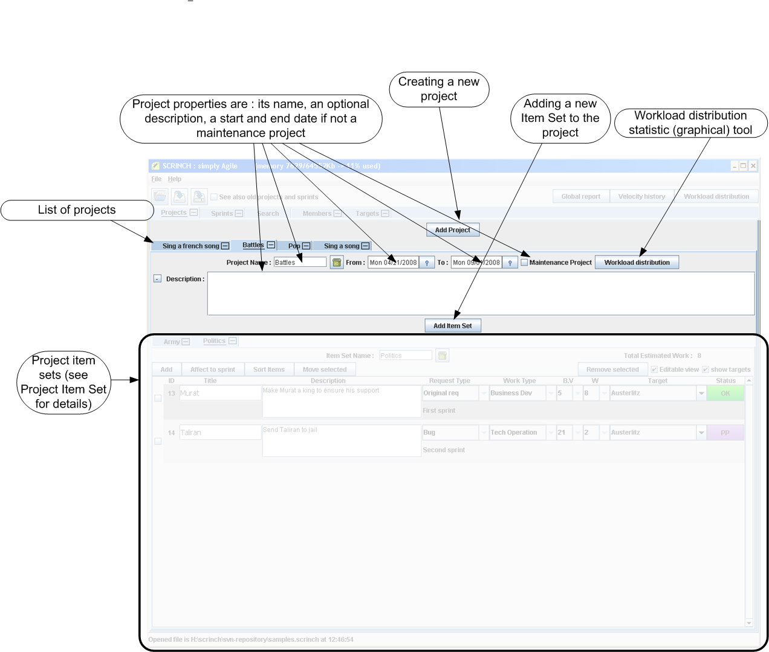

The project item set
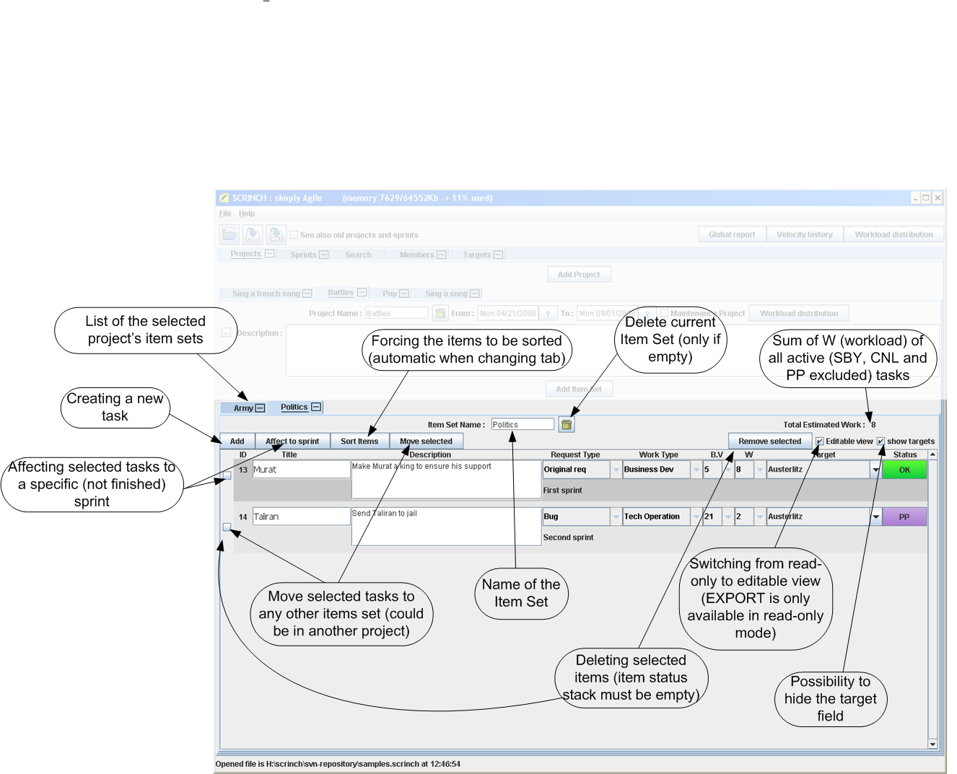

The item
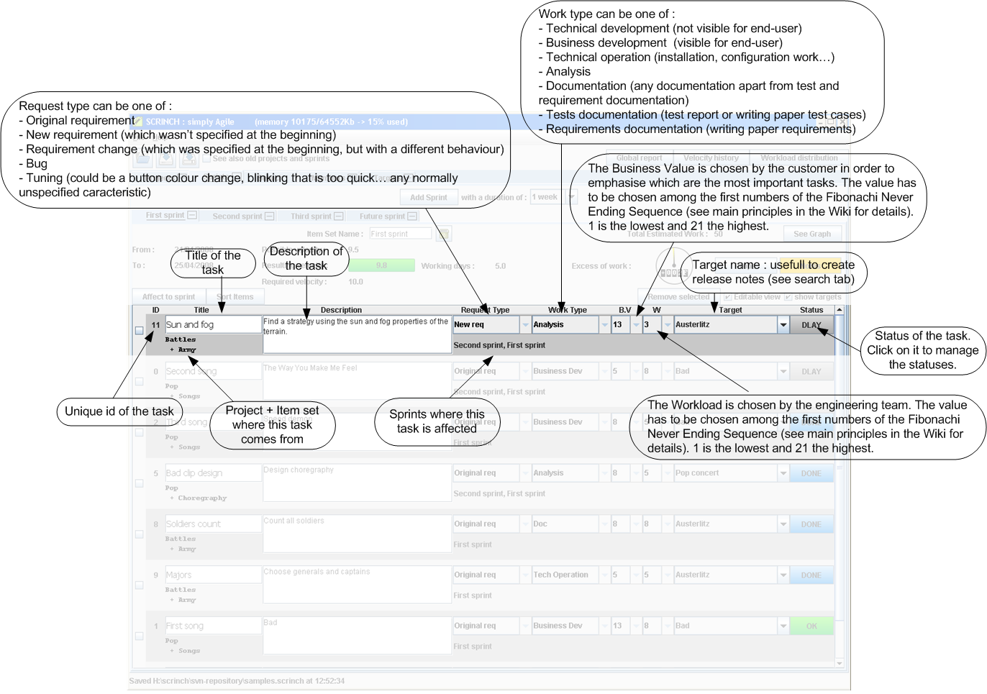

Status management
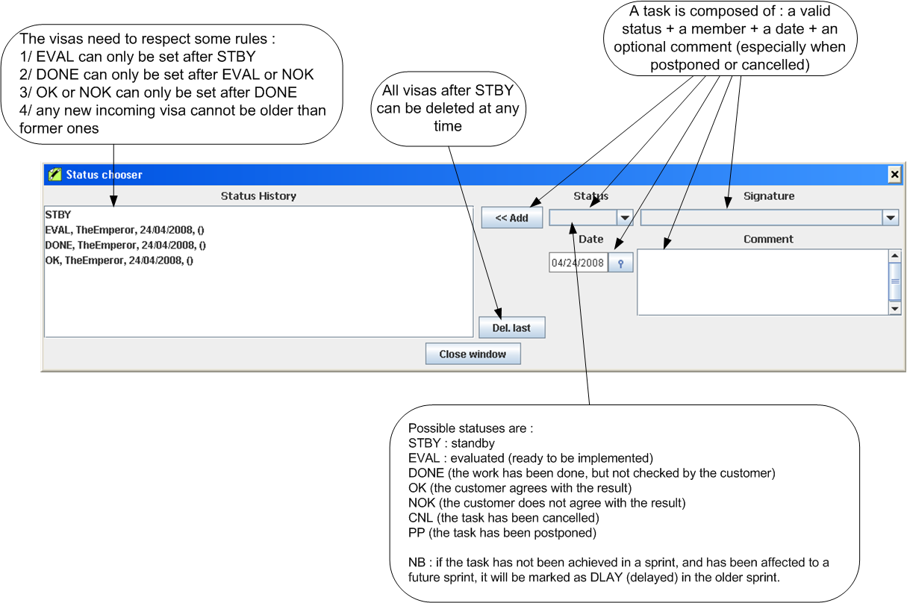

The Sprint
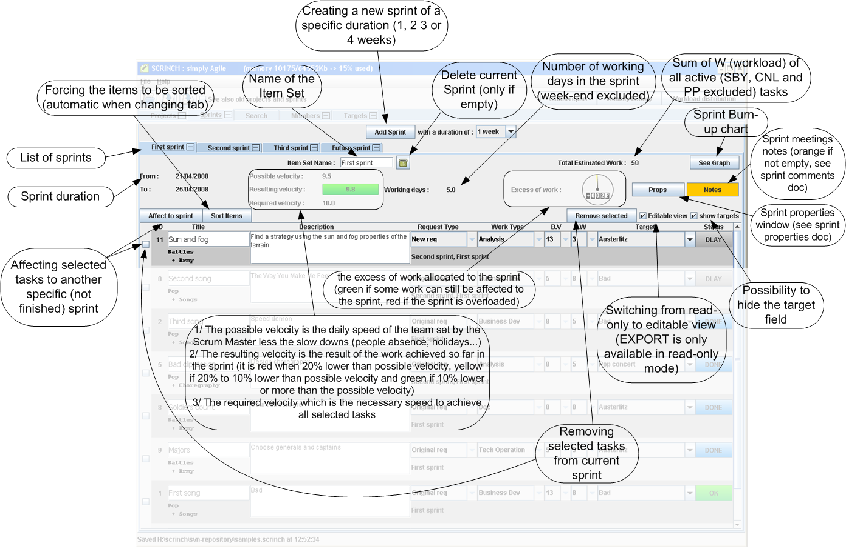

Sprint properties
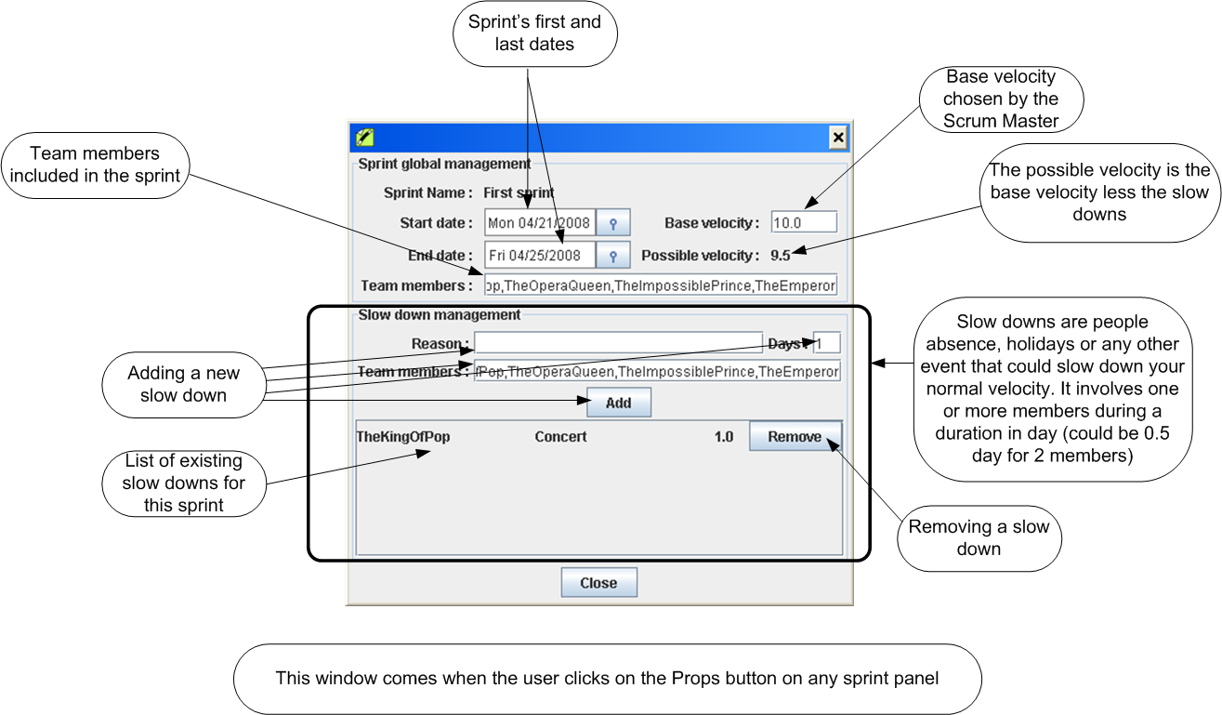

The sprint meetings notes
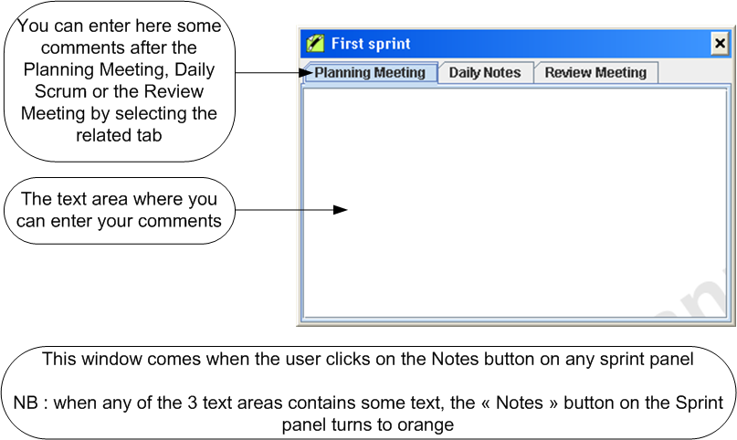

Exporting and printing
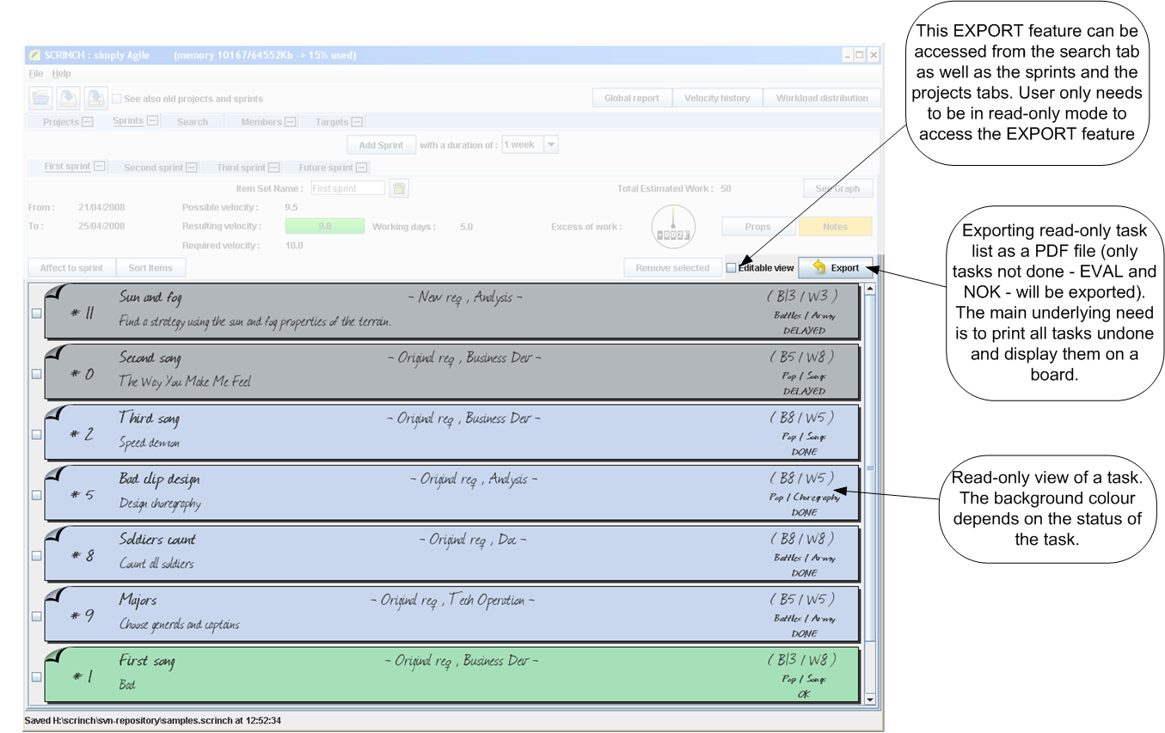

Searching items
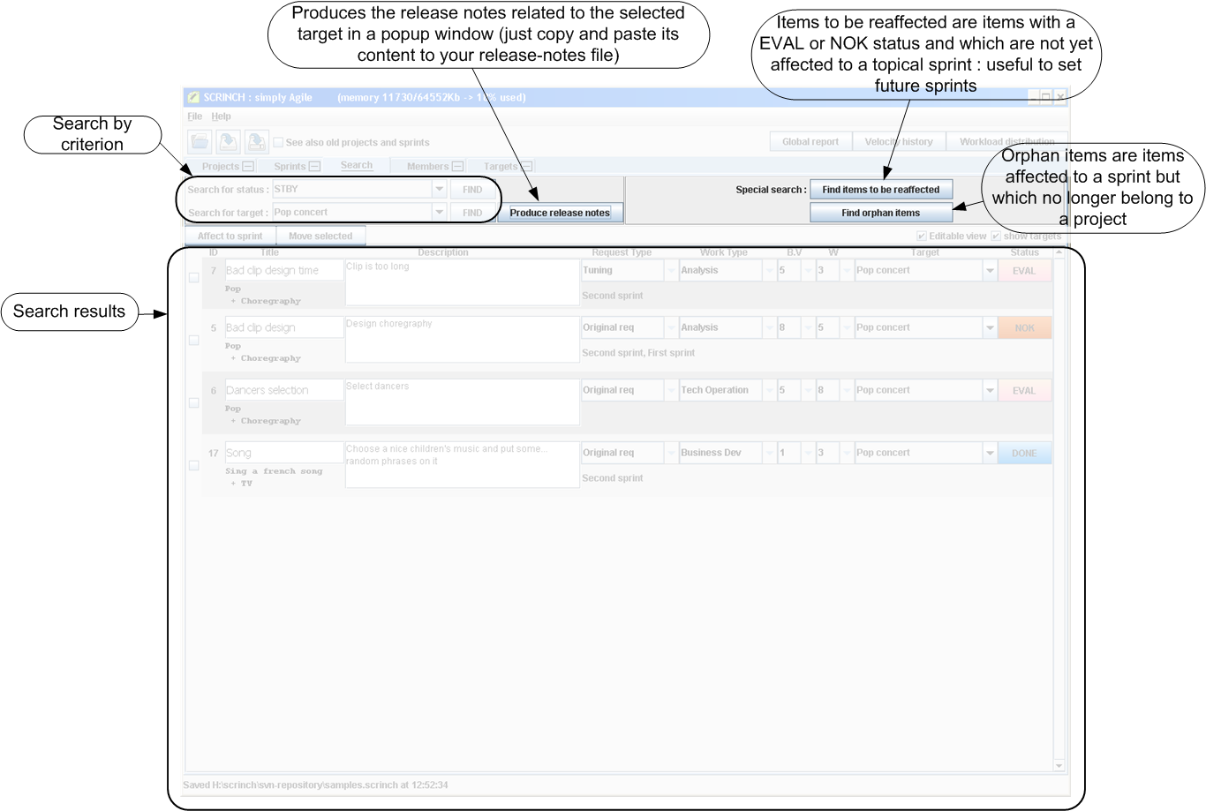

Members
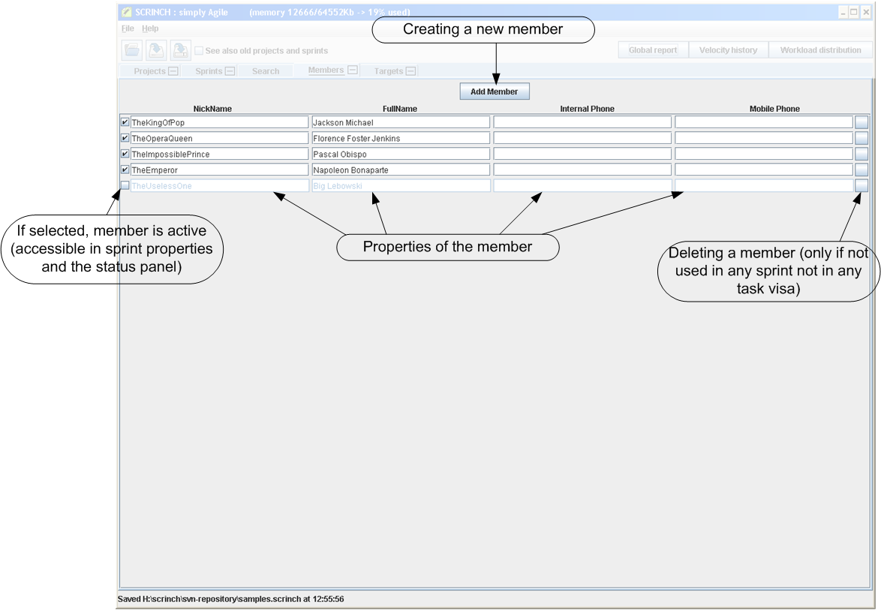

Targets
