**Lab Manual with Solutions**

1. ***Write a Java Applications to extract a portion of a character string and print the extracted string.***

**import** java.util.Scanner;

**/\***

**@Purpose : Find the substring of a string given the start and end index numbers.**

**\*/**

**public** **class** ExtractString {

**public** **static** **void** main(String args[]) {

String string, subString;

**int** firstIndex, secondIndex;

Scanner in = **new** Scanner(System.*in*);

System.*out*.println("Enter the String : ");

string = in.next();

System.*out*.println("Enter the index 1 : ");

firstIndex = in.nextInt();

System.*out*.println("Enter the index 2 : ");

secondIndex = in.nextInt();

subString = string.substring(firstIndex, secondIndex);

System.*out*.println("The Substring is : " + subString);

}

}

**OUTPUT :**

Enter the String :

BeautifulDay

Enter the index 1 :

9

Enter the index 2 :

12

The Substring is : Day

1. ***Write a Java Program to implement the concept of multiple inheritance using Interfaces***

**/\***

**@Purpose : Implement multiple interface using Interfaces.**

**\*/**

**class** Student {

**int** rollNo;

String name = "Smith Jones";

**void** setRollNumber(**int** rollNumber) {

rollNo = rollNumber;

}

**void** printStudentDetails() {

System.*out*.println("RollNo : " + rollNo);

System.*out*.println("Name : " + name);

}

}

**class** StudentTest **extends** Student {

**int** mark1, mark2;

**void** setMarks(**int** firstMark, **int** secondMark) {

mark1 = firstMark;

mark2 = secondMark;

}

**public** **void** printMarks() {

System.*out*.println("Mark1 : " + mark1);

System.*out*.println("Mark2 : " + mark2);

}

}

**interface** Sports {

**int** *sportsMark* = 75;

**void** printSportsMark();

}

**class** Result **extends** StudentTest **implements** Sports {

**int** totalMarks;

**public** **void** printSportsMark() {

System.*out*.println("SportMark=" + *sportsMark*);

}

**void** displayTotalMarks() {

totalMarks = mark1 + mark2 + *sportsMark*;

System.*out*.println("\tSCORE CARD");

printStudentDetails();

printMarks();

System.*out*.println("\n\nSports Marks :" + *sportsMark*);

System.*out*.println("Total Marks :" + totalMarks);

}

}

**class** ExampleMultipleInheritance {

**public** **static** **void** main(String args[]) {

Result studentObject = **new** Result();

studentObject.setRollNumber(1000);

studentObject.setMarks(75, 100);

studentObject.displayTotalMarks();

}

}

**OUTPUT :**

SCORE CARD

RollNo : 1000

Name : Smith Jones

Mark1 : 75

Mark2 : 100

Sports Marks :75

Total Marks :250

1. ***Write a Java Program to create an Exception called payout-of-bounds and throw the exception.***

**import** java.io.DataInputStream;

**import** java.io.IOException;

**/\***

**@Purpose : This program throws an exception when the payout is out of bounds.**

**\*/**

**public** **class** ExceptionCheck {

**public** **static** **void** main(String args[]) **throws** IOException {

**int** payAmount;

DataInputStream inputAmount = **new** DataInputStream(System.*in*);

System.*out*.println("\n\nCHECK PAY MODULE");

System.*out*.println("* * *");

System.*out*.println("\n Enter a Basic Pay Amount : ");

payAmount = Integer.*parseInt*(inputAmount.readLine()); **// This denotes the deprecated function**

**// DataInputStream Class.**

**/* A piece of code enclosed within a try - catch block will be handled by the**

**Exception Handler */**

**try** {

**if** (payAmount > 1000)

**throw** **new** PayoutOfBoundException("Basic Pay is Out of Bound");

**else**

System.*out*.println("\n Given Basic Pay is:" + payAmount);

} **catch** (Exception exception) {

System.*out*.println("Caught:" + exception);

}

}

}

**class** PayoutOfBoundException **extends** IOException {

**private** **static** **final** **long** *serialVersionUID* = 1L;

PayoutOfBoundException(String message) {

System.*out*.println("\nOOPS!!!! ----- "+message);

}

}

**OUTPUT :**

CHECK PAY MODULE

* * *

Enter a Basic Pay Amount :

1200

OOPS!!!! ----- Basic Pay is Out of Bound

Caught:PayoutOfBoundException

1. ***Write a Java Program to implement the concept of multithreading with the use of any three multiplication tables and assign three different priorities to them.***

**import** java.lang.Thread;

**/\***

**@Purpose : The purpose of this program is to implement multithreading using 3 threads**

**\*/**

**class** FirstThread **extends** Thread {

**public** **void** run() {

**int** firstNumber = 0, secondNumber = 2, result;

**for** (firstNumber = 1; firstNumber <= 4; firstNumber++) {

result = firstNumber * secondNumber;

System.*out*.println("From thread FirstThread:"+firstNumber+"*"+secondNumber+"="+result);

}

System.*out*.println("====== \n Exit from FirstThread \n====== \n ");

}

}

**class** SecondThread **extends** Thread {

**public** **void** run() {

**int** firstNumber, secondNumber = 3, result;

**for** (firstNumber = 1; firstNumber <= 4; firstNumber++) {

result = firstNumber * secondNumber;

System.*out*.println("From thread SecondThread:"+firstNumber+"*"+secondNumber+"="+result);

}

System.*out*.println("====== \n Exit from SecondThread \n====== \n ");

}

}

**class** ThirdThread **extends** Thread {

**public** **void** run() {

**int** firstNumber, secondNumber = 5, result;

**for** (firstNumber = 1; firstNumber <= 4; firstNumber++) {

result = firstNumber * secondNumber;

System.*out*.println("From ThirdThread:"+firstNumber+"*"+firstNumber+"="+result);

}

System.*out*.println("====== \n Exit from ThirdThread \n====== \n ");

}

}

**class** ExampleMultiThreading {

**public** **static** **void** main(String args[]) {

**int** tempPriority = 0;

FirstThread firstThreadObj = **new** FirstThread();

SecondThread secondThreadObj = **new** SecondThread();

ThirdThread thirdThreadObj = **new** ThirdThread();

firstThreadObj.setPriority(Thread.*MAX_PRIORITY*);

secondThreadObj.setPriority(firstThreadObj.getPriority() + tempPriority);

thirdThreadObj.setPriority(Thread.*MIN_PRIORITY*);

secondThreadObj.setPriority(firstThreadObj.getPriority() + tempPriority);

thirdThreadObj.setPriority(Thread.*MIN_PRIORITY*);

System.*out*.println("----\nStart thread FirstThread\n----");

firstThreadObj.start();

System.*out*.println("----\nStart thread SecondThread\n----");

secondThreadObj.start();

System.*out*.println("----\nStart thread ThirdThread\n----");

thirdThreadObj.start();

}

}

**OUTPUT :**

----

Start thread FirstThread

----

----

Start thread SecondThread

----

----

Start thread ThirdThread

----

From thread FirstThread:1*2=2

From thread FirstThread:2*2=4

From thread FirstThread:3*2=6

From thread SecondThread: 1*3=3

From thread FirstThread:4*2=8

From thread SecondThread: 2*3=6

======

Exit from FirstThread

======

From thread SecondThread: 3*3=9

From thread SecondThread: 4*3=12

======

Exit from SecondThread

======

From ThirdThread :1*1=5

From ThirdThread :2*2=10

From ThirdThread :3*3=15

From ThirdThread :4*4=20

======

Exit from ThirdThread

======

1. ***Write a Java Program to draw several shapes in the created windows.***

**import** java.awt.*;

**import** java.applet.*;

**/\***

**@Purpose : This applet draws several shapes in the window created.**

**\*/**

**public** **class** Shapes **extends** Applet {

**private** **static** **final** **long** *serialVersionUID* = 1L;

**int** xPoint[] = { 60, 240, 440, 40 };

**int** yPoint[] = { 60, 240, 40, 40 };

**int** nPoints = 4;

**public** **void** paint(Graphics g) {

g.drawPolygon(xPoint, yPoint, nPoints);

g.drawLine(20, 20, 160, 280);

g.drawRect(300, 200, 160, 280);

g.fillRect(200, 200, 80, 40);

g.fillRoundRect(40, 320, 20, 60, 10, 10);

g.drawRoundRect(20, 300, 160, 100, 20, 20);

g.drawOval(550, 400, 100, 40);

}

}

**/\***

**\* <html> <head> <applet code="shapes",height=400 width=400> </applet> </head>**

**\* </html>**

**\*/**

**OUTPUT:**

[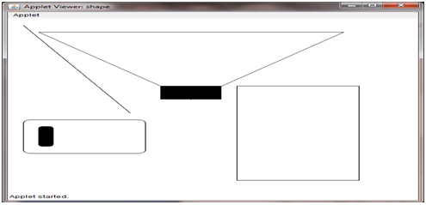](https://github.com/kgashok/orientations/blob/master/img/ex5.png)

1. ***Write a Java Program to create a frame with four text fields name, street, city and pin code with suitable tables. Also add a button called "my details". When the button is clicked its corresponding values are to be appeared in the text fields***

**import** java.awt.*;

**import** java.awt.event.*;

**/\***

**@Purpose : This Java Program creates a frame with four text fields name, street, city and pin code with suitable tables. Also add a button called "my details"**

**When the button is clicked its corresponding values are to be appeared in the text fields**

**\*/**

**public** **class** ButtonClick **extends** Frame **implements** ActionListener {

**private** **static** **final** **long** *serialVersionUID* = 1L;

TextField nameTextField, streetTextField, cityTextField, placeTextField;

Label nameLabel, streetLabel, cityLabel, placeLabel;

Button button1;

ButtonClick() {

setLayout(**new** GridLayout(4, 2));

nameTextField = **new** TextField(30);

streetTextField = **new** TextField(30);

cityTextField = **new** TextField(30);

placeTextField = **new** TextField(30);

nameLabel = **new** Label("name:", Label.*LEFT*);

streetLabel = **new** Label("street:", Label.*LEFT*);

cityLabel = **new** Label("city:", Label.*LEFT*);

placeLabel = **new** Label("place:", Label.*LEFT*);

button1 = **new** Button("my details");

add(nameLabel);

add(nameTextField);

add(streetLabel);

add(streetTextField);

add(cityLabel);

add(cityTextField);

add(placeLabel);

add(placeTextField);

setLayout(**new** FlowLayout(FlowLayout.*CENTER*));

button1.addActionListener(**this**);

add(button1);

}

**public** **void** actionPerformed(ActionEvent actionEventObj) {

**if** (actionEventObj.getSource() == button1) {

nameTextField.setText("Vivek Sabu");

streetTextField.setText("Nehru Nagar");

cityTextField.setText("Texas City");

placeTextField.setText("20");

}

}

**public** **static** **void** main(String arg[]) {

ButtonClick buttonObj = **new** ButtonClick();

buttonObj.setSize(600, 300);

buttonObj.addWindowListener(**new** WindowAdapter() {

**public** **void** windowClosing(WindowEvent e) {

System.*exit*(0);

}

});

buttonObj.show();

}

}

**OUTPUT:**

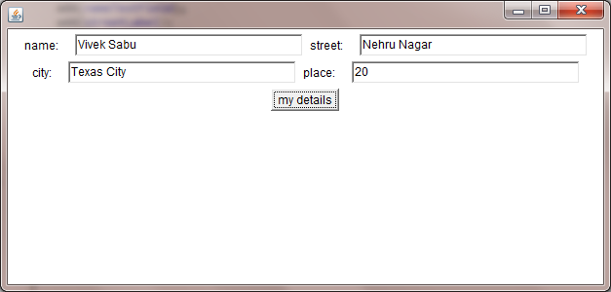

1. ***Write a Java Program to demonstrate the Multiple Selection List-box.***

**import** java.applet.Applet;

**import** java.awt.*;

**import** java.awt.event.*;

**/\***

**@Purpose : This Java applet creates multiple selection list box.**

**\*/**

**public** **class** MultipleSelectionList **extends** Applet **implements** ActionListener {

**private** **static** **final** **long** *serialVersionUID* = 1L;

List osList;

TextField osListTextField;

Button showButton;

String Selections[];

**public** **void** init() {

osListTextField = **new** TextField(40);

add(osListTextField);

osList = **new** List(3, **true**);

osList.add("Windows NT");

osList.add("Windows Vista");

osList.add("Windows XP");

osList.add("LINUX");

osList.add("UNIX");

osList.add("Xenix");

add(osList);

showButton = **new** Button("Show Selection");

showButton.addActionListener(**this**);

add(showButton);

}

**public** **void** actionPerformed(ActionEvent e) {

String outString = **new** String("YOU SELECTED : ");

**if** (e.getSource() == showButton) {

osListTextField.setText("");

Selections = osList.getSelectedItems();

**for** (**int** loopIndex=0;loopIndex<Selections.length;loopIndex++) {

outString += " " + Selections[loopIndex];

}

osListTextField.setText(outString);

}

}

}

**/\***

**\* <html> <applet code = MultipleSelectionList.class width=400 height=400>**

**\* </applet> </html>**

**\*/**

**OUTPUT:**

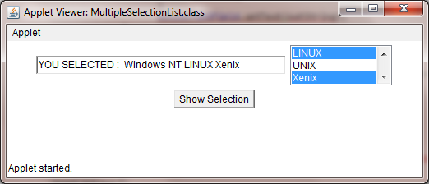

1. ***Write a Java Program to create a frame with three text fields for name, age and qualification and a text field for multiple line for address***

**import** java.awt.*;

**import** java.awt.event.*;

**/\***

**@Purpose : This Program creates a frame with three text fields for name, age, qualification and a text field for multiple line for address**

**\*/**

**public** **class** PersonalDetails **extends** Frame {

**private** **static** **final** **long** *serialVersionUID* = 1L;

TextField nameText, ageText, qualificationText, addressText;

Label nameLabel, ageLabel, qualificationLabel, addressLabel;

TextArea textArea;

PersonalDetails() {

setLayout(**new** GridLayout(4, 2));

nameText = **new** TextField(30);

ageText = **new** TextField(30);

qualificationText = **new** TextField(30);

addressText = **new** TextField(40);

textArea = **new** TextArea(" ", 2, 5);

nameLabel = **new** Label("Name", Label.*LEFT*);

ageLabel = **new** Label("Age", Label.*LEFT*);

qualificationLabel = **new** Label("Qualification", Label.*LEFT*);

addressLabel = **new** Label("Address", Label.*LEFT*);

add(nameLabel);

add(nameText);

add(ageLabel);

add(ageText);

add(qualificationLabel);

add(qualificationText);

add(addressLabel);

add(addressText);

}

**public** **static** **void** main(String[] args) {

PersonalDetails personalDetails = **new** PersonalDetails();

personalDetails.setSize(300, 250);

personalDetails.addWindowListener(**new** WindowAdapter() {

**public** **void** windowClosing(WindowEvent e) {

System.*exit*(0);

}

});

personalDetails.show();

}

}

**OUTPUT:**

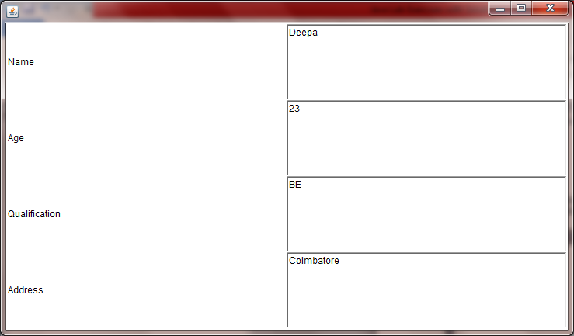

1. ***Write a Java Program to create Menu Bars and pull down menus***

**import** java.awt.*;

**import** java.applet.*;

**/\***

**@Purpose : This Applet creates a menu bar and sets menu items on the menu bar.**

**\*/**

**public** **class** MenuBarApplication **extends** Applet {

**private** **static** **final** **long** *serialVersionUID* = 1L;

**public** **void** init() {

**/* method initializationOfMenuBar is described. */**

**int** width = Integer.*parseInt*(getParameter("width"));

**int** height = Integer.*parseInt*(getParameter("height"));

Frame frame = **new** Frame("First Frame");

**/* Frame constructor with String Parameter */**

frame.resize(width, height);

MenuBar menuBar = **new** MenuBar();

frame.setMenuBar(menuBar);

Menu menuFile = **new** Menu("File");/* Menu constructor with String Parameter */

menuFile.add(**new** MenuItem("New"));

menuFile.add(**new** MenuItem("Open"));

menuFile.add(**new** MenuItem("Close")); /* File operation on Menu */

menuFile.add(**new** MenuItem("-"));

menuFile.add(**new** MenuItem("new"));

menuBar.add(menuFile);

Menu menuEdit = **new** Menu("Edit");/* Menu constructor with String Parameter */

menuEdit.add(**new** MenuItem("Cut"));

menuEdit.add(**new** MenuItem("Copy")); /* Menu Items to edit */

menuEdit.add(**new** MenuItem("paste"));

menuEdit.add(**new** MenuItem("-"));

Menu menu = **new** Menu("Special");/* Menu constructor with String Parameter */

menu.add(**new** MenuItem("First"));

menu.add(**new** MenuItem("Second")); /* Add Menu Items */

menu.add(**new** MenuItem("Third"));

menuEdit.add(menu);

menuEdit.add(**new** CheckboxMenuItem("Debug"));

menuEdit.add(**new** CheckboxMenuItem("Testing"));

menuBar.add(menuEdit);

frame.show();

}

}

**/\***

**\* TO RUN THE APPLET <html> <head> <applet code="Menudemo.class" width=400**

**\* height=400> </applet> </head> </html>**

**\*/**

**OUTPUT:**

[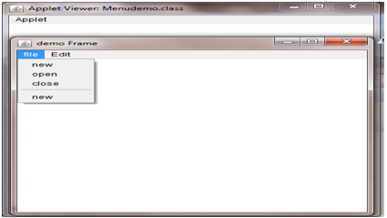](https://github.com/kgashok/orientations/blob/master/img/ex9.png)

1. ***Write a Java Program to create frames which respond to the mouse clicks. For each events with mouse such as mouse up, mouse down, etc., the corresponding message to be displayed.***

**import** java.applet.*;

**import** java.awt.*;

**import** java.awt.event.*;

**/\***

**@Purpose : This Java Applet tracks the Mouse Events and displays appropriate messages.**

**\*/**

**public** **class** MouseEventTracking **extends** Applet **implements** MouseListener, MouseMotionListener {

**private** **static** **final** **long** *serialVersionUID* = 1L;

String msg = " ";

**int** msgheight, msgwidth, mousex = 0, mousey = 0;

**public** **void** init() {

addMouseListener(**this**);

addMouseMotionListener(**this**);

}

**public** **void** mousePressed(MouseEvent me) {

msgheight = 50;

msgwidth = 100;

msg = "Mouse Pressed";

repaint();

}

**public** **void** mouseClicked(MouseEvent me) {

msgheight = 50;

msgwidth = 100;

msg = "You CLICKED your Mouse";

repaint();

}

**public** **void** mouseExited(MouseEvent me) {

msgheight = 50;

msgwidth = 100;

msg = "Oops! You have EXITED";

repaint();

}

**public** **void** mouseReleased(MouseEvent me) {

msgheight = 50;

msgwidth = 100;

msg = "Mouse is RELEASED :)";

repaint();

}

**public** **void** mouseEntered(MouseEvent me) {

msgheight = 50;

msgwidth = 100;

msg = "Mouse ENTERING the frame!!!";

repaint();

}

**public** **void** mouseDragged(MouseEvent me) {

msg = "";

showStatus("DRAGGING at" + me.getX() + "," + me.getY());

repaint();

}

**public** **void** mouseMoved(MouseEvent me) {

showStatus("MOVED at" + me.getX() + "," + me.getY());

repaint();

}

**public** **void** paint(Graphics g) {

g.drawString(msg, msgheight, msgwidth);

}

}

**/\***

**\* TO RUN THE APPLET**

**\* <html> <head> <applet code="MouseEvents", width=400**

**\* height=400> </applet> </head> </html>**

**\*/**

**OUTPUT:**

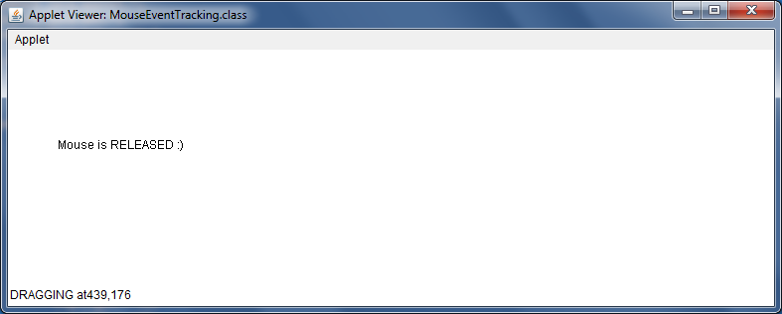

1. ***Write a Java Program to draw circle, square, ellipse and rectangle at the mouse click positions.***

**import** java.applet.*;

**import** java.awt.*;

**import** java.awt.event.*;

**/\***

**@Purpose : This Applet draws a shape on the screen.**

**\*/**

**public** **class** MouseClick **extends** Applet {

**private** **static** **final** **long** *serialVersionUID* = 1L;

**int** length = 0, width = 0, count = 0;

**public** **void** init() {

addMouseListener(**new** MouseAdapter() {

**public** **void** mousePressed(MouseEvent event) {

count++;

length = event.getX();

width = event.getY();

repaint();

}

});

}

**public** **void** Paint(Graphics g) {

**if** (count % 4 == 1)

g.drawOval(length, width, 150, 150);

**else** **if** (count % 4 == 2)

g.drawRect(length, width, 150, 150);

**else** **if** (count % 4 == 3)

g.drawOval(length, width, 100, 150);

**else** **if** (count % 4 == 0)

g.drawRect(length, width, 100, 150);

}

}

**/\***

**\* <html> <head> <title>Mouse click</title></head> <body> <applet code =**

**\* Mouseclick.class width=400 height=400> </applet> </body> </html>**

**\*/**

**OUTPUT:**

[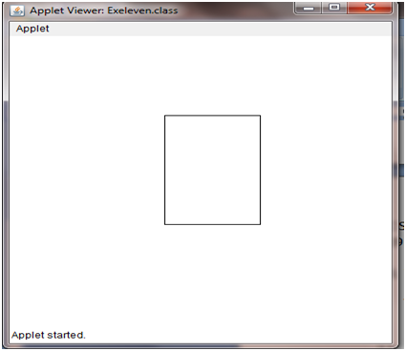](https://github.com/kgashok/orientations/blob/master/img/ex11.png)

1. ***Write a Java Program which open an existing file and append text to that file.***

**import** java.io.*;

**/\***

**@Purpose : This Program opens an existing file and appends text(CHENNAI) to that file.**

**\*/**

**public** **class** RandomAccessFileTryOut {

**public** **static** **void** main(String args[]) {

RandomAccessFile randomFile;

**try** {

randomFile = **new** RandomAccessFile("city.txt", "rw");

randomFile.seek(randomFile.length());

randomFile.writeBytes("\nCHENNAI");

randomFile.close();

} **catch** (IOException ioe) {

System.*out*.println(ioe);

}

}

}

**OUTPUT:**

CHENNAI