**Name :** Makhate Makhate

**Student Number:** 224073404

**Course:** STAT602 - Time Series and Forecasting Econometrics

**Class Activity:** Box-Jenkins methodology: Model Identification, Parameter Estimation, Diagnostic Checking & Forecasting.

Disclaimer: all text that appears like this is R code to show how the output was achieved

**Question 1**

myData = Viscosity$Yt

ts.plot(myData)

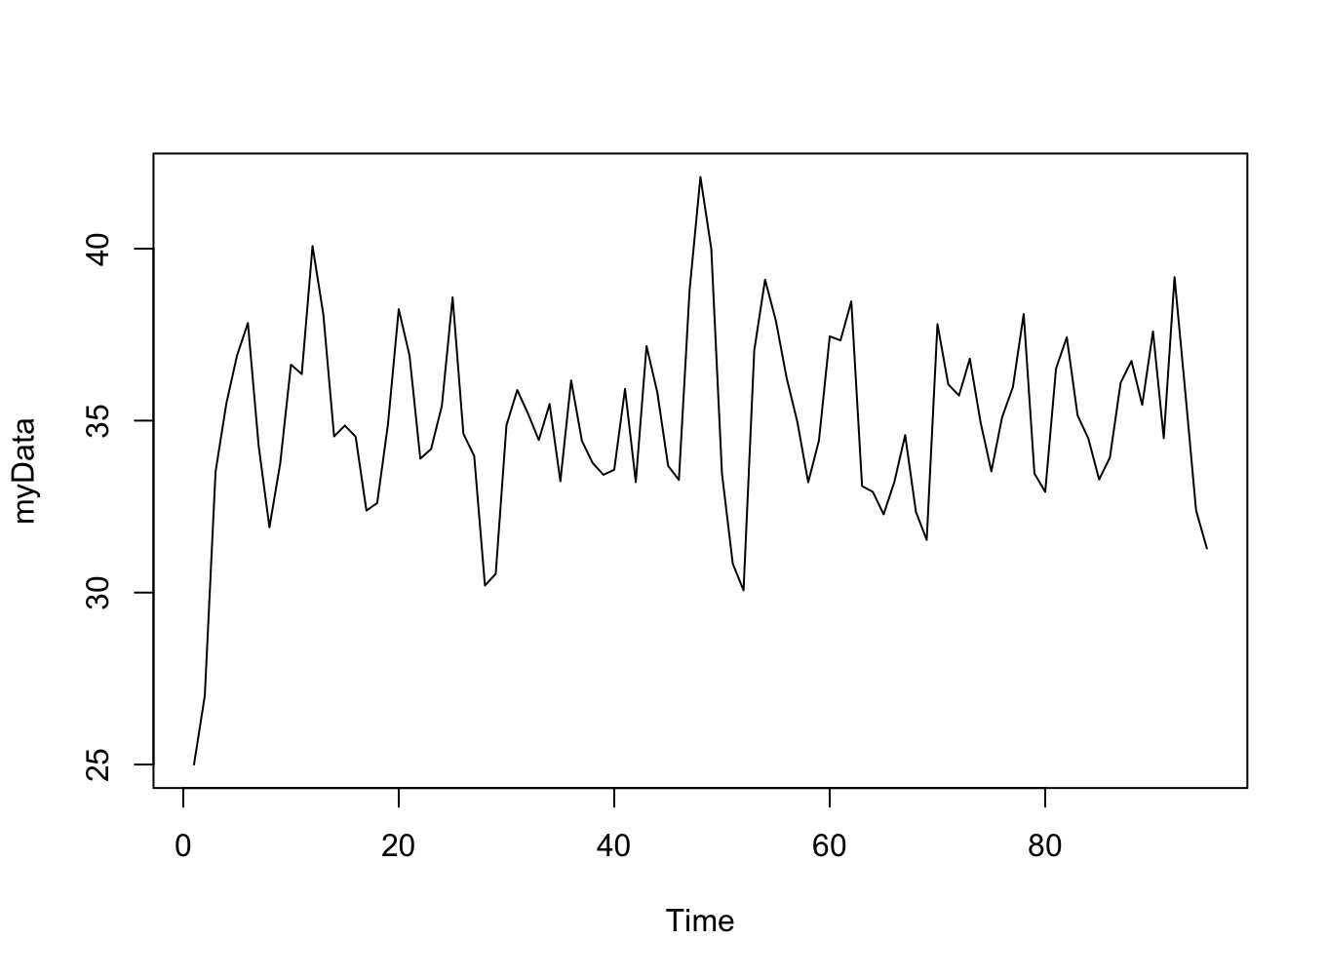

When ignoring a few outliers from this plot, the graph shows that data is stationary: there’s little variability.

adf.test(myData)

Augmented Dickey-Fuller Test

Dickey-Fuller = -5.1949,

Lag order = 4,

p-value = 0.01

The p-value from the test is significantly less than 0.05 and hence we reject null hypothesis in favor of the alternative and conclude that the data is stationary

|  |
| --- |
| adf.test(myData)  acfPlot(myData)  **ACF Plot** |
|  |

The ACF plot decays exponentially.

|  |
| --- |
| **PACF Plot** |
|  |

The PACF plot cuts off at lag 2. This suggest a AR(2) model



myData_arma2 = arma(myData, order = c(2,0))

summary(myData_arma2)

|  |  |  |  |  |
| --- | --- | --- | --- | --- |
|  | **Estimate** | **Std. Error** | **t-value** | **p-value** |
| **Φ2** | 0.56712 | 0.09317 | 6.087 | 1.15 x 10-9 |
| **Φ1** | -0.36479 | 0.08615 | -4.234 | 2.29 x 10-5 |
| **Φ0** | 27.99610 | 3.24294 | 8.633 | < 2 x 10-16 |

Thus, the model is:

|  |
| --- |
| $$Xt = 27.99610+ 0.56712X_{t-1} – 0.364792X_{t-2} + a_{t}$$ |

The associated p-values are significantly less than 0.05, hence the estimates are significant.

The absolute values of the t-values |*t*| are also significantly larger than 2, further confirming that the estimates are significant.

myData_arima2 = Arima(myData,

order = c(2,0,0),

include.mean = TRUE)

forecast(myData_arima2,h=5)

plot(forecast(myData_arima2,h=5))

|  |  |
| --- | --- |
| **Point** | **Forecast** |
| 96 | 33.55752 |
| 97 | 35.58574 |
| 98 | 35.98431 |
| 99 | 35.37733 |
| 100 | 34.79061 |

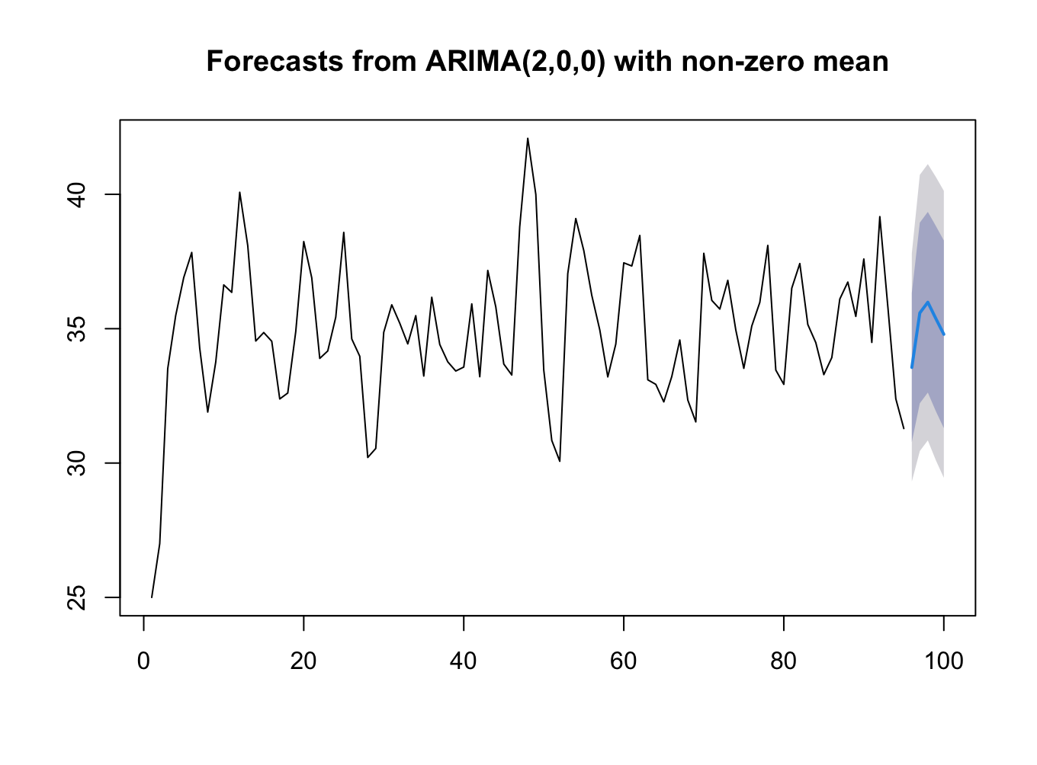

**Question 2**

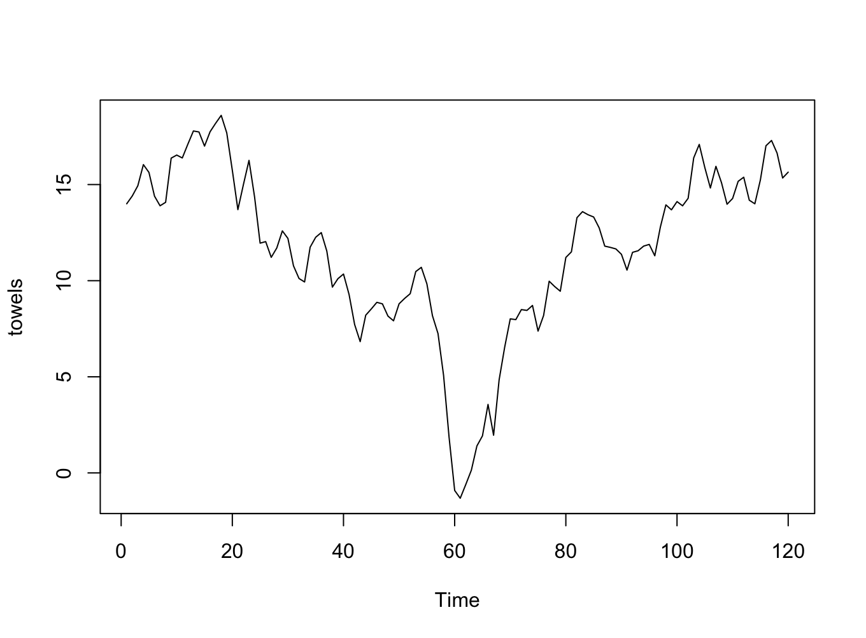

The data does not appear to be stationary, when looking at its mean, and covariance.

Augmented Dickey-Fuller Test

Dickey-Fuller = -1.776, Lag order = 4, **p-value = 0.6696**

The associated p-value is larger than 0.05 significantly. We fail to reject the null hypothesis. Hence, the data is non-stationary.

towels_diff = diff(towels)

ts.plot(towels_diff)

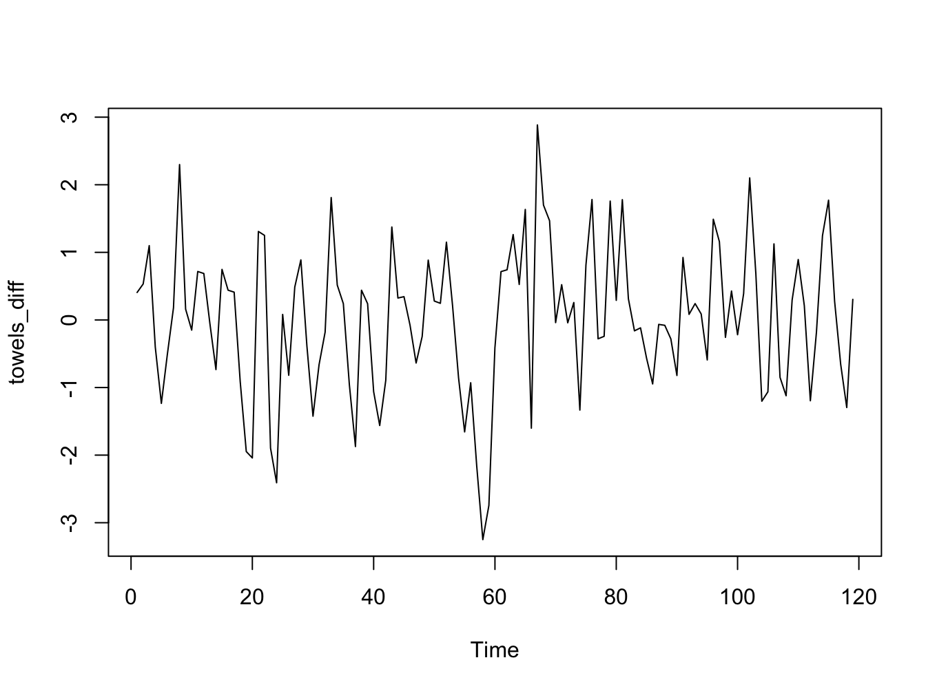

After differencing, the graph seems to be stationary

adf.test(towels_diff)

Augmented Dickey-Fuller Test

Dickey-Fuller = -4.2044, Lag order = 4, p-value = 0.01

The associated p-value from the differenced data is significantly less than 0.05, hence the data is now stationary.

acfPlot(towels_diff)

pacfPlot(towels_diff)

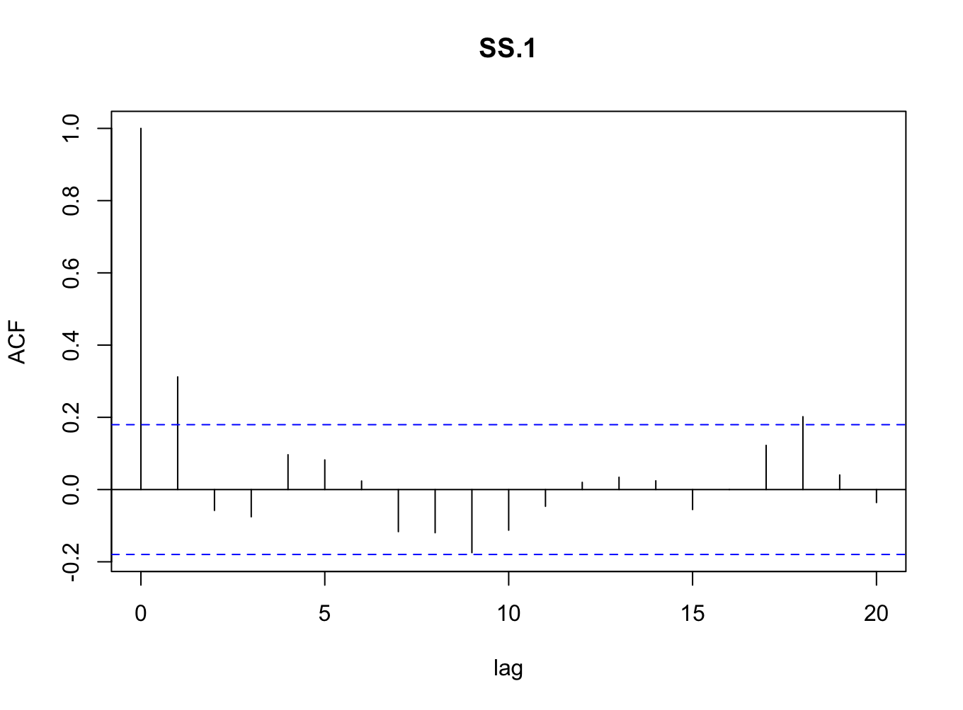

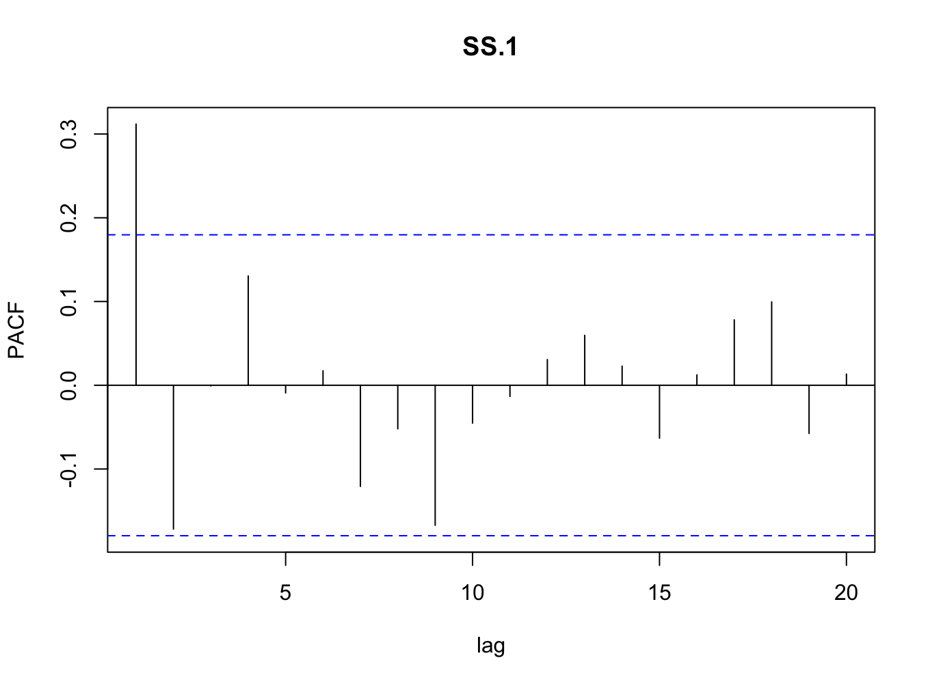

The ACF and PACF plots suggest a mixed model.

towels_ima1_1 = arma(towels_diff,order = c(0,1))

summary(towels_ima1_1)

|  |  |  |  |  |
| --- | --- | --- | --- | --- |
|  | **Estimates** | **Std. Error** | **t-value** | **p-value** |
| **Θ1** | 0.35541 | 0.07974 | 4.457 | 8.3 x 10-6 |
| **Θ0** | 0.01313 | 0.12841 | 0.102 | 0.919 |

AIC = 351.24

The intercept’s t-value, significantly less that 2 and the associated p-value is greater than 0.05, hence we fail to reject the null hypothesis for it. It will be omitted from the model.

Thus, the model is:

|  |
| --- |
| $$Xt = 0.355414X_{t-1}+ a_{t}$$ |

towels_ari1_1 = arma(towels_diff,order = c(1,0))

summary(towels_ima1_1)

|  |  |  |  |  |
| --- | --- | --- | --- | --- |
|  | **Estimates** | **Std. Error** | **t-value** | **p-value** |
| **Φ1** | 0.312094 | 0.087067 | 3.585 | 0.000338 |
| **Φ0** | 0.006983 | 0.096000 | 0.073 | 0.942011 |

AIC = 353.69

The intercept’s t-value, significantly less that 2 and the associated p-value is greater than 0.05, hence we fail to reject the null hypothesis for it. It will be omitted from the model.

Thus, the model is:

|  |
| --- |
| $$Xt = 0.312094X_{t-1}+ a_{t}$$ |

1. When the AIC statistic of the two models, it looks like the ARI(1,1) will perform better than IMA(1,1) because when using the AIC statistic, less is better.

towels_arima2 = Arima(towels,

order = c(1,1,0),

include.mean = TRUE)

forecast(towels_arima2,h=10)

|  |  |
| --- | --- |
| **Point** | **Forecast** |
| 121 | 15.73961 |
| 122 | 15.76884 |
| 123 | 15.77790 |
| 124 | 15.78070 |
| 125 | 15.78157 |
| 126 | 15.78184 |
| 127 | 15.78193 |
| 128 | 15.78195 |
| 129 | 15.78196 |
| 130 | 15.78196 |