Final Project

Background
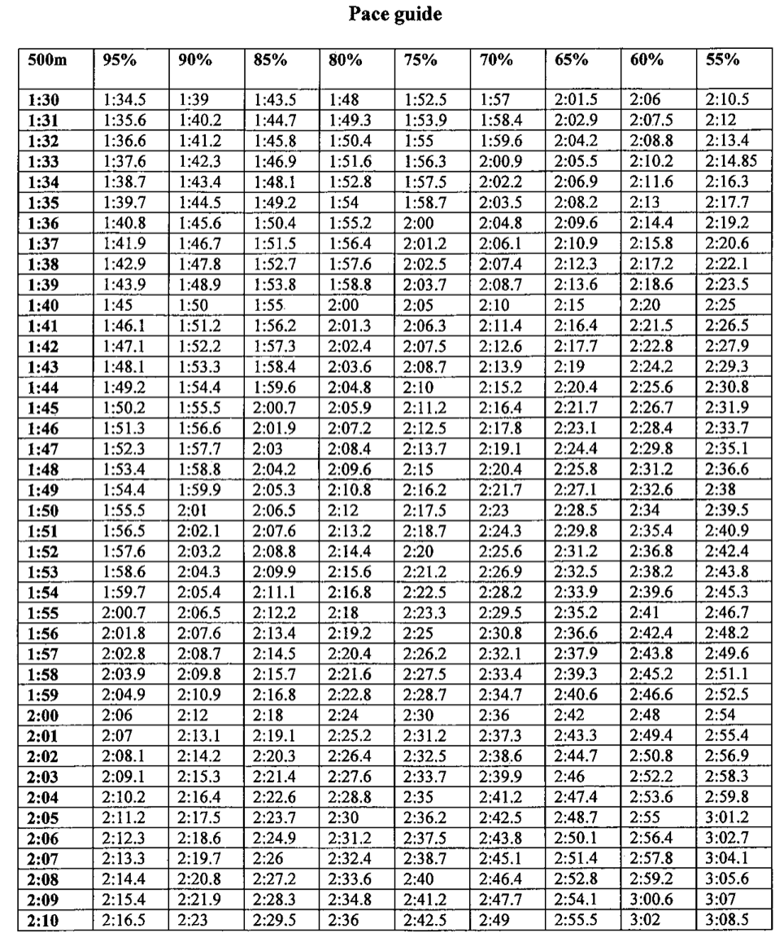
For workouts on the ergs, rowers have to pull, or generate, a given split, the amount of time it would take them to row 500 meters on ideal water conditions. Each rower's split is different, as it is a function of a) their fastest or most recent 500m erg test (you erg as fast and as hard as you can for 500m) time and b) the percentage of the piece, how much power application is expected for the workout.
Before beginning a workout, rowers identify the percentages for that piece and consult a pace guide to find their goal splits. The rows are a range of 500m erg test times, and the columns are percentages. For example, if my season best for a 500 is 1:47 and the workout calls for 60%-70% pressure, my goal is to maintain consistent splits between 2:29.8 and 2:19.1.

Concept
I want to write an app to provide a more convenient, less cluttered alternative to the pace guide. Often, rowers will not have their own copy of the pace guide during workouts on their own, and on occasions where coaches and coxswains need to reference the pace guide quickly during a workout, it will be simpler to reference an app rather than a large chart. The app would also store rowers' most recent 500 times.
The user would select a rower, input the percentage(s) for the piece, and see the goal splits.

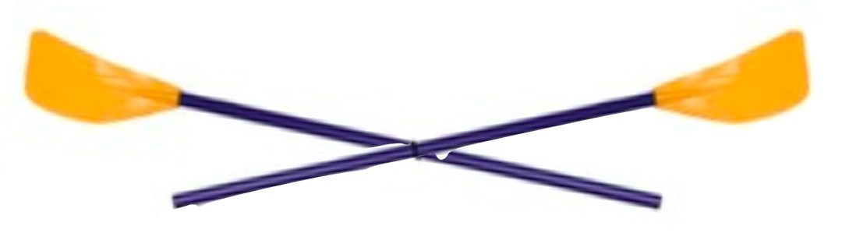
View
Pace guide
Goal Splits
Rower:
Percentage: to
Karina B.
65

report by
5
2:25.8
65
Goal Splits
500m:
Percentage: to
1:47.9
65

report by
5
2:25.8
65
Pace guide
Rowers
Rower:
Karina B.
500m:
1:47.9
save
Name
500
Alexa F.
1:48.0
Clarice J.
2:09.1
Erin L.
1:45.2
Jess R.
1:52.8
Karina B.
1:48.5
1)
2)
3)

View, in text
Slightly more interactive view but without color
- Screen 1
  - Double-tap on “Pace guide” to switch to screen 3
  - Switch on Rower
    - Drop-down menu
    - Shows name but accesses stored 500 time
    - If no names stored, selecting this option redirects to Rower DB
  - Percentage
    - At least one input
    - If not multiple of 5, rounds to closest multiple
  - Report by checkbox
    - Option to display splits by 5s, 10s, or bounds
    - Drop-down menu
  - Goal splits list
    - Displays time and percentage
    - Ordered from lowest to highest percentage
    - Pace guide
      - Look-up splits in some data structure
      - Maybe dictionary of splits each with dictionary of values
- Screen 2
  - Switch on 500m
    - Number input
    - If time too slow, corrects to slowest time on chart
  - Everything else is the same
- Screen 3
  - Double-tap “Rowers” to return to calculation screen
  - Rower
    - Text input
    - If existing name is entered, overwrites
    - 500m is related input
  - List of existing names and times on bottom half
    - Dictionary
    - To remove entry, slide left
    - Scrolls up and down

