//YOUR TITLE

A Case Study Document to Present to the subjects of
Object-Oriented Programming
Database Management 1

In Partial Fulfilment of the Requirements for the course
of Bachelor of Science in Information Technology

Submitted to:
//Instructors

Submitted by:
//Leader:
//Members:

Date of Submission:
//Date
Table of Contents

1. Introduction
1.1 Background |  |  |  | .................................................................................................. |  |  |  |  |  |  | 1
1.2 Scope and Limitations |  |  |  |  |  |  | .................................................................................. |  |  |  | 2
1.3 Key Terms |  |  | ..................................................................................................... |  |  |  |  |  |  |  | 2
2. Design and Methodology
2.2. Database Design |  |  |  |  |  | .......................................................................................... |  |  |  |  | 4
2.2.1. ERD | ......................................................................................................... |  |  |  |  |  |  |  |  |  | 4
2.2.2. Data Dictionary per Table |  |  |  |  |  |  |  | .......................................................................... |  |  | 5
2.2.3. Story Board |  |  |  |  | ............................................................................................... |  |  |  |  |  | 12
3. Screenshot of SQL (SELECT, UPDATE, DELETE, JOIN AND ETC.) |  |  |  |  |  |  |  |  |  |  | 13
4. References |  |  |  |  |  |  |  |  |  |  | 13

1. Introduction
This part of the paper discusses the background of the problem that contains a short representation of the study, the statement of the problem together with the general and specific objectives, the purpose and description which states how the study can help the expected users, and lastly the scope and limitation of the study, which discusses the functionalities and limitations of the study.
  - Background of the Problem

The Student Enrollment System was developed to address administrative challenges in educational institutions, particularly the management of student records. With the increasing volume of student data, traditional manual processes have become time-consuming and error-prone. The goal of the team was to digitize the student enrollment process, making it more efficient, secure, and accessible, while reducing the potential for human error.
The idea for the system originated from observing the inefficiencies and challenges in traditional school record-keeping systems. These systems often relied heavily on manual data entry and paper-based processes, which led to various issues, including enrollment delays, lost records, and inconsistencies in student data. The team recognized the need for a more modern and efficient approach to managing student information, one that could eliminate the repetitive, error-prone tasks involved in enrollment and data entry.
By automating these processes, the team aimed to provide educational institutions with a system that would not only save time but also improve the accuracy and reliability of student records. With a centralized database and real-time access, the system would empower administrators, faculty, and students alike to quickly and easily manage course enrollments, track academic progress, and ensure that records are up-to-date. This system would also provide added security by reducing the risk of data loss or unauthorized access, something that was a constant concern in traditional, paper-based systems.
The system was developed using a combination of modern technologies and tools to ensure its efficiency, scalability, and maintainability. Microsoft Visual Studio was used as the primary integrated development environment (IDE) for both the front-end (design and layout) and back-end (coding components, form connections, and logic). The back-end integrates with MySQL, managed through phpMyAdmin, to handle student records, course enrollments, and other essential data. GitHub was employed as the version control system to store, track, and manage changes to the codebase, ensuring smooth collaboration among developers and maintaining a history of updates.
Through this system, the team aimed to modernize student data management, supporting educational institutions in handling the growing volume of student data and improving overall efficiency. The ultimate goal was to create a solution that was not only functional but also adaptable, capable of evolving with the needs of educational institutions in the digital age.
1.2. Scopes and Limitations
The system covers all offered courses and subjects for the entire academic year, from the first semester through the second semester. It manages student profiles, subject enrollment, and course offerings. Administrators have the ability to add, edit, and remove records, while user authentication ensures only authorized personnel can access and modify data.
The system does not include a grade generator feature, and the database is run on a single server locally, with no remote or distributed access. There is no integration with a payment API for the official process of payments. The system must be run locally on the machine using XAMPP, and it is not hosted online. Additionally, the system is not mobile-responsive, with the user interface optimized for desktop use. It is currently only accessible within the school's local network and does not have a mobile application. It does not provide a student self-service portal for enrollment or record management, and its functions are limited to administrative roles, with no features for students to manage their enrollment.
1.3 Key Terms
Administrator – a person who manages and oversees computer systems or networks, ensuring their proper operation and maintenance.
System – an organized set of components or procedures designed to function together to perform a specific task.
Student Enrollment System – a software platform designed to streamline and centralize the student enrollment process, automating functions like application processing and data analysis.
Database – a structured collection of data stored electronically, designed for rapid search and retrieval by a computer.
IDE (Integrated Development Environment) – A software suite that consolidates basic tools required for software development, including a code editor, compiler, and debugger.
MySQL – an open-source relational database management system (RDBMS) that uses Structured Query Language (SQL) for accessing and managing data.
phpMyAdmin – a free, web-based tool written in PHP intended to handle the administration of MySQL databases over the web.
Version Control – the practice of tracking and managing changes to software code, enabling multiple developers to collaborate efficiently.
Remote – refers to accessing a computer or network from a distant location, often over the internet, allowing users to control systems as if they were local.
XAMPP – a free and open-source cross-platform web server solution stack package developed by Apache Friends, consisting mainly of the Apache HTTP Server, MariaDB database, and interpreters for scripts written in PHP and Perl.
Portal – an online platform (such as a website) that provides access to services or information of a specific kind.
Server – a computer or system that provides data, services, or programs to other computers, known as clients, over a network.
effectively.
ERD (Entity Relationship Diagram) – a visual representation of entities within a system and their interrelationships, commonly used in database design.
SMS (Short Message Service) – a text messaging service component of most telephone, internet, and mobile device systems, allowing the exchange of short text messages.
API (Application Programming Interface) – a set of rules that allows software applications to communicate with each other, enabling the exchange of data and functionality between different systems.

2. Design and Methodology

2.1 Database Design
2.1.1 Entity Relationship Diagram
Database is an integral part of a system. With this, the researchers of the system Interactive LAN-based educational tool for Marilao SPED Center used an Entity Relationship Diagram, also known as ERD to graphically illustrate the entities present in the system and the relationship between those entities.
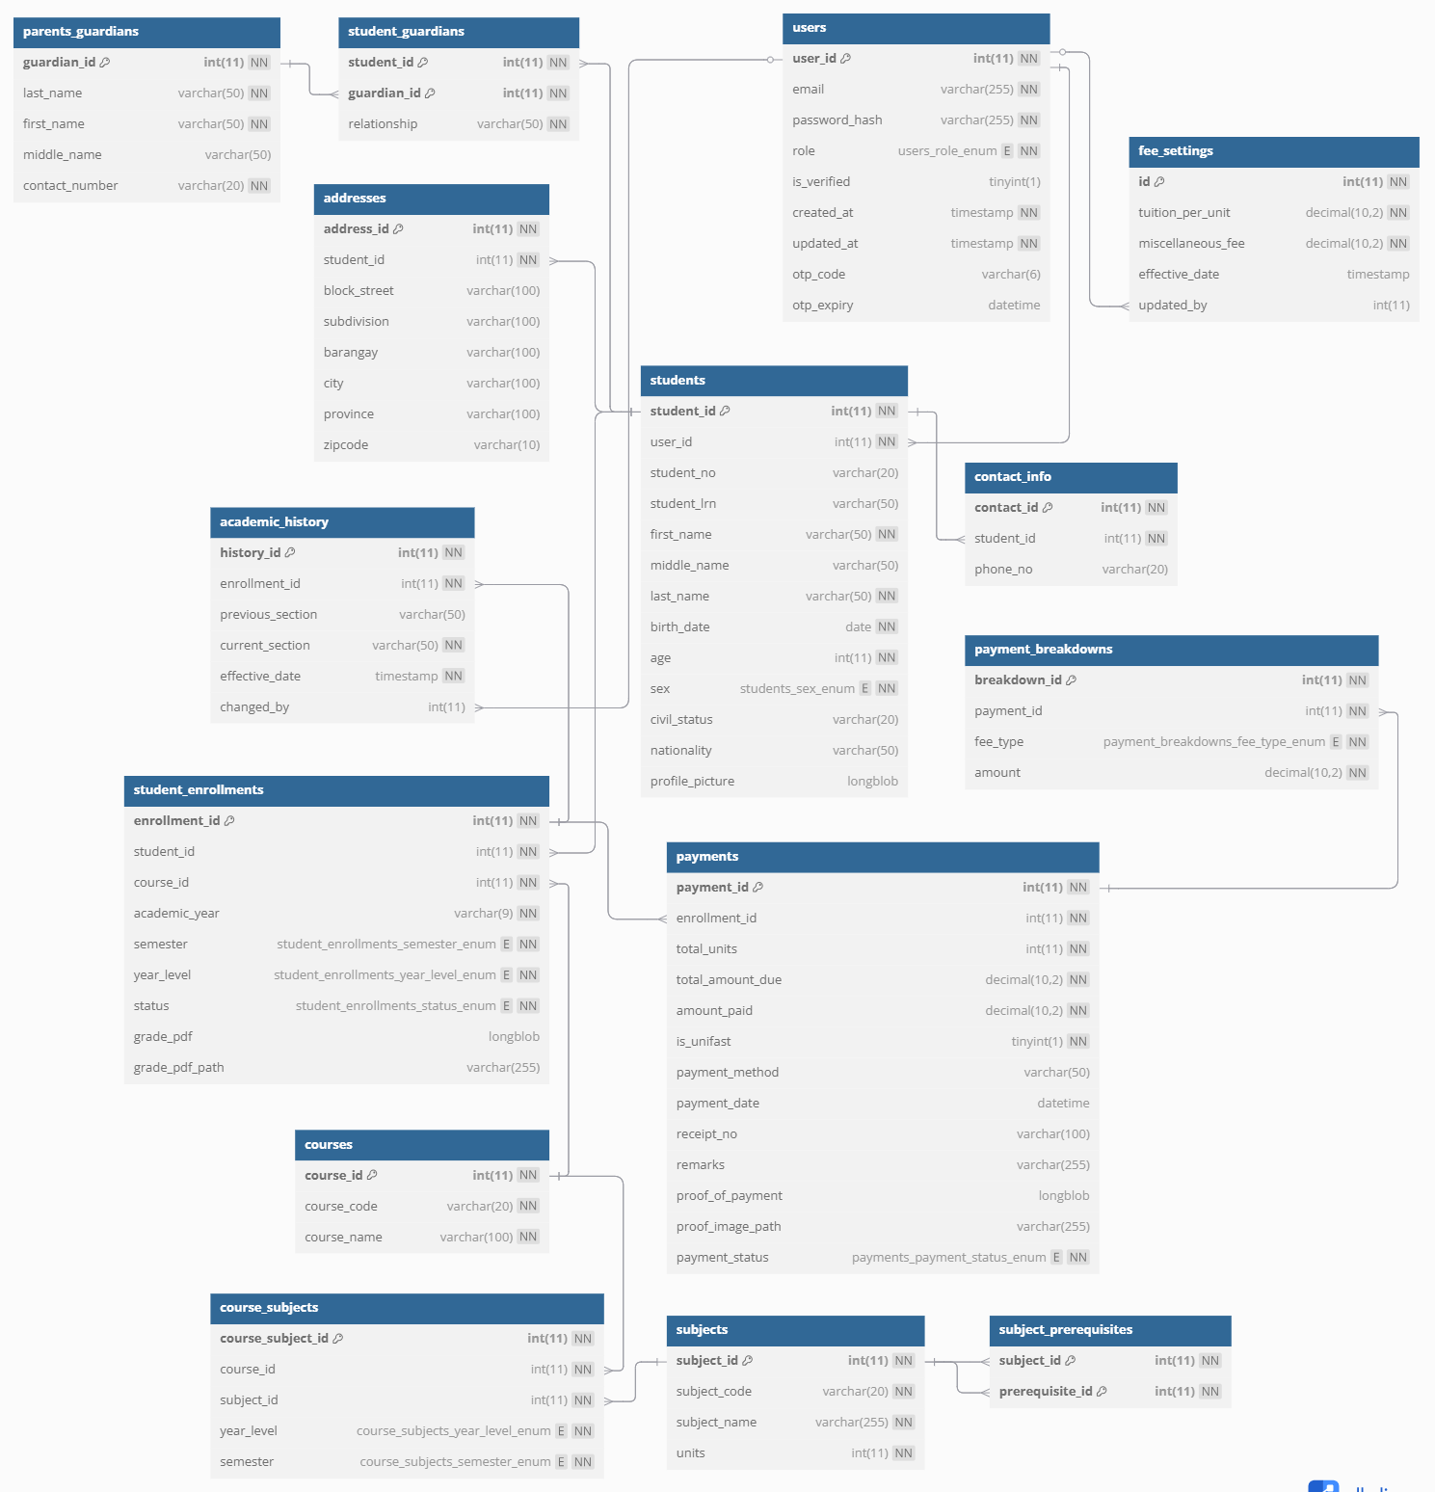
Figure 1: Entity Relationship Diagram
Figure 1 shows the relationship of entities of the database tiptopAdmin and it shows 11 tables and those are: User Account, Student Information, Archive Student Information, Teacher Information, Student Logs, Student Assessment, Student Progress, Question Per Day, Student Monitoring, Questions, and Student score in Subjects.

2.1.2 Data Dictionary per Table // All tables of your project
Data Dictionary shows all the fields that are included into a particular table. It also shows what are the different tables included in the database.

Table 1. ACADEMIC_HISTORY

Field | Data Type | Key | Description
history_id | int(11) | Primary key | Unique identifier for each academic history.
student_id | int(11) | Foreign key | References the student this record belongs to.
previous_school | varchar(255) | - | Name of the previous school attended.
school_address | varchar(255) | - | Address of the previous school.
awards | varchar(255) | - | Awards or honors received.
date_created | timestamp | - | When the record was created.
changed_by | int(11) | Foreign key | User ID of the person who last modified it.

2.2.3 Story Board //SS of your project

Figure 2: Login
It appears and system's entry point. The login screen where administrators input their email and password credentials to access the system. Only verified users can proceed to the homepage.


Figure 3: Register
The registration screen for creating new admin accounts. It collects necessary information such as name, email, and password. During registration, an OTP (One-Time ………..)
3. References
Merriam-Webster. (n.d.). Administrator. In Merriam-Webster.com dictionary.
Retrieved from https://www.merriam-webster.com/dictionary/administrator
Oxford University Press. (n.d.). System. In Oxford Learner's Dictionaries.
Retrieved from https://www.oxfordlearnersdictionaries.com/us/definition/ english/system
Merriam-Webster. (n.d.). Database. In Merriam-Webster.com dictionary.
Retrieved from https://www.merriam-webster.com/dictionary/database
Microsoft. (n.d.). What is the Visual Studio IDE?
Retrieved from https://learn.microsoft.com/en-us/visualstudio/get-started/visual-studio-ide?view=vs-2022

