|  |
| --- |
| Enterprise Resource Planning (ERP) |
| Krishibid Feed Limited (KFL) |
| PREPARED BY: KRISHIBID GROUP (IT) |

Table of Contents

1 Objective 3

2 Krishibid Feed Limited (KFL) 3

3 Requirement Specification 4

4 Business Process of KFL 5

5 Functional Requirement 6

5.1 Terminology 6

6 Inventory management Systems 6

6.1 Finish Goods 7

6.2 Maintenance, Repair, and Operations (MRO) goods 8

7 Sales 8

8 Cost of Goods Sold (COGS) 10

8.1 Cost of Goods Sold (COGS) Formula 10

8.1.1 FIFO 11

8.1.2 LIFO 11

8.1.3 Average Cost Method 11

9 Customer Relationship Management (CRM) 11

9.1 Different Business functions benefit from using CRM 12

9.2 Operational 12

9.3 Analytical 13

9.4 Collaborative 13

10 Conclusion 13

# Objective

ERP (Enterprise Resource Planning) is a suite of integrated business software applications (often called modules) that allow companies to track and manage data and even automate some business functions, including procurement, purchase, inventory management, sales, accounting etc. Here easy to setup, very easy to browse through master data, quickly find any information, easy and intuitive interface, change the system as per requirement, grid reporting with customizable report writer and above all integrated with ERP of Krishibid Group.

# Krishibid Feed Limited (KFL)

The Krishibid Feed Limited (Krishibid Feed) An automatic feed mill has been set up to manufacture poultry, cattle and fish feeds of different types. It markets high quality feeds. The mill has a capacity of manufacturing 9 ton floating and sinking feeds per hour. It is located at Nishinda Bazar of Bhaluka, Mymensingh on Dhaka-Mymensingh High Way. The mill is producing both floating and sinking feeds for fish and shrimps. It production poultry feed of all kinds. Besides, it will produce quality cattle feeds. All environmental protection is ensured within and around the mill area. Krishibid Feed Mill is equipped with all modern processing and production machineries and hence guarantees supply of quality products to its customers. Krishibid Feed Limited (KFL) is a member of Feed Industry Association of Bangladesh (FIAB). Planning is going on toenchnace the production capacity of the mill in the near future.

# Requirement Specification

Requirements are primarily categorized as Functional requirement and Technical requirement for the ERP system that is to be implemented in the Bangla Link. Detail requirements are further categorized under specific functional and technical area. The HR concern person must put comment against each detail requirement to show whether their proposed solution complies with the requirement.

# Business Process of KFL

**Fig: 02 Business Process of KFL**

# Functional Requirement

Functional requirements are categorized according the following functional areas that are sought into the proposed solution.

This types of functional requirements

## Terminology

|  |  |  |
| --- | --- | --- |
| **#** | **Acronym** | **Technical Area** |
| **1** | KFL | Krishibid Feed Limited |
| **2** | ERP | Enterprise Recourse Planning |
| **3** | HRMS | Human Resource Management System |
| **4** | WIP | Work in Progress |
| **5** | COGS | Cost of Goods Sold |

# ****Inventory management Systems****

**Inventory** is the collection of unsold products waiting to be sold. Inventory is listed as a current asset on a company's balance sheet. Inventory is commonly thought of as the finished goods a company accumulates before selling them to end users. But inventory can also describe the [raw materials](https://investinganswers.com/node/6329) used to produce the finished goods, goods as they go through the production process (referred to as "work-in-progress" or WIP), or goods that are "in transit."

**There are generally five reasons companies maintain inventories:**

* To meet an anticipated increase in demand;
* To protect against unanticipated increases in demand;
* To take advantage of price breaks for ordering raw materials in bulk;
* To prevent the idling of a whole factory if one part of the process breaks down; and,
* To keep a steady stream of material flowing to retailers rather than making a single shipment of goods to retailers.

**Typically,** inventory types can be grouped into four categories: (1) Raw Materials, (2) Works-in-Process, (3) Finished Goods, and (4) Maintenance, Repair, and Operations (MRO) Goods.

1. **Raw materials** are any items used to manufacture components or finished products. These can be items produced directly by your business or purchased from a supplier. For example, a candle-making business could purchase raw materials such as wax, wicks, and decorative ribbons.
2. **Works-in-progress inventory** refers to unfinished items moving through production but not yet ready for sale. In the case of a candle-making business, work-in-progress inventory might be candles that are drying and unpackaged.
3. **Finished goods** are products that have completed the production process and are ready to be sold: the candles themselves.
4. **Maintenance, repair, and operations (MRO) goods** are items used to support and facilitate the production of finished goods. These items are usually consumed as a result of the production process but aren’t a direct part of the finished product. For instance, disposable molds used to manufacture candles would be considered MRO inventory.

## ****Finish Goods****

Finish goods are products that have completed the production process and are ready to be sold the seeds themselves. Finished goods are indeed the final products obtained after the application of the manufacturing processes on the raw materials and the semi-finished goods discussed above in the article. They are saleable and their sale contributes fully to the revenue from the core operations of the company. Regarding the level of finished goods inventory, there are two types of industries that we need to look at. First, we would take the industries in which the finished goods are mass produced and the sale happens after the production. For a company in such an industry, the correct approach is to maintain the finished goods inventory in a similar manner as the raw material inventory is maintained i.e. at an optimized level as per the demand in the market.

## ****Maintenance, Repair, and Operations (MRO) goods****

**Maintenance, repair, and operations (MRO) goods** are items used to support and facilitate the production of finished goods. These items are usually consumed as a result of the production process but aren’t a direct part of the finished product. For instance, disposable molds used to manufacture seeds packet would be considered MRO inventory.

# **Sales**

Sale is an important activity in an organization. Strategic sales management involves effective and efficient handling of systems and processes towards successful sales. An effective sales process is key for closing more sales and generating more repeat business. For this careful management, following is required. KFL have some sales process in their business strategy.

* **Sales Force- An efficient and effective Salesforce is required for enhancing the sales productivity of an organization.**
* **Sales territories - These are important to get good customer coverage target achievement with more sales, lower costs and performance evaluation.**

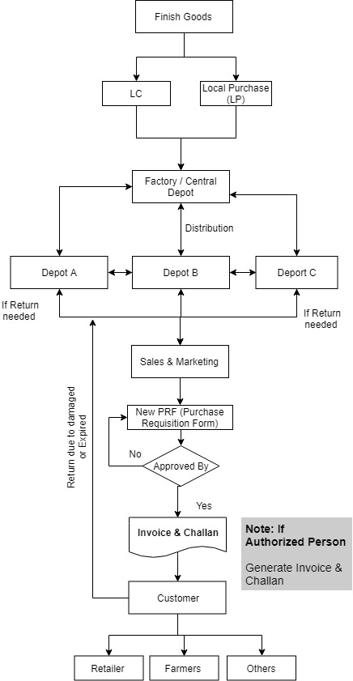KFL maintain a Central Deport in their central area. After that Product will preserve some other depot which hold like deport A, deport B, depot C. Respective Area Manager (AM) dealings with customers for the product. Order Taken by Dealers from the customers. Order Process will be

**Fig: 03 Sales Process of KFL**

pending for the further approval and checked by the Depot In charge / Area Manager (AM) / Supportive Territory Manager (TM) after that order will forward to the immediate depot just Like depot A, depot B, depot C.

# **Cost of Goods Sold (COGS)**

The cost of goods sold (COGS), also referred to as the cost of sales or cost of services, is how much it costs to produce your products or services. COGS include direct material and direct labor expenses that go into the production of each good or service that is sold. When calculating the cost of goods sold, do not include the cost of creating goods or services that you don’t sell.

COGS does not include indirect expenses, like certain overhead costs. Do not factor things like utilities, marketing expenses, or shipping fees into the cost of goods sold.

If you own a cabinetry company, examples of COGS would include the wood, screws, hinges, glass, paint, and labor used to make the cabinets you sell. However, the costs to market the cabinets, the electricity needed to operate the machinery, and shipping are not included in the COGS. To find the COGS on a product, add up the cost of raw materials and direct labor needed to create it.

## **Cost of Goods Sold (COGS)** Formula

To find the cost of goods sold during an accounting period, use the COGS formula:

COGS = Beginning Inventory + Purchases during the Period – Ending Inventory

Your beginning inventory is whatever inventory is left over from the previous period. Then, add the cost of what you purchased during the period. Subtract whatever inventory you did not sell at the end of the period. Accounting periods might be months, quarters, or calendar years.

The three inventory costing methods are:

* FIFO (first in, first out)
* LIFO (last in, first out)
* Average

### FIFO

The earliest goods to be purchased or manufactured are sold first. Since prices tend to go up over time, a company that uses the FIFO method will sell its least expensive products first, which translates to a lower COGS than the COGS recorded under LIFO. Hence, the net income using the FIFO method increases over time.

### LIFO

The latest goods added to the inventory are sold first. During periods of rising prices, goods with higher costs are sold first, leading to a higher COGS amount. Over time, the net income tends to decrease.

### Average Cost Method

The average price of all the goods in stock, regardless of purchase date, is used to value the goods sold. Taking the average product cost over a time period has a smoothing effect that prevents COGS from being highly impacted by extreme costs of one or more acquisitions or purchases.

If you use the FIFO method, the first goods you sell are the ones which you purchased or manufactured first. Generally, this means that you sell your least expensive products first. As a result, you record a lower cost of goods sold.

# Customer Relationship Management (CRM)

Unify your business—from data to people to processes—with modern, intelligent business applications that adapt to your changing needs.

CRM or Customer Relationship Management is a strategy for managing an organization’s relationships and interactions with customers and potential customers. A CRM system helps companies stay connected to customers, streamline processes, and improve profitability.

It uses data analysis about customers' history with a company to improve business relationships with customers, specifically focusing on customer retention and ultimately driving sales growth.

One important aspect of the CRM approach is the systems of CRM that compile data from a range of different communication channels, including a company's website, telephone, email, live chat, marketing materials and more recently, social media. Through the CRM approach and the systems used to facilitate it, businesses learn more about their target audiences and how to best cater to their needs

## Different Business functions benefit from using CRM

* Sales teams can use CRM to understand their sales pipeline better.
* Marketing teams can use CRM to make forecasting simpler and more accurate.
* Customer service teams can effectively track conversations across channels.
* Supply-chain, procurement and partner management teams can manage relationships better.
* The HR team can use CRM to accelerate the recruitment process and track employee performance.

Strategic CRM is concentrated upon the development of a customer-centric business culture.

## Operational

The primary goal of customer relationship management systems is to integrate and automate sales, marketing, and customer support. Therefore, these systems typically have a dashboard that gives an overall view of the three functions on a single customer view, a single page for each customer that a company may have. The dashboard may provide client information, past sales, previous marketing efforts, and more, summarizing all of the relationships between the customer and the firm. Operational CRM is made up of 3 main components: sales force automation, marketing automation, and service automation.

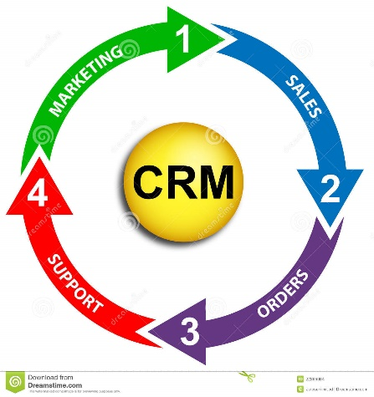

**Fig: 04 Operational Process**

## Analytical

The role of analytical CRM systems is to analyze customer data collected through multiple sources and present it so that business managers can make more informed decisions. Analytical CRM systems use techniques such as data mining, correlation, and pattern recognition to analyze the customer data.

## Collaborative

The third primary aim of CRM systems is to incorporate external stakeholders such as suppliers, vendors, and distributors, and share customer information across groups/departments and organizations. For example, feedback can be collected from technical support calls, which could help provide direction for marketing products and services to that particular customer in the future.

# Conclusion

Necessary attribute detail has been given based on the requirements and understanding from the user end. But IT Team must analyze and improvise if there needed more attributes and condition to manage the inventory management system more efficiently in KG of KFL.