|  |
| --- |
| Enterprise Resource Planning (ERP) |
| Krishibid Farm Machinery and Automobiles Limited (KFMAL) |
| PREPARED BY: KG IT Division |

Table of Contents

1 Objective 4

2 Krishibid Farm Machinery and Automobiles Limited (KFMAL) 4

3 Requirement Specification 4

3. Business Process of KFMAL 5

4 Functional Requirement 6

4.1 Terminology 6

5 Inventory management types 6

4 Sales 8

5 Customer Relationship Management (CRM) 9

5.1 Different business functions benefit from using CRM 10

5.2 Operational 10

5.3 Analytical 11

5.4 Collaborative 11

6 Conclusion 11

# Objective

ERP (Enterprise Resource Planning) is a suite of integrated business software applications (often called modules) that allow companies to track and manage data and even automate some business functions, including inventory management. Here easy to setup, very easy to browse through master data, quickly find any information, easy and intuitive interface, change the system as per requirement, grid reporting with customizable report writer and above all integrated with ERP of Kreishibid Group.

# Krishibid Farm Machinery and Automobiles Limited (KFMAL)

This is a new company of KG that aims to import quality vehicles from Japan, Indonesia, Malaysia, Thailand and Korea for local sales and also to develop an assembly plant to assemble imported CKD vehicles. In addition, the company is addicting up a modern repair and maintenance workshops for providing top class routine and back up maintenance services with facilities for automatic diagnosis and fault detection systems. Besides, KFMAL has a plan to import high quality farm machinery suitable for local conditions with an aim to enhance agricultural production in Bangladesh. Thus, KFMAL aims to enhance agricultural mechanization and raise the living standards of the millions of farmers by creating favorable environment through access to appropriate farm machinery.

# Requirement Specification

Requirements are primarily categorized as Functional requirement and Technical requirement for the ERP system that is to be implemented in the Bangla Link. Detail requirements are further categorized under specific functional and technical area. The HR concern person must put comment against each detail requirement to show whether their proposed solution complies with the requirement.

# Business Process of KFMAL

**Fig: 01 Business Process of KFMAL**

# Functional Requirement

Functional requirements are categorized according the following functional areas that are sought into the proposed solution.

## Terminology

|  |  |  |
| --- | --- | --- |
| **#** | **Acronym** | **Technical Area** |
| **1** | GCCL | Glorious Crop Care Limited |
| **2** | ERP | Enterprise Recourse Planning |
| **3** | HRMS | Human Resource Management System |
| **4** | WIP | Work in Progress |
| **5** | COGS | Cost of Goods Sold |

# ****Inventory management types****

**Inventory** is the collection of unsold products waiting to be sold. Inventory is listed as a current [asset](https://investinganswers.com/node/2278) on a company's [balance sheet](https://investinganswers.com/node/1083). Inventory is commonly thought of as the finished goods a company accumulates before selling them to end users. But inventory can also describe the [raw materials](https://investinganswers.com/node/6329) used to produce the finished goods, goods as they go through the production process (referred to as "work-in-progress" or WIP), or goods that are "in transit."

There are generally five reasons companies maintain inventories:

* To meet an anticipated increase in demand;
* To protect against unanticipated increases in demand;
* To take advantage of price breaks for ordering raw materials in bulk;
* To prevent the idling of a whole factory if one part of the process breaks down; and,
* To keep a steady stream of material flowing to retailers rather than making a single shipment of goods to retailers.

Typically, inventory types can be grouped into four categories: (1) raw materials, (2) works-in-process, (3) finished goods, and (4) maintenance, repair, and operations (MRO) goods.

1. **Raw materials** are any items used to manufacture components or finished products. These can be items produced directly by your business or purchased from a supplier. For example, a candle-making business could purchase raw materials such as wax, wicks, and decorative ribbons.
2. **Works-in-progress inventory** refers to unfinished items moving through production but not yet ready for sale. In the case of a candle-making business, work-in-progress inventory might be candles that are drying and unpackaged.
3. **Finished goods** are products that have completed the production process and are ready to be sold: the candles themselves.

Finish goods are products that have completed the production process and are ready to be sold the seeds themselves. Finished goods are indeed the final products obtained after the application of the manufacturing processes on the raw materials and the semi-finished goods discussed above in the article. They are saleable and their sale contributes fully to the revenue from the machine operations of the company. Regarding the level of finished goods inventory, there are two types of industries that we need to look at. First, we would take the industries in which the finished goods are mass produced and the sale happens after the production. For a company in such an industry, the correct approach is to maintain the finished goods inventory in a similar manner as the raw material inventory is maintained i.e. at an optimized level as per the demand in the market.

1. **Maintenance, repair, and operations (MRO) goods** are items used to support and facilitate the production of finished goods. These items are usually consumed as a result of the production process but aren’t a direct part of the finished product. For instance, disposable molds used to manufacture candles would be considered MRO inventory.

# **Sales**

Sale is an important activity in an organization. Strategic sales management involves effective and efficient handling of systems and processes towards successful sales. An effective sales process is key for closing more sales and generating more repeat business. For this careful management, following is required. KFMAL have some sales process in their business strategy.

* **Sales Force- An efficient and effective Salesforce is required for enhancing the sales productivity of an organization.**
* **Sales territories - These are important to get good customer coverage target achievement with more sales, lower costs and performance evaluation.**

KFMAL maintain a Central Deport in their central area. After that Product will reserved some other depot which hold like deport A, deport B, depot C. Respective Area Manager (AM) dealings with customers for the product. Order Taken by Dealers from the customers. Order Process will be pending for the further approval and checked by the Depot In charge / Area Manager (AM) / Supportive Territory Manager (TM) after that order will forward to the immediate depot just Like depot A, depot B, depot C.

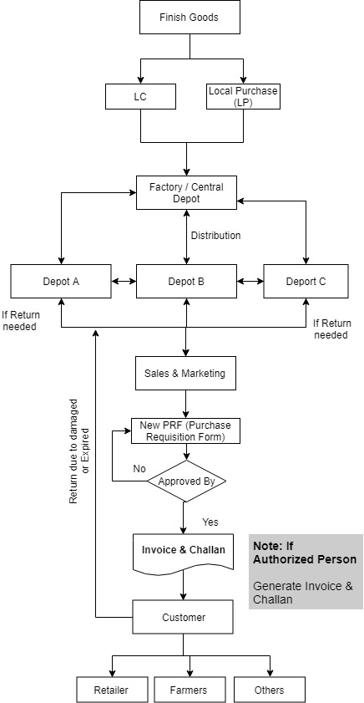

**Fig: 02 Sales Process of KFMAL**

# Customer Relationship Management (CRM)

Unify your business—from data to people to processes—with modern, intelligent business applications that adapt to your changing needs.

CRM or Customer Relationship Management is a strategy for managing an organization’s relationships and interactions with customers and potential customers. A CRM system helps companies stay connected to customers, streamline processes, and improve profitability.

It uses data analysis about customers' history with a company to improve business relationships with customers, specifically focusing on customer retention and ultimately driving sales growth.

One important aspect of the CRM approach is the systems of CRM that compile data from a range of different communication channels, including a company's website, telephone, email, live chat, marketing materials and more recently, social media. Through the CRM approach and the systems used to facilitate it, businesses learn more about their target audiences and how to best cater to their needs

## Different business functions benefit from using CRM

* Sales teams can use CRM to understand their sales pipeline better.
* Marketing teams can use CRM to make forecasting simpler and more accurate.
* Customer service teams can effectively track conversations across channels.
* -chain, procurement and partner management teams can manage relationships better.
* The HR team can use CRM to accelerate the recruitment process and track employee performance.

Strategic CRM is concentrated upon the development of a customer-centric business culture.

## Operational

The primary goal of customer relationship management systems is to integrate and automate sales, marketing, and customer support. Therefore, these systems typically have a dashboard that gives an overall view of the three functions on a single customer view, a single page for each customer that a company may have. The dashboard may provide client information, past sales, previous marketing efforts, and more, summarizing all of the relationships between the customer and the firm. Operational CRM is made up of 3 main components: sales force automation, marketing automation, and service automation.

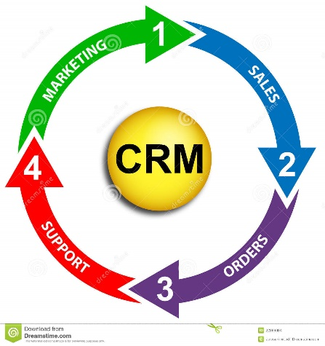

## Analytical

The role of analytical CRM systems is to analyze customer data collected through multiple sources and present it so that business managers can make more informed decisions. Analytical CRM systems use techniques such as data mining, correlation, and pattern recognition to analyze the customer data.

## Collaborative

The third primary aim of CRM systems is to incorporate external stakeholders such as suppliers, vendors, and distributors, and share customer information across groups/departments and organizations. For example, feedback can be collected from technical support calls, which could help provide direction for marketing products and services to that particular customer in the future.

# Conclusion

Necessary attribute detail has been given based on the requirements and understanding from the user end. But IT Team must analyze and improvise if there needed more attributes and condition to manage the KFMAL more efficiently in KG.