STAT 7500 – Statistical Programming
SAS Homework 04
Submission instructions: same as previous weeks. Multiple formats are okay, so long as it is organized / well labeled.
This week, you will be working with the Phillies_2025.xlsx dataset. Much of the data cleaning was done together in class.
Assigned Problems
- (A lot of this is done in class) Conduct necessary cleaning steps to get the Phillies_2025.xlsx data in the form shown below (will have 28 obs, 10 shown here)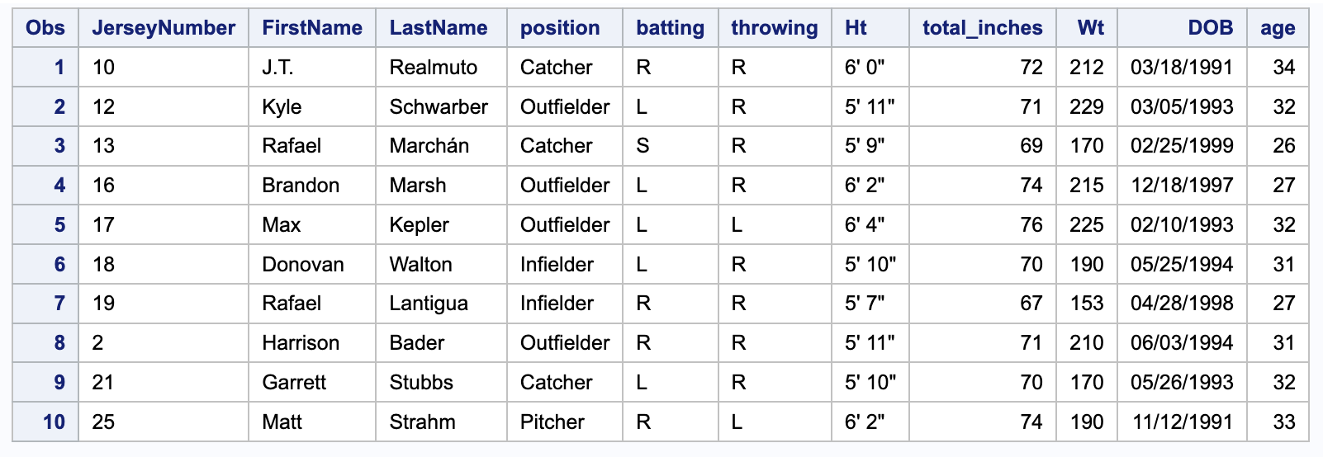
- Create a new dataset with only players whose last name starts with “S”. Print this data, with an appropriate title.
- With cleaned data created in (1), create 4 clean datasets – one for each position – from a single data step. [Note, this is just for practice, you won’t use these in the remaining analysis]
- [Back to data with all players] Convert FirstName and LastName to all uppercase letters. Print the first 5 rows of these columns to demonstrate they have been converted.
- Find the oldest and youngest players for each position (using the dataset with all players). Print out these results (should be 8 players total) and comment on anything you notice.
- Calculate average age, height, and weight by position. Comment on the results.
- Produce a frequency table for batting x throwing. Comment on the results.

