StudentPulse
Data-Driven Event Management Platform
ISTE 240 – Web and Mobile II
Spring 2026 | Group 6
Team Members
Aditya Avinash | 761005899
Khaleel Hassan | 412002594
Harsh Kanaya Bhatia | 400003132
Rochester Institute of Technology – Dubai | Final Report | April 26, 2026

Rubric

Component | Max Pts | Criteria Summary
Frontend | 20 | Professional Bootstrap, responsive, toasts, loading states
REST API | 25 | Each student has own controller + all 6 HTTP methods
JPA | 20 | Each student has own repository + 5+ methods + entity classes
Git | 10 | Branches + 5+ commits + good messages + PRs
Demo | 15 | 5+ pages + all CRUD + no errors
Final Report | 10 | Complete documentation + API docs + team contributions + screenshots
Final Presentation | 10 | Clear explanation + live demo works + answers questions confidently
TOTAL | 110

Manifesto
Each member was fully responsible for their own entity, repository, service, controller, and frontend page.

Aditya Avinash – 761005899
- Owned the Student entity: @Entity, @Table, @Id, @Column, unique constraints
- StudentRepository: findByName, findByEmail, searchByName (JPQL LIKE), updateActiveById (@Modifying), existsByEmail
- StudentService: full CRUD with validation, @Transactional
- StudentController: all 6 REST endpoints (@RestController)
- students.html: Bootstrap 5 + jQuery table, real-time search, Add/Edit modal, toast notifications
- StudentDataSeeder: @PostConstruct seed of 5 students via JPA
- Configured application.properties (MariaDB, iste240 DB), pom.xml (JPA + MariaDB deps), redesigned index.html

Khaleel Hassan – 412002594
- Owned Action and Comment entities: @Entity, @ManyToOne relationships to Event and Student
- ActionRepository: findByEventId (JPQL), updateTimestampById (@Modifying)
- CommentRepository: findByEventId, findByStudentId (JPQL), updateContentById (@Modifying)
- ActionService + CommentService: full CRUD, @Transactional
- ActionController + CommentController: all 6 REST endpoints each
- comments.html: full CRUD table, search by event ID, Add/Edit modal, toast notifications
- event-details.html: per-event view with threaded comments, support actions sidebar, edit panel

Harsh Kanaya Bhatia – 400003132
- Owned the Event entity: @Entity, @OneToMany to Comment and Action (cascade = ALL)
- EventRepository: findByStatus, findByCategory (derived), searchByTitle (JPQL LIKE), updateStatusById (@Modifying)
- EventService: full CRUD with title validation, @Transactional
- EventController: all 6 REST endpoints
- Events.html: Bootstrap table, keyword search, Add/Edit, support event via student dropdown, View Details link
- DataSeeder: @PostConstruct seed of 4 events via JPA

Abstract
StudentPulse is a full-stack web application for RIT Dubai that lets students formally propose campus events, gather peer support through 'action' votes, and track proposals through a defined lifecycle (PENDING → IN_PROGRESS → COMPLETED). Built with Java Spring Boot (REST APIs), MySQL/JPA on the backend, and Bootstrap 5 + jQuery on the frontend, it replaces scattered WhatsApp threads with a transparent, accountable workflow. Four JPA entities Student, Event, Comment, Action are owned independently by each team member end-to-end, from database table to frontend HTML page.

Problem Definition
Student interest at RIT Dubai is scattered across WhatsApp groups, verbal requests, and overlooked emails. There is no formal mechanism to propose events, measure peer demand, or receive structured administrative feedback. This creates three problems: proposals go unacknowledged; administration cannot gauge activity demand; and there is no transparency in the event approval lifecycle. StudentPulse addresses this with a support-threshold model and explicit status tracking that holds both students and administration accountable.

Current Similar Solutions
Eventbrite allows event creation and RSVP but has no institutional proposal/approval workflow. Campus Groups is used by universities for student org management but is expensive and complex. Google Forms + Sheets is common for informal proposals but lacks built-in status tracking or comment threads. StudentPulse is purpose-built for RIT Dubai, combining proposal creation, peer-support tracking, comment feedback, and admin status management in a single lightweight platform.

Technologies Used

Category | Technology
Backend Framework | Java Spring Boot 3.x
Database | MySQL (database: iste240, auto-created on startup)
ORM / Persistence | Spring Data JPA / Hibernate (ddl-auto=update)
Frontend | HTML5, Bootstrap 5.3, jQuery 3.7.1
Build Tool | Apache Maven
Version Control | Git / GitHub (private repo, per-student branches)

Technical Architecture
The application follows a standard layered MVC architecture. Each team member owns a full vertical slice for their entities.

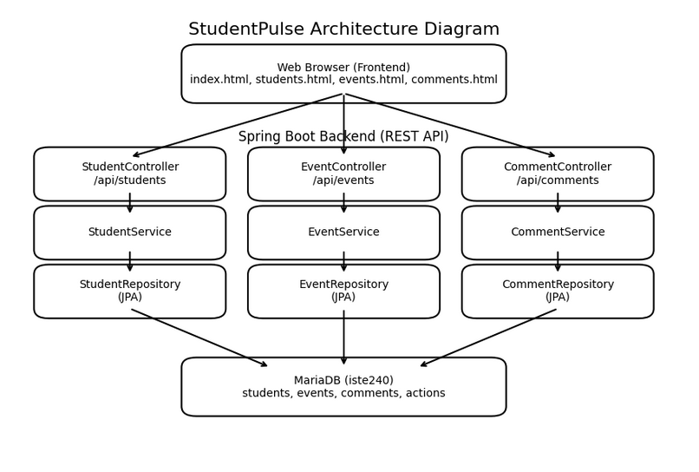

Layer | Technology | Responsibility
Frontend | HTML / Bootstrap 5 / jQuery | REST API consumer; all CRUD via $.ajax; no page reloads
Controller | @RestController | Exposes RESTful endpoints; returns JSON via ResponseEntity
Service | @Service + @Transactional | Business logic, validation, transaction management
Repository | JpaRepository interfaces | DB queries: JPQL, @Modifying, derived-query methods
Model | @Entity classes | JPA-mapped tables; @ManyToOne / @OneToMany relationships
Database | MariaDB - iste240 | Persistent store; schema managed by Hibernate
Flow: Browser (HTML/jQuery) -> REST Request -> @RestController -> @Service -> JpaRepository -> MySQL (iste240). Responses return as JSON; jQuery updates the DOM in place.
Key Website Features

Student Management (students.html) - Aditya Avinash
- Bootstrap 5 table of all students with Active/Inactive badge per record
- Real-time name search (jQuery + JPQL LIKE); Add/Edit via Bootstrap modal; Delete with confirmation
- Toast notifications for every Create, Update, Delete operation; no page reloads

Event Management (Events.html) - Harsh Bhatia
- Full event table with keyword title search, inline Add form, and Edit card
- Support Event button records an Action for the selected student; View Details navigates to event-details.html
- Status lifecycle: PENDING, IN_PROGRESS, COMPLETED managed via PUT /api/events/{id}

Comment & Action Management (comments.html + event-details.html) - Khaleel Hassan
- Global comments page: filter by event ID, Add/Edit/Delete with modal and toasts
- Per-event detail page: threaded comments, support-actions sidebar with student ID and timestamp, inline edit panel

Landing Page (index.html)
- Beige themed homepage with Bootstrap 5 navigation cards linking to all entity pages and Quick Add entry points

Design Summary
Colour palette: #F5F0E8 parchment background, #3D2B1F dark espresso, #6B4F35 medium brown, a calm academic aesthetic for a university context. Bootstrap 5 modals are used for Add/Edit forms to keep table context visible. Toast notifications (green/red) give immediate feedback. Real-time search requires no submit button. The Bootstrap grid ensures full responsiveness across desktop and mobile. All five pages share the same dark-brown navigation bar for consistency.

Database Design and Implementation
Database: iste240 (auto-created via createDatabaseIfNotExist=true). Schema managed by Hibernate (ddl-auto=update). Relationships: Comment and Action each hold @ManyToOne FKs to both Event and Student; Event holds @OneToMany to Comment and Action (cascade=ALL).

Table | Key Columns | Relationships
students | id (PK), rit_id (UNIQUE), name, email (UNIQUE), active | Referenced by comments.student_id, actions.student_id
events | id (PK), title, description, category, status | @OneToMany → comments, @OneToMany → actions
comments | id (PK), event_id (FK), student_id (FK), content | @ManyToOne → events, @ManyToOne → students
actions | id (PK), event_id (FK), student_id (FK), timestamp | @ManyToOne → events, @ManyToOne → students

REST API Documentation
Method | Endpoint | Status | Description
GET | /api/students | 200 | All students
GET | /api/students/{id} | 200/404 | Student by ID
GET | /api/students/search?name= | 200 | Partial name search (JPQL LIKE)
POST | /api/students | 201/400 | Create student
PUT | /api/students/{id} | 200/404 | Full update
DELETE | /api/students/{id} | 204/404 | Delete student
GET | /api/events | 200 | All events
GET | /api/events/{id} | 200/404 | Event by ID
GET | /api/events/search?keyword= | 200 | Title keyword search
POST | /api/events | 201/500 | Create event
PUT | /api/events/{id} | 200/404 | Full update
DELETE | /api/events/{id} | 204/404 | Delete event
GET | /api/comments | 200 | All comments
GET | /api/comments/{id} | 200/404 | Comment by ID
GET | /api/comments/search?eventId= or ?studentId= | 200 | Filter by event or student
POST | /api/comments | 201 | Create comment
PUT | /api/comments/{id} | 200/404 | Full update
DELETE | /api/comments/{id} | 204 | Delete comment
GET | /api/actions | 200 | All actions
GET | /api/actions/{id} | 200/404 | Action by ID
GET | /api/actions/search?eventId= | 200 | All actions for an event
POST | /api/actions | 201 | Record a support action
PUT | /api/actions/{id} | 200/404 | Full update
DELETE | /api/actions/{id} | 204 | Remove action

JPA Repository Methods
Repository | Method | Type
StudentRepository | findAll(), findById(Long) | Inherited
StudentRepository | findByName(String), findByEmail(String), existsByEmail(String) | Derived
StudentRepository | searchByName(String name) | JPQL @Query (LIKE)
StudentRepository | updateActiveById(Long, boolean) | @Modifying @Query
EventRepository | findAll(), findById(Long) | Inherited
EventRepository | findByStatus(String), findByCategory(String) | Derived
EventRepository | searchByTitle(String keyword) | JPQL @Query (LIKE)
EventRepository | updateStatusById(Long, String) | @Modifying @Query
CommentRepository | findAll(), findById(Long) | Inherited
CommentRepository | findByEventId(Long), findByStudentId(Integer) | JPQL @Query
CommentRepository | updateContentById(Long, String) | @Modifying @Query
ActionRepository | findAll(), findById(Integer) | Inherited
ActionRepository | findByEventId(Long) | JPQL @Query
ActionRepository | updateTimestampById(int, String) | @Modifying @Query

Git Repository
Repository URL https://github.com/kgh6265/iste240-team6.git
Branch strategy: each student worked on their own branch (e.g. aditya/student-entity, harsh/event-entity, khaleel/comment-action-entity)
- Merge Manager: Khaleel Hassan: responsible for reviewing and merging all PRs into main
- Repository organised into sub-folders: frontend/, backend/, database/
- README.md includes Group 6 and all team member names/IDs; each student added their own entry via a personal commit
- Each student made 5+ commits with clear descriptive messages; Pull Requests used for all merges into main

