**Contents**

Getting started

Website progress for 12 week

Week 1 – 4

Week 4 – 8

Week 8 – 12

Designs

Wireframes for desktop

Homepage wireframe

CV wireframe

Biography wireframe

Contact wireframe

Wireframes for mobile

Homepage wireframe

CV wireframe

Biography wireframe

Contact wireframe

Conclusion

**Getting started**

I started creating the webpage after assignment was given to us. I started doing that by using html. At first my web page was very much simple. After few weeks when I started using css and css3 learned from the tutor, my web page was improved. Later I started using several properties of css and css3 and also modified the html code and css and css3 code regularly which led to the creation of present web page. During developing this webpage I took help from teacher and my friend Santosh Khanal and the following websites.

<http://joel.sh/>

<https://www.codeacademy.com/>

<https://www.w3schools.com/>

**Website progress for 12 week**

**Week 1 – 4**

During first four weeks I learned how to create a GitHub account and new repository and how to use it. I also learned to add, commit and to push the html and css document to the repository of GitHub account. I also learned how to write basic html code and their css code.

**Week 4 – 8**

During week 4 to 8 at first I learnt how to structure a webpage using html and css. I learnt to create a web page with header, section and footer and also to provide navigation. And during eight week I learnt about flex property and its use to properly manage the block.

**Week 8 – 12**

I learnt about gradient, transition, transformation, form and others during last four weeks. After practicing a lot and taking help from teacher and friends and different websites suggested on slides I was able to design webpage well. So, I was able to create this webpage.

**Designs**

**Wireframe for desktop**

**Homepage wireframe**

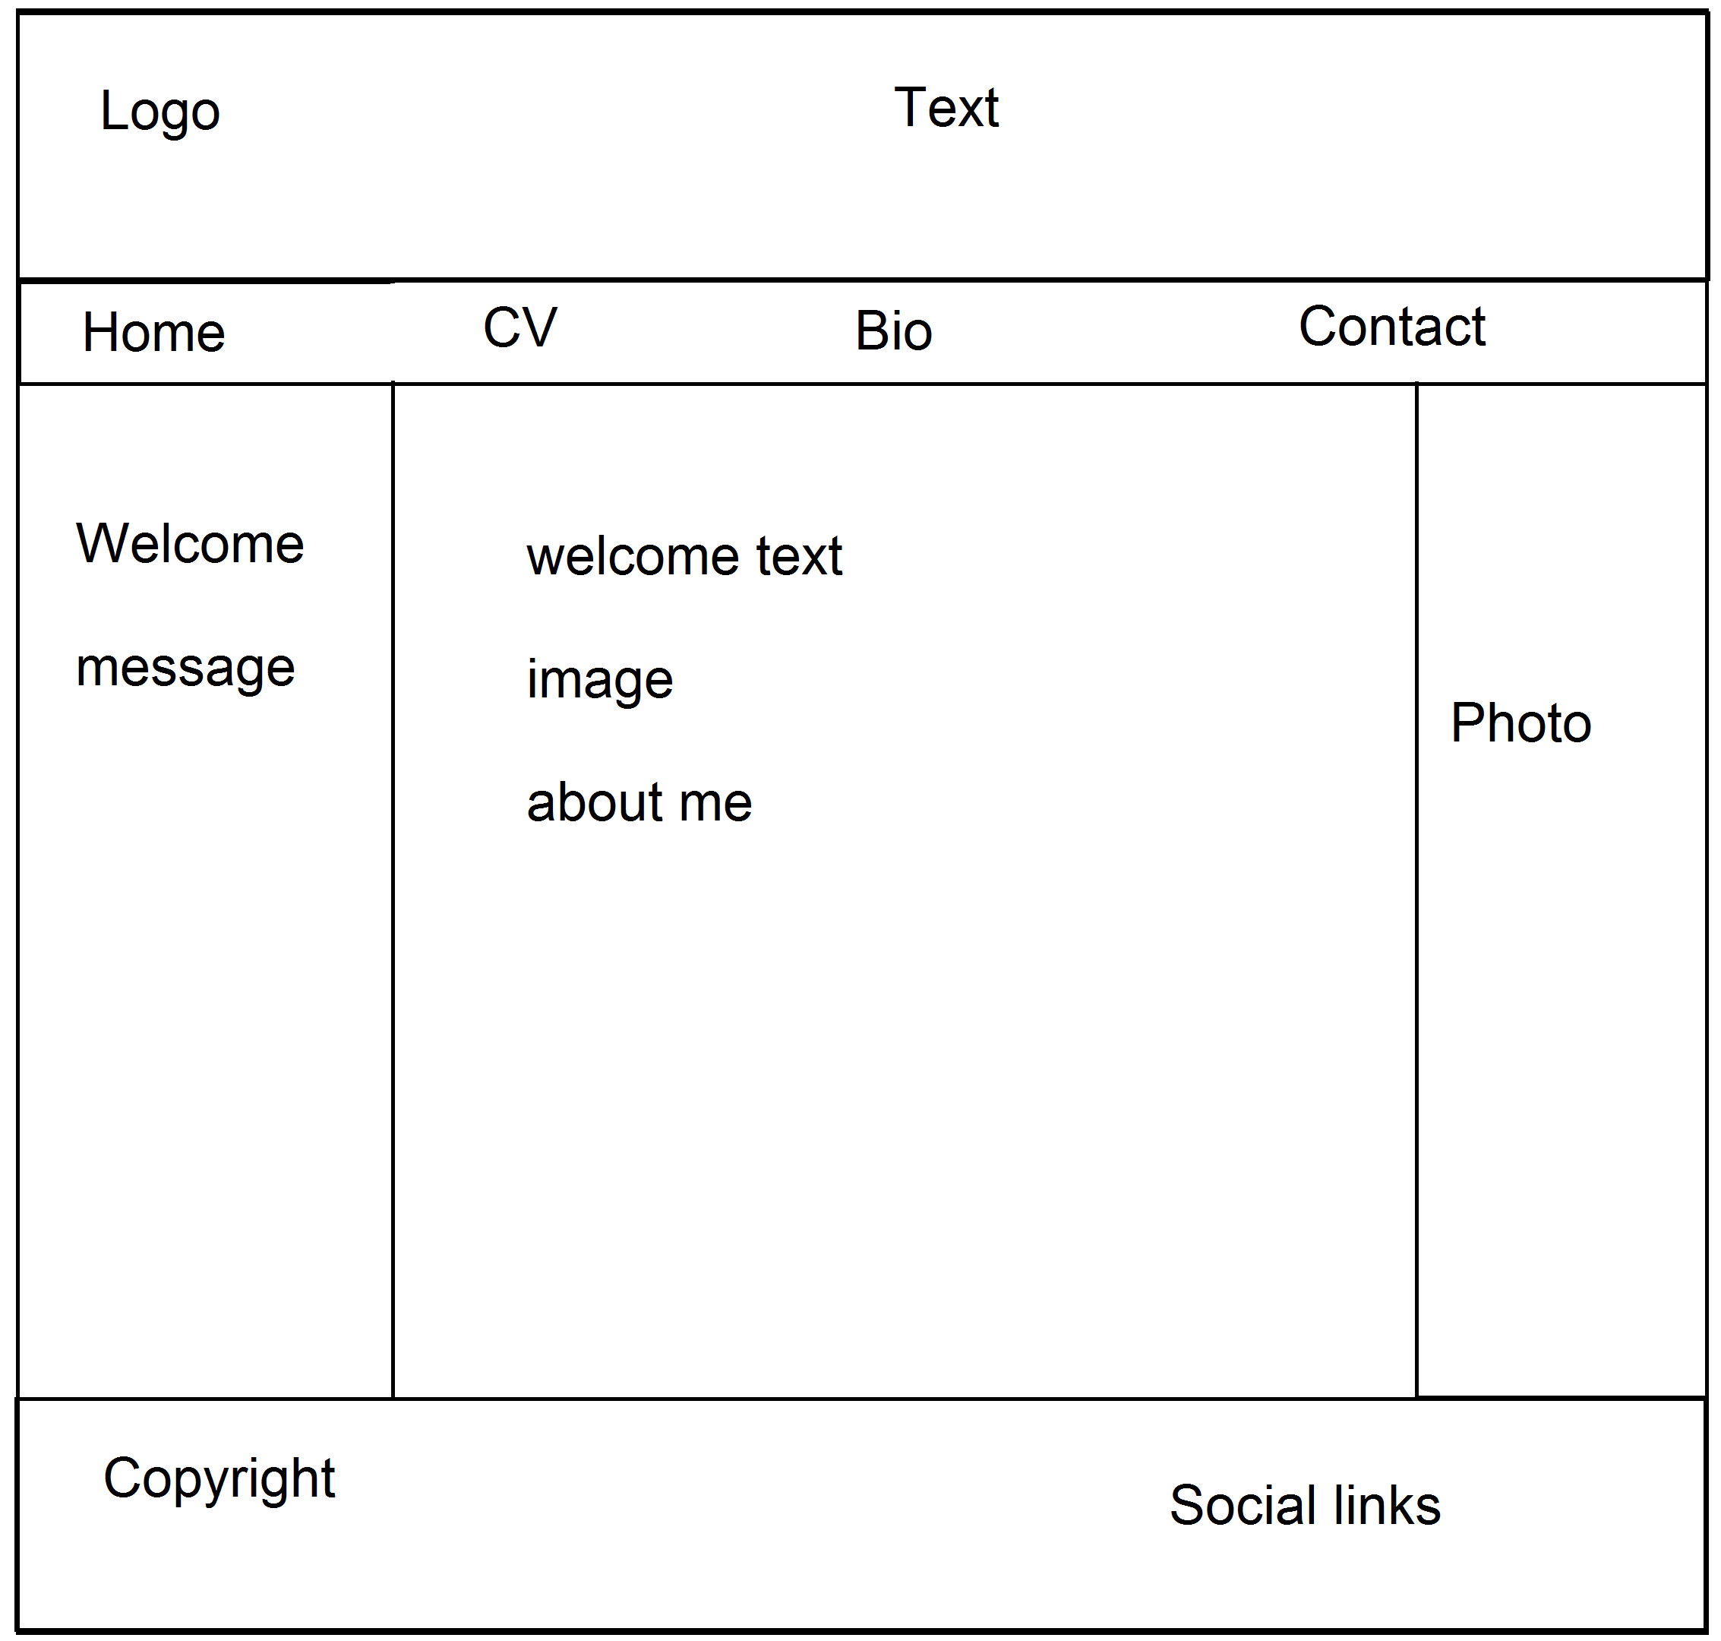

**CV wireframe**

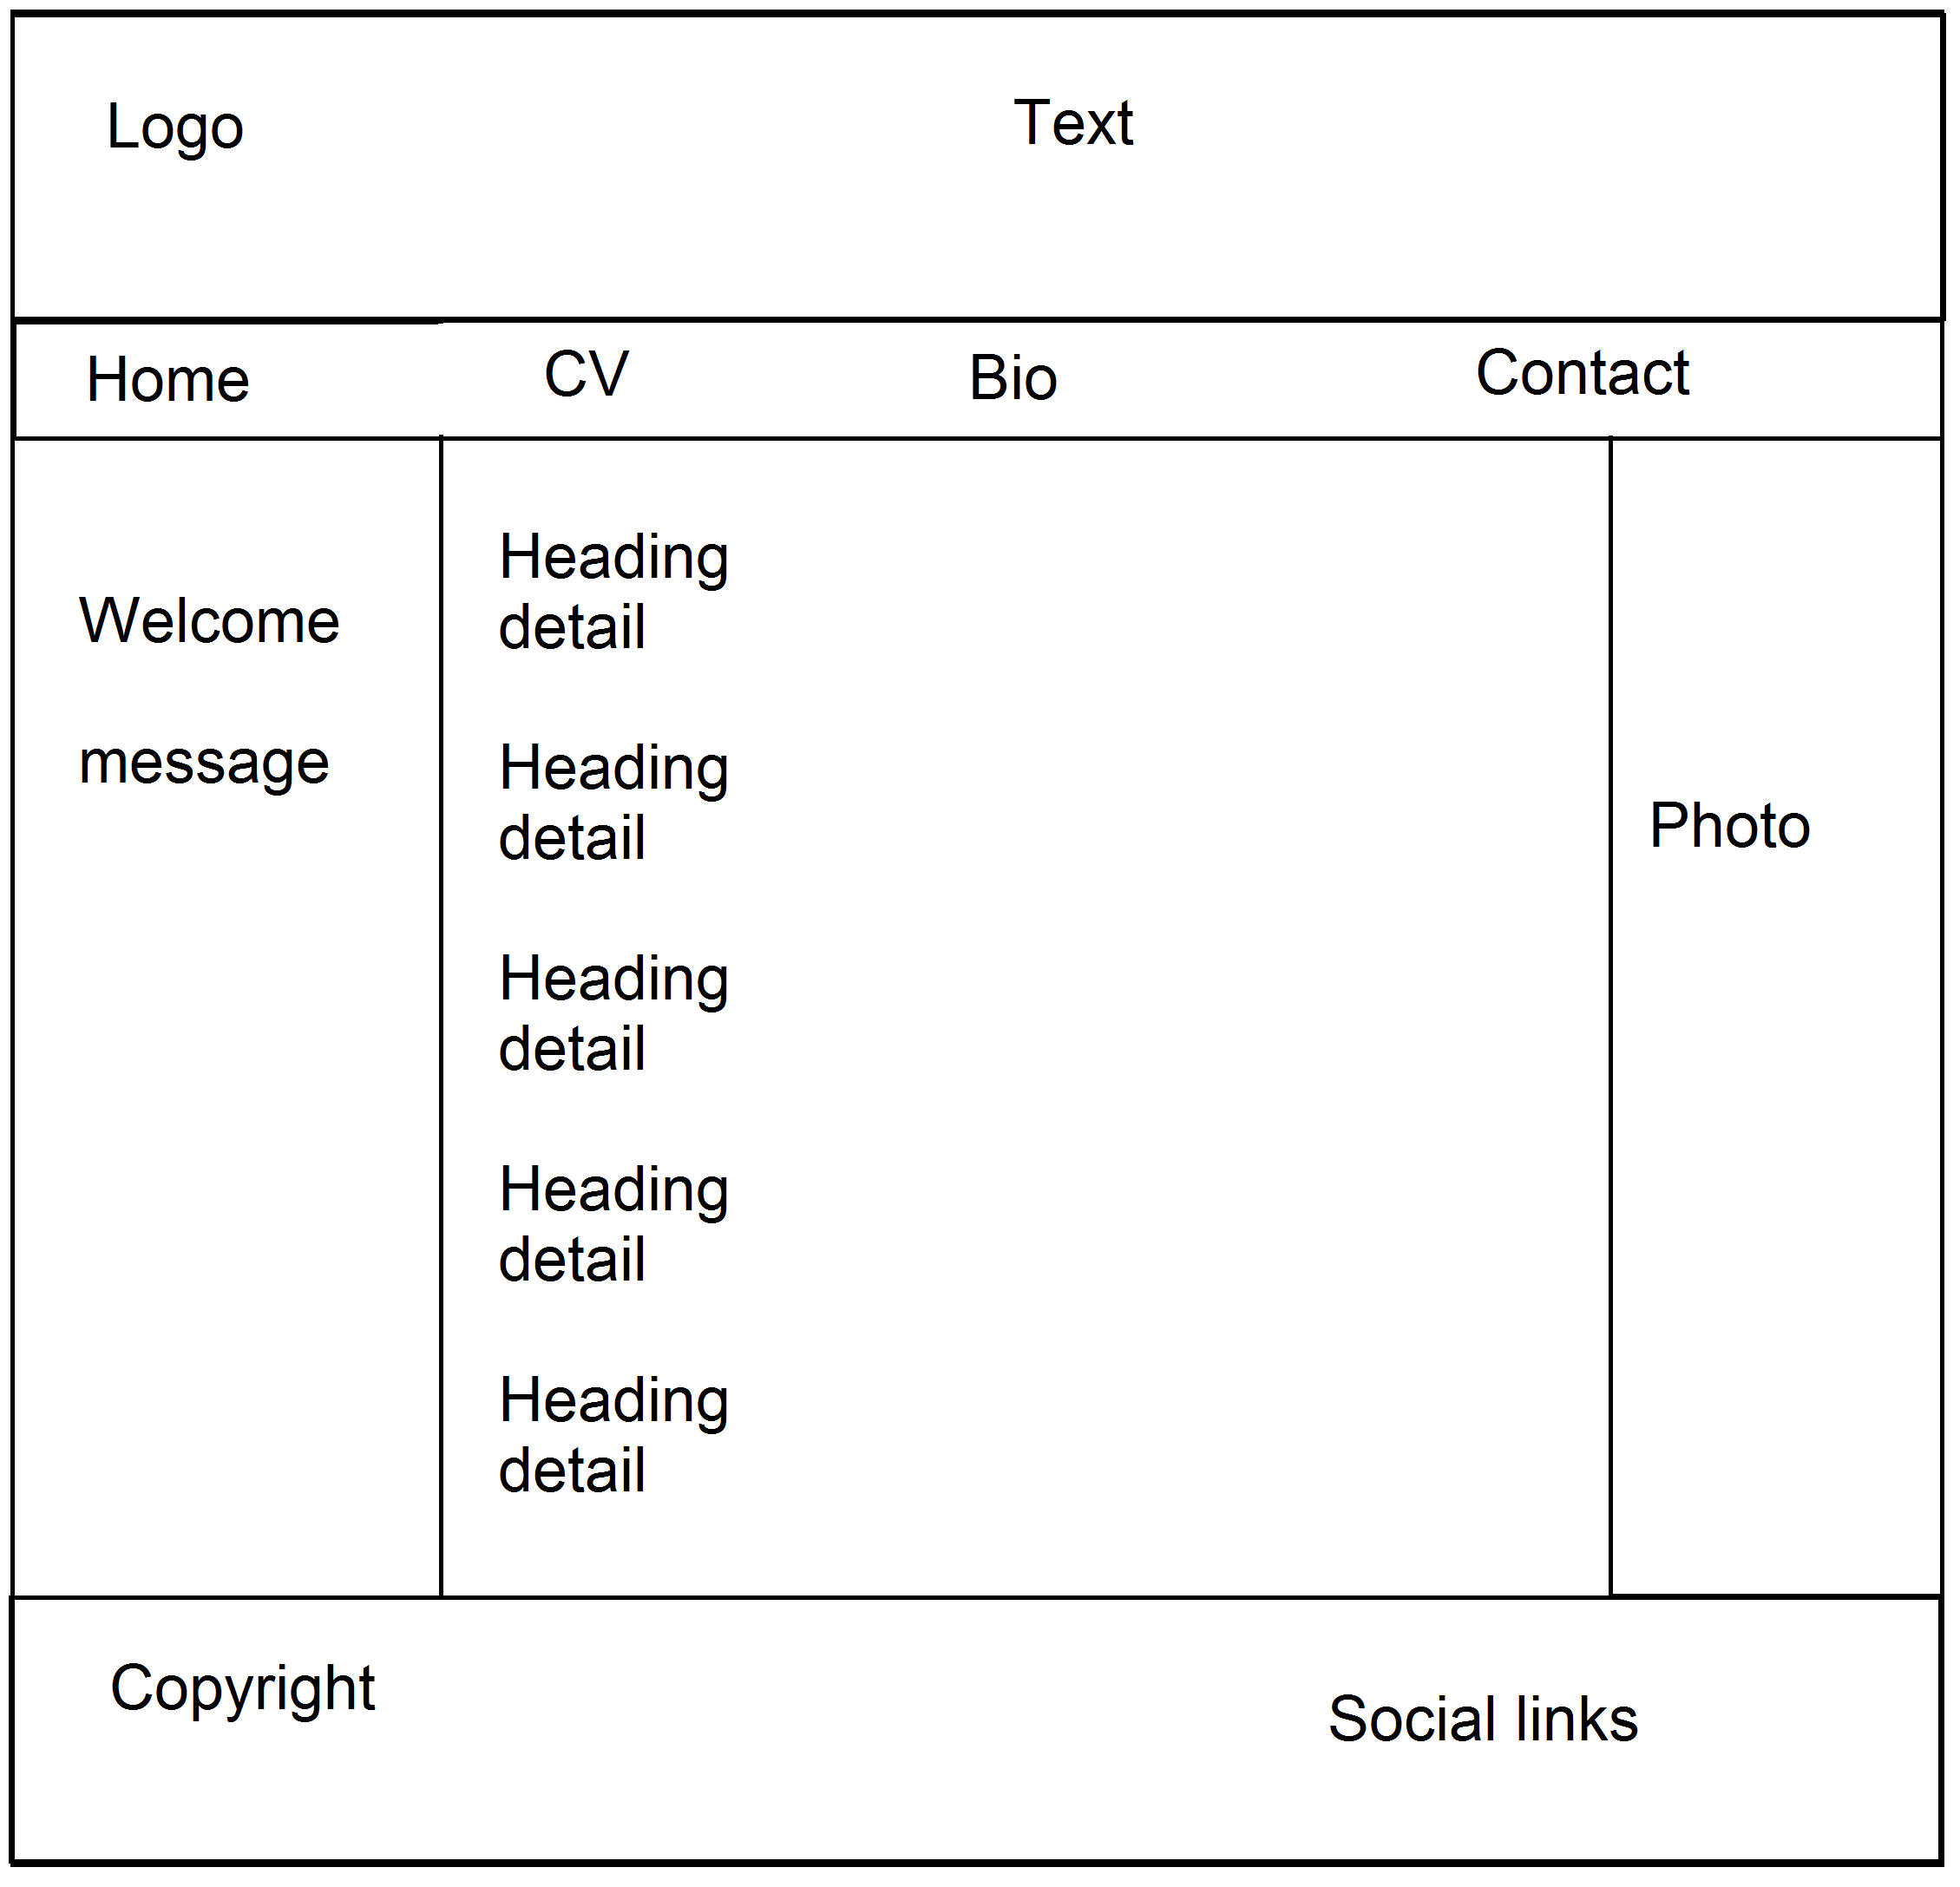

**Biography wireframe**

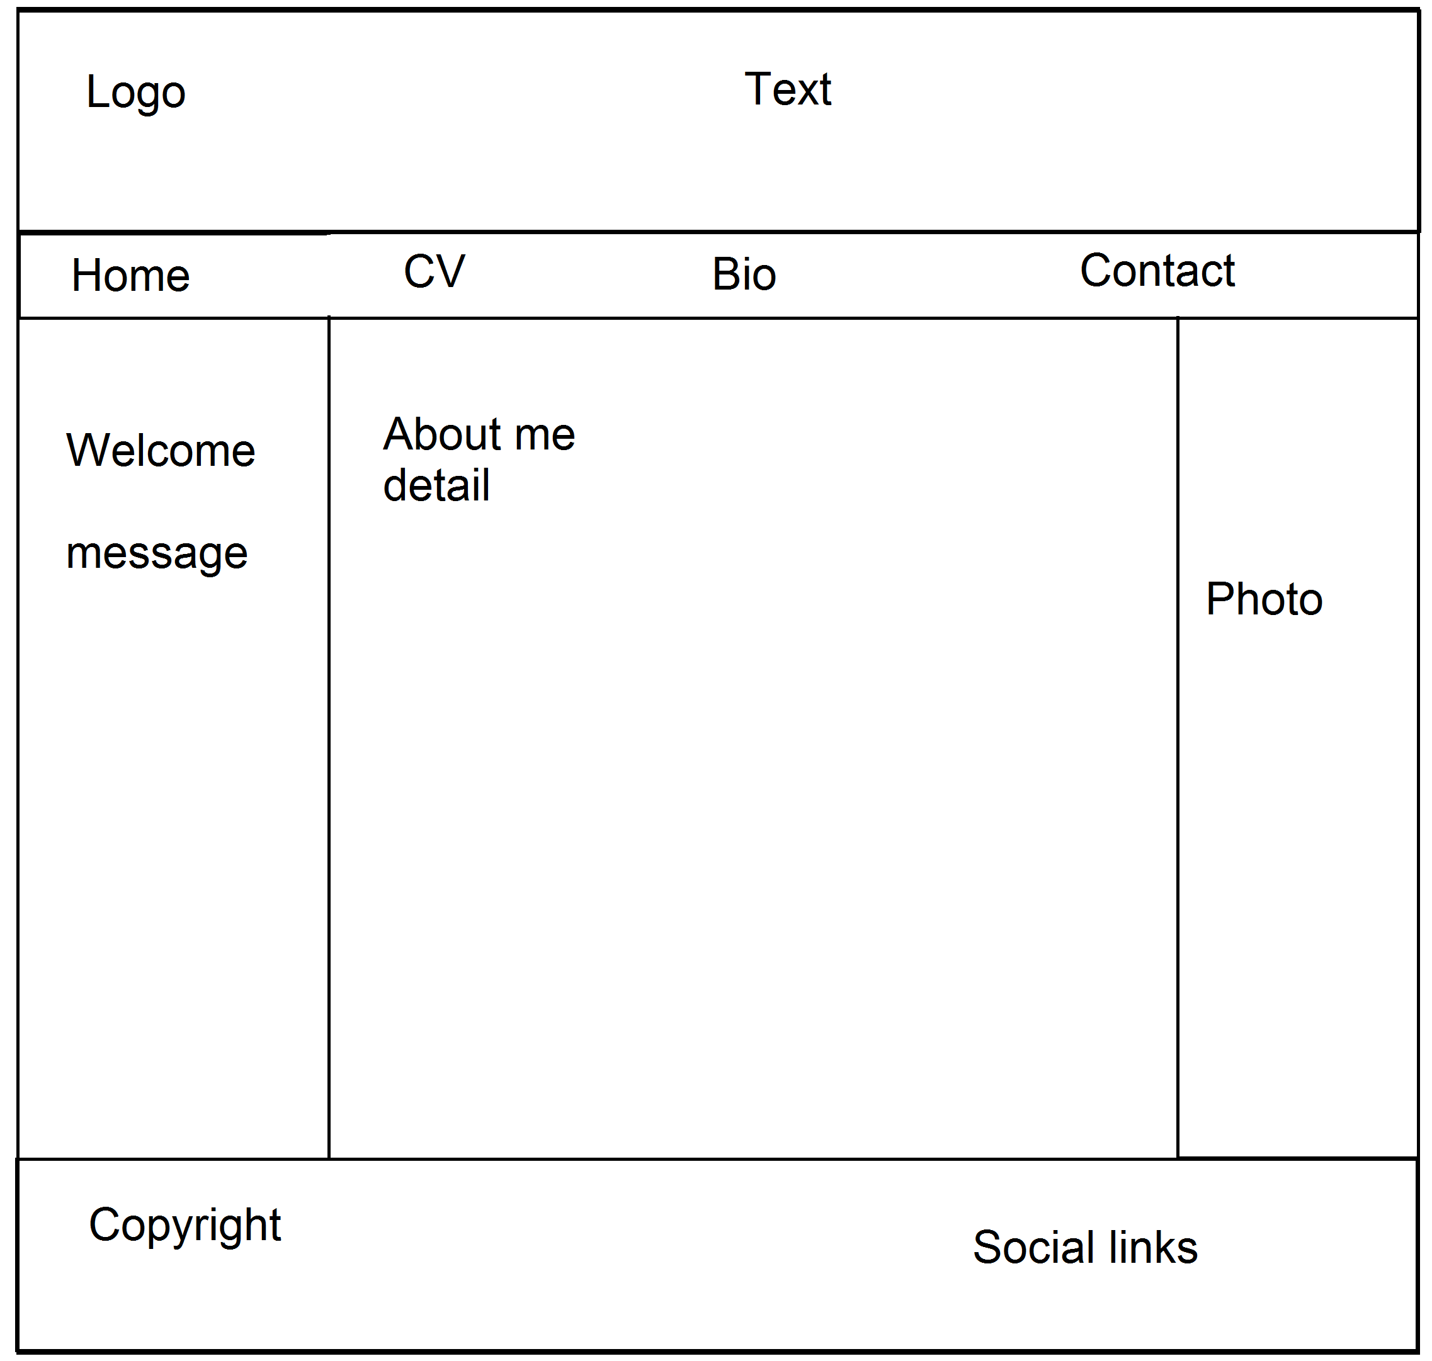

**Contact wireframe**

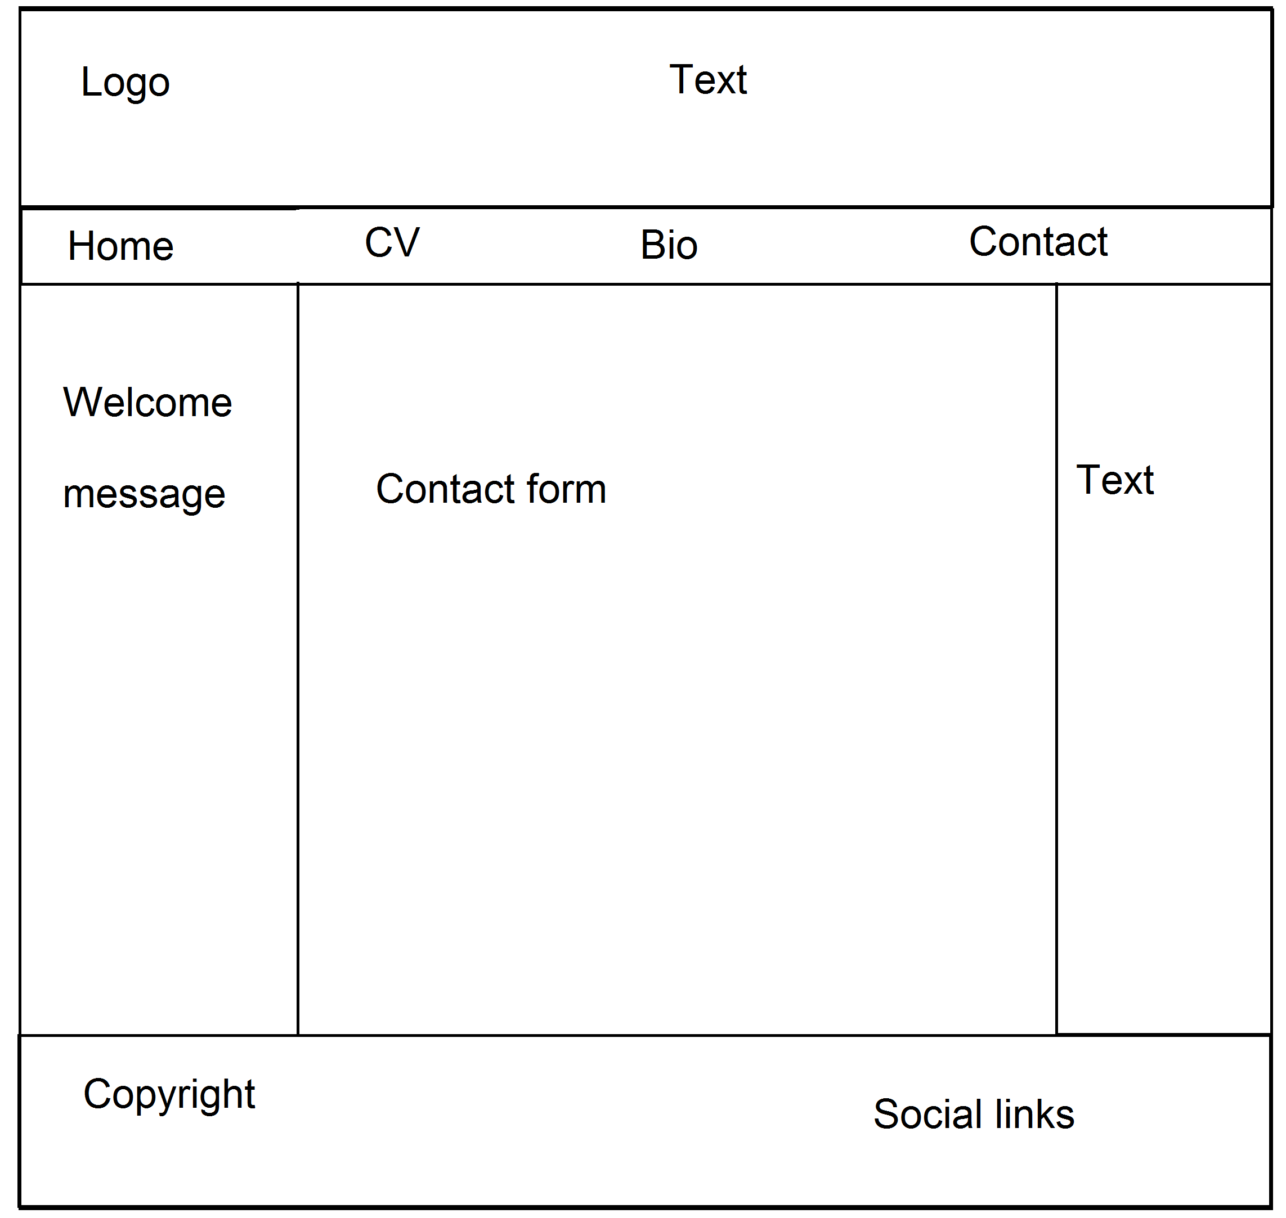

**Wireframe for mobile**

**Homepage wireframe**

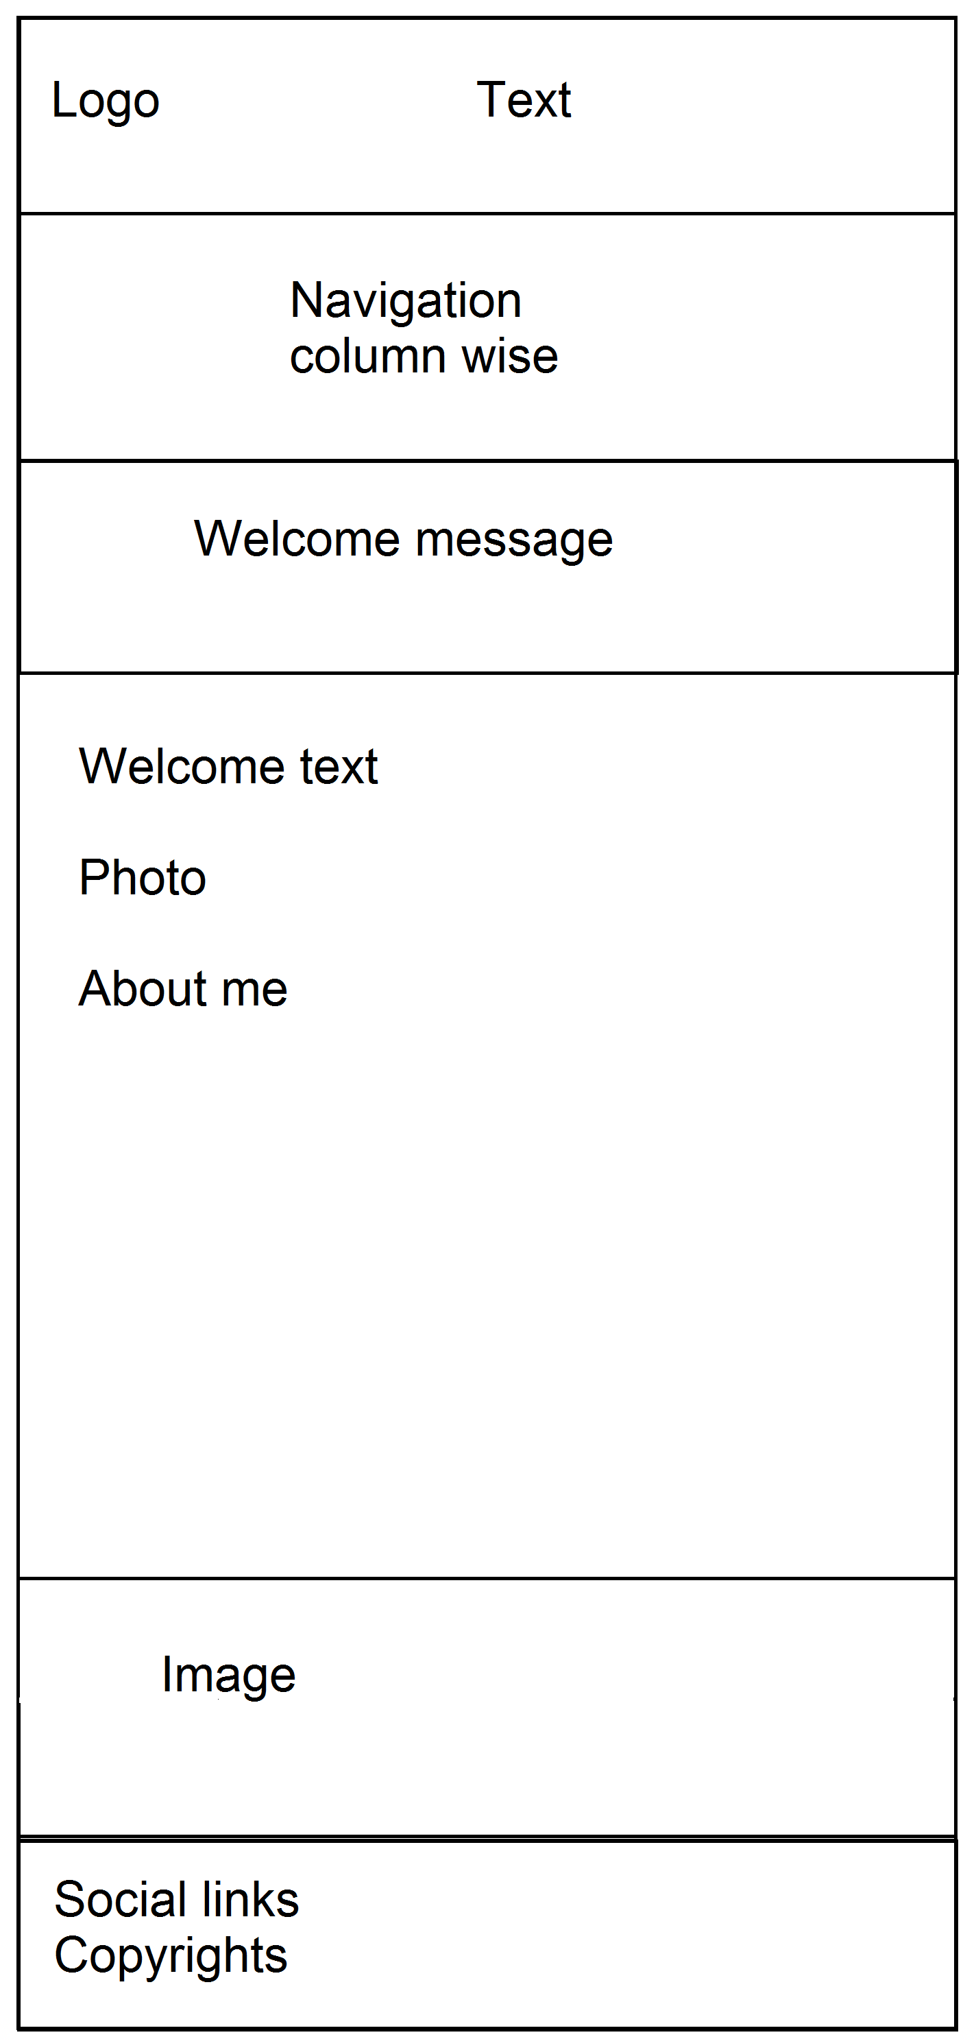

**CV wireframe**

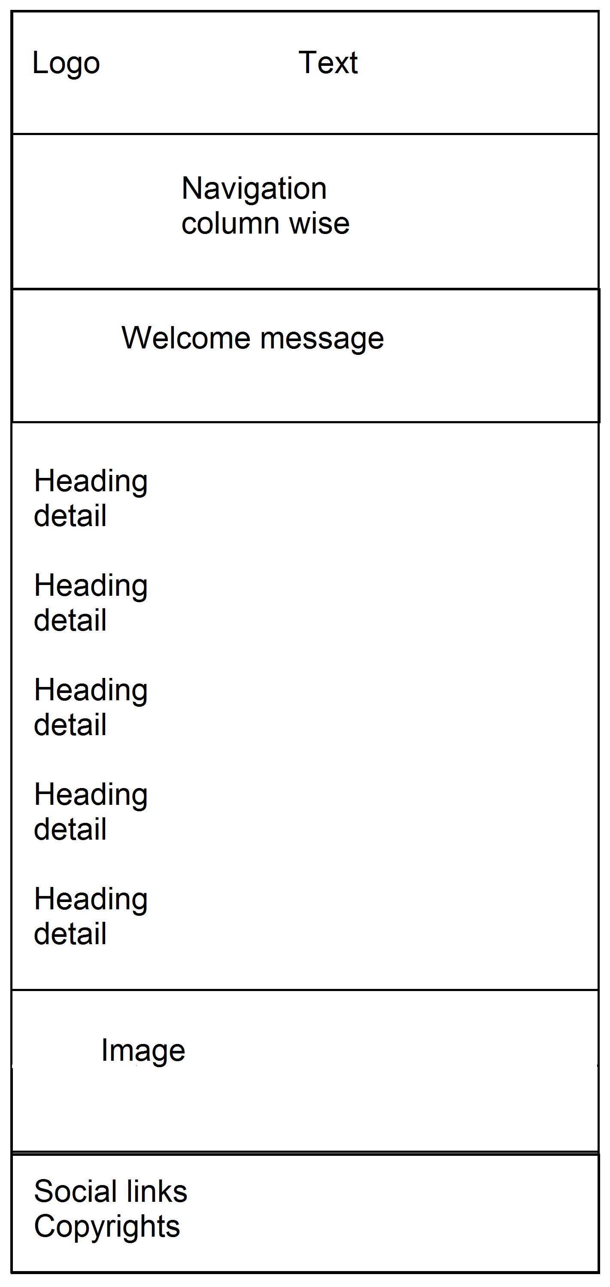

**Bio wireframe**

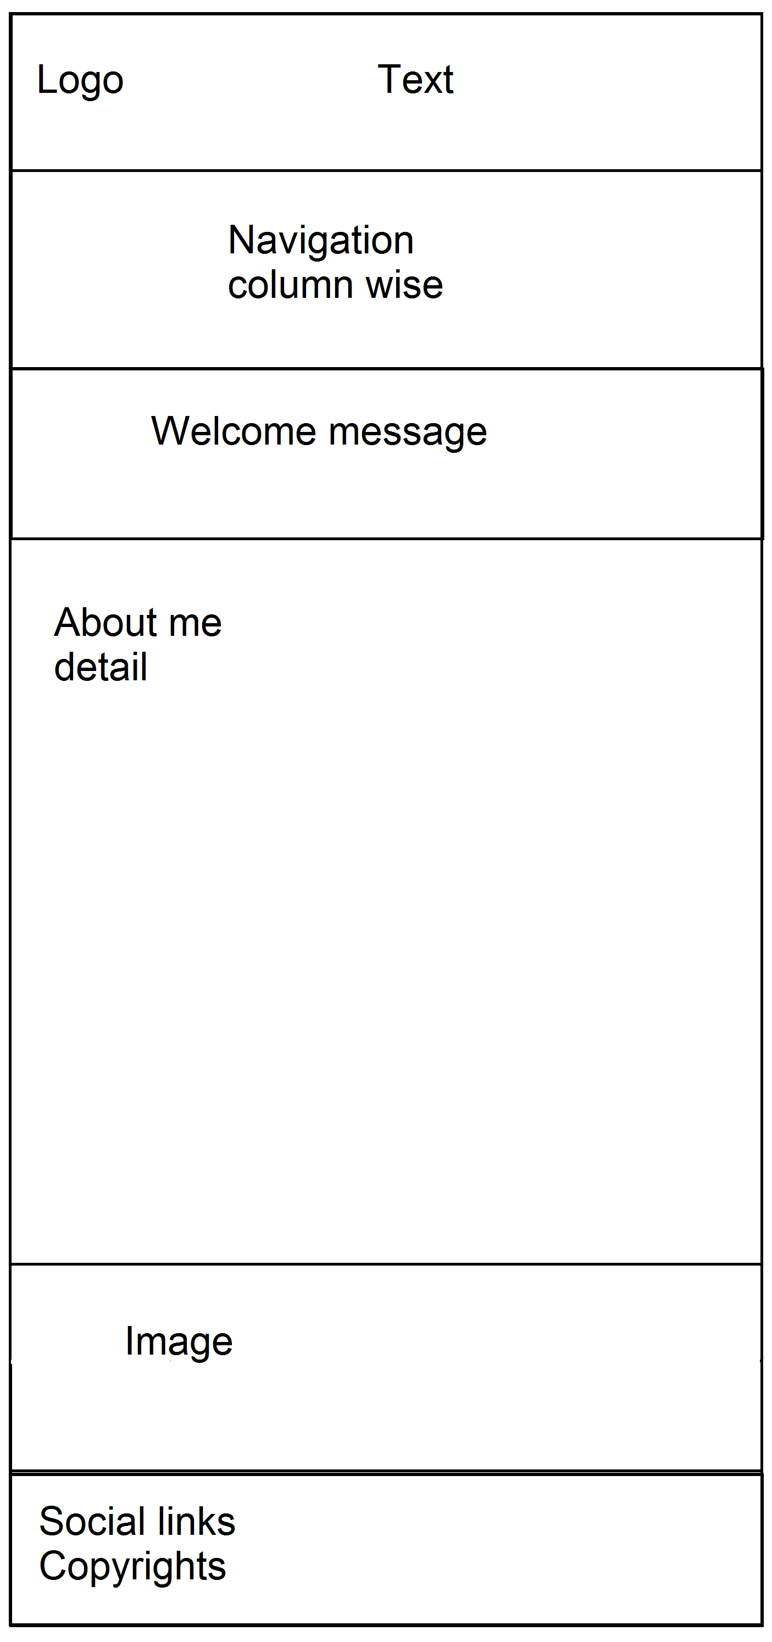

**Contact wireframe**

