BUSITEMA UNIVERSITY

FACULTY OF ENGINEERING

DEPARTMENT OF COMPUTER ENGINEERING

HOME AUTOMATION SYSTEM

BY

OBIA WILLIAM

Reg No: BU/UG/2011/86

Tel: +256757415220

Email:jrwilliamz@gmail.com

Supervisor: **MR. ALUNYU ANDREW EGWAR**

A Project Report Submitted to the Department of Computer Engineering in Partial Fulfillment of the Requirements for the Awards of a Bachelor’s Degree of Computer Engineering of Busitema University

April, 2015

# DECLARARTION

I **Obia William** Reg No: BU/UG/2011/86 hereby declare that this project report is my original work except where explicit citation has been made and it has not been presented to any institution of higher learning for any academic award.

Signature …………………………………….

Date………………………………………….

# APPROVAL

This is to certify that the project report under the title “***Home Automation System***” has been done under my supervision and is now ready for examination.

Sign ……………………………….

Date ……………………………….

**MR.ALUNYU ANDREW EGWAR**

Department of Computer Engineering, Busitema University

# ACKNOWLEDGEMENT

This project report would not have been successfully completed without the assistance and cooperation of a number of people and mentors.

Special thanks go to all the staff of the Busitema University, Department of Computer Engineering. Mr. Alunyu Andrew Egwar and my friends who took time off from their very busy schedules for the discussions and their willingness to allow consultation and documentation is also acknowledged.

# 

# LIST OF ACRONYMS

ADT Android development kit

API Application programming interface

APP Application

apk Android package

BT Bluetooth

GPIO General Purpose input/output

AMQP Advance messaging queuing protocol

HAS Home Automation System

IDE Integrated development environment

OS Operating system

LCD Liquid crystal display

HVAC  heating, ventilation and air conditioning

IoT Internet of Things

IFTTT if this then that

PC personal computer

SDK software development kit

JDK Java development kit

JRE Java runtime environment

ISM industrial, scientific and medical

RF Radio frequency

EM Electromagnetic

Wi-Fi Wireless Fidelity

AC Alternating current

DC Direct current

KHz kilohertz

GHz gigahertz

LED Light emitting diodes

TABLE OF CONTENTS

DECLARARTION i

APPROVAL ii

ACKNOWLEDGEMENT iii

LIST OF ACRONYMS iv

CHAPTER ONE: INTRODUCTION 1

**1.0** **Introduction** 1

**1.1** **Background** 1

**1.2** **Problem statement** 2

**1.3** **Objective** 2

**1.3.1** **Main objective** 2

**1.3.2** **Specific objectives** 2

**1.4** **Scope of the study** 2

**1.4.1** **Subject scope** 2

**1.4.2** **Geographical scope** 2

**1.5** **Significance of the study** 2

**1.6** **Justification** 3

**1.7** **Limitations** 3

CHAPTER TWO: LITERATURE REVIEW 4

**2.0** **Introduction** 4

**2.1** **Save energy and money with home automation** 4

**2.2** **Energy saving** 4

**2.3** **Energy saving methods** 5

**2.3.1** **Turn out the Lights** 5

**2.3.2** **Unplug** 5

**2.3.3** **Set Computers to Sleep and Hibernate** 5

**2.3.4** **Use Appliances Efficiently** 5

**2.3.5** **Home automation** 6

**2.3.5.1** **Existing home automation systems and related works** 6

**2.3.5.2** **Wi-Fi Based Home Automation System** 6

**2.3.5.3** **Microcontroller based voice activated wireless automation system** 7

**2.3.5.4** **Internet controlled systems** 7

**2.3.5.5** **Synco living-the energy-saving home automation system** 7

**2.3.5.6** **Webee android home automation system** 7

**2.3.5.7** **Technologies used by these existing systems** 8

**2.4** **Bluetooth** 9

**2.5** **Internet** 9

**2.6** **Conclusions** 10

CHAPTER THREE: METHODOLOGY 11

**3.0** **Introduction** 11

**3.1** **Data collection** 11

**3.2** **System analysis** 11

**3.2.1** **Functional requirements** 11

**3.3** **System design and development** 12

**3.3.1** **Block diagram of the system** 12

**3.3.2** **Tools used** 12

**3.4** **System implementation** 13

**3.5** **Testing and validation** 13

**3.5.1** **Unit Testing** 13

**3.5.2** **Integration testing** 13

**3.5.3** **System testing** 14

CHAPTER FOUR: SYSTEM ANALYSIS AND DESIGN 15

**4.0** **Introduction** 15

**4.1** **Functional analysis** 15

**4.1.1** **Functional requirements** 15

**4.1.2** **Non-functional requirements** 15

**4.1.3** **User requirements** 16

**4.1.4** **System requirement** 16

**4.2** **Flow Chart** 17

**4.3** **Logical and physical design** 18

**4.4** **System development platform or environment** 21

**4.4.1** **Windows operating system** 21

**4.4.2** **Android Studio** 21

**4.4.3** **Sublime text** 21

**4.4.4** **SQLite** 21

**4.5** **Code Design** 21

**4.6** **Verification** 21

**4.6.1** **System testing** 21

**4.6.2** **Unit testing** 21

**4.6.3** **Integration testing** 22

CHAPTER FIVE: RECOMMMENDATION AND CONCLUSION 27

**5.0** **Introduction** 27

**5.1** **Summary of my work** 27

**5.2** **Challenges or shortcomings** 27

**5.3** **Success** 28

**5.4** **Future research areas** 28

**5.5** **Recommendations** 28

**5.6** **Conclusion** 28

REFERENCES 30

APPENDICES 33

**Appendix A: Android code for turning on/off lights** 33

**Appendix B: Android code for creating passcode** 33

**Appendix C: Python script** 34

TABLE OF FIGURES

Figure 3.1System block diagram 12

Figure 4.1 System flow chart 17

Figure 4.2 Use Case Diagram 18

Figure 4.3 Physical Design 19

Figure 4.4 Before activating lights 23

Figure 4.5 All lights activated 23

Figure 4.6 Lights on 24

# CHAPTER ONE: INTRODUCTION

1. **Introduction**

This chapter comprises of background, problem statement, justification and objective of the study**.**

* 1. **Background**

**Home Automation** is a term used to describe the working together of all household amenities and appliances. For example, a centrally-controlled LCD panel can have the capability to control everything from heating, air conditioning, security systems, audio systems, video systems, lighting, kitchen appliances, and home theatre installations [1].

With the continuous growth of mobile devices in its popularity and functionality, the demand for

advanced ubiquitous mobile applications in people’s daily lives is continuously increasing.

Utilizing web services is the most open and interoperable way of providing remote service access

or enabling applications to communicate with each other. An attractive market for home

automation and networking is represented by busy families and individuals with physical limitations.

IoTs can be described as connecting everyday objects like smart phones, internet televisions, sensors and actuators to the internet where the devices are intelligently linked together to enable new forms of communication amongst people and themselves [2].

The advancement is leading to anyone, anytime, anywhere (AAA) connectivity for things with the expectation being that this extend and create an entirely advanced dynamic network of IoTs. The IoTs technology can be used for creating new concepts and wide development space for smart homes in order to provide intelligence, comfort and improved quality of life.

With the dramatic increase in smart phone users, smart phones have gradually turned into an all-purpose portable device and provided people for their daily use. This project therefore, intends to develop a home automation system based on raspberry pi and an android application to remotely control lights in the house with regard to switching them on/off off-site. A cloud server with real IP connectivity is used for accessing and controlling appliances and other devices remotely from an Android app, which can be used from any android supported device.

* 1. **Problem statement**

Saving electrical power is very important to everybody since doing it means saving on electrical bills especially at such a time when the economic status is so pressing on everyone, rich or poor and yet the affinity to accumulate more and more electronics is on the rise daily.

In Uganda there is lack of a home automation system for households, which implies amenities have got to be turned on/off manually. In the event that it’s on and there is no one on-site, high power consumption is realized, thus power wastage and huge monthly power bills which if not cleared may result in to power disconnections. Therefore**,** in this project I propose a system that will be used to turn on/off lights remotely using an android app and web service technology (IoT).

* 1. **Objective**
     1. **Main objective**

To construct home light automation system.

* + 1. **Specific objectives**

1. To study the existing literature on home automation system and energy saving.
2. To design home automation system.
3. To implement the home automation system.
4. To test and validate the operation of the system.
   1. **Scope of the study**
      1. **Subject scope**

This project is geared towards the development of a home automation system which will enable Ugandans owning android OS powered smart phones to control with regard to turning the off/on and monitor the status of lighting remotely via the internet, be able to turn them off/on at their own convenience so as to save power hence reduced electrical bills.

* + 1. **Geographical scope**

This research will be carried out in Uganda especially in the city of Kampala with the largest number of households having electricity.

* 1. **Significance of the study**

The study is important since as economic situation becomes harder and harder everyday mankind is determined to save as much power as possible and thus reduce on their electrical bills and as mobile technology continues to advance remote home automation using smart phones will be needed a lot as thus this will act a literature to those who may want to explore in the same filed.

* 1. **Justification**

In the present time, the technologically advanced world is getting more and more advance as new technology is penetrating deeper into our personal lives even in our homes as well. Home automation system concept is becoming very popular around the world. Home automation is used to control and monitor electronic security systems, lighting, climate, appliances, audio or video equipment and they are at the fore-front of energy saving in most households. Hence this calls for the development of an application that would be used to control and monitor the status of electrical appliances in homes and improve the lifestyle, standard of living, save energy and reduce occupant’s electrical bills.

* 1. **Limitations**

The following limitations could be faced during the implementation of the project and these include but not limited to the financial budget and developing the overall system in the given timeframe. In addition to the above limitation, one must be connected to a fast internet (3G/4G) network and require internet access for it to operate. The system will work with only lights.

# CHAPTER TWO: LITERATURE REVIEW

1. **Introduction**

This chapter summarizes all the related literature about existing home automation systems and concept of their operation and their limitations gaps and techniques used.

* 1. **Save energy and money with home automation**

Home automation may indeed be the next big trend in what consumers can do today to stand up for the environment. By setting up a wired or wireless system, homeowners can optimize lighting level efficiency, cut heating and cooling energy costs and deactivate energy consuming devices and appliances off-site [3]. With the difficult economic status in most of Uganda’s society saving on energy could save a lot on electrical bills and improve on the standards of living, thus home automation is the way to go.

Save money on energy use while keeping your home comfortable, energy saving is no longer just for greenies with the typical family power bills rising by 78% in less than a decade statistics by **iPower Ltd** [4]. The cost of simply forgetting to turn off your bathroom light can really add up over time. However controlling temperature and lighting based on time day or occupancy can reduce energy costs.

Automating your heating and lighting systems allows you to hand over the routine chores to a smart system and remove the cost of human error. Approximately 55% of a home’s energy use is spent on heating and cooling and approximately 15% for lighting, thus energy efficiency through home automation can generate energy savings on all of these systems for example studies show that dimming a light by just 10% can save 10% of electricity and double the life of a bulb [4].

An automated home brings together security, fire, lighting, temperature control and anything else that you want so that these systems can work together making it comfortable, convenient and safer.

* 1. **Energy saving**

Energy saving or sometimes referred to as energy conservation refers to reducing energy through using less of an energy service.

Energy conservation can also be described as the reduction in the amount of energy consumed in a process or system, or by an organization or society, through economy, elimination of waste, and rational use [5].

Saving energy isn’t just about being environmentally conscious but also a great way to save money as we all know we could do more around home to save energy but where to start is the problem [6].

* 1. **Energy saving methods**
     1. **Turn out the Lights**

Lighting is the most commonly used item in all houses, domestic and industrial, approximately 15% of energy usage is spent on lighting alone thus not forgetting turn off the lights when one leaves the room. Remember this at the office, too. Turning out or dimming the lights in unused conference rooms, and when you step out for lunch could work along way to save electricity and save money on electrical bills too. Work by daylight when possible. A typical commercial building uses more energy for lighting than anything else [7].

* + 1. **Unplug**

Unplug seldom-used appliances, like an extra refrigerator in the basement or garage that contains just a few items.

Unplug your chargers when you're not charging. Every house is full of little plastic power supplies to charge cell phones, PDA's, digital cameras, cordless tools and other personal gadgets. Keep them unplugged until you need them.

Use power strips to switch off televisions, home theater equipment, and stereos when you're not using them. Even when you think these products are off, together, their "standby" consumption can be equivalent to that of a 75 or 100 watt light bulb running continuously [7].

* + 1. **Set Computers to Sleep and Hibernate**

Enable the "sleep mode" feature on your computer, allowing it to use less power during periods of inactivity. Configure your computer to "hibernate" automatically after 30 minutes or so of inactivity. The "hibernate mode" turns the computer off in a way that doesn't require you to reload everything when you switch it back on. Allowing your computer to hibernate saves energy and is more time-efficient than shutting down and restarting your computer from scratch and only shutting down when you're done for the day [7].

* + 1. **Use Appliances Efficiently**

Most of the household amenities use electricity with each having their energy consumption levels. However, ensuring that they are efficiently used when on could save on their energy consumption. For example using the power-save switch if your fridge has one, and make sure the door seals tightly is one way of efficiently utilizing your refrigerator or Setting your refrigerator temperature at 38 to 42 degrees Fahrenheit, your freezer set between 0 and 5 degrees Fahrenheit.5

This would ensure that the amount of power consumed by this appliance is kept at minimum thus energy saving leading to less utility bills.

* + 1. **Home automation**

Home automation (also known as domotics) refers to the automatic and electronic control of household features, activity, and appliances. Various control systems are utilized in this residential extension of building automation. Some components of an automated home may include the centralized control of security locks on doors and gates, appliances, windows, lighting, surveillance cameras and HVAC systems[8].

With home automation, you dictate how a device or appliance should react, when it should react, and why it should react.

* + - 1. **Existing home automation systems and related works**

This section describes already existing home automation systems, their operations and limitations. Smart home is not a new term for science society however**,** it is still far more away from people’s vision and audition. As electronic technologies are converging, the field of home automation is expanding. Various smart systems have been proposed where the control is via Bluetooth [9], internet [10], short message service (SMS) based [11], etc. Bluetooth capabilities are good and most of current laptop/notebook, tablets and cell phones have built-in adaptor that will indirectly reduce the cost of the system. However it limits the control to within the Bluetooth range of the environment while most other systems are not too feasible to be implemented as low cost solution.

* + - 1. **Wi-Fi Based Home Automation System**

In [12], Wi-Fi based home automation system is presented. It uses a PC (with built in Wi-Fi card) based web server that manages the connected home devices. The users can manage and control the system locally (LAN) or remotely (internet). The system supports a wide range of home automation devices like power management components and security components.

The system utilizes a PC which leads to a direct increase in cost and power consumption and limits mobility. On the other hand, the development and hosting of the web page will also result in additional costs.

* + - 1. **Microcontroller based voice activated wireless automation system**

The user speaks the voice commands through a microphone, which is processed and sent wirelessly via radio frequency (RF) link to the main control receiver unit.

Voice recognition module is used to extract the features of the voice command. This extracted signal is then processed by the microcontroller to perform the desired action. The drawback is that the system can only be controlled from within the RF range [13].The drawback is that the system can only be controlled from within the RF range.

* + - 1. **Internet controlled systems**

It consist of dedicated web server, database and a web page for interconnecting and managing the devices in the house[14] [15].

These systems utilize a PC which leads to a direct increase in cost and power consumption. On the other hand, the development and hosting of the web page will also result in additional costs.

* + - 1. **Synco living-the energy-saving home automation system**

Synco living is a comprehensive home automation system designed to control and operate lights, blinds, and heating, ventilation and air-conditioning systems to suit occupants’ needs and requirements. It also incorporates a range of security and safety features – to monitor doors and windows, simulate occupancy as a safeguard against break-ins, and detect water-leaks and smoke. In addition, Synco living makes it easy to read out consumption data for heating, cooling, hot and cold water, gas and electricity, enabling occupants to keep track of their energy and water use and helping them to economize [16].

* + - 1. **Webee android home automation system**

Webee is an android home automation that allow home owners to control and monitor their homes from anywhere over the internet. Webee runs on Android 4.0 and is the first system that learns from you and programs itself accordingly to your preferences. The system allows users to control their homes while also learning about a user’s lifestyle, habits, and schedules. It then makes suggestions to allow for savings, comfort, and efficiency.

Any home electrical device can be controlled by the Webee hub called the “Boss” and an accompanying Android app that is installed in a mobile device. Light switches, TV, stereo, air condition, and sprinklers are just some of the few household devices that can easily be controlled. To allow the Boss to communicate with a user’s non-smart appliances several “Bees” have been made which are used to facilitate the connection. These include smart plug, smart lamp holder, and smart host open/close sensor. In addition to allow one to control and monitor their homes from anywhere, webee also provides notifications to users on how to save energy usage and water as well [17]. Though webee home automation system allow control from anywhere, it has a lot of external components such as smart plugs which the user must buy to make their houses smart, this increases the overall cost.

* + - 1. **Technologies used by these existing systems**

Existing systems above use a number of technologies, which in RF, Wi-Fi and internet of things with a client side being with a mobile phone or Pcs and some use both.

1. **RF**

Radio frequency is a term that refers to alternating current (AC) having characteristics such that, if the current is input to an [antenna](http://searchmobilecomputing.techtarget.com/definition/antenna), an electromagnetic (EM) field is generated suitable for wireless broadcasting and/or communications. These frequencies cover a significant portion of the [electromagnetic radiation spectrum](http://searchcio-midmarket.techtarget.com/definition/electromagnetic-radiation-spectrum), extending from nine kilohertz (9 [kHz](http://searchnetworking.techtarget.com/definition/kHz)),the lowest allocated wireless communications frequency (it's within the range of human hearing), to thousands of gigahertz(GHz) [18].

1. **Wi-Fi**

Wi-Fi is a type of wireless networking protocol that allows devices to communicate without cords or cables. Wi-Fi is technically an industry term that represents a type of wireless local area network (LAN) protocol based on the 802.11 IEEE network standards. It's the most popular means of communicating data wirelessly, within a fixed location [19].

1. **Internet of Things**:

The Internet of Things is the network of physical objects accessed through the Internet, as defined by technology analysts and visionaries [20]. These objects contain embedded technology to interact with internal states or the external environment. In other words, when objects can sense and communicate, it changes how and where decisions are made, and who makes them. Internet of things can connect every appliance in households to the internet and owners can be able to access the home premises from anywhere in the world on any mobile phone or PC that has the client application installed on it.

The above technology have their different limitations which also impact on the existing systems, for example RF works within a short range thus remote control outside the RF range will be impossible, with Wi-Fi, the client device must be with the wireless network coverage, this therefore limits the mobility of the users and finally with internet of things using web services, additional cost is involved in hosting the web pages. Though some of the existing systems may be using the internet, the have additional external components the user must buy in order to make their houses smart thus increasing cost. These systems utilize a PC which leads to a direct increase in cost and power consumption.

* 1. **Bluetooth**

Bluetooth technology is the global wireless standard enabling, convenient, secure connectivity for an expanding range of devices and service​s. It is an essential element for bringing everyday objects into the connected world. Bluetooth wireless technology was originally conceived as a wireless alternative to RS-232 data cables. Bluetooth technology exchanges data over short distances using radio transmissions. Bluetooth technology operates in the unlicensed ISM band at 2.4 to 2.485 GHz, using a spread spectrum, frequency hopping, full-duplex signal at a nominal rate of 1600 hops/sec. The 2.4 GHz ISM band is available and unlicensed in most countries [21]. The Bluetooth wireless technology is set to revolutionize the way people perceive digital devices in our homes and office environment. Now they are no longer just the individual devices; instead, with the embedded Bluetooth technology, they form a network in which appliances can communicate with each other. This wireless technology is especially useful in home environment, where there exists hardly any infrastructure to interconnect intelligent appliances. It could be suitably used for home automation in a cost-effective manner. Operating over unlicensed, universally available frequency of 2.4 GHz, it can link digital devices within a range of 10 m (expandable to 100 m, by increasing the transmitted power) at the speed of 1 Mbps. Building upon this theme; we propose a home automation system based on Bluetooth technology [22] [23]. Bluetooth may be working within short range but some of the benefits is that it’s free i.e. user will not incur any charges for the provider and most of the mobile devices have Bluetooth embedded it them and so user will not have to buy a separate Bluetooth component.

The user within the Bluetooth range will be able to remote operate lightings in the house so not to waste internet bundles.

* 1. **Internet**

The internet is a global network of computers that works much like the postal system, only at sub-second speeds. Just as the postal service enables people to send one another envelopes containing messages, the internet enables computers to send one another small packets of digital data [24]. This will allow the user of my system access and control of lighting in the house if they are outside the Bluetooth range.

* 1. **Conclusions**

In this project, an internet based smart home system that can be controlled remotely upon user authentication is proposed and implemented. The Android based smart home app communicates with a raspberry pi via internet utilizing cloud services. Any android supported device can be used to install the smart home app, and control and monitor the smart home environment. A low cost smart home system has been developed which does not require a PC as all processing is handled by the microcontroller on pi board. The system also run locally with the rabbitmq server configured on the raspberry pie. Prospective future works include incorporating SMS, monitoring which of the appliances is consuming much power as compared to the rest of them and call alerts, adding other home appliances onto the system, and reducing the wiring changes for installing the proposed system in pre-existing houses by creating a wireless network within the home environment for controlling and monitoring the smart home environment.

# CHAPTER THREE: METHODOLOGY

1. **Introduction**

Finding appropriate research methodologies is of paramount importance in drawing up model solutions/systems to the identified problems (Finkelstein, 1994). Simply put, it’s impossible for one to come up with a system without having good research methodologies. This chapter explained the techniques, tools and procedures that was used in order to realize the problem.

* 1. **Data collection**

The sources of data needed for the success of the project included;

* Use of library books, journals and publications which relate to home automation systems in general
* Using the internet to search for documents, websites and blogs, journals, manuals, tutorials that explain how similar systems were developed and any other related documents in reference to home automation and household energy saving.
* Consultation with friends on how best to design a system that will operate successfully in our country Uganda.
  1. **System analysis**

System analysis was done to identify and obtain the functional requirements and non - functional requirements of the system. Functional and non-functional requirements as seen below:

* + 1. **Functional requirements**

This section was concerned with the intended behavior of the system which included, lights control i.e. turning off/on, indicating status of the lights, the android apk provided the user interface for remote control, and security to ensure that only authorized persons have control of the lights in the house.

* + 1. **Non-functional requirements**

This was concerned with requirements that don’t impact of the operation of the system and includes; availability of the application on Google play store, performance, portability, reliability, robustness, [security](http://searchsoftwarequality.techtarget.com/feature/Security-testing-basics-QA-professionals-take-the-lead), scalability in case of more appliances needs to be added and , testability and was user friendly.

* 1. **System design and development**

The design of a home automation system will compose of several modules including; android app to provide the user interface for off-site control, raspberry pi which is the brain of the system, and a relay circuit where all of the different loads will be connected.

* + 1. **Block diagram of the system**

Figure 3.1System block diagram

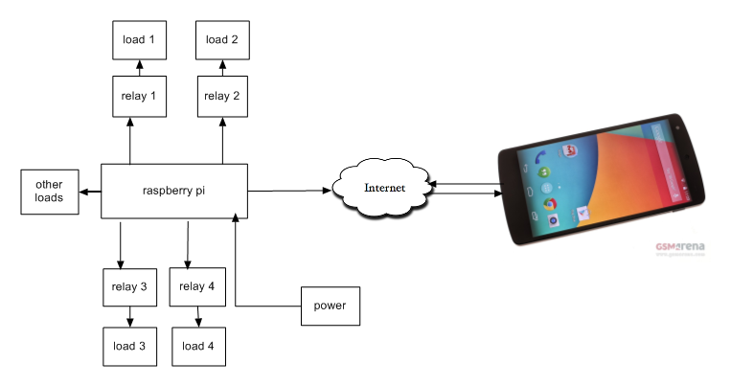

* + 1. **Tools used**

The successful development and implementation of the home automation and the mobile application will require the following major tools;

1. Android studio

Android studio was used as the development environment and it was used because of its rich variety android libraries and easy integration or interaction with external libraries. In addition it is the official integrated development environment for android applications.

1. Java Programming Language

This was used as the core programming language to implement the functionality of the android application. Because Java is easy to run, object-oriented and independent and it can be transferred from one computer to another.

1. Python. Python scripts was used to connect the system to the internet, receive messages or commands from the android application and manipulate pins where loads are connected according to those commands received.
2. Raspberry pi

This is a small, barebones computer developed by the raspberry pi foundation. The printed circuit board houses all the General Purpose Input/output pins.

1. Android mobile phone where the client app was be installed.
2. Four energy saving bulbs connected through a relay board.
3. Light emitting diodes (LED) to represent the other four loads.
4. Raspberry pi to connect entire system to the cloud.
   1. **System implementation**

The mobile application was simulated using the android virtual device embedded in android studio, it was then be compiled and the APK downloaded and installed on to the real android phone. Python scripts was used to interact with raspberry pi connected to the internet with the mode of connection being wireless or Ethernet and a rabbitmq message broker. The cloud server used was cloudAMQP where rabbitmq message broker is configured to receives commands from android and manipulate GPIO pins on pi board.

* 1. **Testing and validation**

The developed system will be tested using different techniques and these will include:

* + 1. **Unit Testing**

This method will involve testing individual units of the system or development process to determine whether they are operational and correct. This will include testing the different modules and classes independently.

* + 1. **Integration testing**

The different modules and classes of the system were brought together and tested for inter-process communication and this was helpful in knowing if the combined units worked as desired.

* + 1. **System testing**

This was carried out to ensure that the system was in line with the specified requirements. It took place on the overall integrated system. The mobile app installed on the android was used to turn off/on electrical bulbs connected to raspberry pi.

# CHAPTER FOUR: SYSTEM ANALYSIS AND DESIGN

1. **Introduction**

This chapter comprised of system analysis and design. The different sections included are functional requirements, system analysis, and hardware and software design, logic design and schematic design.

* 1. **Functional analysis**

The mobile application was analyzed to ensure that it communicates with the hard system properly. The application is able to send commands via a producer to the rabbitmq server configured in the cloud, consumer written in python receives and analyses the command and then manipulate GPIO pins on pi on which the loads are connected. The application sends on/off commands specifying the load name to turn on/off. The mode of communication is based on server client model with the android app as the client.

Communication is based on client-server model with the mobile app being the client and virtual cloud server as the server.

Once any particular load has been turned on/off, the mobile app is able to save the state so the when the user logs back he/she is able to know which load were left on thus allowing monitoring.

* + 1. **Functional requirements**

These requirements describes the behavior of the system as it relates to it functionality. Functional requirements capture the intended behavior of the system, it can be described as services, tasks or functions the system must or required to perform.

The functional requirements of the home automation system included the following;

* Allowed a user to turn on/off lights from specific rooms in their homes remotely using an android application.
* Allowed a user to know which room has light be left on.
* Application was able to save the state of the load whether it’s on or off.
  + 1. **Non-functional requirements**

Non-functional requirements are the metrics that can be measured about the system for example performance. Non-functional requirements also describe aspects of the system that don't relate to its execution, but rather to its evolution over time.

These include the following;

* The mobile application should not just crash just in case the server is offline, thus feedback should be given to the user that it could not connect,
* The mobile application should perform faster on tested devices
* The mobile application should not allow unauthorized access
* The app should give feedback to the user.
* System availability
* System reliability
  + 1. **User requirements**

The user is required to login into the application using the correct passcode set by them at first setup. This is to ensure that no unauthorized access is granted. After logging in, the user can then use the switch buttons to turn off/on lights.

* + 1. **System requirement**

During the development of the system I used the following tools;

**Software tools**

* Java development kit 8 (JDK 8)
* Android studio
* Sublime Text
* Microsoft office 2013 for documentation

**Hardware tools**

* Raspberry pi model A+
* Four channel relay shield
* Four energy saving bulbs
* Four LEDs
* Android phone with version 4.4, 1.2GHz, 5.0 MP
* A laptop computer core i5 with processor speed of 2.50GHz, 4.00GB RAM and 320GB secondary memory with windows 32-bit operating system

**Target System**

* Four energy saving bulbs.
* Four LEDs.
* A relay shield
* Raspberry pi board model A+
* Bread board.
* Android application
  1. **Flow Chart**

The flow chart below shows the operation of the application;

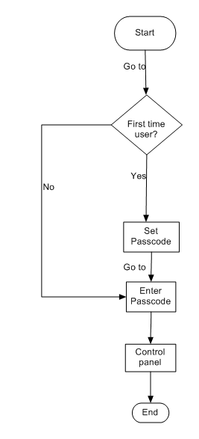Figure 4.1 System flow chart

* 1. **Logical and physical design**

**Use Case diagram**

A use case diagram shows the goal oriented set of interactions between the external actors and the developed application that is used to interact with the hardware with connected loads.

Actors are parties outside the application which in this case are the users that interact with the application.

Figure 4.2 Use Case Diagram

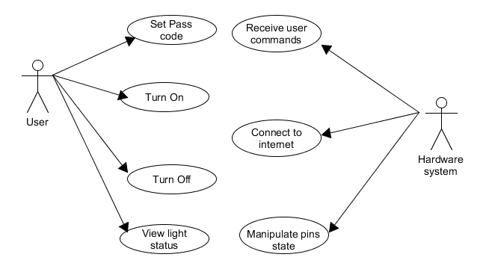

**Physical design**

Figure 4.3 Physical Design

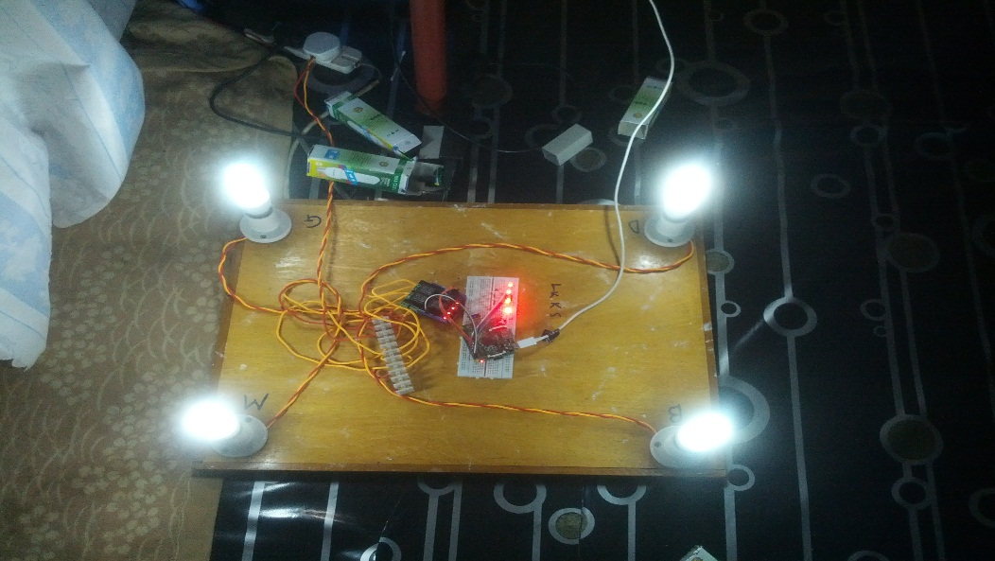

* 1. **System development platform or environment**

Before development began, it was necessary to choose an Integrated Development Environment (IDE) with which the application would be developed. The IDEs chosen was android studio for mobile application and sublime text for writing scripts.

## **Windows operating system**

This was the operating system where the Integrated Development Environments (IDEs), and Sublime text to be used in the development or programming were installed. The specific windows was Windows 7 and was chosen due to its high efficiency and stability.

* + 1. **Android Studio**

Android studio was an integrated development environment (IDE) for development on the android platform. It is the official android development as of the time this project was being implemented. Based on JetBrains’ IntelliJ IDEA software, it’s designed specifically for android application development.

* + 1. **Sublime text**

Sublime text was a text editor and source code editor for windows. It supports and allows working with multiple open files in a single window. It also opens larger files compared to other text editors. However it’s also available for other operating systems as well.

* + 1. **SQLite**

SQLite was a software library that implements a self-contained, server less, zero-configuration, transactional SQL database engine. Mostly used for mobile devices as it is less complex.

* 1. **Code Design**

Refer to the appendices.

* 1. **Verification**

This was done to ensure that the developed system meets and satisfy all requirements.

* + 1. **System testing**
    2. **Unit testing**

During the development of the system, in particular the code design; the codes for different parts were tested to find and rectify errors that existed. In unit testing, each class was tested and integrated different units together, tested and the result was affirmative.

* + 1. **Integration testing**

The mobile app and the hardware where the loads were connected were both tested and the app was able to turn on/off the loads via internet. The specifications of the server and the test device used in testing are detailed below.

**Client mobile phone**

The mobile phone used was Samsung galaxy nexus with the following specifications;

* 16 GB of Internal memory
* 1 GB Ram
* HSPDA 21.1/5.76Mbps
* Wi-Fi 802.11a/ b/g/n, dual-band, DLNA, hotspot
* Dual-core 1.2GHz cortex-A9 CPU
* Android OS, v4.3.0 (Jelly bean)

Also some tests were done on other android versions for example a Huawei Y330 running Android 4.2.2 (Jelly bean) and HTC desire android 4.0.4 (Ice Cream sandwich).

**Server**

The rabbitmq server was configured in the cloudAMQP online server. Rabbitmq was an open source message broker software that implemented advanced message queuing protocol (AMQP). It allowed different applications and processes to communicate with each other by sending messages. CloudAMQP are managed RabbitMQ servers in the cloud. Hosted messages queues that lets you pass messages between processes and other systems. Messages are published to a queue by a producer in this case the android application, the consumer in this case the python scripts, can the get the messages off the queue when the consumer wants to handle the messages. In-between it can route, buffer and persist the messages according to the rule you give it. Messages can be sent across languages, platforms and Operating Systems.

* 1. **Validation**

Validation of the application and the entire hardware side were done to ensure that the entire system meets the specified functional and non-functional requirements.

Figure 4.4 before activating lights

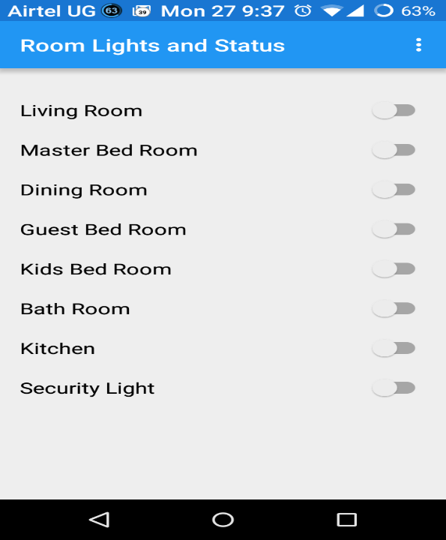

Figure 4.5 all lights activated

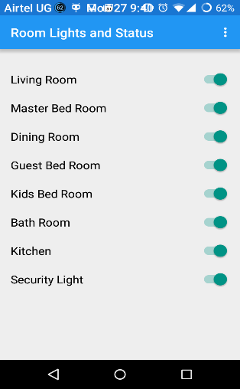

Figure 4.6 Lights on

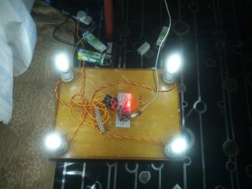

# CHAPTER FIVE: RECOMMMENDATION AND CONCLUSION

1. **Introduction**

This chapter evaluated whether or not the project specification was met, any weaknesses in the approach taken and possible directions this project could be taken in the future to achieve a more regarded goal.

* 1. **Summary of my work**

The main objective of this project was to develop home lights automation system that would allow a user to turn on/off lights from their houses remotely from anywhere.

For presentation and demonstration purposes, an android phone on which the app was installed and raspberry pi, relay shield and bread board on which the lights are connected were used.

Home lights automation was programmed using java, python and rabbitmq server java libraries to link the two languages.

The android app provided the user interface for interaction with the lights and from there a user can set pass code or enter in case it existed. When logged, the user was presented with a control panel which consisted of switch buttons and the room name.

Home light automation system allowed a user to know the status of each light which was saved locally in a file using shared preference in android. The status being on/off and by knowing that a user was able to monitor to make sure there was no unnecessary wastage of power. This helped reduce power consumption thus a reduction in monthly energy bills.

* 1. **Challenges or shortcomings**
* Identifying the programming language that would be used to program the hardware so as to communicate with the android app
* Identifying which java libraries to use in android application to facilitate communication protocol to the internet
* Identifying the hardware board which could be connected to the internet easily
* Finding a secure cloud server to use
* Identifying the message broker that was to be used to facilitate communication between the hardware and the android app.
  1. **Success**

As per the time of this presentation the following were able to be done

* Turn on/off lights using an android app via the internet.
* Being able to know which light was left on.
* Easy to user interface was developed.
* System connected to internet successfully.
  1. **Future research areas**

The following areas should be considered by anyone hoping to venture in developing home automation systems;

* How to determine which load is consuming much power compared with the rest.
* Including all household appliances into the home automation system.
* How to add home appliances dynamically into the system such that when a new electrical appliance is bought, one could just add it.
  1. **Recommendations**
* Use of raspberry Pi 2 Model B: it would do it better since it has A 900MHz quad-core ARM Cortex-A7 CPU, 1GB RAM, 4 USB ports, 40 GPIO pins, Full HDMI port, Ethernet port, Combined 3.5mm audio jack and composite video, Camera interface (CSI), Display interface (DSI), Micro SD card slot, Video Core IV 3D graphics core.

Because it has an ARMv7 processor, it can run the full range of ARM GNU/Linux distributions, including Snappy Ubuntu Core, as well as Microsoft Windows 10.

* 1. **Conclusion**

From this examination, it has been shown that good monitoring of the lights in a home would reduce unnecessary energy consumption when lights are left on accidentally and the ability to remotely operate them with regard to turning on/off also provides convenience.

This was a good way to reduce on electrical bills for most families.

In conclusion, it is worth repeating and emphasizing that the factors contributing to the reduction of electrical consumption in household or family need not be a reminder from UMEME all the time but can be a personal initiative. Indeed, if this system was adopted and installed in most homes, the electrical consumption rate and electrical bills of the households and individuals would reduce.

# REFERENCES

|  |  |
| --- | --- |
| [1] | "Home Automation," 12 feb 2012. [Online]. Available: http://www.engineersgarage.com/articles/home-automation. [Accessed 5 10 2014]. |
| [2] | F. K. D. F. a. V. S. G. Kortuem, " "Smart objects as building blocks for," *Internet Computing,* vol. 14, no. IEEE, pp. 44-51, 2010. |
| [3] | R. Goodman, "Save energy and money with home automation," [Online]. Available: http://www.emagazine.com/earth-talk/saving-energy-and-money-with-home-automation. [Accessed 14 10 2014]. |
| [4] | "Energy Saving with Home Automation," [Online]. Available: http://www.smarthomeautomation.co.nz/energy-efficiency-control-home.htm. [Accessed 12 10 2014]. |
| [5] | "energy conservation," [Online]. Available: http://www.businessdictionary.com/definition/energy-conservation.html. [Accessed 10 11 2014]. |
| [6] | "free-energy-saving -tips," [Online]. Available: www.uswitch.com/energy-saving/guides/free-energy-saving -tips. [Accessed 12 10 2014]. |
| [7] | "How to Reduce Your Energy Consumption," [Online]. Available: http://www.nrdc.org/air/energy/genergy.asp. [Accessed 12 10 2014]. |
| [8] | "Home Automation," [Online]. Available: http://www.comcast.com/resources/home-automation.html. [Accessed 15 10 2014]. |
| [9] | S. A. a. S. V. Altaf, "RTOS based Home Automation System using Android," *International Journal of Advanced Trends in Computer Science and Engineering,* vol. 2, no. 2013, pp. 480-484, January 2013. |
| [10] | B. M. C. S. H. V. R. C. D. C. Y. Z. e. a. C. C. Ko, "IEEE Transactions on Systems, Man and Cybernetics," *Part C: Applications and Reviews,* vol. 31, no. 2001, pp. 295-303. |
| [11] | A. K. a. E. S. M. S. H. Khiyal, "SMS Based Wireless Home Appliance Control System (HACS) for Automating Appliances and Security," *Issues in Informing Science and Information Technology,* vol. 6, no. 2009, pp. 887-894. |
| [12] | A. E. a. K. A. Hamed, " "Design and Implementation of a WiFi Based Home Automation System," *World Academy of Science, Engineering and Technology,* vol. 68, no. 2012, pp. 2177-2180. |
| [13] | P. R. a. V. S. K. P. Dutta, " Microcontroller Based Voice Activated Wireless Automation system," *VSRD Internation Journal of Electrocal, Electronics & Communication Engineering,* vol. 2, no. 2012, pp. 642-649. |
| [14] | A. Z. A. a. U. Buhur, ""An internet based wireless home automation system for multifunctional devices," *IEEE Transactions on Consumer Electronics,* vol. 51, no. 2005, pp. 1169-1174. |
| [15] | L.-C. F. a. C.-L. W. N.-S. Liang, ""An integrated, flexible, and Internet-based control architecture for home automation system in the Internet era,"," *in IEEE International Conference on Robotics and Automation,* no. Washington, DC 2002, p. Robotics and Automation. |
| [16] | "Synco living – the energy-saving home automation system," [Online]. Available: http://www.siemens.com/about/sustainability/en/environmental-portfolio/productssolutions/building-technology/home-automation.htm. [Accessed 14 10 2014]. |
| [17] | C. Buenaflor, "Webee is an Android Home Automation System," 13 Feb 2014. [Online]. Available: http://thedroidguy.com/2014/02/webee-android-homeautomation-system-85024. [Accessed 15 10 2014]. |
| [18] | M. Rouse, "radio frequency," [Online]. Available: http://searchnetworking.techtarget.com/definition/radio-frequency. [Accessed 10 11 2014]. |
| [19] | M. Pinola, "What is Wi-Fi?," [Online]. Available: http://mobileoffice.about.com/od/glossary/g/wi-fi.htm. [Accessed 10 11 2014]. |
| [20] | "Internet of Things,"What Is the Internet of Things?"," [Online]. Available: http://www.cisco.com/web/solutions/trends/iot/overview.html. [Accessed 10 11 2014]. |
| [21] | "Bluetooth Fast Facts What is Bluetooth technology?," [Online]. Available: http://www.bluetooth.com/Pages/FastFacts.aspx. [Accessed 5 11 2014]. |
| [22] | "The official Bluetooth website from Bluetooth SIG," [Online]. Available: www.Bluetooth.com. [Accessed 5 11 2014]. |
| [23] | "Bluetooth Committee, Specifications of the Bluetooth System (Core)," vol. 1.0B, no. December 1999. |
| [24] | W. Team, "WebWise," 10th October 2012. [Online]. Available: http://www.bbc.co.uk/webwise/guides/what-is-the-internet. [Accessed 29 10 2014]. |
| [25] | H. C. Y. W. S.-C. a. L. C.-M. C. Chiu-Chiao, "Bluetooth-Based Android," *in 2nd International Conferenceon Innovations in Bioinspired Computing and Appplications(IBICA 2011),* pp. 309-312, 2011. |
| [26] | M. M. S. N. a. M. S. D. Javale, "Home Automation and Security System," *International Journal of Electronics Communication and Computer ,* vol. 3, no. 2013, pp. 382-385, March 2013 . |
| [27] | J. P. a. S. Sukittanon, ""Exploiting Bluetooth on Android mobile devices for home security "," *in Southeastcon,* F2012. |
| [28] | M. H. L. R. S. S. S. M. M. I. M. A. O. H. A. S. e. a. R. A. Ramlee, "Bluetooth Remote Home Automation System Using Android Application," *The International jorunal of Engineering and Science,* vol. 2, no. 2013, pp. 149-153, 11January 2013 . |
| [29] | O. K. a. F. L. L. N. Swamy, "Internet-based educational control systems lab using," *IEEE Transactions on Education,* vol. 45, no. 2002, pp. 145-151, 07 August 2002 . |
| [30] | T. H. L. a. C. Y. S. K. K. Tan, ""Internet-based monitoring of distributed control systems -An undergraduate experiment,"," *IEEE Transactions on Education,* vol. 45, no. 2002, pp. 128-134, May 2002. |
| [31] | A. R. M. a. Z. F. J. A. Rajabzadeh, "A Mobile Application for Smart House Remote Control System,," *World Academy of Science, Engineering and Technology ,* vol. 62, no. 2010.. |

# APPENDICES

## **Appendix A: Android code for turning on/off lights**

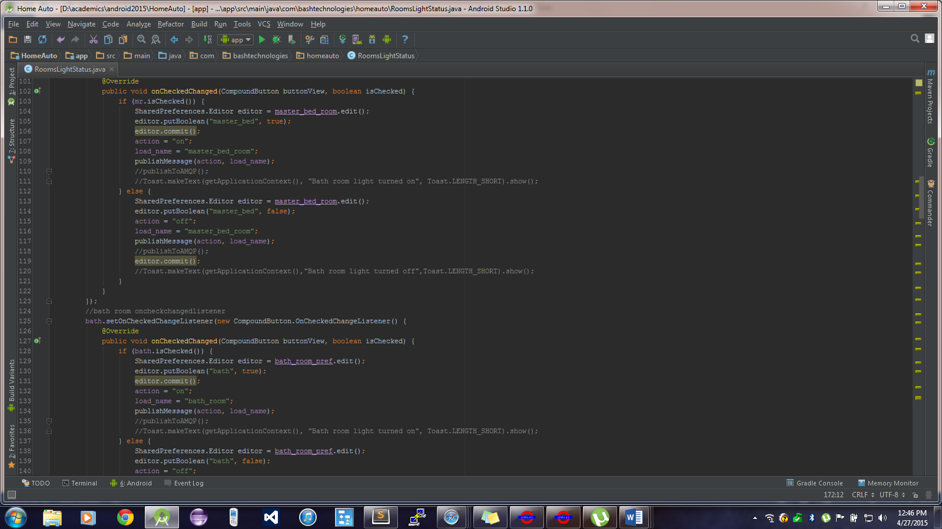

## **Appendix B: Android code for creating passcode**

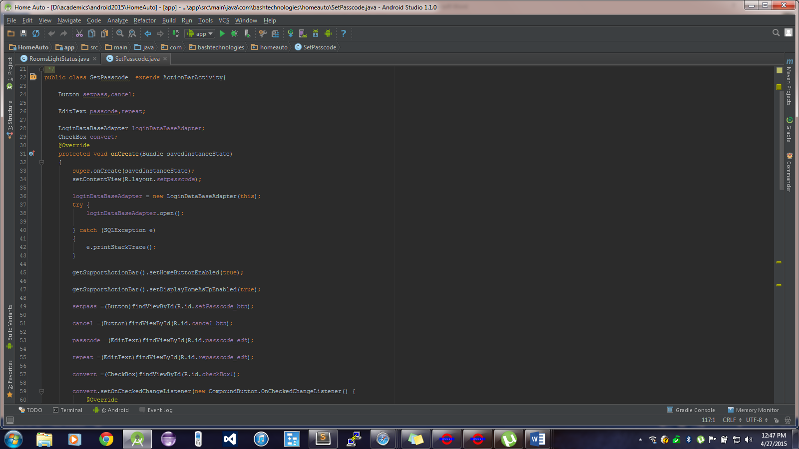

## **Appendix C: Python script**

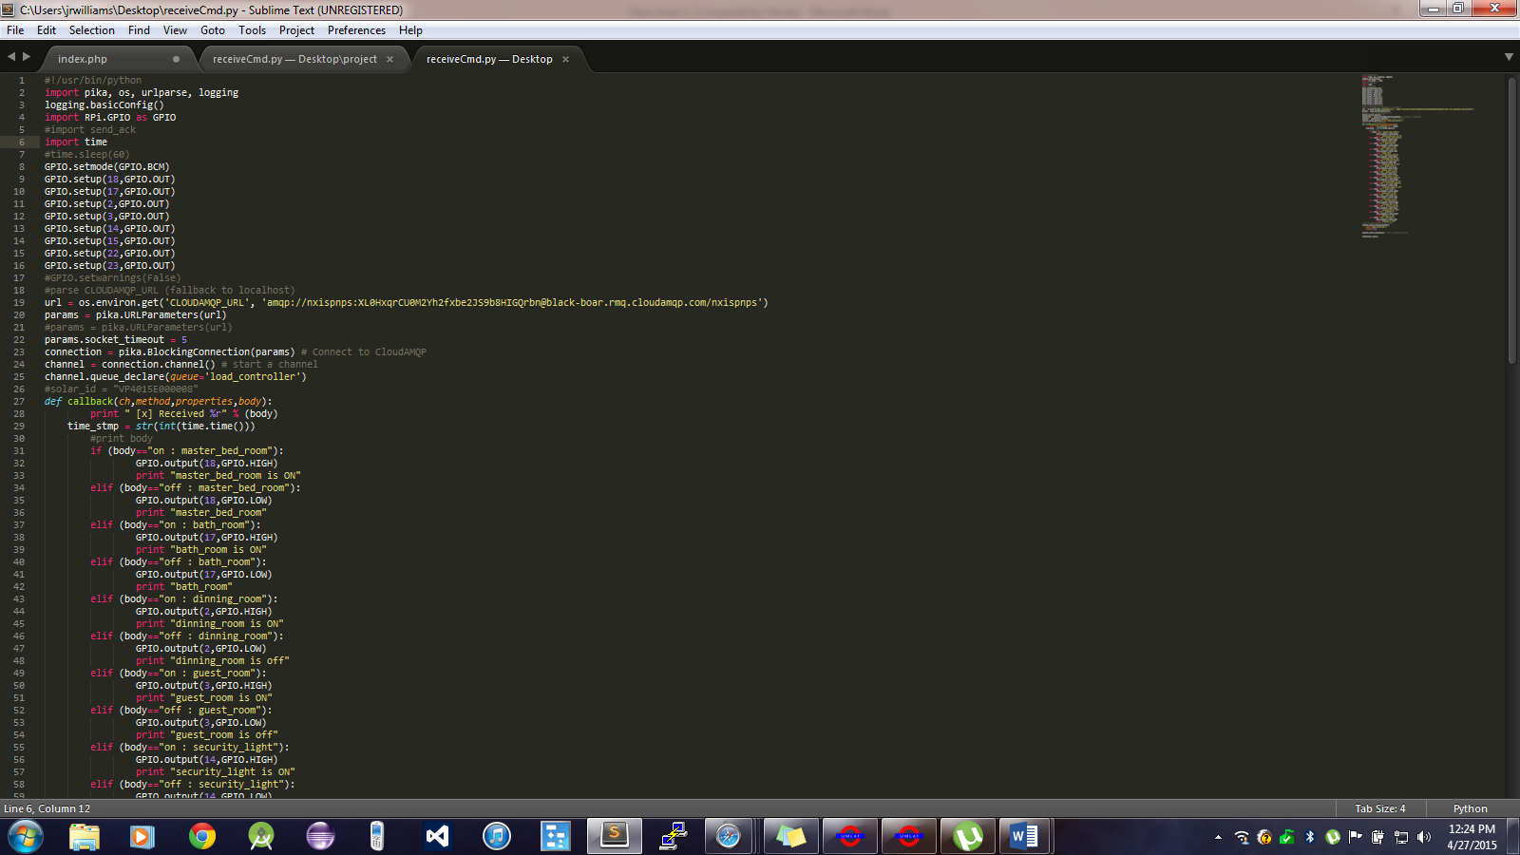

**Appendix D: Java publisher code**

public void publishToAMQP()

{

publishThread = new Thread(new Runnable() {

@Override

public void run() {

while (true)

{

try {

Connection connection = connectionFactory.newConnection();

Channel ch = connection.createChannel();

String queue_name ="load_controller";

//String routingKey ="project_messages_and";

//String exchange_name =" ";

//ach.exchangeDeclare(exchange_name,"fanout",true);

//ch.exchangeDeclare("","fanout");

ch.queueDeclare(queue_name,false,false,false,null);

//ch.exchangeDeclare();

ch.confirmSelect();

while (true)

{

message = queue.take();

try {

ch.basicPublish("","load_controller",null,message.getBytes());

Log.d("Rabbitmq","[s]" + message);

ch.waitForConfirmsOrDie();

}catch (Exception e){ Log.d("Rabbitmq","[f]" + message);

queue.put(message);

throw e;}}} catch (IOException e) {

e.printStackTrace();}

catch (Exception e)

{

Log.d("Rabbitmqublish", "Connection Broken" + e.getClass().getName());

try {

Thread.sleep(1000);

} catch (InterruptedException e1) {

e1.printStackTrace();

break;

}

}

}});

publishThread.start();}