girlSurveyReport

Kevin Gilds

Saturday, July 04, 2015

## $ILearnedFromTheBooksWeReadThisYear  
##   
## -99   
## 0 4   
## Agree Agree a little   
## 298 157   
## Disagree Disagree a little   
## 18 35   
## Don't Know/Prefer Not to say Strongly Agree   
## 15 194   
## Strongly Disagree   
## 14   
##   
## $myReadingSkillsImprovedThisYear  
##   
## -99   
## 0 4   
## Agree Agree a little   
## 304 139   
## Disagree Disagree a little   
## 16 24   
## Don't Know/Prefer Not to say Strongly Agree   
## 25 212   
## Strongly Disagree   
## 11   
##   
## $EstablishedAPostiveRelationship...  
##   
## -99   
## 0 2   
## Agree Agree a little   
## 268 85   
## Disagree Disagree a little   
## 8 20   
## Don't Know/Prefer Not to say Strongly Agree   
## 16 333   
## Strongly Disagree   
## 3   
##   
## $...HelpedMeRecognizeThingsIDoWell  
##   
## -99   
## 0 3   
## Agree Agree a little   
## 267 74   
## Disagree Disagree a little   
## 7 18   
## Don't Know/Prefer Not to say Strongly Agree   
## 14 349   
## Strongly Disagree   
## 3

## [1] 735 4

## ILearnedFromTheBooksWeReadThisYear  
## -99   
## 0 4   
## Agree Agree a little   
## 298 157   
## Disagree Disagree a little   
## 18 35   
## Don't Know/Prefer Not to say Strongly Agree   
## 15 194   
## Strongly Disagree   
## 14

## myReadingSkillsImprovedThisYear  
## -99   
## 0 4   
## Agree Agree a little   
## 304 139   
## Disagree Disagree a little   
## 16 24   
## Don't Know/Prefer Not to say Strongly Agree   
## 25 212   
## Strongly Disagree   
## 11

##   
## Paired t-test  
##   
## data: hr2$hr.avg.x and hr2$hr.avg.y  
## t = 2.4758, df = 400, p-value = 0.01371  
## alternative hypothesis: true difference in means is not equal to 0  
## 95 percent confidence interval:  
## 0.03641414 0.31720182  
## sample estimates:  
## mean of the differences   
## 0.176808

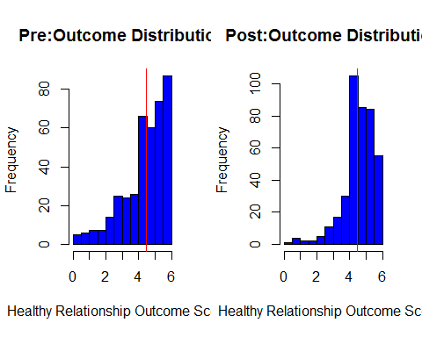

### Tests

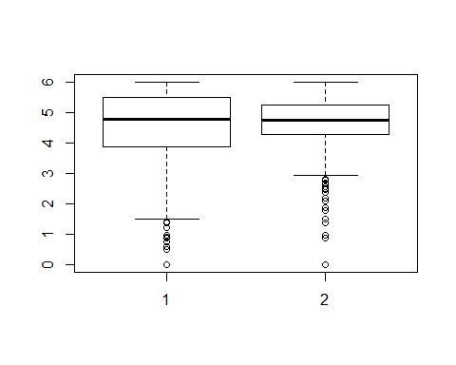

##   
## Wilcoxon signed rank test with continuity correction  
##   
## data: hr2$hr.avg.y and hr2$hr.avg.x  
## V = 34197, p-value = 0.1179  
## alternative hypothesis: true location shift is less than 0

## Outcome Tables

### Pre Survey Data and Graphs

ggplot(hr1, aes(hr.avg.y >=4.45)) + geom_bar(stats="identitiy", fill="blue", width = .5) + labs(x="Achieving at High Level", title = "Pre: Healthy Relationships")

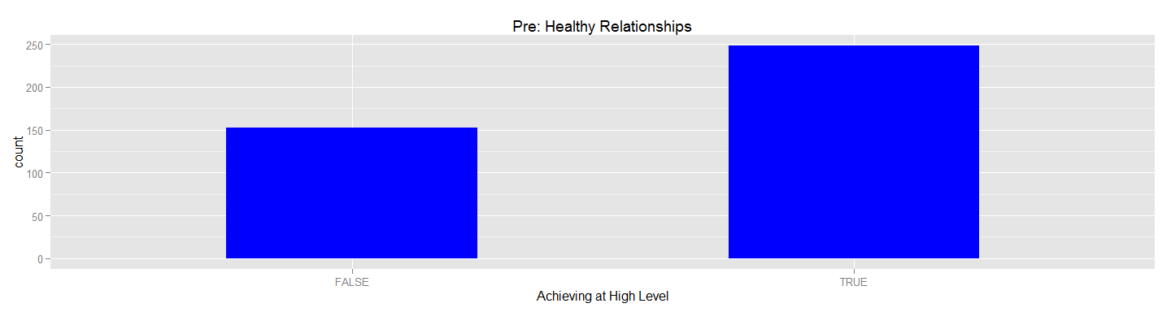

ggplot(hr, aes(hr.avg.y >=4.45, fill= council.x)) + geom_bar(stats = "identity") + facet_grid(~council.x) + labs(x = "Achieving at High Level", title = "Pre: Healthy Relationships by Council")

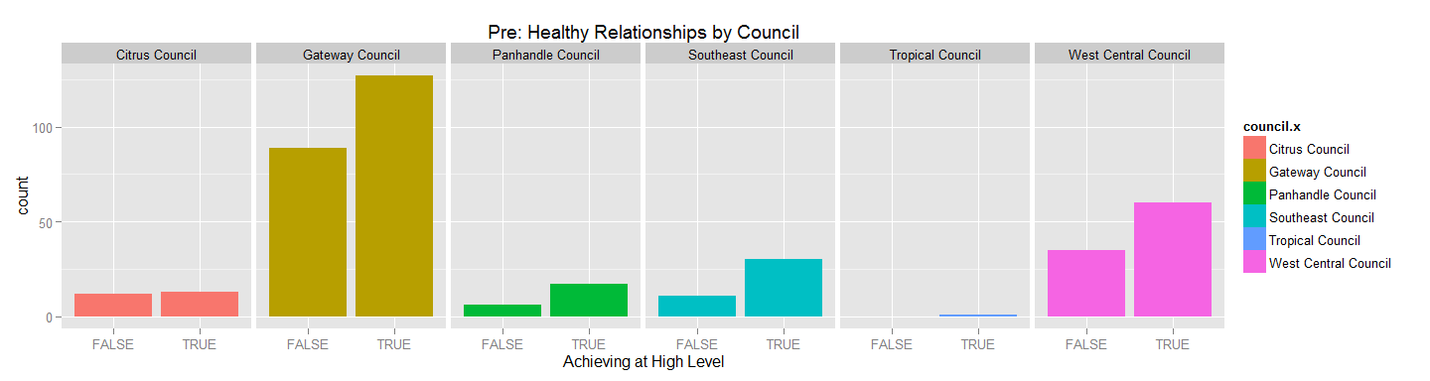

###########Pre Survey Results  
  
hr_table_pre <- with(hr1,table(hr.avg.y >=4.45))  
  
pander(hr_table_pre, style = "multiline")

|  |  |
| --- | --- |
| FALSE | TRUE |
| 153 | 248 |

#########Pre by council#################  
  
hr_table_pre_council <-with(hr1,table(council.x, hr.avg.y >=4.45))  
  
pander(hr_table_pre_council, style = "multiline")

|  |  |  |
| --- | --- | --- |
|  | FALSE | TRUE |
| **Citrus Council** | 12 | 13 |
| **Gateway Council** | 89 | 127 |
| **Panhandle Council** | 6 | 17 |
| **Southeast Council** | 11 | 30 |
| **Tropical Council** | 0 | 1 |
| **West Central Council** | 35 | 60 |

##########By Percents##################

#### Post Survey

####Post Council  
  
hr_post <- with(hr, hr.avg.x >=4.45)  
  
  
  
hr_table_post <-with(hr1,table(hr.avg.x >=4.45))  
  
hr_table_post

##   
## FALSE TRUE   
## 113 288

hrTableCouncilPost <-with(hr1,table(council.x, hr.avg.x >=4.45))  
  
pander(hrTableCouncilPost, style = "simple")

|  |  |  |
| --- | --- | --- |
|  | FALSE | TRUE |
| **Citrus Council** | 10 | 15 |
| **Gateway Council** | 66 | 150 |
| **Panhandle Council** | 7 | 16 |
| **Southeast Council** | 13 | 28 |
| **Tropical Council** | 0 | 1 |
| **West Central Council** | 17 | 78 |

##########Maintain High Level but did not increase Outcome Score############  
  
hr_maintain <-filter(hr1, hr.avg.x >=4.45 & diffhr <=0)  
  
  
  
  
hr_maintain_council <- with(hr1, table(council.x, hr.avg.x >=4.45 & diffhr <=0))  
  
pander(hr_maintain_council, style = "multiline")

|  |  |  |
| --- | --- | --- |
|  | FALSE | TRUE |
| **Citrus Council** | 20 | 5 |
| **Gateway Council** | 148 | 68 |
| **Panhandle Council** | 15 | 8 |
| **Southeast Council** | 28 | 13 |
| **Tropical Council** | 0 | 1 |
| **West Central Council** | 55 | 40 |

##############Increased Score###################3  
  
hrIncrease <-filter(hr1, diffhr > 0)  
  
dim(hrIncrease)

## [1] 184 6

hr_increase_tbl <-with(hr1, table( diffhr >0))  
  
pander(hr_increase_tbl, style = "multiline")

|  |  |
| --- | --- |
| FALSE | TRUE |
| 217 | 184 |

hr_increase_council_tbl <- with(hr1, table(council.x, diffhr >0))  
  
pander(hr_increase_council_tbl, style = "multiline")

|  |  |  |
| --- | --- | --- |
|  | FALSE | TRUE |
| **Citrus Council** | 12 | 13 |
| **Gateway Council** | 113 | 103 |
| **Panhandle Council** | 14 | 9 |
| **Southeast Council** | 24 | 17 |
| **Tropical Council** | 1 | 0 |
| **West Central Council** | 53 | 42 |

###########From not achieving to achieving###################  
  
### General outcome Df did not achieve on pre  
hr_not_a <-filter(hr1, hr.avg.y < 4.45)  
  
##################Table did not achieve pre; acheived post########33  
hr_table_not_pre <- with(hr_not_a, table(hr.avg.x>=4.45))  
  
pander(hr_table_not_pre, style = "multiline")

|  |  |
| --- | --- |
| FALSE | TRUE |
| 56 | 97 |

##############Table did not achieve by Council  
  
hr_not_a_council <- with(hr_not_a, table(council.x, hr.avg.x >=4.45 ))  
  
pander(hr_not_a_council, style = "multiline")

|  |  |  |
| --- | --- | --- |
|  | FALSE | TRUE |
| **Citrus Council** | 6 | 6 |
| **Gateway Council** | 31 | 58 |
| **Panhandle Council** | 3 | 3 |
| **Southeast Council** | 8 | 3 |
| **Tropical Council** | 0 | 0 |
| **West Central Council** | 8 | 27 |

####### Pre/Post Outcome   
  
par(mfrow=c(1,2))  
  
ggplot(hr1, aes(hr.avg.y >=4.45)) + geom_bar(stats="identitiy", fill="blue", width = .5)

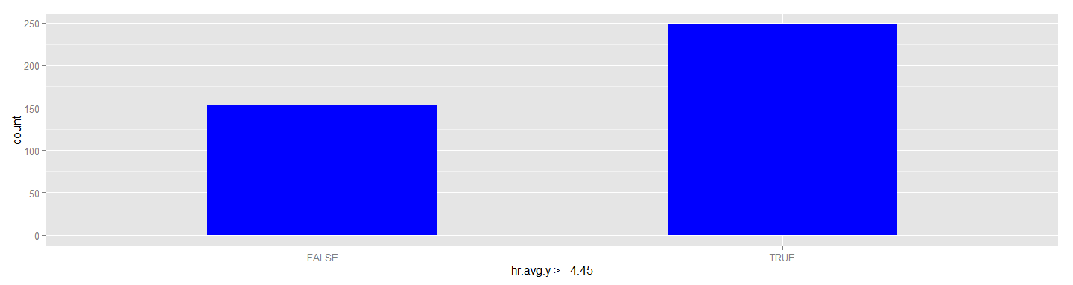

ggplot(hr, aes(x= hr.avg.x >=4.45)) + geom_bar(fill= "blue", stats="identity", width = .5)

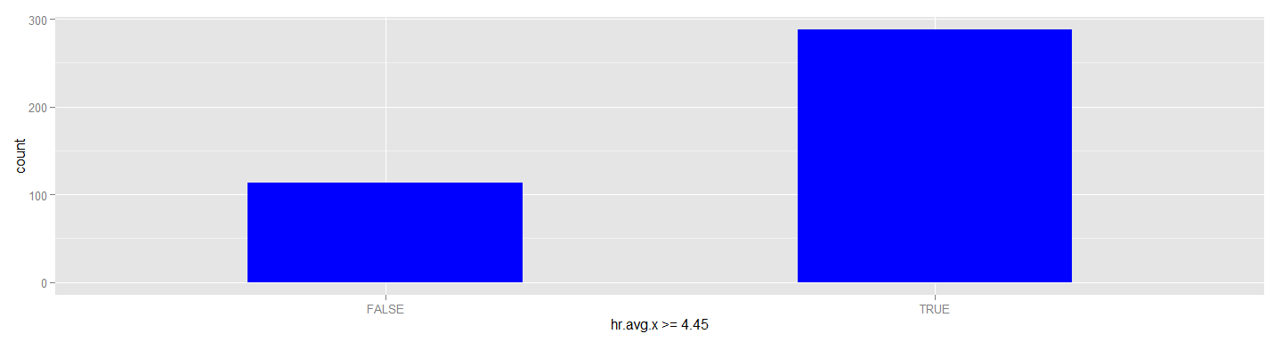

######Pre   
ggplot(hr, aes(hr.avg.y >=4.45, fill= council.x)) + geom_bar(stats = "identity") + facet_grid(~council.x)

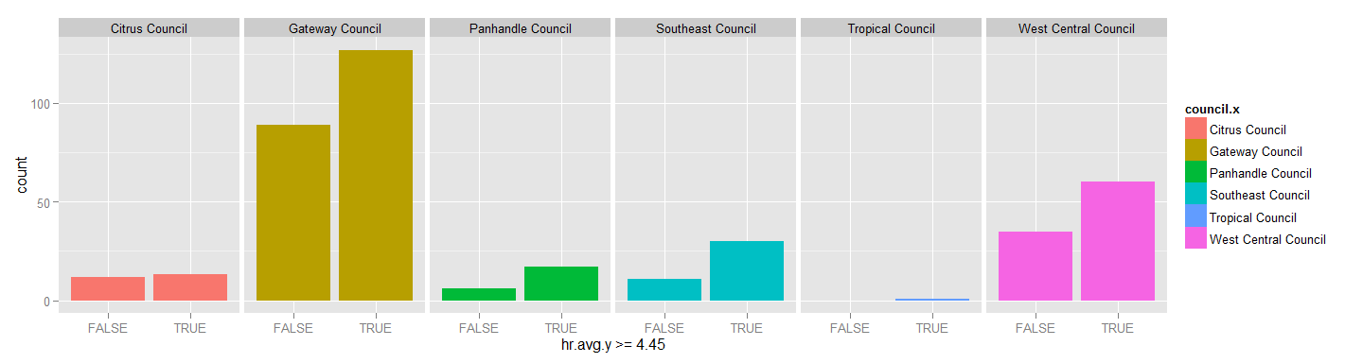

ggplot(hr, aes(x= hr.avg.x >=4.45, fill=council.x)) + geom_bar(stats="identity") + facet_grid(~council.x)

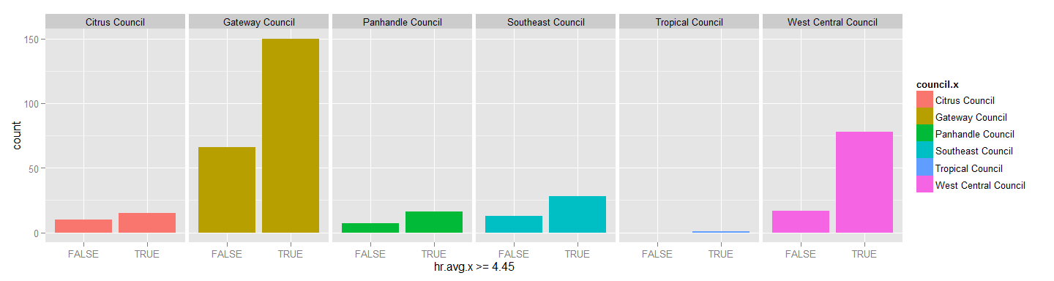

barplot(hr_table_pre, col="blue", main="Pre Survey: ")  
  
barplot(hr_table_post, col="blue", ylim=c(0,300), main="Post Survey: Achieved Outcome Healthy Relationships")  
abline(h=0)

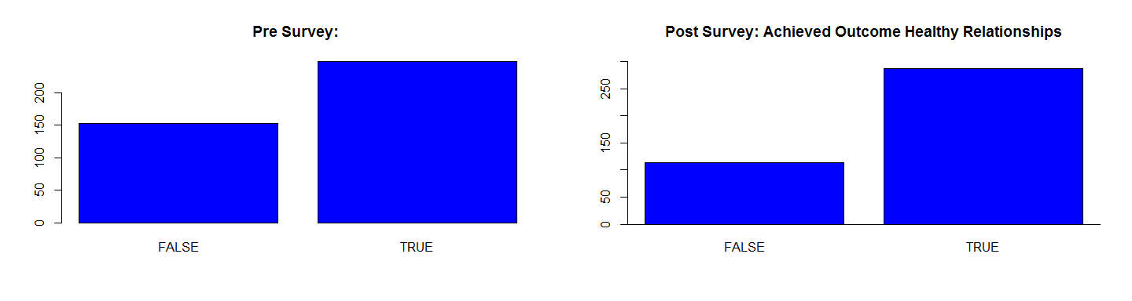

ggplot(hr, aes(x = hr.avg.x >=4.45)) + geom_bar(stats = "identify")

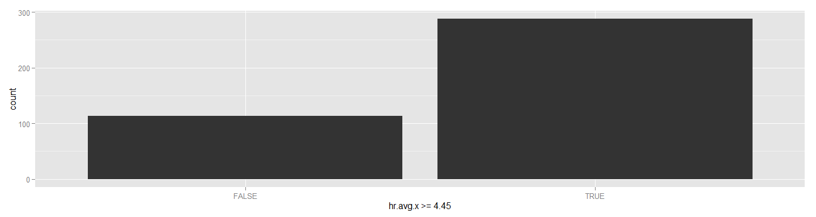

### Academic Mastery

####################Pair down date frame into the Outcomes that we are interested in#########  
am <- select(prePost, Time.x, council.x, girlCode, am.avg.x, am.avg.y)  
  
  
#########################Match the completed cases################################  
am1<- am %>% filter(complete.cases(am))   
  
  
############################Calculate diff between post score and pre score##########  
diffam <- (am1$am.avg.x-am1$am.avg.y)  
  
###################Bind to dataframe##########################################  
  
am1<-cbind(am1, diffam)

##################T-tests###################################################3  
  
am2 <- select(am1, Time.x, council.x, girlCode,am.avg.x, am.avg.y)  
  
t.test(am2$am.avg.x, am2$am.avg.y, paired=TRUE)

##   
## Paired t-test  
##   
## data: am2$am.avg.x and am2$am.avg.y  
## t = -2.6017, df = 400, p-value = 0.009622  
## alternative hypothesis: true difference in means is not equal to 0  
## 95 percent confidence interval:  
## -0.26794264 -0.03729427  
## sample estimates:  
## mean of the differences   
## -0.1526185

par(mfrow=c(1,2))  
hist(am2$am.avg.y, col="blue", main="Pre Outcome Distribution", xlab="Academic Mastery Outcome Scores")  
abline(v=4.8, col="red")  
hist(am2$am.avg.x, col="blue", main="Post Outcome Distribution", xlab="Academic Mastery Outcome Scores")  
abline(v=4.8, col="red")

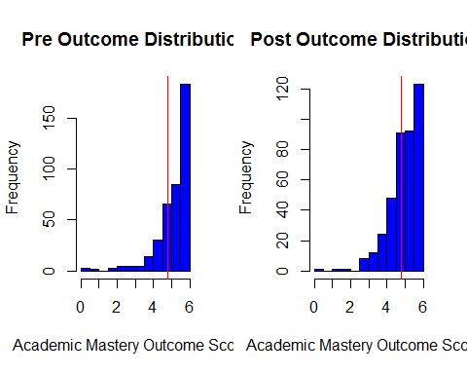

boxplot(am2$am.avg.y, am2$am.avg.x)  
  
wilcox.test(am2$am.avg.y, am2$am.avg.x, "less",paired=TRUE)

##   
## Wilcoxon signed rank test with continuity correction  
##   
## data: am2$am.avg.y and am2$am.avg.x  
## V = 34984, p-value = 0.9999  
## alternative hypothesis: true location shift is less than 0

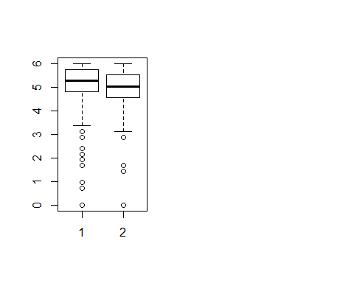

### Academic Mastery: Pre Survey

#####Pre Results  
  
ggplot(am2, aes(am.avg.y >=4.8)) + geom_bar(stats="identitiy", fill="blue", width = .5)

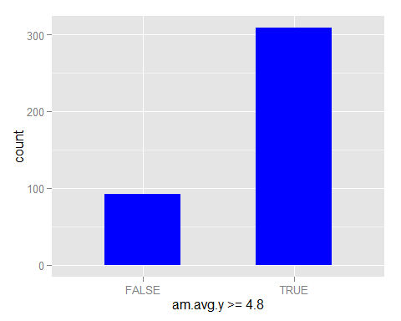

am_pre_df <- filter(am2, am.avg.y >= 4.8)  
  
amTablePre <- with(am2,table(am.avg.y >=4.8))  
  
pander(amTablePre, style = "multiline")

|  |  |
| --- | --- |
| FALSE | TRUE |
| 92 | 309 |

########Pre Results By Council################  
  
ggplot(am2, aes(am.avg.x >=4.8, fill= council.x)) + geom_bar(stats = "identity") + facet_grid(~council.x)

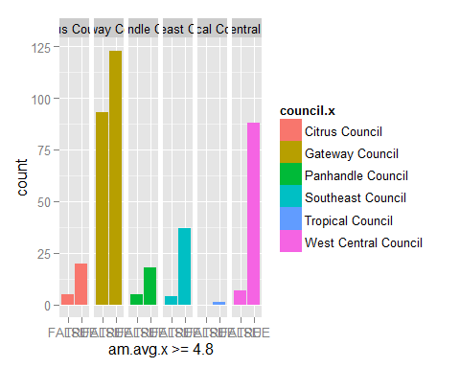

amTableCouncilPre <- with(am2,table(council.x,am.avg.y >=4.8))  
  
  
pander(amTableCouncilPre, style = "multiline")

|  |  |  |
| --- | --- | --- |
|  | FALSE | TRUE |
| **Citrus Council** | 7 | 18 |
| **Gateway Council** | 65 | 151 |
| **Panhandle Council** | 2 | 21 |
| **Southeast Council** | 5 | 36 |
| **Tropical Council** | 0 | 1 |
| **West Central Council** | 13 | 82 |

### Academic Mastery: Post Survey Result

############Post Results by Council######33  
  
am_post_df <- filter(am2, am.avg.x >=4.8)  
  
  
amTablePost <-with(am2,table(am.avg.x >=4.8))  
  
pander(amTablePost, style = "multiline")

|  |  |
| --- | --- |
| FALSE | TRUE |
| 114 | 287 |

amTableCouncilPost <- with(am2,table(council.x,am.avg.x >=4.8))  
  
pander(amTableCouncilPost, style = "multiline")

|  |  |  |
| --- | --- | --- |
|  | FALSE | TRUE |
| **Citrus Council** | 5 | 20 |
| **Gateway Council** | 93 | 123 |
| **Panhandle Council** | 5 | 18 |
| **Southeast Council** | 4 | 37 |
| **Tropical Council** | 0 | 1 |
| **West Central Council** | 7 | 88 |

### Academic Mastery: Pre and Post Bar Plots

par(mfrow=c(1,2))  
barplot(amTablePre, col="blue", main = "Pre Survey", xlab="Achieving Academic Mastery")  
abline(h=0)  
  
barplot(amTablePost, col="blue", main = "Pos Survey", xlab="Achieving Academic Mastery", ylim=c(0,300))  
abline(h=0)

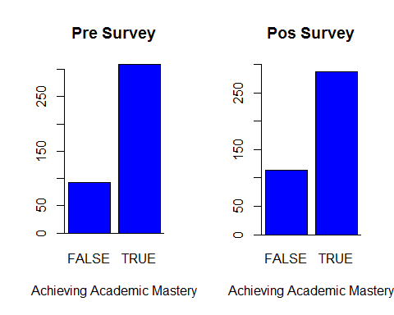

###########From not achieving to achieving###################  
  
amNotA <-filter(am1, am.avg.y < 4.8)  
  
amTableNotPre <- with(amNotA, table(am.avg.x>=4.8))  
  
pander(amTableNotPre, style = "multiline")

|  |  |
| --- | --- |
| FALSE | TRUE |
| 33 | 59 |

################By Council#######################3  
  
am_not_a_council <- with(amNotA, table(council.x, am.avg.x >= 4.8))  
  
pander(am_not_a_council, style = "multiline")

|  |  |  |
| --- | --- | --- |
|  | FALSE | TRUE |
| **Citrus Council** | 3 | 4 |
| **Gateway Council** | 23 | 42 |
| **Panhandle Council** | 2 | 0 |
| **Southeast Council** | 2 | 3 |
| **Tropical Council** | 0 | 0 |
| **West Central Council** | 3 | 10 |

###########Raw Increase##################3  
  
amIncrease <- with(am1, table(diffam >0))   
  
pander(amIncrease, style = "multiline")

|  |  |
| --- | --- |
| FALSE | TRUE |
| 264 | 137 |

am_increase_council <- with(am1, table(council.x, diffam >0))  
  
pander(am_increase_council, style = "multiline")

|  |  |  |
| --- | --- | --- |
|  | FALSE | TRUE |
| **Citrus Council** | 15 | 10 |
| **Gateway Council** | 142 | 74 |
| **Panhandle Council** | 16 | 7 |
| **Southeast Council** | 25 | 16 |
| **Tropical Council** | 1 | 0 |
| **West Central Council** | 65 | 30 |

######### By council##################3  
  
am_increase_council <- with(am1, table(council.x, diffam >0))  
  
pander(am_increase_council, style = "multiline")

|  |  |  |
| --- | --- | --- |
|  | FALSE | TRUE |
| **Citrus Council** | 15 | 10 |
| **Gateway Council** | 142 | 74 |
| **Panhandle Council** | 16 | 7 |
| **Southeast Council** | 25 | 16 |
| **Tropical Council** | 1 | 0 |
| **West Central Council** | 65 | 30 |

#####Maintain  
  
amMaintain <- filter(am1, am.avg.x >=4.8)  
  
amMaintainTbl <-with(amMaintain, table(diffam <=0))  
  
pander(amMaintainTbl, style = "multiline")

|  |  |
| --- | --- |
| FALSE | TRUE |
| 121 | 166 |

am_maintain_tbl_council <- with(amMaintain, table(council.x,diffam <=0))  
  
pander(am_maintain_tbl_council)

|  |  |  |
| --- | --- | --- |
|  | FALSE | TRUE |
| **Citrus Council** | 9 | 11 |
| **Gateway Council** | 63 | 60 |
| **Panhandle Council** | 6 | 12 |
| **Southeast Council** | 14 | 23 |
| **Tropical Council** | 0 | 1 |
| **West Central Council** | 29 | 59 |

############################Academic Engagement##########################333  
ae <- select(prePost, Time.x, council.x, girlCode,ae.avg.x, ae.avg.y )  
  
  
  
ae1<-ae %>% filter(complete.cases(ae))   
  
  
  
#############Find the difference  
  
ae_diff <- (ae1$ae.avg.x- ae1$ae.avg.y)  
  
############Bind ae_diff to ae1###########################3  
  
ae2 <- cbind (ae1, ae_diff)

######################T-Tests###############################3  
ae3 <- select(ae1, Time.x, council.x, girlCode,ae.avg.x, ae.avg.y)  
  
t.test(ae3$ae.avg.x, ae3$ae.avg.y, paired=TRUE)

##   
## Paired t-test  
##   
## data: ae3$ae.avg.x and ae3$ae.avg.y  
## t = 5.4754, df = 400, p-value = 7.724e-08  
## alternative hypothesis: true difference in means is not equal to 0  
## 95 percent confidence interval:  
## 0.3134855 0.6646940  
## sample estimates:  
## mean of the differences   
## 0.4890898

par(mfrow=c(1,2))  
hist(ae2$ae.avg.y, col="blue", main="Pre Outcome Distribution", xlab="Academic Engagement Outcome Scores")  
abline(v=4.5, col="red")  
hist(ae2$ae.avg.x, col="blue", main="Post Outcome Distribution", xlab="Academic Engagement Outcome Scores")  
abline(v=4.5, col="red")

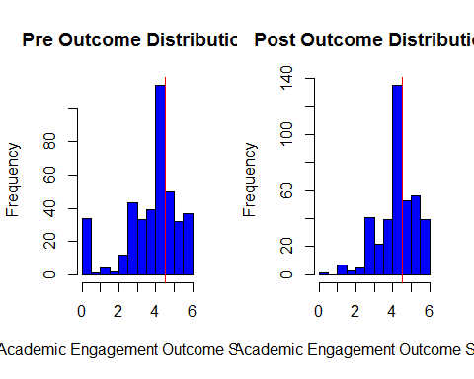

boxplot(ae2$ae.avg.y, ae2$ae.avg.x)  
wilcox.test(ae2$ae.avg.y, ae2$ae.avg.x, "less", paired=TRUE)

##   
## Wilcoxon signed rank test with continuity correction  
##   
## data: ae2$ae.avg.y and ae2$ae.avg.x  
## V = 22950, p-value = 5.148e-06  
## alternative hypothesis: true location shift is less than 0

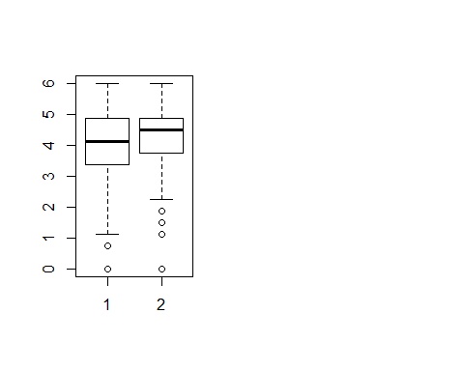

#### Academic Engagement

###################General Outcome Table####################3  
  
########Pre Survey#########  
  
  
ggplot(ae2, aes(ae.avg.y >= 4.5)) + geom_bar(stats = "identity", fill="blue", width = .5)

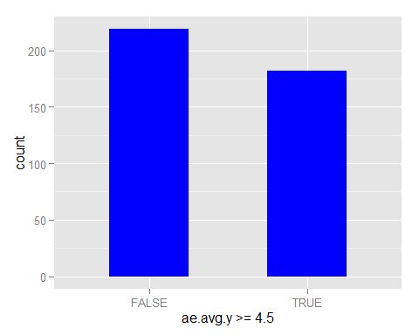

aeTablePre <-with(ae2,table(ae.avg.y >=4.5))  
  
pander(aeTablePre, style = "multiline")

|  |  |
| --- | --- |
| FALSE | TRUE |
| 219 | 182 |

##########Council Pre##################3  
  
ggplot(ae2, aes(ae.avg.y >=4.5, fill= council.x)) + geom_bar(stats = "identity") + facet_grid(~council.x)

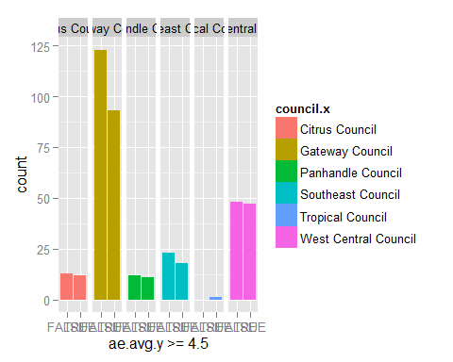

aeTableCouncilPre <- with(ae2,table(council.x,ae.avg.y >=4.5))  
  
pander(aeTableCouncilPre, style = "multiline")

|  |  |  |
| --- | --- | --- |
|  | FALSE | TRUE |
| **Citrus Council** | 13 | 12 |
| **Gateway Council** | 123 | 93 |
| **Panhandle Council** | 12 | 11 |
| **Southeast Council** | 23 | 18 |
| **Tropical Council** | 0 | 1 |
| **West Central Council** | 48 | 47 |

### Academic Engagement: Post Survey

############Post########################3  
  
ggplot(ae2, aes(ae.avg.x >= 4.5)) + geom_bar(stats = "identity", fill="blue", width = .5)

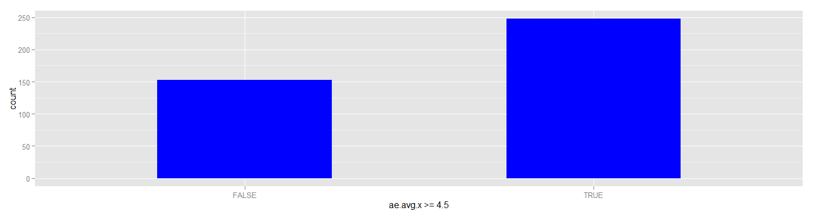

aeTablePost <-with(ae2,table(ae.avg.x >=4.5))  
  
  
pander(aeTablePost, style = "multiline")

|  |  |
| --- | --- |
| FALSE | TRUE |
| 153 | 248 |

############Council Post##################  
  
ggplot(ae2, aes(ae.avg.x >=4.5, fill= council.x)) + geom_bar(stats = "identity") + facet_grid(~council.x)

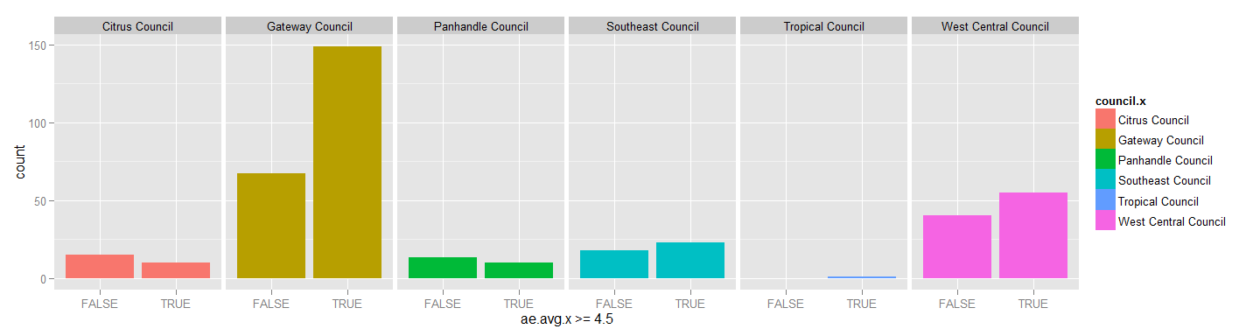

aeTableCouncilPost <- with(ae2,table(council.x,ae.avg.x >=4.5))  
  
  
  
pander(aeTableCouncilPost, style = "multiline")

|  |  |  |
| --- | --- | --- |
|  | FALSE | TRUE |
| **Citrus Council** | 15 | 10 |
| **Gateway Council** | 67 | 149 |
| **Panhandle Council** | 13 | 10 |
| **Southeast Council** | 18 | 23 |
| **Tropical Council** | 0 | 1 |
| **West Central Council** | 40 | 55 |

### Barplots Pre and Post Survey

par(mfrow=c(1,2))  
barplot(aeTablePre, col="blue", main="Pre Survey", xlab="Achieving Academic Engagement")  
abline(h=0)  
  
barplot(aeTablePost, col="blue", main="Post Survey", xlab="Achieving Academic Engagement")  
abline(h=0)

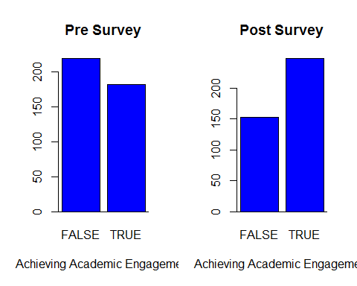

##########From not achieving to achieving####################  
  
  
  
ae_not_df <- filter(ae2, ae.avg.y < 4.5)  
  
aeNotATbl <- with(ae_not_df,table(ae.avg.x >=4.5))  
  
pander(aeNotATbl, style = "multiline")

|  |  |
| --- | --- |
| FALSE | TRUE |
| 93 | 126 |

ae_not_a_council <- with(ae2, table(council.x, ae.avg.x >=4.5))  
  
pander(ae_not_a_council, style = "multiline")

|  |  |  |
| --- | --- | --- |
|  | FALSE | TRUE |
| **Citrus Council** | 15 | 10 |
| **Gateway Council** | 67 | 149 |
| **Panhandle Council** | 13 | 10 |
| **Southeast Council** | 18 | 23 |
| **Tropical Council** | 0 | 1 |
| **West Central Council** | 40 | 55 |

##########From not achieving to achieving####################  
  
  
ae_not_df <- filter(ae2, ae.avg.y < 4.5)  
  
aeNotATbl <-with(ae_not_df,table(ae.avg.x >=4.5))  
  
pander(aeNotATbl, style = "multiline")

|  |  |
| --- | --- |
| FALSE | TRUE |
| 93 | 126 |

ae_not_a_council <- with(ae_not_df, table(council.x, ae.avg.x >=4.5))  
  
pander(ae_not_a_council, style = "multiline")

|  |  |  |
| --- | --- | --- |
|  | FALSE | TRUE |
| **Citrus Council** | 10 | 3 |
| **Gateway Council** | 41 | 82 |
| **Panhandle Council** | 8 | 4 |
| **Southeast Council** | 13 | 10 |
| **Tropical Council** | 0 | 0 |
| **West Central Council** | 21 | 27 |

###### Raw Increase Score  
  
aeIncrease <-with(ae2,table(ae_diff >0))  
  
aeIncrease

##   
## FALSE TRUE   
## 198 203

######### Increase by Council################  
  
ae_increase_council <-with(ae2,table(council.x, ae_diff >0))  
  
pander(ae_increase_council, style = "multiline")

|  |  |  |
| --- | --- | --- |
|  | FALSE | TRUE |
| **Citrus Council** | 20 | 5 |
| **Gateway Council** | 85 | 131 |
| **Panhandle Council** | 15 | 8 |
| **Southeast Council** | 20 | 21 |
| **Tropical Council** | 1 | 0 |
| **West Central Council** | 57 | 38 |

######Maintain Score  
  
ae_maintain <-filter(ae2, ae.avg.x >=4.5)  
  
ae_maintain_tbl <- with(ae_maintain, table(ae_diff <=0))  
  
pander(ae_maintain_tbl, style = "multiline")

|  |  |
| --- | --- |
| FALSE | TRUE |
| 166 | 82 |

############By Council#########################3  
  
ae_maintain_council <-with(ae2, table(council.x, ae_diff <=0))  
  
pander(ae_maintain_council, style = "multiline")

|  |  |  |
| --- | --- | --- |
|  | FALSE | TRUE |
| **Citrus Council** | 5 | 20 |
| **Gateway Council** | 131 | 85 |
| **Panhandle Council** | 8 | 15 |
| **Southeast Council** | 21 | 20 |
| **Tropical Council** | 0 | 1 |
| **West Central Council** | 38 | 57 |

###############Test Anydecrease#############3  
  
ae_decrease <-filter(ae2, ae.avg.x < 4.5 & ae_diff <0)