**Get REAL! Program**

Academic Information Directions and Procedures

Key Points:

* There will be four separate Academic Data Web Links to enter academic data for your program participants.
* All the required information we need to collect for this program may not be found in report cards, but it is still your responsibility to obtain this information from your school contact.
* Enter the date the girl started attending the Get REAL! Program for the current program year.
  + The date of enrollment provides context of when we should start seeing improvement.
  + If the Girl Code information and school information
* Even if a girl starts the program after Quarter 1, it is critical that you still enter their Quarter 1 data. In theory, that it is where we can monitor progress.
* Reading and Language Arts courses are listed in Qualtrics. Simply find the relevant course and enter the grade that the students earned.
  + Courses were pulled from the Florida Department of Education’s Course Code Directory.
  + If you can’t find a student’s reading and or language arts course, there is an option to add one course. Please contact GSWCF to have the course added in Qualtrics.

**Page 1:**

**Participant Information**

* The first heading will tell you which Quarter you are entering grades for.
* Select your Girl Scout Council from the drop down selection.
* Enter the Girl Code that is the same from the surveys
  + Council Code: 3 Characters, Example -320
  + First Name Initial Letter: 1 Character, Example- K
  + Last Name Initial Letter: 1 Character, Example - G
  + Birth Month: 2 Characters, Example- 01
  + Birth Day: 2 Characters, Example- 04
  + Birth Year, last 2: 2 Characters, Example - 01
  + Total Characters: 11--If it is not 11 characters Qualtrics will give you error.
* Enter the School Name

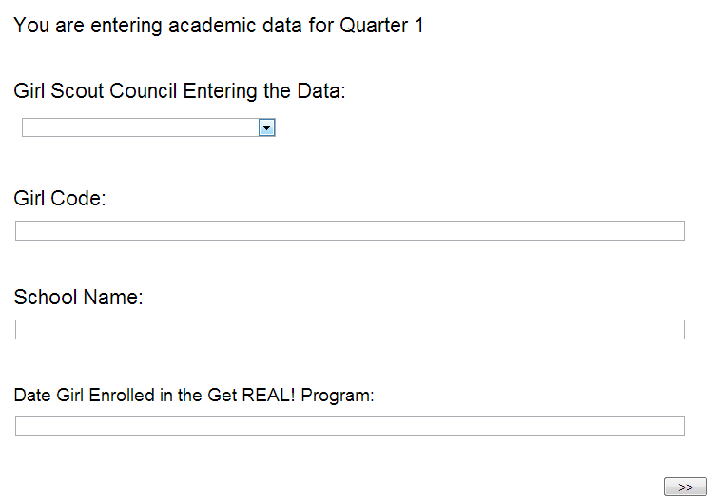

**Page 2:**

**Academic Attendance/Behavior Categories:**

All this information may not be on report cards but it still your responsibility to obtain this information from your school contact.

* **Heading:** No data entry required.
  + You are entering data for “Grading Period”
  + There is Piped Text that will remind you what student you are entering data for and their school.
* **Absences:** 
  + Enter the number of excused and unexcused absences during the quarter in the relevant box.
* **Expelled:**
  + Was the student expelled during the quarter? Yes/No

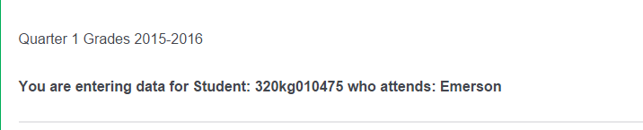

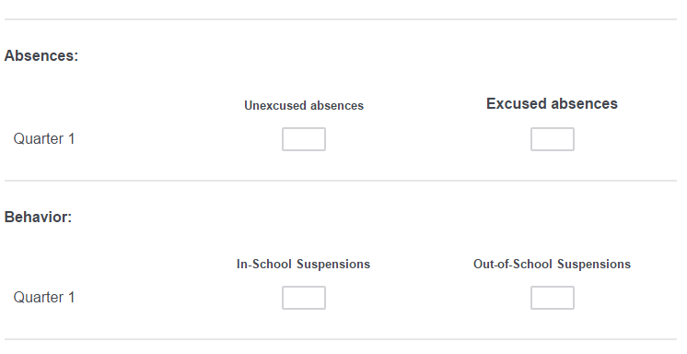

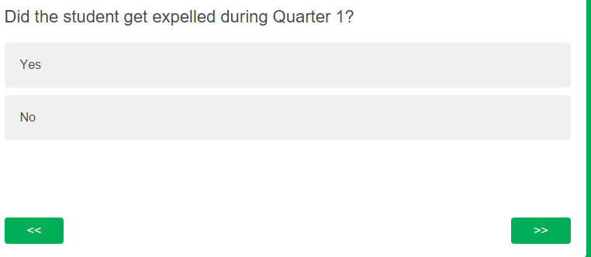

**Addition Question for Quarter 4:**

**Page 3**

**Directions**

Reading and Language Arts Courses from the Florida Course Code Directory have

been listed in the following sections.

There is an attempt to keep the courses in a logical order . You should not have to enter a course; however, there is spot to enter one reading and or language arts courses to help you keep moving. Grades from courses other than Reading or Language Arts are disregarded.

Please see your grade data entry reference guide if additional courses need to entered.

Change from last year

**Use the following guidelines when entering data.**

**If a student earns an A in a course enter A in the text box next to the course.**

**If a student earns a B in a course enter B in the text box next to the courses.**

**If a student earns a C in a course enter C in the text box next to the course.**

**If a student earns a D in a course enter D in the text box next to the course.**

**If a student obtain a F in a course enter F in the text box next to the course.**

**If a student has an Incomplete do not enter the grade until a grade is assigned.**

**Page 4**

**Reading Courses**

**Reading Courses have been put in one page.**

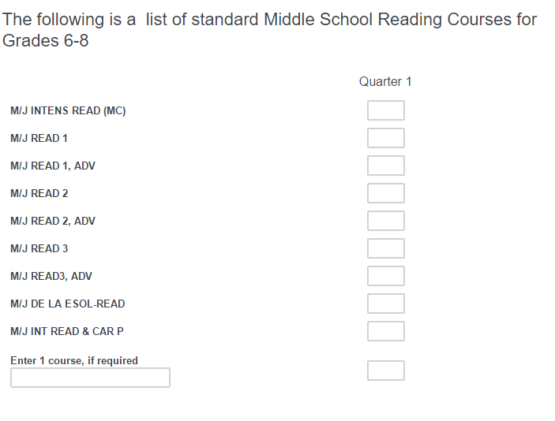

**Page 5**

**Language Arts Courses:**

