# Reading Improvement:

## Objective:

*50% of participating students will improve their reading skills as demonstrated by their Language Arts grade increasing or maintaining a "C" grade from the baseline grading period to the final grading period as evidenced by report cards/school reports.*

### Language Arts Grade: % of Students that increased Grade or maintained a C

The number of students that could be matched from baseline to final is **543**

Success is defined by students who increased their grade and finished with a C or higher and students who maintained at least a “C” grade. A student who improves from a F to D is not considered a success for the purpose of this analysis. Students who went from an A to B is not considered a success for this analysis.

The percent of students with the successful outcome is **82.32%**.

1. The number of students who increased their Language Arts Grade with a final grade of at least a C is **196**
2. The number of students who maintained their baseline grade with at least a C grade is **251**
3. The percent of students who had a failing grade at basline and finished with a passing final grade is **15.29%**

The mean difference betwween baseline grades and final grade ***0.2689***.

### Grade Change Plot from baseline to final grading period:

The changes in grades from baseline to final grading period is represented below. The vertical axis represents baseline grades and the bottom axis the change from the baseline. Thus ideally we want to see circles moving to right. Note that,students with an A in Q1 can decrease but not increase.

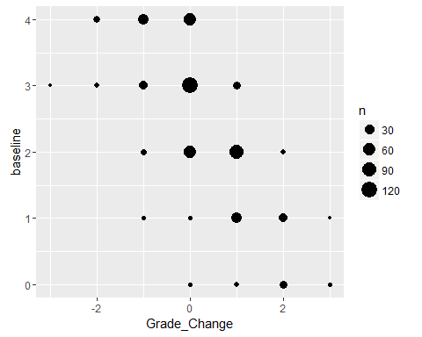

### Reading Success: % of Students that increased Grade or maintained a C

The number of students records that could be matched is **280**.

The percent of students with a successful outcome is **82.86%**.

1. The number of students who increased their reading grade is **95**
2. The number of stuents who maintained at least a "C" grade is **137**

### GPA Difference between baseline and final grading period:

The reading gpa for students is **2.66**, and the average reading grade difference is ***0.2607***.

### Reading Grades Plots:

The changes in grades from baseline to the final grading period is represented below. The vertical axis represents baseline grades and the bottom axis the change from the baseline. Thus ideally we want to see circles moving to right. Note, students with an A during baseline can decrease but not increase.

### Reading Grade Change from baseline to final grading period:

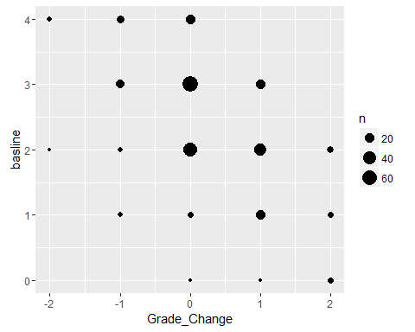

# Improved Attendance:

## Objective:

*60% of participating students will either maintain or improve their attendance rates as demonstrated by their decreased absences from the baseline grading period to the final grading period as evidenced by report cards/school reports.*

The number of student records that could be matched is **542**.

* The percent of students with a successful outcome is **76.38%**.

1. The number of studens who decreased their absences from basline to the final grading period is **292**
2. The number of students who has no absences between the baseline grading period and the final grading period is **122**

* The average difference of absences between basline and final is ***-0.9317***.

### Absences Change Table:

|  |  |  |  |  |  |  |  |  |  |  |  |  |  |  |  |  |  |  |  |
| --- | --- | --- | --- | --- | --- | --- | --- | --- | --- | --- | --- | --- | --- | --- | --- | --- | --- | --- | --- |
| -10 | -9 | -8 | -7 | -6 | -5 | -4 | -3 | -2 | -1 | 0 | 1 | 2 | 3 | 4 | 5 | 6 | 7 | 8 | 9 |
| 3 | 1 | 4 | 8 | 9 | 20 | 28 | 51 | 72 | 96 | 143 | 34 | 23 | 24 | 11 | 11 | 1 | 1 | 1 | 1 |

### Plot of Change in Absences from baseline to final grading period:

The plot below has the council on the vertical axis and the difference in absences between baseline and final grading period.

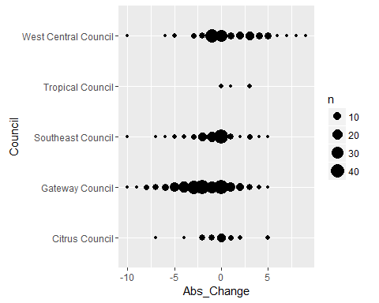

# Improvement In School Behavior

## Objective:

*70% of participating students will show improvement in behavior by decreasing their number of suspensions from the baseline grading period to final grading period or not having a suspension during the school year as evidenced from the student's report card/school reports.*

|  |  |  |  |  |  |  |  |  |  |  |  |
| --- | --- | --- | --- | --- | --- | --- | --- | --- | --- | --- | --- |
| -8 | -5 | -4 | -3 | -2 | -1 | 0 | 1 | 2 | 3 | 4 | 5 |
| 1 | 5 | 3 | 5 | 16 | 24 | 457 | 18 | 8 | 2 | 2 | 1 |

The number of student records that could be matched is **542**.

The percent of students with a successful outcome is **94.1%**.

1. The number of students who decreased their suspensions from baseline to final is **54**
2. The number of students who had no suspensions during baseline and final grading period **456**

The average difference of suspensions between basline and final grading period is ***-0.1162***

### Suspensions Change Plots from baseline to final grading period:

The plot below reflects that their has been an increase in suspensions from baseline to final. The council is on the vertical axis and the suspensions change is on the bottom axis 