# Life Skills

*Objective 4: 70% of participating girls will demonstrate an increased understanding of pertinent life skills as demonstrated by a pre and post assessment*

The students in Get REAL! program met this objective as students achieved across all life skill domains.

Students, parents, and teachers are asked to complete surveys at the time of enrollment in the Get REAL! program and at the end of their session. The questions in the survey are designed to measure the following life skills.

1. Healthy Relationships
2. Academic Engagement
3. Academic Mastery

The questions and the scoring methodology of the girl survey were developed and tested by the Girl Scout Research Institute. Girls answer multiple questions to obtain an outcome score for each life skill domain. Responses to survey questions are assigned numbers/points and outcome scores are calculated by averaging responses to survey questions for each category. The points for each outcome set are averaged to obtain an outcome score. Outcomes scores range from 0-6. Outcome cut points are used to determine high achievement, and they are determined by the number of questions in the outcome set and response options. Below is a breakdown of the cut points by the outcomes measured.

Life Skills Achievement Average Score to Indicate High Achievement

1. Healthy Relationships 4.45=>
2. Academic Mastery 4.8=>
3. Academic Engagement 4.5=>

There were 418 post survey responses and 330 student responses could be matched from the pre-survey to the post survey. There were 844 valid pre survey entry thus an approximate match rate is around 37 percent.

This analysis views any increase in outcome score from the pre assessment to the post assessment or maintaining high achievement as demonstrating an understanding of a life skill. The students demonstated increase knowledge across all life skill domains.

Parent and teacher surveys also provide evidence that the students are benefiting from the program. Please note pre teacher surveys are not analyzed as only 50 were received. Responses from the parent and teacher surveys are summarized with a low , neutral, high, mean, sd heading.

The low heading equates to the percent that responded in the following manner

Strongly Disagree-Disagree- Slight Disagree

The neutral heading equates to the percent that responded in the following manner:

The high heading equates to the percent of that responded in the following manner:

Strongly Agree, Agree, Slightly Agree

The mean heading conveys the mean given that Strongly Agree is 7 and Strongly Disagree is Strongly Disagree is 1.

The sd heading stands for standard deviation.

## Healthy Relationship Life Skill:

Relationship skills are a critical component of success in all realms of life. The Healthy Relationship questions measures the behaviors and attitudes of the respondent regarding their relationship skills. Questions that measure healthy relationships skills include the following:

*Healthy Relationship Questions*

1. If I have a serious problem, I have people to talk with.
2. I let people know if they have hurt my feelings.
3. I let my friends know when I think they are good at something.
4. In any relationship - romantic or not - I make it clear when I don't feel comfortable.

The number of pre and post survey that could be matched is **330**, and the percent of students with a successful outcome is **84.85%**

1. The number of students who achieved at a high level is **257**:
2. The number of studens who did not achieve at high level but increased outcome socre **23**:

The improvement in outcome scores is graphically represented below.

The percent of students who achieved the healthy releationship at a high level is **77.88%**. The imrovement is represented graphically below.

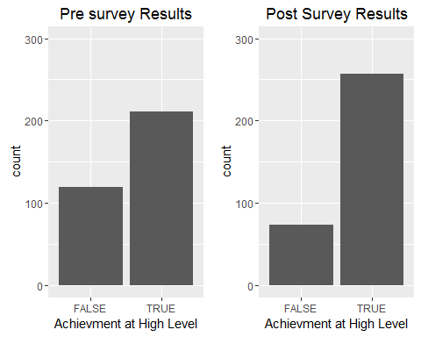

The percent of students who went from low achievment to high achievement **26.67%**. The number of students who had the opportunity to improve their healthy relationship outcome score is **238**, and the mean increase in outcome score is **0.5244748**

The increase in the healthy relationship outcome scores is represented graphically below. Marks to the right of the veticial red line represents an increase in the outcome score. Marks above the horizintal line represents scores above the high and low achievement.

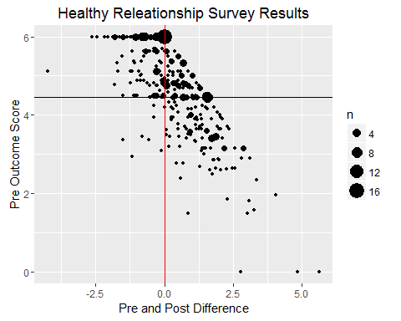

Two statistical tests were administered on the matched survey results the wilcox test and Cohen's D test. The outcome distributions did not approximate a normal distribution, thus A wilcox.test was administered and the results show that the difference between the pre and post outcome scores are significant at .05 level. However, the Cohen’s D test indicates the effect of the intervention is small

Wilcoxon rank sum test with continuity correction: hr_2016$Pre and hr_2016$Post

|  |  |  |
| --- | --- | --- |
| Test statistic | P value | Alternative hypothesis |
| 42887 | 1.101e-06 * * * | less |

The Cohen D test indicates that the effect was small.

##   
## Cohen's d  
##   
## d estimate: 0.3316444 (small)  
## 95 percent confidence interval:  
## inf sup   
## 0.1774961 0.4857928

## Cross Validation of Healthy Relationship Skills

Survey results from teachers and parents also provide evidence that the Get REAL! program helps students increase their relationship skills. Below are tables that provide a breakdown of questions on the post survey from the parent and teacher surveys. The pattern again shows improvement in moderate agreement with the question being both with the parent survey and teacher survey.

### Pre Parent Survey

* Question 5: She develops positive relationships with her classmates.

Results based on 466 responses.

Item low neutral high mean sd  
 Q5 1.502146 9.44206 89.05579 6.321888 1.042863

### Post Parent Survey’

Results based on

* Question 5: She develops positive relationships with her classmates
* Question 9: The Get REAL! program helped my daughter establish positive relationships with her classmates

Item low neutral high mean sd  
 Q9 0.4132231 0.4132231 99.17355 6.706612 0.5547584  
 Q5 0.8230453 1.6460905 97.53086 6.514403 0.7292575

### Teacher Post Survey

* Question 7: She has developed positive relationships with her classmates (N=397)
* Question 10: The Get REAL! program helped her develop positive relationships with classmates. (N=394)

Results based on 397 responses.

Item low neutral high mean sd  
 Q7 0 1.259446 98.74055 6.463476 0.6250665  
 Q10 0 2.791878 97.20812 6.624365 0.6623385

# Academic Engagement

Academic Engagement questions gauge tangible behaviors that help students succeed in school. Questions that measure Academic Engagement include the following.

Number Question

1. I talk with my teachers before or after school, or during lunch about my assignments.

2. I hand in my assignments on time

3. I finish my homework even if it is boring

4. If I can't understand my schoolwork at first, I keep trying until I do understand it.

The number of pre and post survey that could be matched is **330**,and the percent of students with a successful outcome is **80.61%**

1. The number of students achieving the academic engagment outcome at a high level is **238**
2. The number of students who did not achieve outcome at high level but increased their outcome score is **28**

The improvement in outcome scores is graphically represented below.

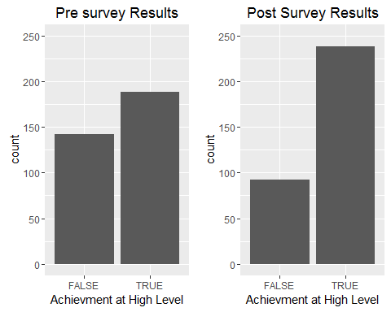

The percent of students who went from low achievement to hig achievement is **25.76%** The number of students who had the opportunity to improve their academic engagement outcome score is **256**, and their mean increase in outcome score is **0.4423828**

The increase in the academic engagement outcome scores is represented graphically below. Marks to the right of the veticial red line represents an increase in the outcome score. Marks above the horizintal line represents scores above the high and low achievement.

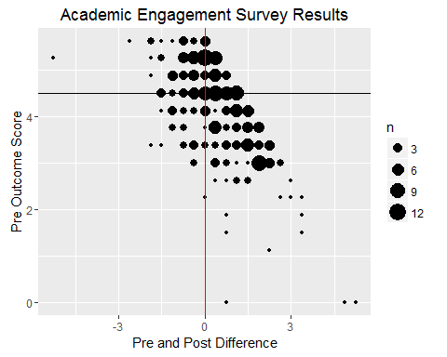

Two statisical tests were administered on the matched survey results the wilcox test and Cohen's D test. The outcome distributions did not approximate a normal distribution, thus A wilcox.test was administered and the results show that the difference between the pre and post outcome scores are significant at .05 level. However the Cohen’s D test indicate the effect of the intervention was small.

Wilcoxon signed rank test with continuity correction: ae_2016$Pre and ae_2016$Post

|  |  |  |
| --- | --- | --- |
| Test statistic | P value | Alternative hypothesis |
| 11932 | 1.163e-08 * * * | less |

The Cohen D test indicates that the effect was small.

##   
## Cohen's d  
##   
## d estimate: -0.3133395 (small)  
## 95 percent confidence interval:  
## inf sup   
## -0.4673752 -0.1593037

## Cross Validation of Academic Engagment

Survey results from teachers and parents also provide evidence that the Get REAL! program helps students learn tangible tools to help them succeed in school. Below are tables that provide a breakdown of questions on the post survey from the parent and teacher surveys. The pattern again shows improvement in moderate agreement with the question being both with the parent survey and teacher survey.

### Parent Pre Survey:

Question 6: She works on her homework at home without supervision (N=465)

Item low neutral high mean sd  
 Q6 1.72043 8.602151 89.67742 6.352688 1.102661

### Post Parent Survey

Question 6: She works on her homework at home without supervision (N=244)

Item low neutral high mean sd  
 Q6 1.234568 0 98.76543 6.584362 0.7413985

### Teacher Post Survey

Only post teacher survey data is reported as there were less than 50 responses to the pre teacher survey.

* Question 5: She positively participates in class
* Question 6: She completes the homework given to her.

Results based on 397 responses.

Item low neutral high mean sd  
 Q5 0.5037783 0.7556675 98.74055 6.405542 0.7136968  
 Q6 0.7556675 0.7556675 98.48866 6.370277 0.7729147

# Academic Mastery Life Skill

The Academic Mastery questions gauge a student's attitude towards school and education. Questions that measure Academic Mastery include the following.

* It's important to me that I improve my skills this year in school
* It's important to me that I really understand my class work
* Learning at school is important to me
* One of my goals in school is to learn as much as I can
* The things I am learning in school will help me later in life

The number of pre and post survey that could be matched is **330**, and the percent of students with a successful outcome is **88.79%**

1. The number of students achieving the academic engagment outcome at a high level is **282**
2. The number of students who did not achieve outcome at high level but increased their outcome score is **11**

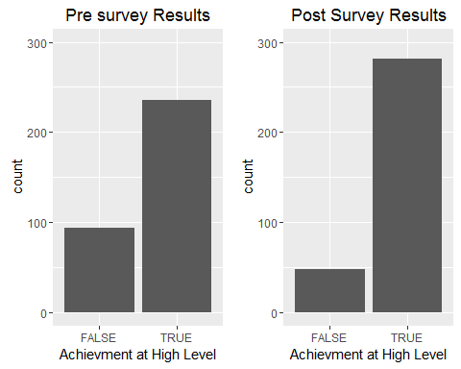

The percent of students who went from low achievement to hig achievement is **24.24%** The number of students who had the opportunity to improve their academic engagement outcome score is **200**, and their mean increase in outcome score is **0.4092.**

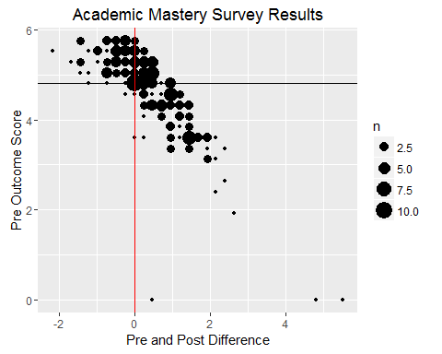

### Statistical Tests

Two statisical tests were administered on the matched survey results the wilcox test and Cohen's D test. The outcome distributions did not approximate a normal distribution, thus a wilcox.test was administered and the results show that the difference between the pre and post outcome scores are significant at .05 level. However, the Cohen’s D Test indicates that the intervention effect size is small.

Wilcoxon signed rank test with continuity correction: am_2016$Pre and am_2016$Post

|  |  |  |
| --- | --- | --- |
| Test statistic | P value | Alternative hypothesis |
| 13671 | 0.0001128 * * * | Less |

The Cohen D test indicates that the effect was small.

Cohen's d  
   
 d estimate: -0.2181761 (small)  
## 95 percent confidence interval:  
## inf sup   
## -0.37172858 -0.06462362

## Cross Validation of Academic Mastery

Survey results from teachers and parents also provide evidence that the Get REAL! program helps students formulate better attitude toward school. Below are tables that provide a breakdown of questions on the post survey from the parent and teacher surveys. The pattern again shows improvement in moderate agreement with the question being both with the parent survey and teacher survey.

#### Pre Parent Survey

* Question 1: She is motivated to graduate high school
* Question 3: She has a Good Attitude About School

Results based on 466 respones.

Item low neutral high mean sd  
 Q3 0.6437768 2.360515 96.99571 6.510730 0.7957499  
 Q1 0.2145923 7.296137 92.48927 6.630901 0.8829508

### Post Parent Survey

* Question 1: She is motivated to graduate high school
* Question 3: She has a Good Attitude About School

Results based on 244 responses.

Item low neutral high mean sd  
 Q1 0.000000 1.2345679 98.76543 6.522634 0.6253115  
 Q3 1.234568 0.8230453 97.94239 6.481481 0.7784989

### Teacher Post Survey

* Question 1: She is motivated to graduate high school
* Question 3: She has a Good Attitude About School

The number of responses to the post teacher survey is 397.

Item low neutral high mean sd  
 Q1 0.2518892 1.007557 98.74055 6.465995 0.6643728  
 Q3 0.7556675 1.259446 97.98489 6.365239 0.7142848