# Introduction

The Get REAL! program is a statewide mentoring program facilitated by six Girl Scout Councils in Florida. The goal of the Get REAL! program is to help at-risk middle school girls achieve academic success by connecting them to caring mentors in the community. Girl Scout facilitators and mentors deliver the Get REAL! program which includes a literacy component, character building, educational enhancement experience, and community service.

The purpose of this report is to measure the program against the established set of performance measures to ensure program quality. Evidence obtained from the program both quantitative and qualitative provide strong confidence that the Get REAL! program is meeting program objectives and providing value to students.

## Program Operation

Each Girl Scout Council collaborates with the school officials to identify girls that would benefit from the Get REAL! program. Referrals come to the Get REAL! staff from school personnel and appropriate referrals for Get REAL! are at-risk girls based on (but not limited to) one or more of the following criteria:

* Enrolled in the 6th to 8th grade
* Are one or more grade levels behind in school;
* Who scored at Level l or Level II in FSA reading;
* Have high absenteeism, or high disciplinary referrals;
* Struggling socially/family problems.

Student recruitment activities included meeting with school officials, word of mouth recruitment, announcement at school assemblies, visiting after-school programs. The enrollment goal of the Get REAL! program was to serve 900 students by the end of the 4th Quarter. The Girl Scouts Councils reached or their goal by serving 909 students. Student enrollment data by Girl Scout Council are as follows:

|  |  |  |  |  |
| --- | --- | --- | --- | --- |
| Council Name | Sixth Grade | Seventh Grade | Eighth Grade | Total |
| Citrus Council | 54 | 51 | 35 | 140 |
| Gateway Council | 93 | 88 | 91 | 272 |
| Panhandle Council | 31 | 56 | 21 | 108 |
| Southeast Council | 17 | 48 | 56 | 121 |
| Tropical Council | 36 | 11 | 47 | 94 |
| West Central Council | 35 | 68 | 71 | 174 |
| Total: |  |  |  | 909 |

## 

## 

## Attendance Data

Students in the program attended on a regular basis as evidenced by monthly attendance reports. Review of attendance data demonstrates that the Girl Scout Councils consistently served over girls a month. The councils started the program year fast by serving over girls in October. From March through May, Girl Scout councils were serving on average over girls a month.

## Staff Quality

All program staff and mentors are personally interviewed, complete an Affidavit of Good Moral Character, submit to a reference check, and must satisfactorily pass a criminal background check in order to begin working with students. Upon successful completion of the application process, new staff and mentors receive training on the approved program curriculum, and safety standards. Trainings that must be completed by new staff and mentors include Girl Scouts 101, CPR/First Aid, Diversity, and Team Building.

## Mentor Recruitment

The Girl Scout Councils recruited and trained a total of 49 individuals to be mentors and the mentors logged at least 1242 hours to assist students in the program. The goal of the Get REAL! program was to recruit enough mentors to maintain a 15-1 student-mentor relationship. The councils were not able to meet the 15-1 ratio. There appears to be variation between councils and their success with mentors. The range of mentors by council ranged from a high of 22 to a low of 1.

## Program Components:

The education literature has shown that students who are engaged in school achieve better educational outcomes such as higher grades and greater achievement on standardized tests. In contrast, students who are disengaged are at a higher risk for dropping out of school. Student engagement is multiple dimensional including behavioral engagement, emotional engagement, and cognitive engagement. Behavioral engagement consists a student's participation in school activities. Emotional engagement refers to the connections and interactions a student has with peers and teachers. Cognitive engagement refers to resilience and the hard work required to be successful at school (Fredricks et al., 2011).

The program components of the Get REAL! program address the multiple facets of student engagement through a literacy program, character building, educational enhancements and community service opportunities. Facilitators and mentors work together to establish relationships with at-risk students and provide opportunities for educational enhancement trips and community services. The program components and activities of the Councils will be discussed in this section.

### Literacy Component:

Girl Quote

The reading portion of the Get REAL! program uses the See Girls Read! curriculum, and girls read at least five books during the 30-session program. As part of the Girl Scout process, students are given input about what books they wish to read. Mentors facilitate discussion about the books the girls are reading, and participants read and write in their journal. The group discussions and writing activities help increase emotional and cognitive engagement in the students. Periodically the girls are encouraged to share their journals with their mentor and the mentor will respond to them. Journaling gives girls additional writing experience and helps establish connections with their mentor.

The reading list for students in the Get REAL! program included:

Bridge to Terabithia  
Hoot  
The Girls Guide to Loving Yourself

My Feet Aren't Ugly  
Chicken Soup for Soul: Teen Talk Middle School  
Life is Not a Fairy Tale  
Crossing Jordan  
Girl Code  
The Cheat  
Wonder  
Diary of a Teenage Girl  
Tease  
Insurgent

Of the 418 respones to the post survey, 81% of the students strongly agreed to the Students in the Program were asked to respond to the following question. “I learned from the books we read this year.

|  |  |  |  |  |
| --- | --- | --- | --- | --- |
| Don't Know/Prefer Not to say | | Strongly Disagree | | Disagree |
| .199% | | .2398% | | 1.439% |
| Disagree a little | Agree a little | | Agree | Strongly Agree |
| 03.597% | 13.43% | | 33.57% | 46.52% |

### Character Building/Life Skills:

Girl Quote

Relationships and connections with peers and teachers plays a critical role in academic engagement for students (Fredricks et al., 2011). All Girl Scout councils utilize the modules "Expressing My Individuality” and "Body Image" from the Girls Circle curriculum. The modules focus on self-esteem, social development and interpersonal relationships to help the students solidify relationships with themselves, peers, and teachers.

### Educational Enhancements:

Girls in the Get REAL! program participate in educational enhancements that consists of out-of-school learning experiences which include camp visits, legislative day and half-day trips to local educational facilities. Examples of the educational enhancement opportunities offered to the students in the program this year include legislative days in Tallahassee to learn about the government process and advocacy. Students also visited Universal Studios to learn how important science and engineering is for the park. Additionally they visited the Digital and Animation and Visual Effects School located at Universal Studios. Students from Citrus Council attended the Disney Y.E.S. program attended a workshop on Techniques for Teamwork through Imrovisation.

### Community Care Projects

An important part of Girl Scouting is community care projects to help girls identify what they can do to help their community. Community care projects give the students opportunities to identify problems and work together to make a plan to help solve that problem. Each program group develops their own projects that is specific to their community. Examples of community care projects implemented this year include:

1. Food Drive for a Stop Summer Hunger Initiative
2. Created activities and worked a crafting station at a Day Camp for special needs children.
3. Developed a "Recycle Thursday" program at their school.
4. Created Positive Image Poster that were Displayed at School
5. Created an anti-bully and friendship garden.

## Objective Assessment

### Reading Improvement:

## Objective:

*50% of participating students will improve their reading skills as demonstrated by their Language Arts grade increasing or maintaining a "C" grade from the baseline grading period to the final grading period as evidenced by report cards/school reports.*

### Language Arts Grade: % of Students that increased Grade or maintained a C

Success is defined by students who increased their grade and finished with a C or higher and students who maintained at least a “C” grade. A student who improves from a F to D is not considered a success for the purpose of this analysis. Students who went from an A to B is not considered a success for this analysis.

The number of students that could be matched from baseline to final is **543,** and thepercent of students with the successful outcome is **82.32%**.

1. The number of students who increased their Language Arts Grade with a final grade of at least a C is **196**
2. The number of students who maintained their baseline grade with at least a C grade is **251**
3. The percent of students who had a failing grade at basline and finished with a passing final grade is **15.29%**

The mean difference betwween baseline grades and final grade ***0.2689***.

### Grade Change Plot from baseline to final grading period:

The changes in grades from baseline to final grading period is represented below. The vertical axis represents baseline grades and the bottom axis the change from the baseline. Thus ideally we want to see circles moving to right. Note that students with an A in the baseline grading period can decrease but not increase.

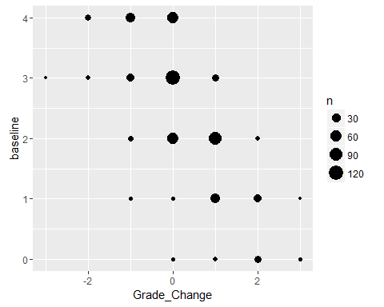

### Reading Success: % of Students that increased Grade or maintained a C

The number of students records that could be matched is **280**.

The percent of students with a successful outcome is **82.86%**.

1. The number of students who increased their reading grade is **95**
2. The number of stuents who maintained at least a "C" grade is **137**

### GPA Difference between baseline and final grading period:

The reading gpa for students is **2.66**, and the average reading grade difference is ***0.2607***.

### Reading Grades Plots:

The changes in grades from baseline to the final grading period is represented below. The vertical axis represents baseline grades and the bottom axis the change from the baseline. Thus ideally we want to see circles moving to right. Note, students with an A during baseline can decrease but not increase.

### Reading Grade Change from baseline to final grading period:

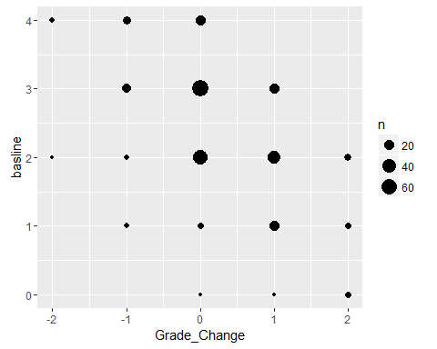

# Improved Attendance:

## Objective:

*60% of participating students will either maintain or improve their attendance rates as demonstrated by their decreased absences from the baseline grading period to the final grading period as evidenced by report cards/school reports.*

The number of student records that could be matched is **542**.

The percent of students with a successful outcome is **76.38%**.

1. The number of students who decreased their absences from basline to the final grading period is **292**
2. The number of students who has no absences between the baseline grading period and the final grading period is **122**

* The average difference of absences between basline and final is ***-0.9317***.

### Absences Change Table:

|  |  |  |  |  |  |  |  |  |  |  |  |  |  |  |  |  |  |  |  |
| --- | --- | --- | --- | --- | --- | --- | --- | --- | --- | --- | --- | --- | --- | --- | --- | --- | --- | --- | --- |
| -10 | -9 | -8 | -7 | -6 | -5 | -4 | -3 | -2 | -1 | 0 | 1 | 2 | 3 | 4 | 5 | 6 | 7 | 8 | 9 |
| 3 | 1 | 4 | 8 | 9 | 20 | 28 | 51 | 72 | 96 | 143 | 34 | 23 | 24 | 11 | 11 | 1 | 1 | 1 | 1 |

### Plot of Change in Absences from baseline to final grading period:

The plot below has the council on the vertical axis and the difference in absences between baseline and final grading period.

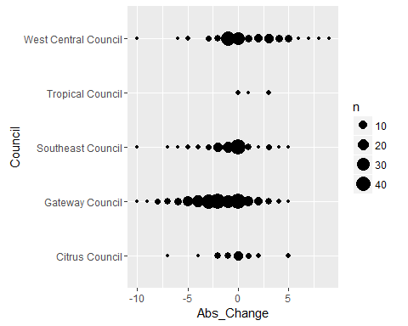

# Improvement In School Behavior

## Objective:

*70% of participating students will show improvement in behavior by decreasing their number of suspensions from the baseline grading period to final grading period or not having a suspension during the school year as evidenced from the student's report card/school reports.*

|  |  |  |  |  |  |  |  |  |  |  |  |
| --- | --- | --- | --- | --- | --- | --- | --- | --- | --- | --- | --- |
| -8 | -5 | -4 | -3 | -2 | -1 | 0 | 1 | 2 | 3 | 4 | 5 |
| 1 | 5 | 3 | 5 | 16 | 24 | 457 | 18 | 8 | 2 | 2 | 1 |

The number of student records that could be matched is **542**.

The percent of students with a successful outcome is **94.1%**.

1. The number of students who decreased their suspensions from baseline to final is **54**
2. The number of students who had no suspensions during baseline and final grading period **456**

The average difference of suspensions between basline and final grading period is ***-0.1162***

### Suspensions Change Plots from baseline to final grading period:

The plot below reflects that their has been an increase in suspensions from baseline to final. The council is on the vertical axis and the suspensions change is on the bottom axis

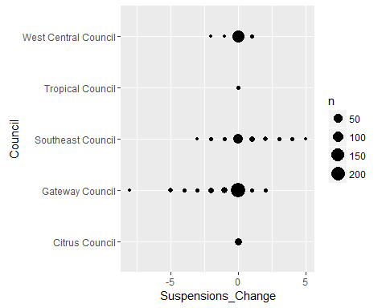

# Life Skills

*Objective 4: 70% of participating girls will demonstrate an increased understanding of pertinent life skills as demonstrated by a pre and post assessment*

The students in Get REAL! program met this objective as students achieved across all life skill domains.

Students, parents, and teachers are asked to complete surveys at the time of enrollment in the Get REAL! program and at the end of their session. The questions in the survey are designed to measure the following life skills.

1. Healthy Relationships
2. Academic Engagement
3. Academic Mastery

The questions and the scoring methodology of the girl survey were developed and tested by the Girl Scout Research Institute. Girls answer multiple questions to obtain an outcome score for each life skill domain. Responses to survey questions are assigned numbers/points and outcome scores are calculated by averaging responses to survey questions for each category. The points for each outcome set are averaged to obtain an outcome score. Outcomes scores range from 0-6. Outcome cut points are used to determine high achievement, and they are determined by the number of questions in the outcome set and response options. Below is a breakdown of the cut points by the outcomes measured.

Life Skills Achievement Average Score to Indicate High Achievement

1. Healthy Relationships 4.45=>
2. Academic Mastery 4.8=>
3. Academic Engagement 4.5=>

There were 418 post survey responses and 330 student responses could be matched from the pre-survey to the post survey. There were 844 valid pre survey entry thus an approximate match rate is around 37 percent.

This analysis views any increase in outcome score from the pre assessment to the post assessment or maintaining high achievement as demonstrating an understanding of a life skill. The students demonstrated increase knowledge across all life skill domains.

Parent and teacher surveys also provide evidence that the students are benefiting from the program. Please note pre teacher surveys are not analyzed as only 50 were received. Responses from the parent and teacher surveys are summarized with a low , neutral, high, mean, sd heading.

The low heading equates to the percent that responded in the following manner

Strongly Disagree-Disagree- Slight Disagree

The neutral heading equates to the percent that responded in the following manner:

The high heading equates to the percent of that responded in the following manner:

Strongly Agree, Agree, Slightly Agree

The mean heading conveys the mean given that Strongly Agree is 7 and Strongly Disagree is Strongly Disagree is 1.

The sd heading stands for standard deviation.

## Healthy Relationship Life Skill:

Relationship skills are a critical component of success in all realms of life. The Healthy Relationship questions measures the behaviors and attitudes of the respondent regarding their relationship skills. Questions that measure healthy relationships skills include the following:

*Healthy Relationship Questions*

1. If I have a serious problem, I have people to talk with.
2. I let people know if they have hurt my feelings.
3. I let my friends know when I think they are good at something.
4. In any relationship - romantic or not - I make it clear when I don't feel comfortable.

The number of pre and post survey that could be matched is **330**, and the percent of students with a successful outcome is **84.85%**

1. The number of students who achieved at a high level is **257**:
2. The number of students who did not achieve at high level but increased outcome score **23**:

The improvement in outcome scores is graphically represented below.

The percent of students who achieved the healthy relationship at a high level is **77.88%**. The improvement is represented graphically below.

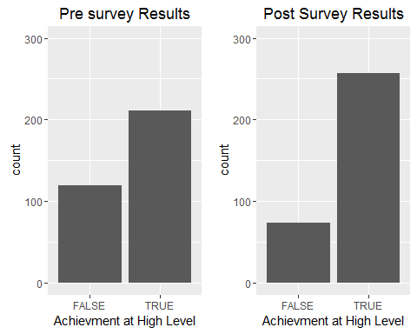

The percent of students who went from low achievement to high achievement **26.67%**. The number of students who had the opportunity to improve their healthy relationship outcome score is **238**, and the mean increase in outcome score is **0.5244748**

The increase in the healthy relationship outcome scores is represented graphically below. Marks to the right of the vertical red line represents an increase in the outcome score. Marks above the horizontal line represents scores above the high and low achievement.

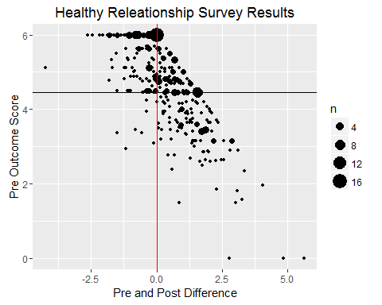

Two statistical tests were administered on the matched survey results the wilcox test and Cohen's D test. The outcome distributions did not approximate a normal distribution, thus a wilcox.test was administered and the results show that the difference between the pre and post outcome scores are significant at .05 level. However, the Cohen’s D test indicates the effect of the intervention is small

Wilcoxon rank sum test with continuity correction: hr_2016$Pre and hr_2016$Post

|  |  |  |
| --- | --- | --- |
| Test statistic | P value | Alternative hypothesis |
| 42887 | 1.101e-06 * * * | Less |

The Cohen D test indicates that the effect was small.

##   
## Cohen's d  
##   
## d estimate: 0.3316444 (small)  
## 95 percent confidence interval:  
## inf sup   
## 0.1774961 0.4857928

## Cross Validation of Healthy Relationship Skills

Survey results from teachers and parents also provide evidence that the Get REAL! program helps students increase their relationship skills. Below are tables that provide a breakdown of questions on the post survey from the parent and teacher surveys. The pattern again shows improvement in moderate agreement with the question being both with the parent survey and teacher survey.

### Parent Survey

* Question 5: She develops positive relationships with her classmates.

Pre results based on 466 responses.

Post results based on

Time Item low neutral high mean sd  
 Pre: Q5 1.502146 9.44206 89.05579 6.321888 1.042863

Post: Q5 0.8230453 1.6460905 97.53086 6.514403 0.7292575

Results based on

* Question 9: The Get REAL! program helped my daughter establish positive relationships with her classmates

Item low neutral high mean sd  
 Q9 0.4132231 0.4132231 99.17355 6.706612 0.5547584

### Teacher Post Survey

* Question 7: She has developed positive relationships with her classmates (N=397)
* Question 10: The Get REAL! program helped her develop positive relationships with classmates. (N=394)

Results based on 397 responses.

Item low neutral high mean sd  
 Q7 0 1.259446 98.74055 6.463476 0.6250665  
 Q10 0 2.791878 97.20812 6.624365 0.6623385

# Academic Engagement

Academic Engagement questions gauge tangible behaviors that help students succeed in school. Questions that measure Academic Engagement include the following.

*Academic Engagement Questions:*

1. I talk with my teachers before or after school, or during lunch about my assignments.

2. I hand in my assignments on time

3. I finish my homework even if it is boring

4. If I can't understand my schoolwork at first, I keep trying until I do understand it.

The number of pre and post survey that could be matched is **330**,and the percent of students with a successful outcome is **80.61%**

1. The number of students achieving the academic engagment outcome at a high level is **238**
2. The number of students who did not achieve outcome at high level but increased their outcome score is **28**

The improvement in outcome scores is graphically represented below.

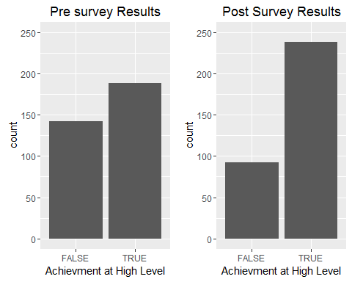

The percent of students who went from low achievement to hig achievement is **25.76%** The number of students who had the opportunity to improve their academic engagement outcome score is **256**, and their mean increase in outcome score is **0.4423828**

The increase in the academic engagement outcome scores is represented graphically below. Marks to the right of the veticial red line represents an increase in the outcome score. Marks above the horizintal line represents scores above the high and low achievement.

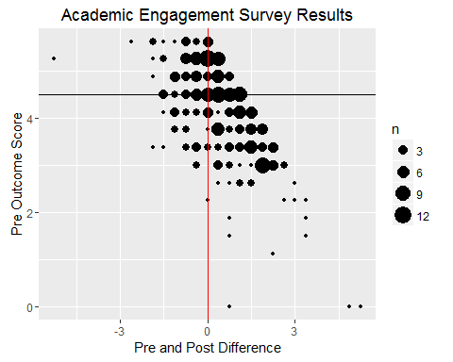

Two statistical tests were administered on the matched survey results the wilcox test and Cohen's D test. The outcome distributions did not approximate a normal distribution, thus a wilcox.test was administered and the results show that the difference between the pre and post outcome scores are significant at .05 level. However, the Cohen’s D test indicate the effect of the intervention was small.

Wilcoxon signed rank test with continuity correction: ae_2016$Pre and ae_2016$Post

|  |  |  |
| --- | --- | --- |
| Test statistic | P value | Alternative hypothesis |
| 11932 | 1.163e-08 * * * | less |

The Cohen D test indicates that the effect was small.

##   
## Cohen's d  
##   
## d estimate: -0.3133395 (small)  
## 95 percent confidence interval:  
## inf sup   
## -0.4673752 -0.1593037

## Cross Validation of Academic Engagement

Survey results from teachers and parents also provide evidence that the Get REAL! program helps students learn tangible tools to help them succeed in school. Below are tables that provide a breakdown of questions on the post survey from the parent and teacher surveys. The pattern again shows improvement in moderate agreement with the question being both with the parent survey and teacher survey.

### Parent Pre Survey:

* *Question 6: She works on her homework at home without supervision (N=465)*

Time Item low neutral high mean sd  
 Pre Q6 1.72043 8.602151 89.67742 6.352688 1.102661

Post Q6 1.234568 0 98.76543 6.584362 0.7413985

### Teacher Post Survey

* *Question 5: She positively participates in class*
* *Question 6: She completes the homework given to her.*

Results based on 397 responses.

Item low neutral high mean sd  
 Q5 0.5037783 0.7556675 98.74055 6.405542 0.7136968  
 Q6 0.7556675 0.7556675 98.48866 6.370277 0.7729147

# Academic Mastery Life Skill

The Academic Mastery questions gauge a student's attitude towards school and education. Questions that measure Academic Mastery include the following.

*Academic Mastery Questions:*

* It's important to me that I improve my skills this year in school
* It's important to me that I really understand my class work
* Learning at school is important to me
* One of my goals in school is to learn as much as I can
* The things I am learning in school will help me later in life

The number of pre and post survey that could be matched is **330**, and the percent of students with a successful outcome is **88.79%**

1. The number of students achieving the academic engagement outcome at a high level is **282**
2. The number of students who did not achieve outcome at high level but increased their outcome score is **11**

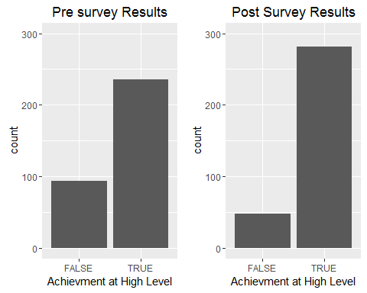

The percent of students who went from low achievement to high achievement is **24.24%** The number of students who had the opportunity to improve their academic engagement outcome score is **200**, and their mean increase in outcome score is **0.4092.**

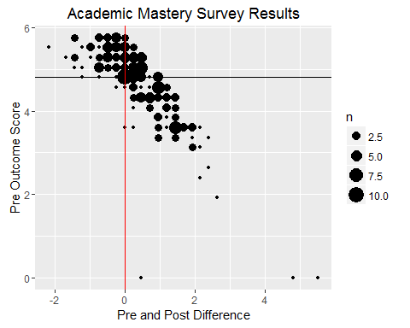

### Statistical Tests

Two statistical tests were administered on the matched survey results the wilcox test and Cohen's D test. The outcome distributions did not approximate a normal distribution, thus a wilcox.test was administered and the results show that the difference between the pre and post outcome scores are significant at .05 level. However, the Cohen’s D Test indicates that the intervention effect size is small.

Wilcoxon signed rank test with continuity correction: am_2016$Pre and am_2016$Post

|  |  |  |
| --- | --- | --- |
| Test statistic | P value | Alternative hypothesis |
| 13671 | 0.0001128 * * * | Less |

The Cohen D test indicates that the effect was small.

Cohen's d  
   
 d estimate: -0.2181761 (small)  
## 95 percent confidence interval:  
## inf sup   
## -0.37172858 -0.06462362

## Cross Validation of Academic Mastery

Survey results from teachers and parents also provide evidence that the Get REAL! program helps students formulate better attitude toward school. Below are tables that provide a breakdown of questions on the post survey from the parent and teacher surveys. The pattern again shows improvement in moderate agreement with the question being both with the parent survey and teacher survey.

#### Parent Survey

* *Question 1: She is motivated to graduate high school*

Time Item low neutral high mean sd  
Pre Q1 0.2145923 7.296137 92.48927 6.630901 0.8829508

Post Q1 0.000000 1.2345679 98.76543 6.522634 0.6253115

* *Question 3: She has a Good Attitude About School*

Time Item low neutral high mean sd  
Pre Q3 0.6437768 2.360515 96.99571 6.510730 0.7957499  
Post Q3 1.234568 0.8230453 97.94239 6.481481 0.7784989

### Teacher Post Survey

* *Question 1: She is motivated to graduate high school*
* *Question 3: She has a Good Attitude About School*

The number of responses to the post teacher survey is 397.

Item low neutral high mean sd  
 Q1 0.2518892 1.007557 98.74055 6.465995 0.6643728  
 Q3 0.7556675 1.259446 97.98489 6.365239 0.7142848