**GIVE Center Volunteer Matching**

**David Bartz**

**Karen Gilmer**

**Ian Stewart**

**Volunteer Matching**

**Mission:**  
Our objective is to develop software for the Give Center at GCSU that allows them to match the student volunteers to agencies and programs that incorporate their interests. We will create a database for the different volunteer opportunities and develop a web interface to work with it. The web interface will allow users to select criteria student volunteers may be interested in which will populate a list of agencies that match that description. Users can then access the descriptions of the agencies and related contact information.  
  
The student staff at the Give Center will all have login credentials which allow them to access this web interface to search for the appropriate agencies. Certain managerial staff at the Give Center will have login credentials that allow them access to a modified web interface where they can easily change the agency information in the database. This design will allow the Give Center to continue maintaining their database with ease once the software development is completed.   
  
**Team Members:**  
David Bartz  
Karen Gilmer  
Ian Stewart

**Specifications for Volunteer Matching**

**Customer Impact:** The Volunteer Matching software package will enable staff at the GIVE Center at Georgia College & State University to quickly and easily cross reference student interests with available volunteer programs. It uses an SQL database as the primary information store and a web browser to handle user interaction and display relevant search results. The web browser interface allows GIVE Center staff to search for agencies and volunteer programs by name, issue, and required time commitment.  
  
**Constraints:**  
C1:Completion Date

This product will be finished by 2 May, 2012.

C2:Hardware

This program requires a server to host the database, computers that can connect to a network, and a printer to print reports.

C3:Software

The server hosting the database must be compatible with MySQL and PHP. Any computers using the system must support popular web browsers such as Firefox, Internet Explorer, and/or Safari. System users may require login credentials.

**Supported Activity List (Acceptance Criteria)**  
AC1:    System users will be prompted with login screen. There will exist two levels of

login credentials: guest and staff. System users may only login to the system on

GCSU campus.

AC2:    [Assumes AC1] Guest credentials will be provided for non-staff students using

GIVE Center computers. They allow for searching agencies and programs and

viewing official agency or student leader contact information.

AC3:    [Assumes AC1] Staff credentials will be provided for GIVE Center student

workers and management. They allow for unlimited access to data including editing in-place data and adding and removing agencies and programs to keep the database up-to-date.

AC4:    [Assumes AC2] A “Guest” button will be provided on the login screen in lieu of

requiring a username and password combination.

AC5:    [Assumes AC3] Staff will be given a master username and password

combination to login to the staff view. Staff login credentials will expire on a per

computer basis after a period of inactivity.

AC6:    [Assumes AC4] Once a guest has logged on to the system, they will be

presented with the option to search for agencies and programs in two fashions:

quick and advanced.

AC7:    [Assumes AC6] Quick search will query the database for agencies and

programs by name. Typing in a string into a the search bar and pressing the

“Enter” key will load a page with a list of results matching the search criteria.

AC8:    [Assumes AC6] Advanced search will query the database for agencies and

programs according to a list of interests and issues as well as available times.

Selecting from a list of interests and available times and then pressing the “Enter” key or clicking on the “Submit” button will load a page with a list of results matching the search criteria.

AC9:    [Assumes AC7 and AC8] Queries yielding matching search results will offer the

option to print all or some of the agencies’ official contact information to a printer.

AC10:  [Assumes AC7 and AC8] In addition to quick and advanced search, there will

be the option to browse through all available programs.

AC11:  [Assumes AC4] A “Logout” button will be provided to log out of the guest

account and return to the login screen.

AC12:    [Assumes AC5] Once a member of GIVE Center staff has logged on to the

system, all search, print, and logout features described in AC6 through AC10 for

guests will also be present for staff.

AC13:  [Assumes AC4 and AC5] A “Help” button will be provided to display a page

describing how to best use the system for maximum effectiveness for both guest

and staff users.

AC14:  [Assumes AC3 and AC5] An “Administrator” button will be provided for the staff

users. Selecting the “Administrator” button will allow the user to upload an unique

GIVE center banner to appear on the top of the home page.

AC15:  [Assumes AC14] Clicking the “Administrator” button will also allow GIVE Center

staff to add and delete programs and agencies as well as edit in-place information.

**Solution Strategies:**  
S1:    Both guest and staff accounts will be able to export their search results into a

printable format.

S2:    In order for the search feature to initially work, there will exist a database

populated with all GIVE Center current program data.

**Intellectual Property Statement**  
"The intellectual property of class assignments and other materials developed using university resources that are commercialized are reviewed under the USG and GC policies to determine ownership and/or payment rights. USG policies can be found at <http://www.usg.edu/policymanual/section6/policy/6.3_intellectual_properties/> and GC policies can be found at  
<http://www2.gcsu.edu/policies/overall/intellectual-property-polic.htm>."  
However, for this project, the GIVE Center will be given the source code for this project.  
  
This project is designed for educational purposes only.  
  
**Signatures:**  
  
I agree to the terms listed above  
_______________________________________         Date: _______________  
_______________________________________         Date: _______________  
_______________________________________         Date: _______________  
_______________________________________         Date: _______________  
  
  
**Screen and Report Designs**  
  
These designs represent the main ideas of the software and are meant to portray the united visions of both the developers and the clients. These sketches are an aide to focus the software development but can be subject to change with progression.  
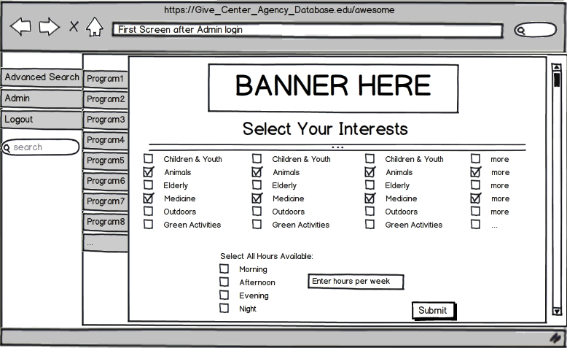  
**Figure 1: The initial screen displayed once logged on with administrator credentials. This picture represents the “Advanced Search” feature to select interests and availability.** 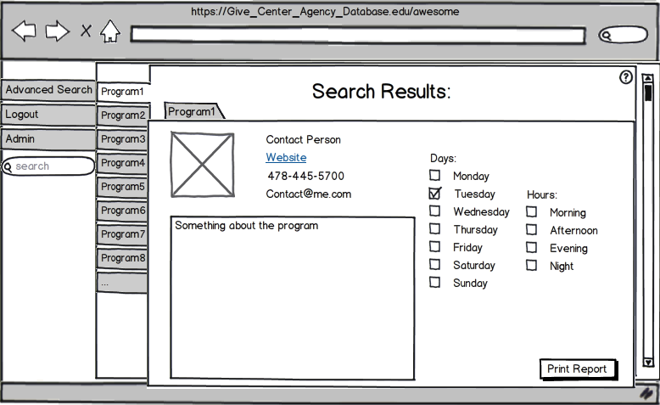  
**Figure 2: Represents the “Search Results” page once the criteria from Figure 1 has been selected. A list of programs matching the criteria is narrowed down and displayed. This picture portrays the option “Program 1” being selected. Selecting an option allows the view of program description, contact information, and any volunteering times. This view also has the option to print a report.**  
  
  
  
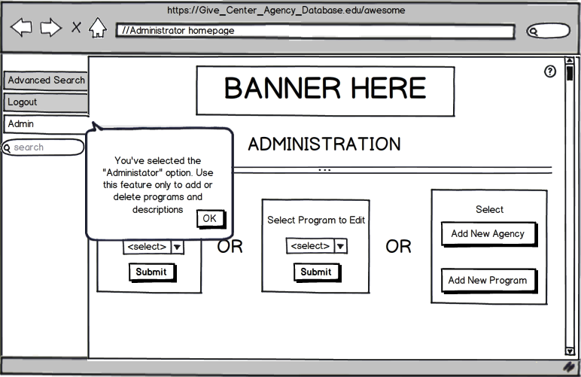  
**Figure 3: This page represents what clicking the “Admin” or “Administrator” button will do. To prevent staff from accidentally modifying the database, an alert will be displayed to notify the user that they are now in a “modification - mode”. The user will have to acknowledge consent of the prompt to continue.**  
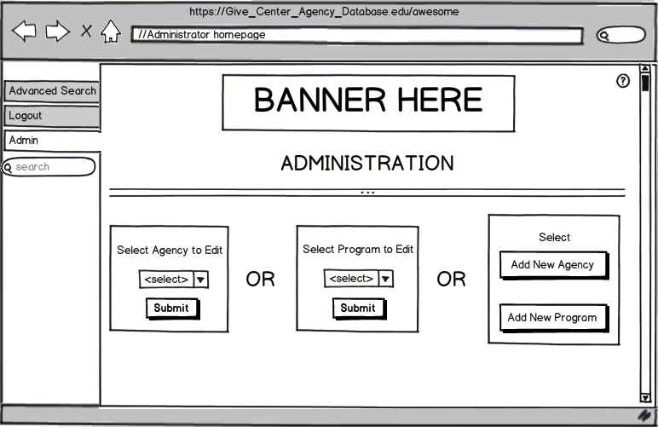  
**Figure 4: This image represents the “Administrator” interface once the user has acknowledge the prompt in Figure 3. The users can then select whether they want to modify an agency, modify a program, add an agency, or add a program. Modifying an agency or a program will allow the user to change all information associated with that program or agency, as well as delete the program or agency.**

**Use Case Diagram**

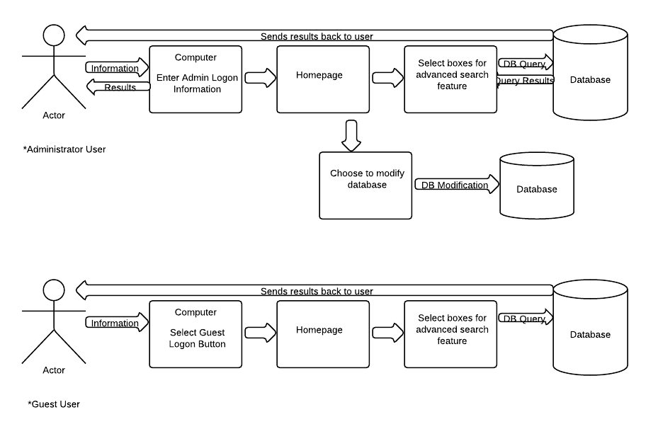

**Class Diagram**

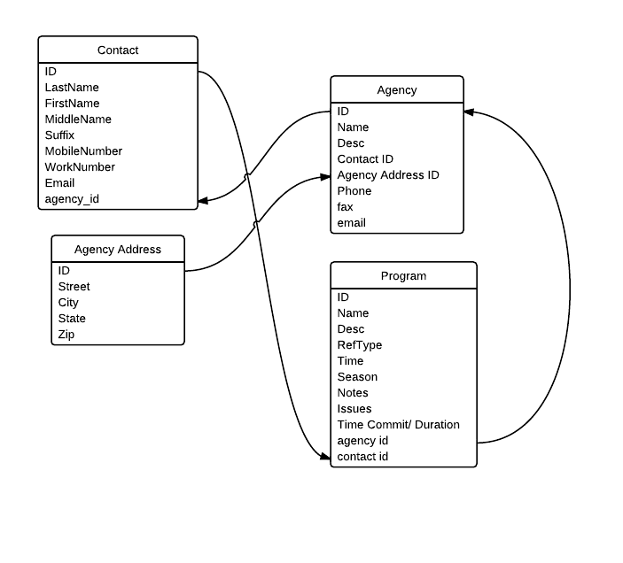

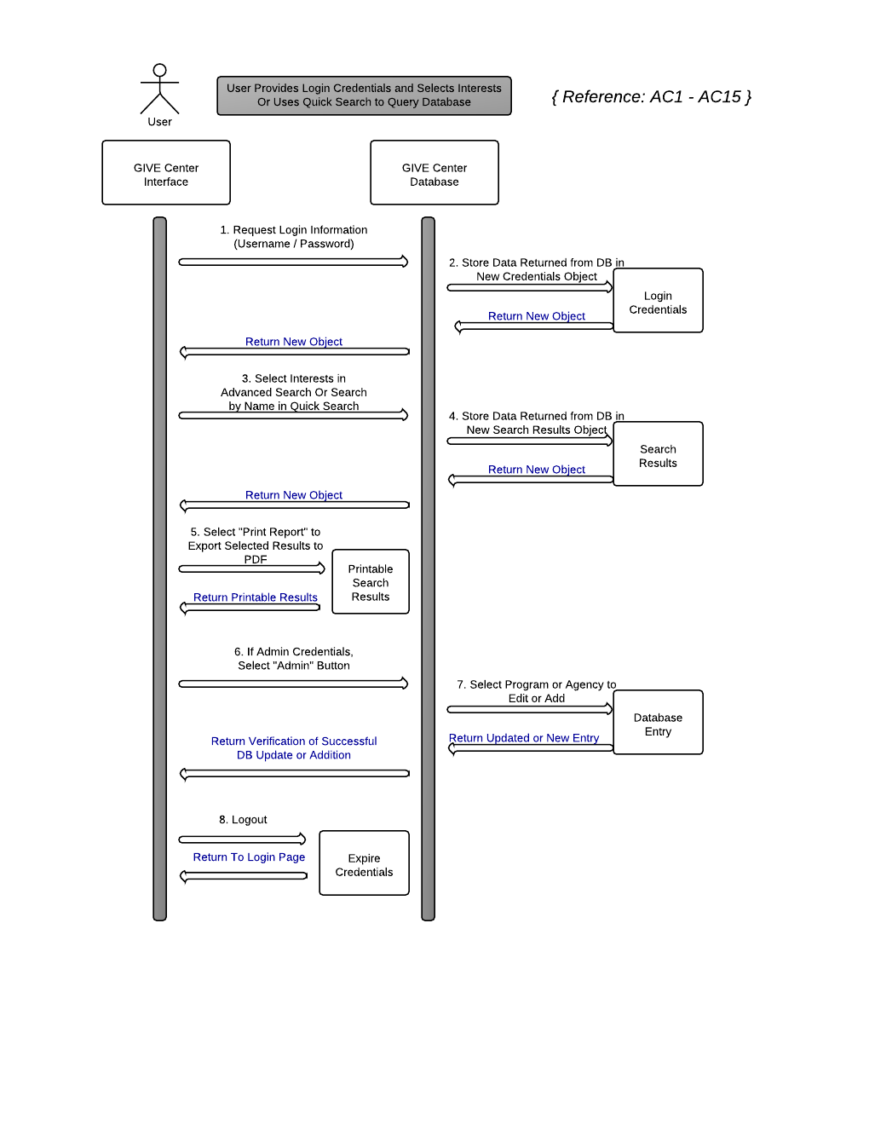**Interaction Diagram**

**Project Plan**

**Phases of Schedule**  
  
Phase 1: Build Database  
    Step 1.1: Collect GIVE Center Data  
    Step 1.2: Organize to Match Database Design  
    Step 1.3: Insert into Database  
    Step 1.4: Design Frequently Used Queries  
Phase 2: Create Interface  
    Step 2.1: Create Login Page  
    Step 2.2: Create Home Page  
        Activity 2.2.1: Home Page Includes Advanced Search Interface  
        Activity 2.2.2: Show “Admin” Button With Proper Credentials  
    Step 2.3: Setup Search Results Page  
        Activity 2.3.1: Display Agencies and Corresponding Programs  
        Activity 2.3.2: Limit Private Data for Guest Login Credentials  
    Step 2.4: Create Administrator Page  
        Activity 2.4.1: Create Interface to Easily Edit Database Entries   
        Activity 2.4.2: Create Interface to Add Programs or Agencies  
        Activity 2.4.3: Create Interface to Edit Programs or Agencies  
Phase 3: Server-Side Scripting

Step 3.1: Design Scripts to Query by Agency or Program Name

    Step 3.2: Design Scripts to Populate Search Results Page  
        Activity 3.2.1: Scripts to Populate List of Agencies  
        Activity 3.2.2: Scripts to Populate Programs from Selected Agency  
        Activity 3.2.3: Scripts to Limit Data Based on Login Credentials  
    Step 3.3: Design Scripts to Edit Database Entries  
        Activity 3.3.1: Design Scripts to Add Programs or Agencies  
        Activity 3.3.2: Design Scripts to Edit Programs or Agencies  
Phase 4: Transfer Database to Client’s Server  
    Step 4.1: Backup Local Database  
    Step 4.2: Upload Database to Client’s Server  
    Step 4.3: Test to Ensure Proper Network Access  
  
  
  
  
   

**Milestones**

|  |  |  |
| --- | --- | --- |
| **Milestone** | **Cross Ref** | **Duration** |
| 1.1 Collect GIVE Center Data | AC1 - AC15 | 1 |
| 1.2: Organize to Match Database Design | AC1 - AC15 | 3 |
| 1.3: Insert into Database | AC1 - AC15 | 3 |
| 1.4: Design Frequently Used Queries | AC1 - AC15 | 2 |
| 2.1: Create Login Page | AC1, AC4 | 4 |
| 2.2.1: Home Page Includes Advanced Search Interface | AC6 | 5 |
| 2.2.2: Show “Admin” Button With Proper Credentials | AC14 | 1 |
| 2.3.1: Display Agencies and Corresponding Programs | AC7, AC8, AC10 | 3 |
| 2.3.2: Limit Private Data for Guest Login Credentials | AC2, | 1 |
| 2.4.1: Create Interface to Easily Edit Database Entries | AC3, AC15 | 4 |
| 2.4.2: Create Interface to Add Programs or Agencies | AC15 | 4 |
| 2.4.3: Create Interface to Edit Programs or Agencies | AC15 | 4 |
| 3.1: Design Scripts to Query by Agency or Program Name | AC7, AC8 | 3 |
| 3.2.1: Scripts to Populate List of Agencies | AC7, AC8 | 5 |
| 3.2.2: Scripts to Populate Programs from Selected Agency | AC7, AC8 | 4 |
| 3.2.3: Scripts to Limit Data Based on Login Credentials | AC2 | 2 |
| 3.3.1: Design Scripts to Add Programs or Agencies | AC3, AC15 | 3 |
| 3.3.2: Design Scripts to Edit Programs or Agencies | AC3, AC15 | 3 |
| 4.1: Backup Local Database | C2 | 1 |
| 4.2: Upload Database to Client’s Server | C3 | 3 |
| 4.3: Test to Ensure Proper Network Access | C2, C3 | 2 |

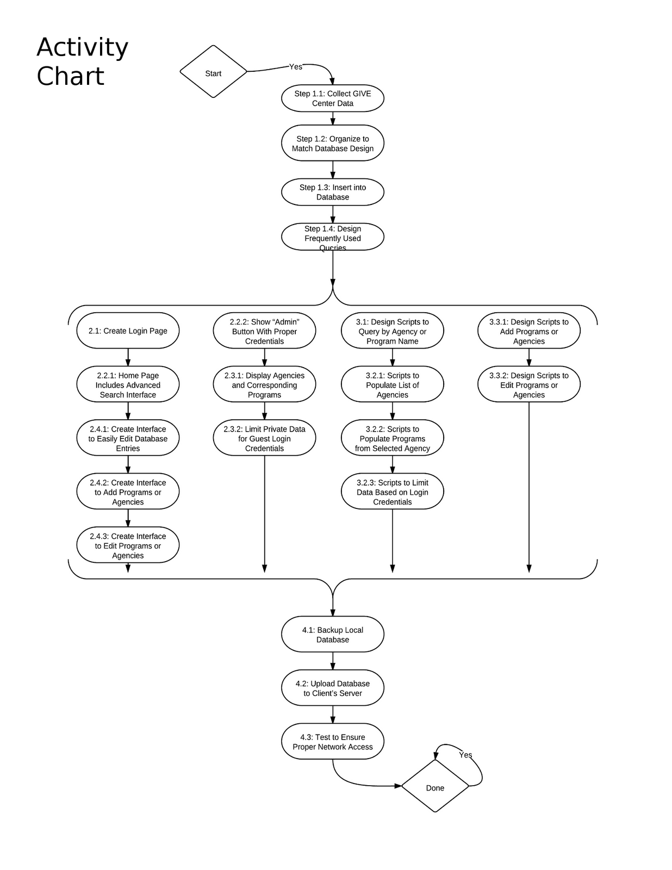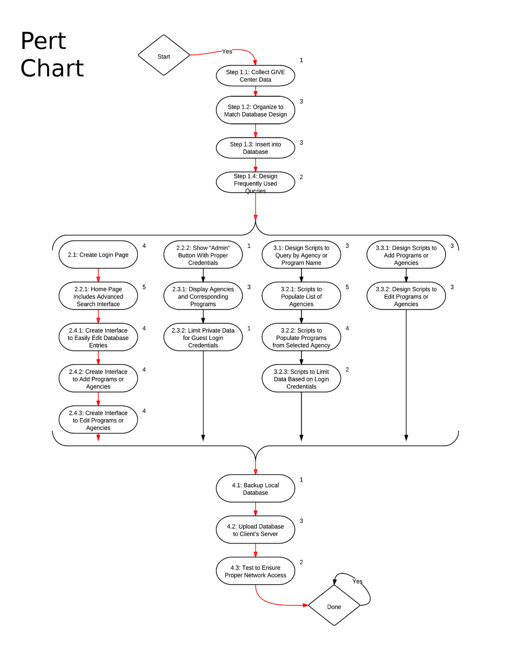

**Project Plan**

**Team Member Responsibilities**  
  
David Bartz:

Unit One: Milestones 1.1, 1.2, 1.3,

Unit Two: Milestones 1.4,

Unit Three: Milestones 4.1, 4.2, .4.3

Karen Gilmer:

Unit One: Milestones 2.1, 2.2.1

Unit Two: Milestones 2.2.2, 2.3.1, 2.3.2, 2.4.1

Unit Three: Milestones 2.4.2, 2.4.3

Ian Stewart:

Unit One: Milestones 3.1, 3.2.3

Unit Two: Milestones 3.2.1, 3.2.2

Unit Three: Milestones 3.3.1, 3.3.2

**Unit 1 Test Cases**

**Team Member: Karen Gilmer**

Date:

March 2, 2012

 Planned Milestones:

2.1 - Create Login Page

2.2.1 - Create Homepage that Includes

Advanced Search Interface

 Completed Milestones:

2.1, 2.2.1

 Testing Procedures for each Milestone:

|  |  |  |
| --- | --- | --- |
| **Milestone** | **Test Case** | **Expected Result** |
| 2.1 | Open file in web browser | Login page should appear  User should be able to enter text in text boxes |
| 2.2.1 | Open file in web browser | Home page should appear populated with correct search information  User should be able to select criteria check boxes |

|  |
| --- |
|  |

**Team Member: David Bartz**

Date:

March 2, 2012

Planned Milestones:  
  1.1 - Collect GIVE Center Data

1.2 - Organize to Match Database Design

1.3 - Insert Data into Database

Completed Milestones:  
  1.1, 1.2, 1.3

Testing Procedures for each Milestone:

|  |  |  |
| --- | --- | --- |
| **Milestones** | **Test Case** | **Expected Result** |
| 1.3 | Query Table Names, And Information in tables | Tables should appear  Information should be displayed within |

**Team Member: Ian Stewart**

Date:

March 2, 2012

Planned Milestones:

3.1 - Design Scripts to Query by Agency or Program Name

3.2.3 -  Scripts to Limit Data Based on Login Credentials

Completed Milestones:

3.1, 3.2.3

        Testing Procedures for each Milestone:

|  |
| --- |
|  |
| **Milestone** | **Test Case** | **Expected Result** |
| 3.1 | Query database using scripts | Scripts return Agency data  Scripts return Program data |
| 3.2.3 | Query database using scripts | Scripts return Agency data sanitized of confidential information  Scripts return Program data sanitized of confidential information |

**Unit 2 Test Cases**

**Team Member: Karen Gilmer**

Date:

March 9, 2012

Planned Milestones:

2.2.2 - Show “Admin” Button With Proper Credentials

2.3.1 - Display Agencies and Corresponding Programs

2.3.2 - Limit Private Data for Guest Login Credentials

2.4.1 - Create Interface to Easily Edit Database Entries

Completed Milestones:

2.2,2, 2.3.2

Testing Procedures for each Milestone:

|  |  |  |
| --- | --- | --- |
| **Milestone** | **Test Case** | **Expected Result** |
| 2.2.2 | Open files in web browser | Page should display with or without “Admin” button visible depending on credentials |
| 2.3.1 | Open file in web browser | Page should display with sample agencies and programs populated in an appealing format |
| 2.3.2 | Open files in web browser | Private data should appear when one file is opened and not the other |
| 2.4.1 | Open file in web browser | Notification should extend from “Admin” button to notify user that they are now in administration mode  Website should be frozen until user selects “OK” from the notification prompt to proceed  Options to add/edit programs and agencies should be displayed |

|  |
| --- |
|  |

**Team Member: David Bartz**

Date:

March 9, 2012

Planned Milestones:

1.4 - Design Frequently Used Queries

Testing Procedures for each Milestone:

|  |  |  |
| --- | --- | --- |
| **Milestone** | **Test Case** | **Expected Result** |
| 1.4 | Run Queries against data and check results | Results should match those done by hand |

**Team Member: Ian Stewart**

Date:

March 9, 2012

Planned Milestones:

3.2.1 - Scripts to Populate List of Agencies

3.2.2 - Scripts to Populate Programs from Selected Agency

Completed Milestones:

3.2.1, 3.2.2

        Testing Procedures for each Milestone:

|  |
| --- |
|  |
| **Milestone** | **Test Case** | **Expected Result** |
| 3.2.1 | Login to Database Using Web Front-end  Search for Agencies | Web page will display list of Agencies matching search terms |
| 3.2.2 | Login to Database Using Web Front-end  Search for Agencies | Web page will display list of Agencies matching search terms  Agencies will display list of programs with which they are currently involved |

**Unit 3 Test Cases**

**Team Member: Karen Gilmer**

Date:

March 16, 2012

Planned Milestones:

2.4.2 - Create Interface to Add Programs or Agencies

2.4.3 - Create Interface to Edit Programs or Agencies

Testing Procedures for each Milestone:

|  |  |  |
| --- | --- | --- |
| **Milestone** | **Test Case** | **Expected Result** |
| 2.4.2 | Open file in web browser | A blank agency template should be displayed, prompting the user to enter the title, descriptions, and contact info into the text fields. |
| 2.4.3 | Open file in web browser | A list of programs should appear.  Once a program is selected, the page for the “add programs or agencies” will appear but have the text fields filled in with the appropriate agency or program data for easy modification.  An option to “save program or agency will appear”  An option to “remove program / agency” will appear |

|  |
| --- |
|  |

**Team Member: David Bartz**

Date:

March 16, 2012

Planned Milestones:

1.1 - Collect GIVE Center Data

1.2 - Organize to Match Database Design

1.3 - Insert Data into Database

Completed Milestones:  
  1.1, 1.2, 1.3,1.4  
  
Testing Procedures for each Milestone:

|  |  |  |
| --- | --- | --- |
| **Milestone** | **Test Case** | **Expected Result** |
| 4.1 | Backup Local Database | backup file should contain correct information |
| 4.2 | Update Database on Client’s Server | same as 4.2 |
| 4.3 | Test database access on client computer | database should be access able and contain correct information |

**Team Member: Ian Stewart**

Date:

March 16, 2012

Planned Milestones:

3.3.1 - Design Scripts to Add Programs or Agencies

3.3.2 - Design Scripts to Edit Programs or Agencies

Completed Milestones:

3.3.1, 3.3.2

        Testing Procedures for each Milestone:

|  |
| --- |
|  |
| **Milestone** | **Test Case** | **Expected Result** |
| 3.3.1 | Use scripts to add new Agencies and Programs | Searches yield new Agencies and Programs in results page |
| 3.3.2 | Use scripts to edit Agency and Program information | Searches yield updated Agency and Program information |

**Integration Test Plan**

|  |  |  |
| --- | --- | --- |
| **Test Case** | **Expected Result** | **Actual Result** |
| Open to Give Center Home page. | Login page appears  User able to enter text in text boxes |  |
| Login with Guest Credentials | Login succeeds  Searches yield data void of sensitive contact info |  |
| Login with Staff Credentials | Login succeeds  Searches yield all available data |  |
| Once logged on, two search options appear: quick and advanced | Quick and Advance search options appear |  |
| Search using the quick search | Quick Search yields Agencies and Programs whose names resemble search text |  |
| Search using the advanced search | Advanced Search yields Agencies and Programs matching search parameters exactly |  |
| Print search results | Send search results to device to be printed |  |
| Browse programs | Browse through list of all available programs  Selecting a program from list displays details and contact info for the program |  |
| Logout | A logout button appears on each page for both sets of credentials. |  |
| Help Button | Selecting the help button will display a page describing how to best use the system for maximum effectiveness for both guest and staff users. |  |