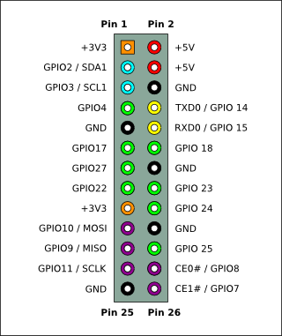 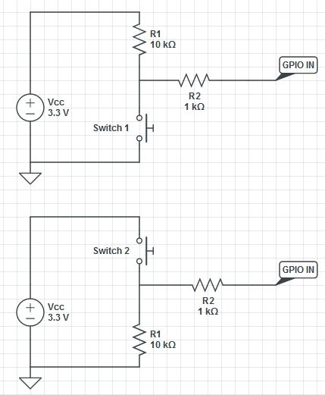

**Motor**

5v – pin 4

3.3v – pin 17

GND – pin 9

In1 – pin 7 (gpio4)

In2 – pin 11 (gpio17)

In3 – pin 13 (gpio 27)

In4 – pin 15 (gpio 22)

**Switch**

Sw – pin 22 (gpio 25)

3.3v – pin 17 (shared with Motor)

GND – pin 20

**Display/Serial**

5v – pin 2

3.3v – pin 1

GND – pin 6

1 (i2c – sda ) – pin 3

2 (i2c – scl ) – pin 5

3 (serial – TX ) – pin 8

4 (serial – RX ) – pin 10