**Rattle Decision tree and Logistic Regression**

**Steps in Building Decision tree using Rattle**

* Import Dataset

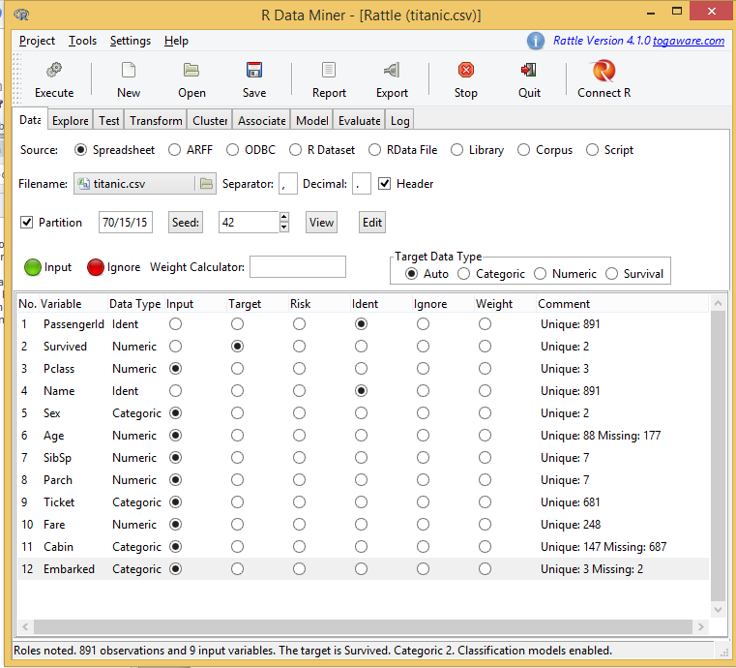

* Select Variable type (Categorical, Numeric) and set the Target. We have Ignored “Passenger ID” and Selected “Survived” as Target Variable.

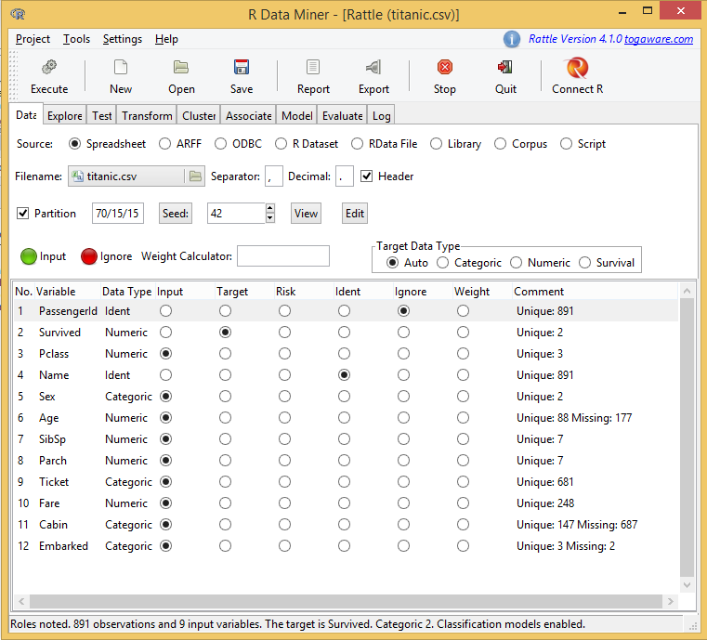

* Then you can explore the data, We just did summary of all columns.

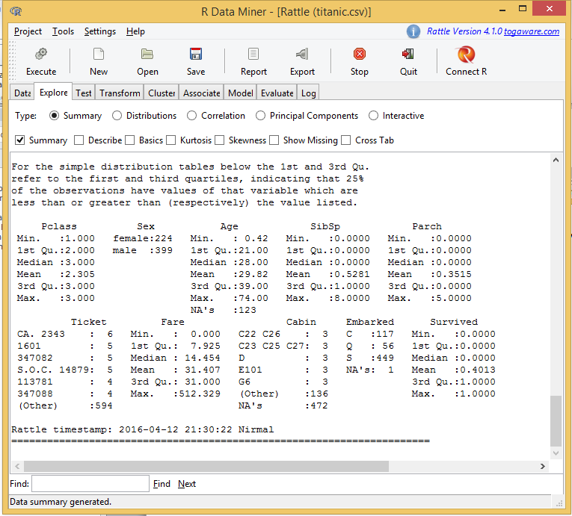

* Next build a Model (Decision Tree)

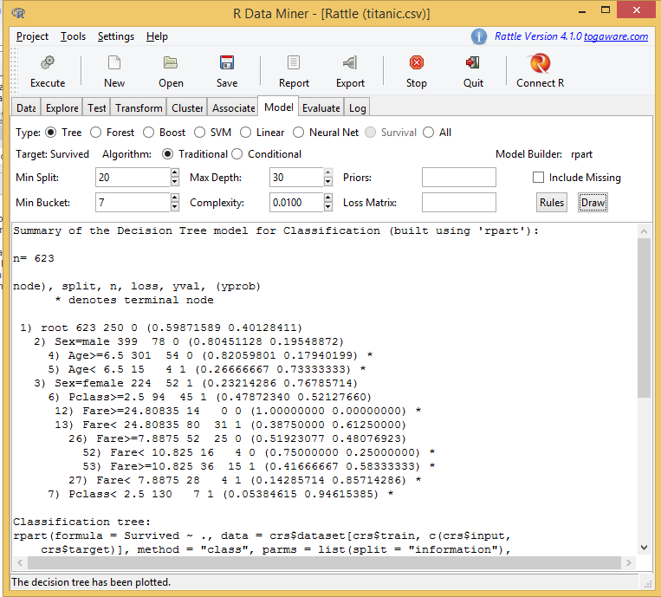

* Draw decision Tree

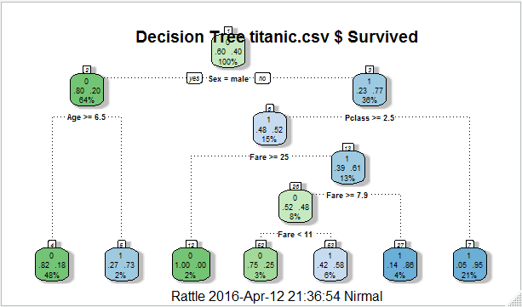

* Interpreting the result

Gives Rules For e.g. if sex = male classify as 1

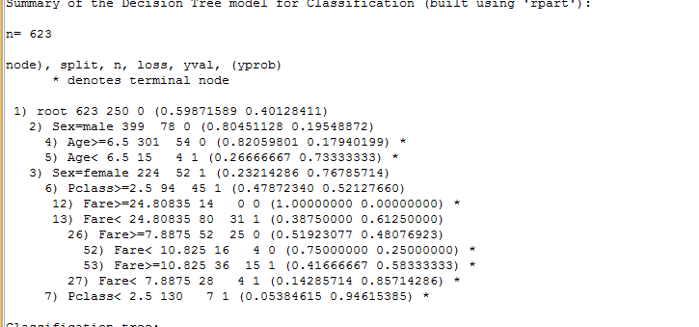

* Decision tree has used four variables Age , Fare, Pclass , Sex and Loss Matrix can also be adjusted

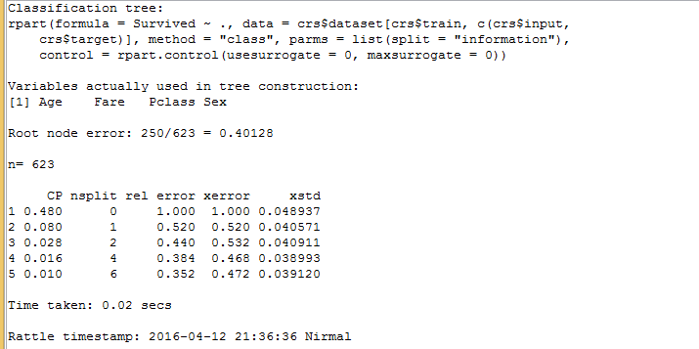

* Let’s fit Logistic regression

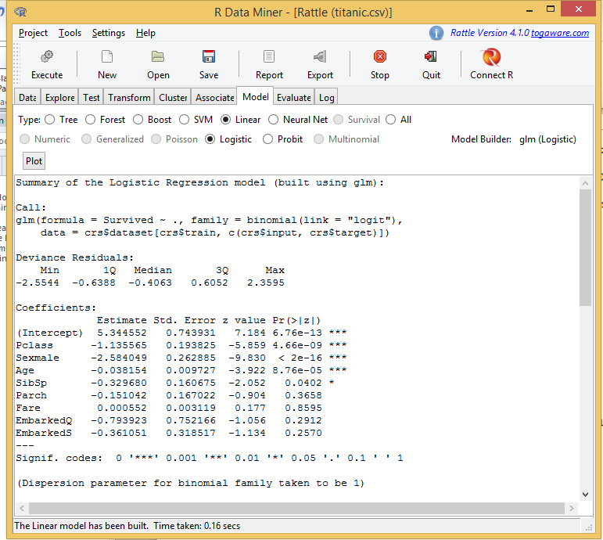

* Let’s have a closer look. This shows P and Z score of various column selected

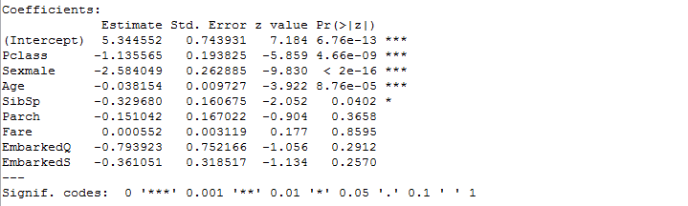

* Let’s compare Both decision tree and Logistic Regression

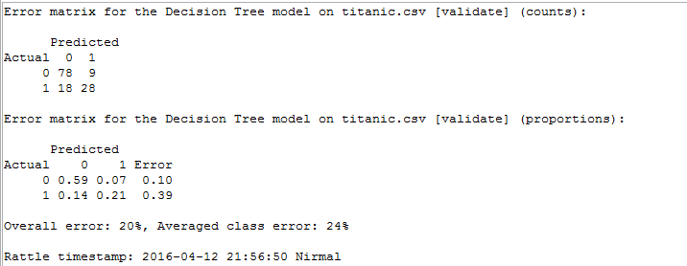

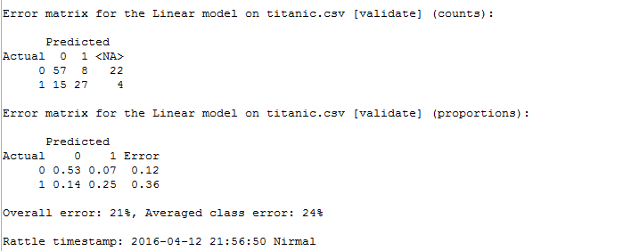

**The Error matrix shows both Logistic and Decision tree almost the same**

**Moreover both models use same set of columns. Decision tree uses 4 columns and the same 4 columns are shown significant in Logistic regression (p value)**

I personally prefer Rstudio because of the following reasons

* Rattle does not let me to use third party library.
* If I want to combine more models for e.g. Decision tree + Logistic regression I cannot do it in Rattle
* In summary Rattle GUI is good but It lacks flexibility (With code I can achieve whatever I want to)