**Problem 03**

Code:

clear all

format long

fplot = linspace(1,3,100);

f=@(x) cos(x)-sin(x);

xL=1;

xR=3;

r=.382;

T= 10^-7;

I=0;

for n=1:200

xM1=xL+(xR-xL)*r;

xM2=xL+(xR-xL)*(1-r);

I=I+1;

if f(xM1)<f(xM2);

xR=xM2;

else

xL=xM1;

end

if(xR-xL)<T

break

end

end

disp((xR+xL)/2)

I

plot(fplot, f(fplot), '-');

xlabel('x-values');

ylabel('y-values');

legend('cos(x)- sin(x)');

Output:

>> problem03

2.356194479684493

I =

35

Graph:

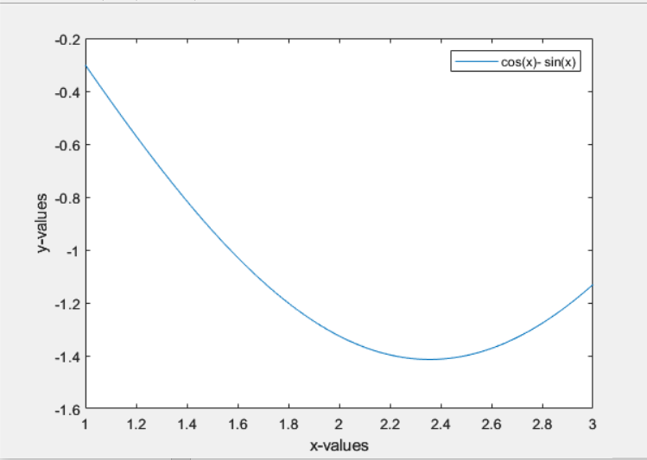

This is unimodal as it only has one minimum value.

**Problem 04:**

Code:

clear all

format long

fplot = linspace(1,3,100);

f=@(x) cos(x)-sin(x);

xL=1;

xR=3;

M=2;

T= 10^-7;

I=0;

for n=1:200

xm=M+.5*((f(xL)-f(M))*((xR-M)^2)-(f(xR)-f(M))*((M-xL)^2)/((f(xL)-f(M))*((xR-M))+(f(xR)-f(M))*((M-xL))));

I=I+1;

if f(xm)<f(M)

xR=M;

else

xL=M;

end

M=xm;

if abs((xR)-(xL))<T

break

end

end

disp((xR+xL)/2)

disp("Number of Iteration:");

disp(I);

Output:

>> problem04

2.356194530441244

Number of Iteration:

20

Function is same as problem03 so, it is unimodal.