**Topic:** Need Finding

**Target Audience:** Lunch Goers (Students/Faculty)

**Questions:**

* What are your thoughts on the allotted time for lunch breaks, is it enough?
* How do you spend your breaks?
* Are the food choices on the cafeteria enough?
* How about the food line queuing?
* What are the reasons for you not to eat at the cafeteria, and where do you usually eat out?

**User Needs:**

* Enough time for breaks
* Food line queueing
* Variety of food
* Volume of students (Lunch Goers) should be taken to consideration in regards of cafeteria availability
* Why students choose to eat out of the campus

**Point of View:**

Based on our interviewed people’s responses. Their lunch time is more than enough however the time with the other classes like example Senior Highschool’s break time tend to interrupt their own break time and caused them to queue more students in the line. Then in that case, they tend to leave the campus to eat somewhere outside since or some will not eat lunch and just hang out with their friends.

* Crowded cafeteria, we need to split the lunch break time
* Boring foods menu, constant change of food menu in the cafeteria
* Expensive food, put “Budget-meals” on the menu
* No seats available, add more tables and seats for everyone

Documentation:

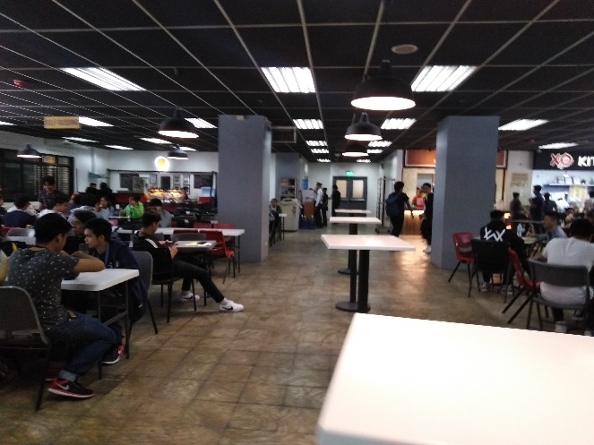 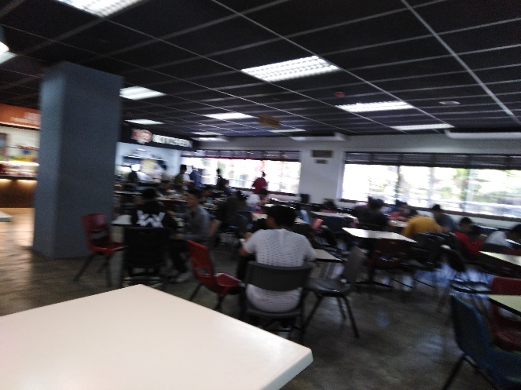

**Members:**

Maga, Katrina Kin

Lapuz, Karlvin