Kathy Schuler
02/21/2026
IT FDN 130 GP
Assignment 6

SQL Views, Functions, and Stored Procedures

Introduction
This week’s assignment demonstrates how Views, Functions, and Stored Procedures can be used to produce meaningful insights while simplifying complex queries for the end-user. I also practiced setting up and sharing files in GitHub. Here is the link to my GitHub repository: https://github.com/kgms369/DBFoundations

When to use a SQL View
A View is useful when dealing with complex code. It results in a simplified Select statement for the end-user. The View can be saved as a script file and/or saved in the database itself, then shared with others to run. For example:
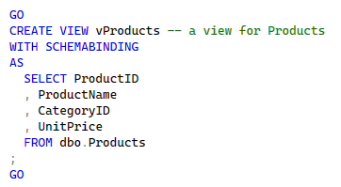
Figure 1: Example of a SQL View.
Others can easily run this code by using the View:
Figure 2: The Select statement for the example View.
I needed to use GO at the start of the script. This signals the start of a new batch where CREATE VIEW is the first thing that occurs. Without GO, SQL will throw an error. I also closed the script with GO to ensure the batch is terminated. For an error-free script, CREATE VIEW must be the only statement in its batch.
This is an example of a Base View or Basic View. This is a benefit to administrators who want to restrict access to a table while allowing access to the View. This supports the Principle of Least Privilege: Users are restricted to the necessary information needed for their role.
In addition, I used SCHEMABINDING to lock the table so that it cannot be modified in ways that would break the View. SQL will block anyone from deleting or renaming a column because it knows the View relies on it. Every column must be listed in the script, and the table referenced after the FROM clause must be preceded by the schema name (i.e., dbo.Products). This removes all ambiguity about the location of the data.

Differences and similarities: Views, Functions, and Stored Procedures

Views: A View is a named Select statement with code saved as a script file or saved in a database. A SELECT TOP clause must be used when using the ORDER BY clause. A View makes changes to the table design seamless for users. The View’s code remains the same, but the data it shows will always be the most current data from the table.
Functions: A Function is also a named Select statement. Microsoft SQL Server requires the DBO prefix in front of the Function name when it is created and used (ex: dbo.fProducts( )). Like Views, Functions also require a SELECT TOP clause when using the ORDER BY clause. Functions use an AS clause, but they also have a RETURNS TABLE clause so that a value can be provided. For example:
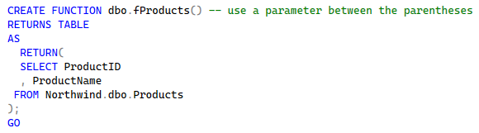
Figure 3: Example of a Function.
To run the Function:
Figure 4: The Select statement for the example Function.
The parentheses must be entered even if no parameters are being used.
Another difference between Views and Functions is that a Function may be used within the Select clause as a mathematical expression that returns a single value (such as two multiplied values like price and quantity used to calculate extended price). This is called a Scalar Function.
Stored Procedures: As with Views and Functions, Stored Procedures are named Select statements. A Stored Procedure is structured in a similar way. Unlike a View and Function, however, a Stored Procedure is run by executing its code instead of as a Select statement.
Another difference is that a Stored Procedure can have many statements of different types (Select, Insert, Delete, etc.). This can include the creation of tables. The flexibility of a Stored Procedure makes it the tool of choice for complex reporting.
While Views and Functions return a set of data and can be used in a JOIN or WHERE clause of another query, Stored Procedures must stand alone. One last difference is that a Stored Procedure allows an ORDER BY command without the TOP clause as required in a View.
In this example of a Stored Procedure, the variable CategoryID has been added to the procedure:
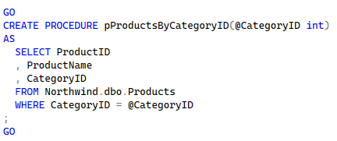
Figure 5: Example of a Stored Procedure.
I used the EXECUTE command to run the Stored Procedure:
Figure 6: The EXECUTE statement for the example Stored Procedure.
Executing the Stored Procedure results in a list of all products with a CategoryID of 1:
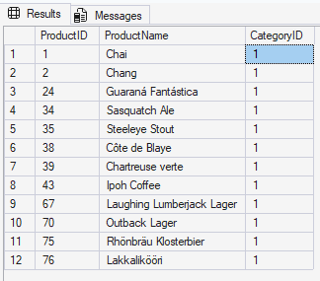
Figure 7: The results table for the example Stored Procedure.

Summary
In summary, choosing when to use a View, Function, or Stored Procedure depends on what is needed. Views work well as simple filters. Functions can include parameters and mathematical calculations within a Select statement. Stored Procedures provide the flexibility for complex script with multiple steps and different types of statements.

