# Content

1 Content 1

2 Title and summary 1

3 Introduction 1

4 Question articulation 3

5 Innovation 3

6 Project plan 4

|  |
| --- |
| Warning The model below indicates which content is required in the project proposal. |

# Title and summary

**SmartSpark – SPARK DETECTION AND PREVENTION DEVICE FOR ELECTROHYDRODYNAMIC ATOMIZATION APPLICATIONS**

Electrohydrodynamic Atomization (EHDA), also known as Electrospray (ES), is a technology which uses strong electric fields to manipulate liquid atomization. Among many other areas, electrospray is used as an important tool for biomedical application (droplet encapsulation), water technology (thermal desalination and metal recovery) and material sciences (nanofibers and nano spheres fabrication, metal recovery, selective membranes and batteries). A complete review about the particularities of this tool and its applications was recently published (2018), as an especial edition of the Journal of Aerosol Sciences. One of the main known bottlenecks of this technique, it is the fact that the necessary strong electric fields create a risk for electric discharges. Such discharges destabilize the process but can also be an explosion risk depending on the application. The goal of this project is to develop a reliable tool to prevent discharges in electrospray applications.

# 3 Introduction

Liquids can be broken up into fine droplets using different techniques, namely: (i) piezo-electric crystals, i.e. ultrasonic atomizers, (ii) fast-moving gases, i.e. wind-break atomizer, (iii) or high-pressured, i.e. pneumatic atomizers. Electrohydrodynamic Atomization (EHDA), is a technique which uses electrical forces, as an additional tool, to manipulate the fragmentation of liquids into small droplets. Currently, many processes use EHDA as a tool, some examples are: drug encapsulation, metal recovery, emulsification, etc.

A consensus among specialist and interested companies is that the potential risk of discharges (sparks) is hindering EHDA from wider its application in industrial processes, especially when highly flammable liquids, gases or solids are used. Being able to prevent discharges is a crucial step to allow this technology to reach real scale phase and broaden its use in industry.

NHL Stenden Water Technology group is an EHDA leading group in The Netherlands. The group has already conducted different studies about how to detect the onset of discharges and how to possibly prevent them. Among other approaches, the group has investigated the correlation between the electric current and the applied voltage, for different electrospray modes and other visible effects such as light emission through corona formation. Results have shown that there is a significant increase of the electric current when corona forms. Further increase of the voltage leads to short, low energy partial discharges initiated by the corona. The experiments were conducted using a nozzle to plate setup, like shown in Figure 1.

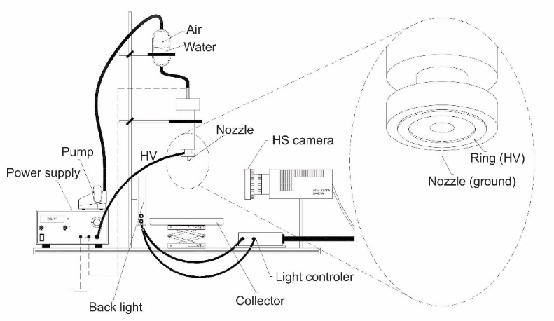

Figure 1 - Electro-spray setup.

At high enough voltage levels, electrode-to-electrode discharges occur. At slightly lower full discharge voltage levels, partial discharges appear (low energy), which can be measured as relative, to the full discharge, small current peaks. Such partial low energy discharges are called streamer onsets. The findings allowed the development of a prototype spark onset detector that can identify such peaks and generate an output signal (intended to stop spark to occur) within 500ns (Figure 2).

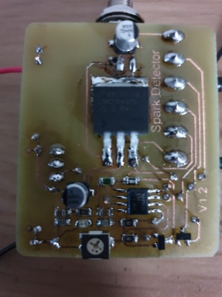

Figure 2 - First partial discharge detector circuit prototype.

Even though this preliminary work has built up quite good understanding about the different aspects of the onset of discharges, it was conducted with a very specific setup, i.e. experimental condition. Thus, more investigation has still to be conducted to allow a generalization of the phenomenon.

This project is structured to tackle this aspect. Its objective is to investigate these discharges under various conditions, i.e. different electrode formats/shapes, liquids, surrounding atmospheres and temperatures. Such approach will help to create enough background information to allow a generalization of the spark episode, i.e. a better understanding about the relation between the occurrence and the different setups used in EHDA and other external factors. Additionally, it will also focus on the circuit’s manipulation after the detection, preventing a discharge. Some approaches are already foreseen as possible solutions, like dynamically changing the resistance in the circuit or interrupting the circuit within (ideally) 500ns. Due to the high voltages used in such systems (up to 15kV), such approach is seen as rather challenging, as, to the best knowledge of the authors, only few commercially available devices can provide such responses, and none fits the specifications/conditions of a typical EHDA setup.

Expected challenges are: (i) current measurement during electrospray depends on a set of factors like applied voltage, mode of electrospray, surrounding atmosphere, humidity, temperature, local convection and gas ionization, hence building a setup controlling these factors is essential, (ii) measuring currents in the nano-ampere and micro-ampere ranges in high ohmic circuits like for high voltage applications are susceptible to high level of interference/noise (iii) voltages of up to 15kV add extra difficulties and safety requirements, (iv) current measurements under high voltage require not off-the-shelf devices and setup, (v) fast switching (<500ns) under high voltage using fast solid state switches, like MOSFETS, requires cascading 10 to 15 MOSFETs, for which a custom driving circuit will be developed.

If successfully, this technology will allow EHDA to be used in processes like milk drying or natural gas odorization. Both processes combine the necessity of having a narrow size distribution of droplets within explosion hazard areas. Additionally, avoiding discharge is crucial for the stability of the spray and to guarantee it operates at the correct current level. Thus, even when spark risks are not foreseen, such device can/should be used.

# Question articulation

According to the knowledge and Innovation Agenda Agriculture, Water and Food, Key Enabling Technologies (KETs), are crucial to concretize this agenda. The presented project combines different aspects inside these KETs, namely: Precise and Non-Destructive Measurement, Sensors, Artificial Intelligence and others. It is also closely linked to the Energy Transition strategy.

The (scientific) question which characterizes this project originated from another one, in which the client hypothesized (NHL Stenden EHDA group) whether EHDA could be used to improve gas odorization systems. The project was conducted, and the results obtained have clearly shown that the technique can improve odorization considerably, especially for periods where low natural gas flows are a necessity (summer period). The development of the device proposed as the object of this project is extremely relevant for the continuation of this technology development, as it is structured to create the necessary safety barrier which will allow the technology to enter the market in real scale. It has to be added, nevertheless, that, its applicability, when proven feasible, can be extended to every other application which involves the use of EHDA.

# Innovation

Spark prevention is key for upscaling EHDA applications. Up to now it is done via manipulating the continuous phase (normally air) properties (permittivity) and voltage control. This is not enough for many applications, especially those with high explosion risks and for applications where the atmosphere cannot be changed.

Key innovations of this project are: (i) continuously measuring current and voltages in high voltage/low current applications with sample rates high enough (estimated 1MS/s – 10MS/s) to record all relevant signals (ii) applying state of the art digital signal processing techniques to extract relevant current patterns to predict the onset of discharges, (iii) integrate those technologies for a pilot setup, (iv) develop a fast (500ns) high voltage solid state switch to manipulate charges at the HV electrodes.

The relevance of the project extends in other ways, namely: It will broaden the use of EHDA technique in different industrial processes, it will extend the knowledge about spark occurrences and prevention and it will allow a (safe) use of EHDA in systems like gas odorization and milk drying processes.

# Project plan

The project is proposed to be executed in 12 months and in four different work packages (WP). A short description of these WP is the following: WP1 **“Current Measurement”**. In this WP a current measurement setup will be developed, series of measurements will be taken for a variety of conditions. The expected outcome is a data base of current signals for different ES-modes, under influence of corona and discharge onsets. WP2 is **“Development of a spark predictor”**. Expected outcome: a device that can reliably predict the onset of discharges and that can be deployed at a pilot installation. WP3 **“Development of High voltage solid state switch”**. Expected outcome: specification of requirements and realization of a solid-state switch WP4 **“Dissemination”. Expected outcome:** Presentation of obtained results to the involved partners and in scientific conferences (posters).

The table presented below is a resume of tasks, and responsibilities.

Table 01: Tasks, responsibilities and timeline.

|  |  |  |  |  |
| --- | --- | --- | --- | --- |
| Task | Task Description | Responsible | When? | Expected outcome |
| 1 | Current measurement | NHL Stenden  (with Support from companies) | 14/12/2020 – 26/03/2021 | Database of current measurements for various conditions of interest. |
| 2 | Development of spark predictor | NHL Stenden  (with Support from companies) | 29/03/2021– 20/08/2021 | A setup that can reliably predict spark onset in a real pilot testbed. |
| 3 | Development of High voltage solid state switch | NHL Stenden  (with Support from companies) | 23/08/2021 – 13/12/2021 | A fully functional, documented prototype switch. |
| 4 | Dissemination | NHL Stenden | Parallel to the project and afterwards | At relevant conferences and journals. |