FTP Client project in Java

I. Introduction
This project implements a graphical FTP client in Java that can interact with public FTP servers such as ftp.gnu.org. The client was developed using Java socket programming and the FTP protocol without using any third-party FTP libraries. The application supports common FTP operations including directory listing, file download and upload, directory management, and user authentication. The main objective of the project is to understand FTP communication, client-server networking, and the use of separate control and data connections.
II. System Architecture
The project consists of two main classes: GUI.java and FTPClient.java. The separation between graphical interface and networking logic helps improve readability, maintainability, and organization of the project.
1. GUI.java
The GUI.java class is responsible for creating and managing the graphical user interface of the FTP client. It handles user interaction, displays operation results and protocol communication.
The GUI contains:
- Host field.
- Username and password field.
- Buttons for FTP commands.
- Input field.
- Status area.
- Protocol log area.
The status area displays simplified operation messages such as successful login, command executed, or failed operations. The protocol log area displays raw FTP communication between the client and server for debugging and protocol analysis.
Each FTP operation runs in a separate thread to prevent the GUI from freezing during network communication. This allows the interface to remain responsive while waiting for server replies or file transfers.
2. FTPClient.java
The FTPClient.java handles all FTP communication and networking operations. It is responsible for:
- Creating sockets.
- Sending FTP commands.
- Reading server responses.
- Parsing FTP reply codes.
- Managing passive mode (PASV).
- Uploading and downloading files.
- Handling errors and resource cleanup.
The class uses one control connection and separate data connections for file transfer operations. FTP commands are sent through the control connection, while directory listings and file data are transferred through data sockets.
The implementation also supports multiline FTP responses, which are commonly used by FTP servers such as FileZilla Server and ftp.gnu.org.
3. Communication Between Classes
The GUI.java class communicates with FTPClient.java by calling FTP methods such as connect(), list(), download(), upload(), and quit().
The FTPClient.java class sends protocol logs back to the GUI through the protocolLog() method. This allows the GUI to display FTP communication in real time inside the protocol log area.
This separation between interface and networking logic improves the modularity of the application and makes the project easier to maintain.
III. FTP Protocol Flow
FTP communication uses control connection and data connection as two separated connections.
The control connection is used for sending FTP commands and receiving server replies. The data connection is used for transferring files and directory listing data.
1. Control Connection
The client first creates a control connection to the FTP server using port 21.
Example:
Client: USER anonymous
Server: 230 Login successful.
The client continuously reads server replies and parses FTP reply codes to determine whether operations were successful or failed.
2. Passive Mode (PASV)
For operations involving data transfer, the client enters passive mode using the PASV command.
Example:
Client: PASV
Server: 227 Entering Passive Mode (209,51,188,20,102,116)
The server returns an IP address and port number inside the response. The FTP server returns the port number as two separate values (p1 and p2, which are the last two values in the parentheses) and the client calculates the actual data port using:
port = p1 * 256 + p2
Passive mode was chosen because it is simpler to implement and works more reliably behind NAT and firewall environments.
3. LIST Operation
LIST flow:
1. Enter passive mode using PASV.
2. Create data socket.
3. Send LIST command.
4. Receive directory listing through data socket.
5. Read final server response.
Example:
Client: PASV
Server: 227 Entering Passive Mode (209,51,188,20,102,116)
Client: LIST
Server: 150 Here comes the directory listing.
<directory listing data>
Server: 226 Operation successful
The directory listing data is displayed inside the protocol log area.
4. RETR Download Operation
The RETR command is used to download files from the FTP server.
The client performs the following steps:
1. Enter passive mode.
2. Create data socket.
3. Send RETR command.
4. Receive file bytes from data socket.
5. Save bytes into local file.
6. Read final server response.
Binary transfer is used for downloading files.
5. STOR Upload Operation
The STOR command is used to upload files to the FTP server.
The client first validates whether the local file exists before starting the upload process.
STOR flow:
1. Validate local file.
2. Enter passive mode.
3. Create data socket.
4. Send STOR command.
5. Read local file bytes.
6. Send bytes through data socket.
7. Read final server response.
Binary transfer is also used for file uploads.
IV. Testing and Validation
1. Public FTP Server Testing
The client was tested using the public FTP server ftp.gnu.org.
The following operations were successfully verified:
- Anonymous login
- LIST
- PWD
- CWD
- RETR
- Multiline FTP responses.
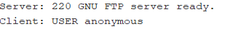
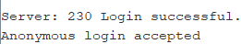
Figure 1. Anonymous login on the public FTP server.
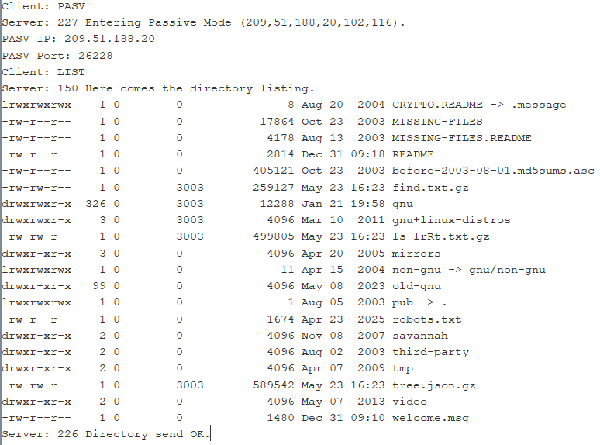
Figure 2. Successful LIST operation using the public FTP server.
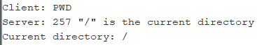
Figure 3. Directory navigation using PWD command.
Figure 4. Successful RETR operation on the public FTP server.

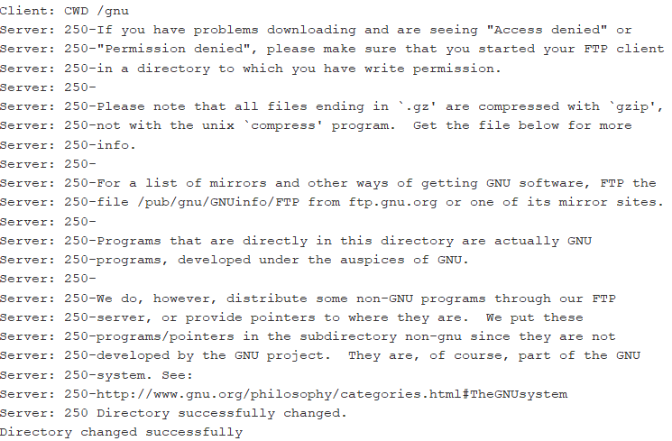
Figure 5. Directory navigation using CWD command.
2. Public FTP Server limitation
Public FTP servers usually disable writeable operations for security reasons. Because of this, operations such as: STOR, DELE, MKD and RMD are denied on ftp.gnu.org.
Example:
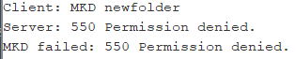
Figure 6. Permission denied response from public FTP server.
3. Local FileZilla Server Testing
To verify writeable FTP operations, additional testing was conducted using FileZilla Server running locally.
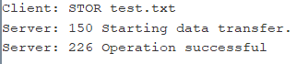
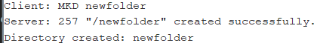
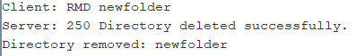
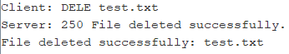
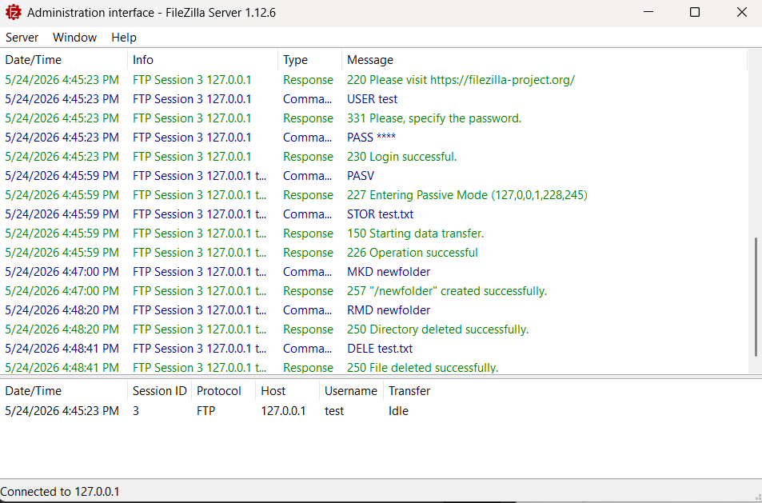
Figure 7. FTP writeable operations testing results on project UI and FileZilla.
V. Challenges and Solutions
1. Multiline FTP Responses
Some FTP servers returned multiple responses instead of single-line replies.
Example:
Figure 8. FileZilla server response.
The client was updated to continue reading lines until the terminating reply code was reached.
2. Public FTP Server Restrictions
The public FTP server denied writeable operations such as upload and directory creation. To handle this issue, a local FileZilla Server was configured for additional testing.
3. GUI Freezing
Long FTP operation initially caused the GUI to freeze during communication and file transfer. This issue was solved by running FTP operations in separate threads.
VI. Conclusion
The project successfully implemented a graphical FTP client in Java using socket programming and the FTP protocol. All required operations were implemented and tested successfully.
The project demonstrates understanding of:
- FTP communication.
- Client-Server networking.
- Socket programming.
- Passive mode data transfer.
- GUI integration.
- Error handling.
This implementation demonstrates the use of separate control and data connections for FTP communication and file transfer operations.

