Updates: Friday, April 1, 2022  
- Anujay Sharma, Kunal Nandanwar  
  
**Updates:**

1. Shifted PC from Prescott to Unity, coordinated amongst Rushikesh, Anujay and Kunal
2. Returned Prescott Key
3. Created the program from scratch, Implemented A* planner on 3D symmetric objects using Euclidean Heuristics
4. Assumptions:
   1. 4 faces
   2. 4 actions (“UP”, “DOWN”, “Rotate CW”, “Rotate CCW”)
   3. Resolution: x, y, z = 1.25, 1.25, 1

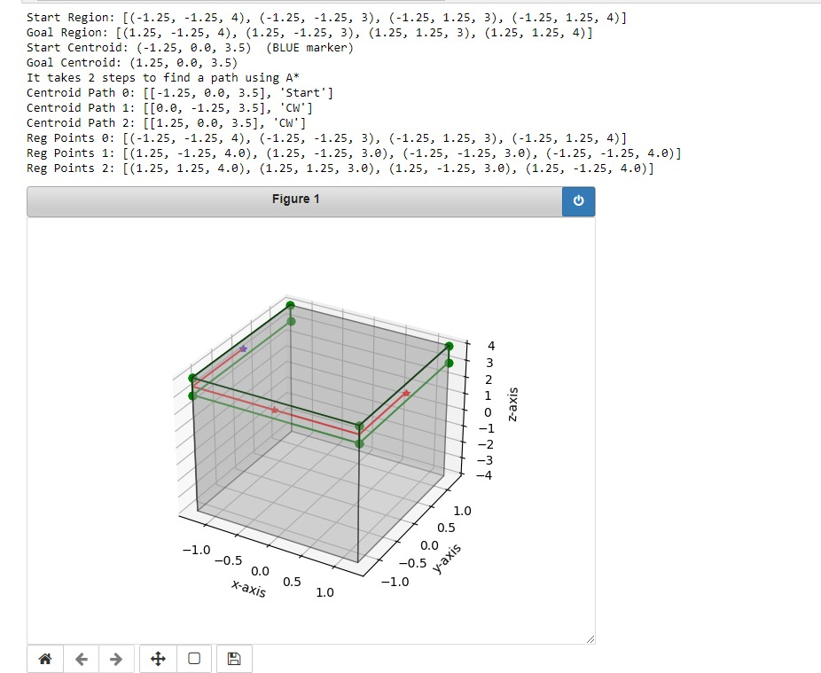

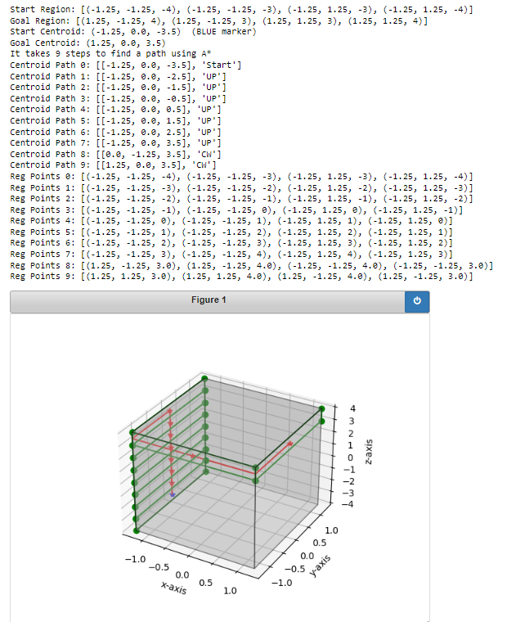

**Summary:**

1. Created 3D planner, with some assumptions
2. Action Plan:
   1. Reg based(full): Apr 1
   2. Pose: Apr 15
   3. Pivot: Apr 22/Apr 29
   4. Report: Apr 29???