Updates: Friday, Feb 11, 2022  
- Kunal Nandanwar  
  
**Updates:**

0. Updated Planner – long term and short term goals

1. Dependencies error-talked to Abhinav(gitignore) - but still faced issues

2. Akshay Laddha helped in installing dependencies and removing errors

3. Talked to Chintan – quite helpful - suggested us to work on the packages of our interest, spent 2-3 hrs with us to install the packages of our interest and resolving issues

4. Installed python libraries:   
 Scipy  
 geometry3d  
 shapely.geometry  
 collection

5. Analysed Chintan’s python code: reg based planning(Visualization of collision geometry generated, The output file generated with sequence of motion primitives):

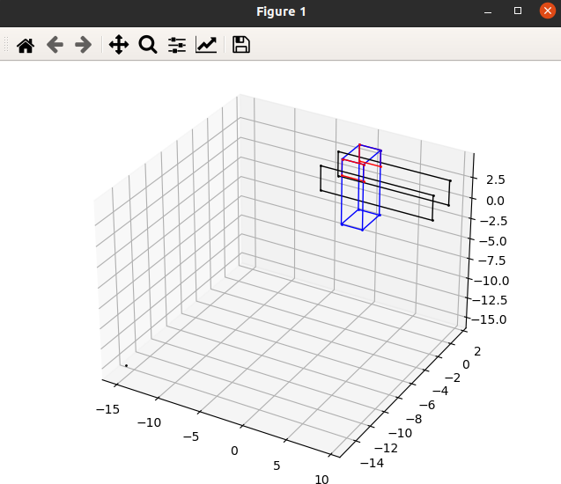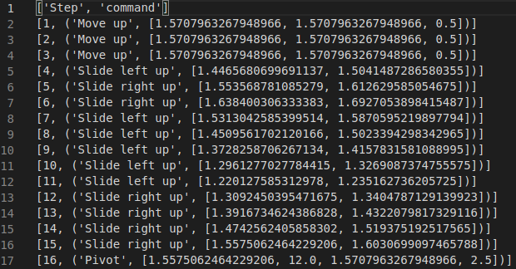  
6. Explored Alp’s work: Gazebo models (wihm-variable-friction: Gripper controls)

7. Explored commands: https://github.com/asahin1/wihm-variable-friction/tree/main/vf_hand_sim/gripper_controls

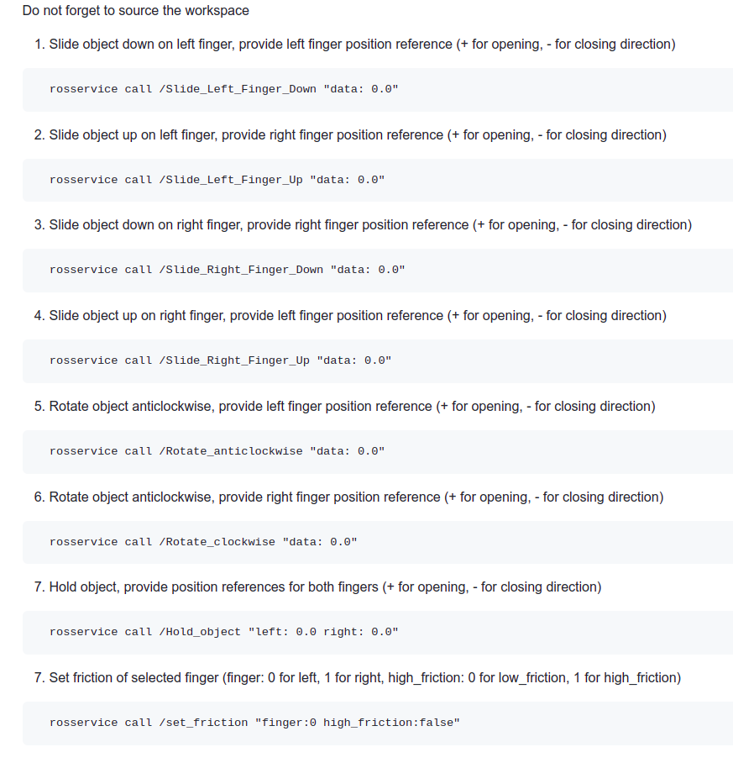

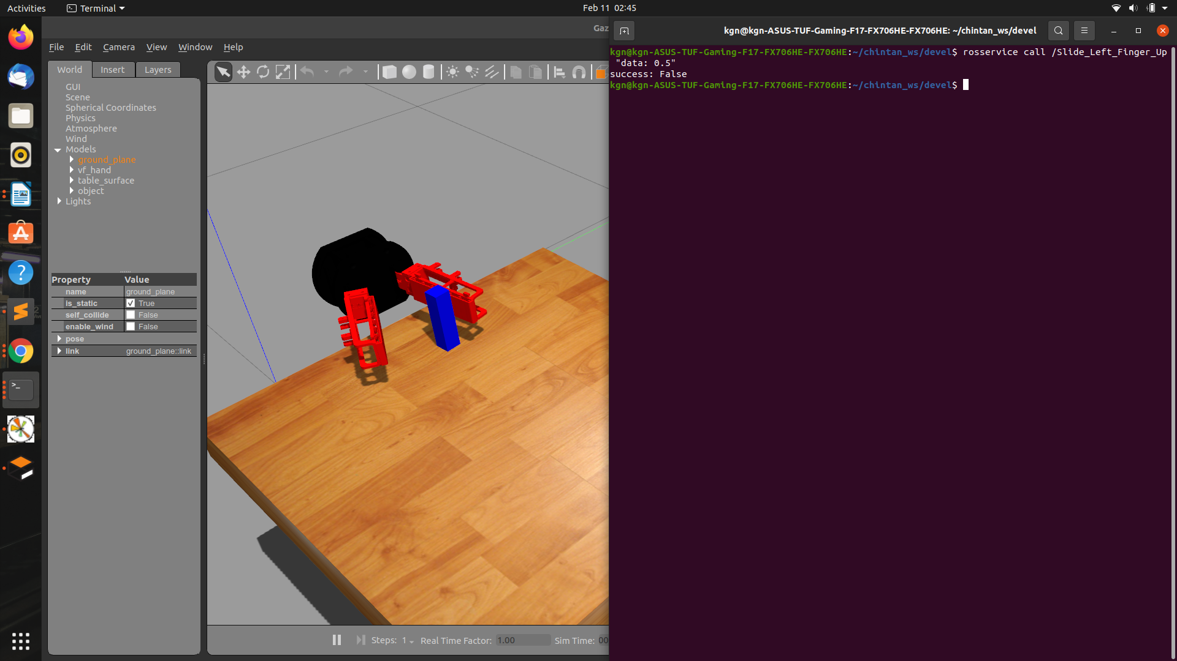

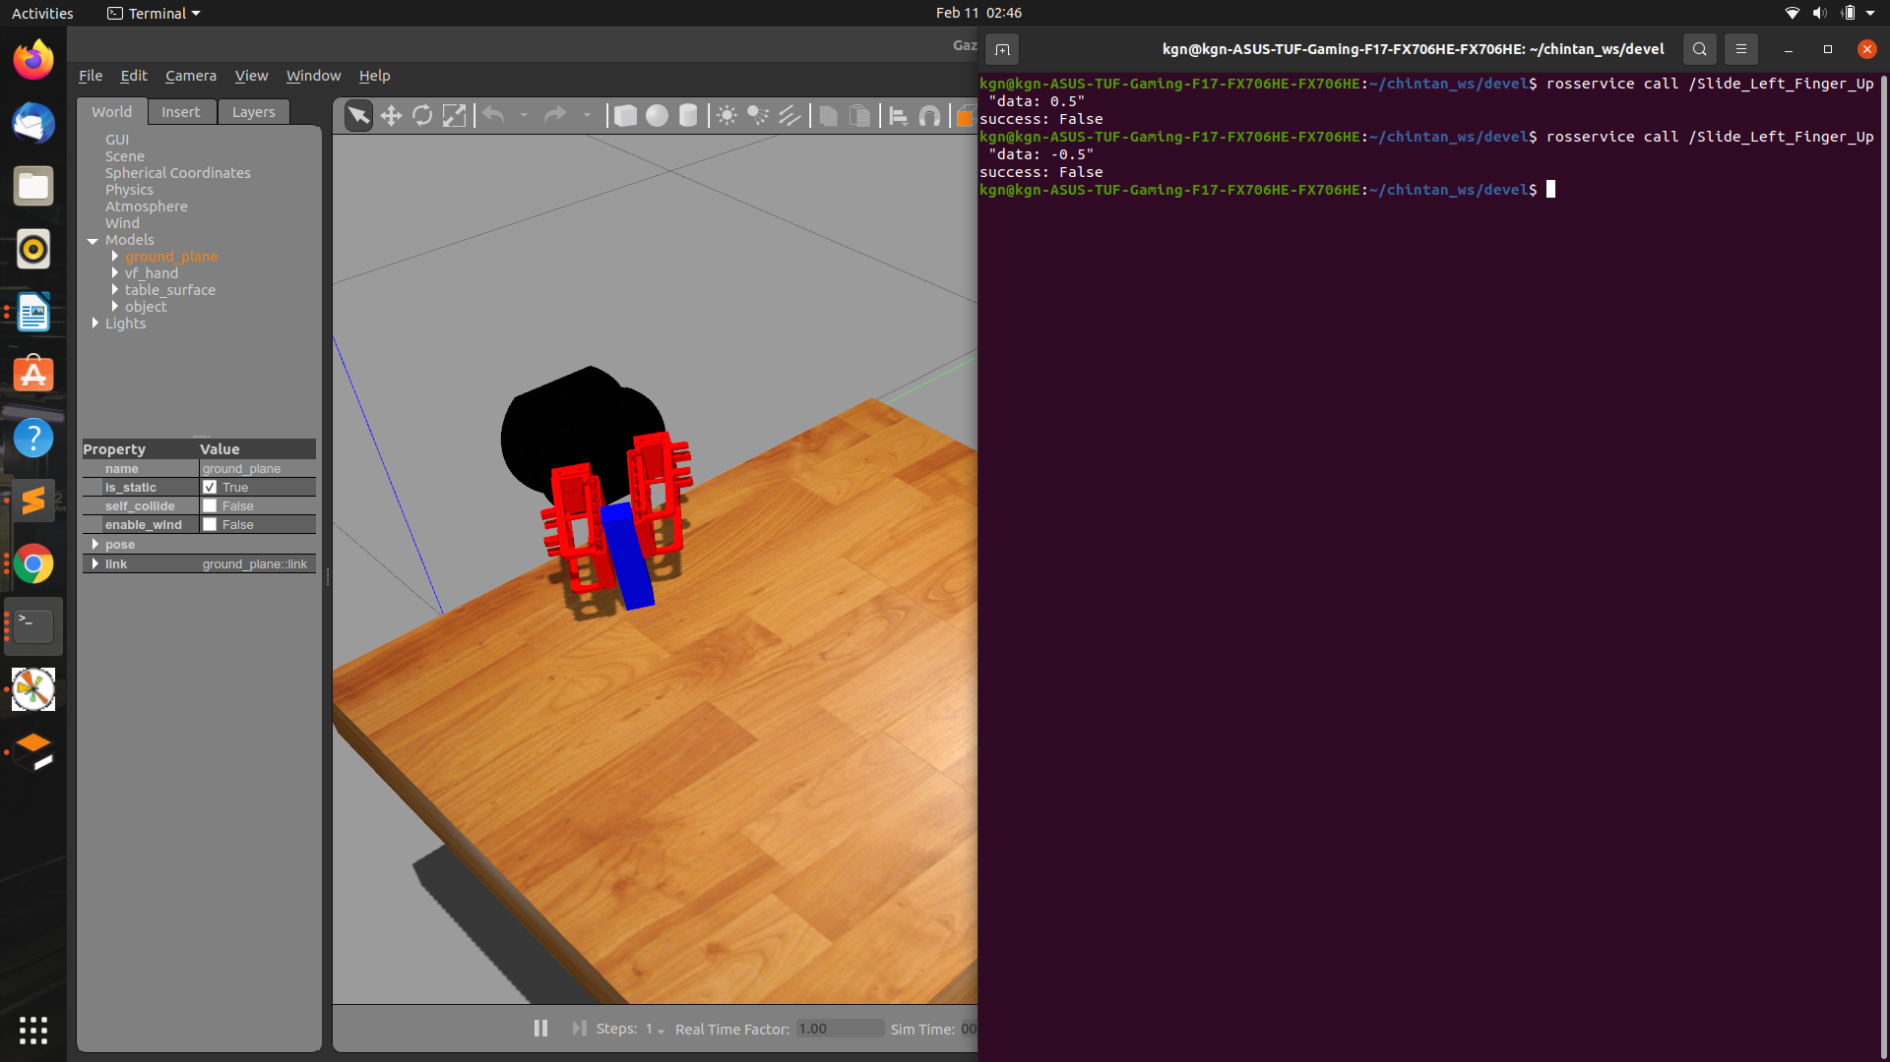

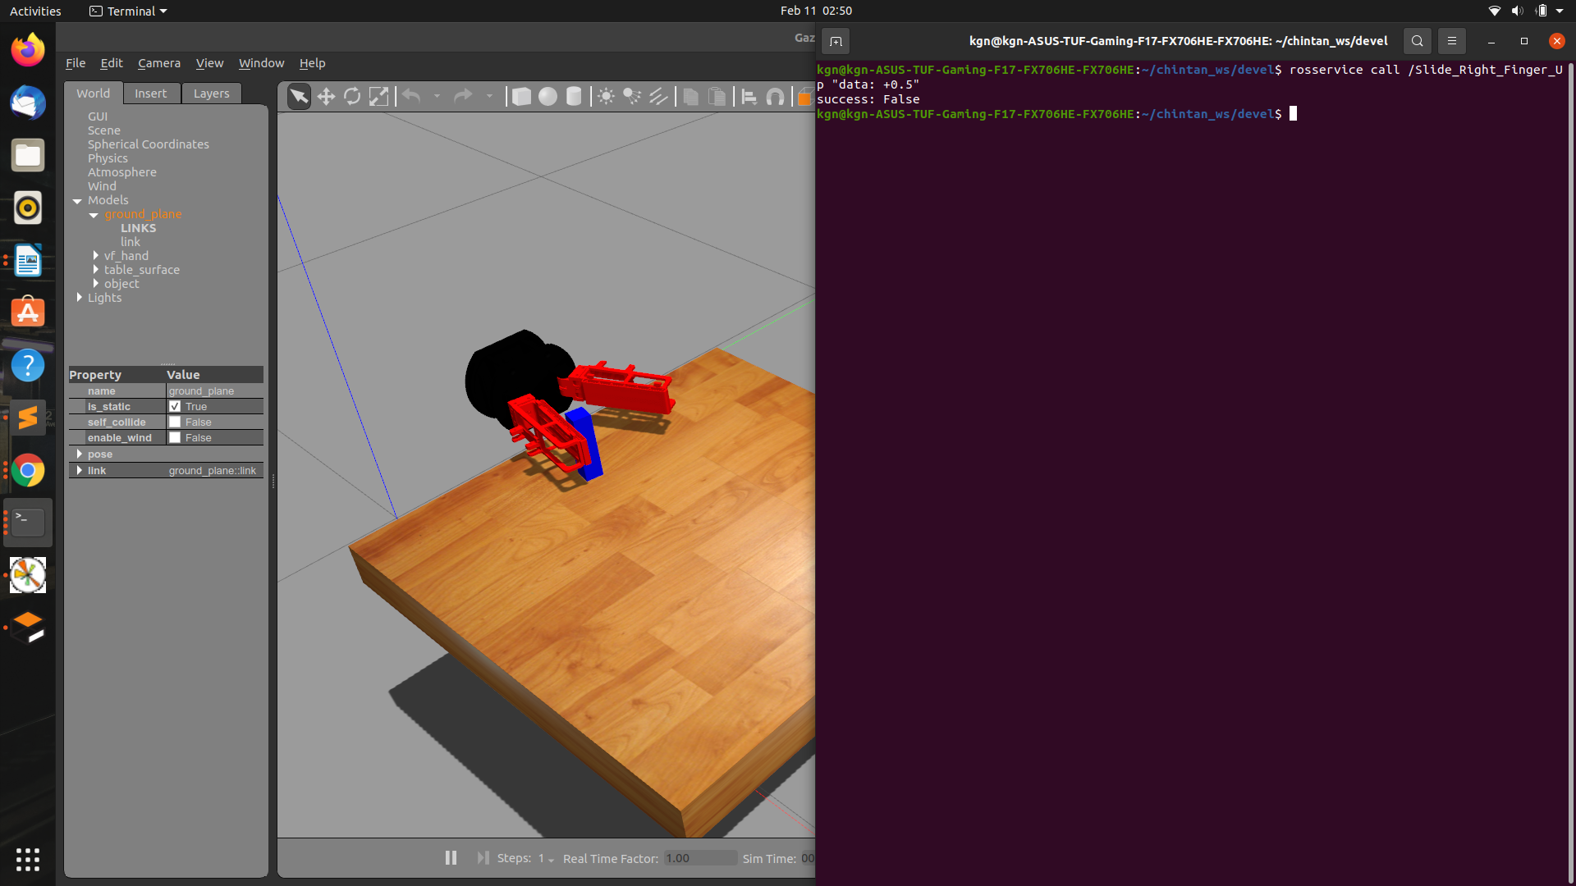



**Important Commands:**

***Chintan Work:***

python3 planning_main.py

***Alp Work:***

In both terminals:

cd chintan_ws/devel/  
source setup.bash  
source setup.sh

In 1 terminals:

roslaunch manipulation_env vf_only.launch

In another tab:

rosservice call /Slide_Left_Finger_Down "data: 0.0"

rosservice call /Slide_Left_Finger_Up "data: 0.0"

rosservice call /Slide_Right_Finger_Down "data: 0.0"

rosservice call /Slide_Right_Finger_Up "data: 0.0"

rosservice call /Rotate_anticlockwise "data: 0.0"

rosservice call /Rotate_clockwise "data: 0.0"

rosservice call /Hold_object "left: 0.0 right: 0.0"

rosservice call /set_friction "finger:0 high_friction:false"

**Meeting Notes/Suggestions:**

1. Continue Chintan’s work of planner: the old work before he switched to a new abstract one!
2. List of planners to be discussed in the meeting
3. Planner: Weekly goals, move the current ones to the history