Updates: Friday, Feb 18, 2022  
- Kunal Nandanwar

Reference Video: [https://wpi0.sharepoint.com/sites/gr-MERLab88/Shared%20Documents/Forms/AllItems.aspx?id=%2Fsites%2Fgr%2DMERLab88%2FShared%20Documents%2FDexterous%20In%2Dhand%20Manipulation%2FICRA%202021%20Files%2FICRA21%20%2D%20Video%20%2D%20Region%2Dbased%20Dexterous%20](https://wpi0.sharepoint.com/sites/gr-MERLab88/Shared Documents/Forms/AllItems.aspx?id=%2Fsites%2Fgr-MERLab88%2FShared Documents%2FDexterous In-hand Manipulation%2FICRA 2021 Files%2FICRA21 - Video - Region-based Dexterous Manipulation First Submission.mp4&parent=%2Fsites%2Fgr-MERLab88%2FShared Documents%2FDexterous In-hand Manipulation%2FICRA 2021 Files&p=true)**Meeting Notes/Suggestions:**

1. Continue Chintan’s work of planner: the old work before he switched to geodesic!
2. List of planners to be discussed in the upcoming meeting
3. Planner: Weekly goals, move the current ones to the history

**Updates:**

0. Updated Planner – weekly goals

1. Chintan’s python code: reg based planning(Visualization of collision geometry generated, The output file generated with sequence of motion primitives)

2. MER lab git files: not working initially: planner was working but not giving output text files, took time to debug, made some modifications and finally gave same results as that of Chintan

3. Runtime Warning/error:

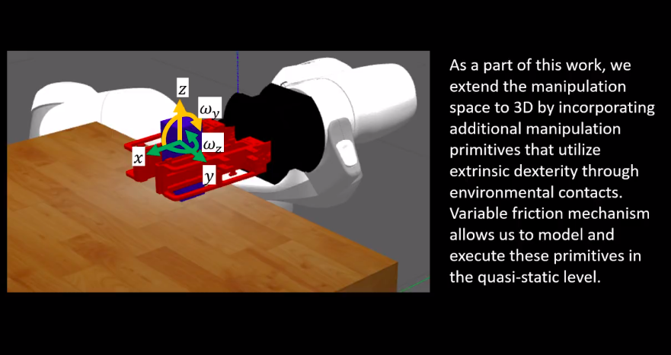

4. Default:

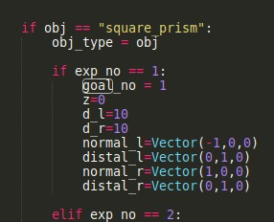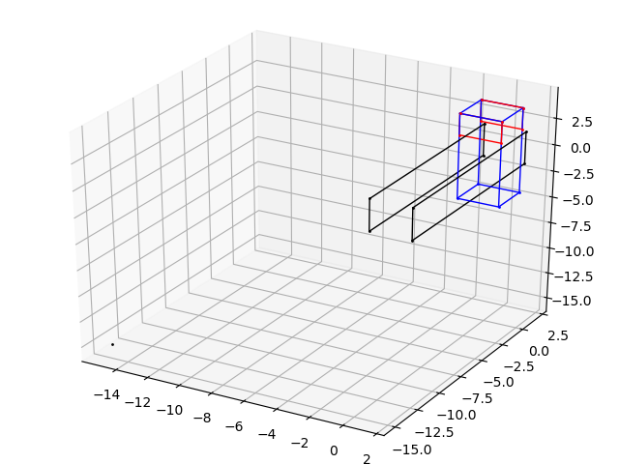

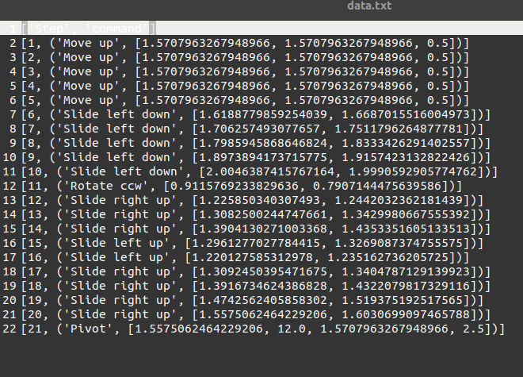

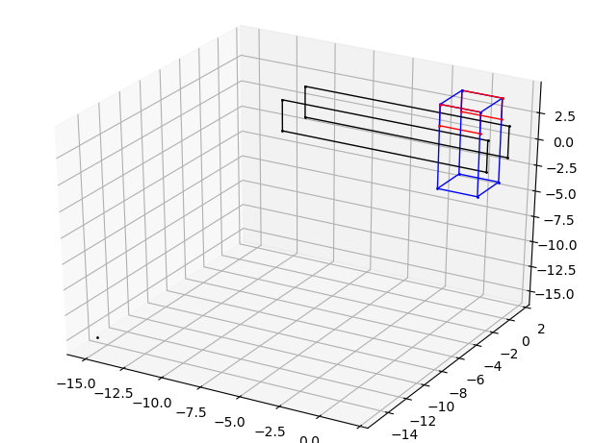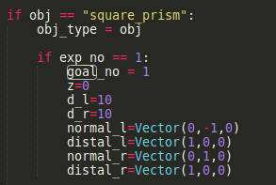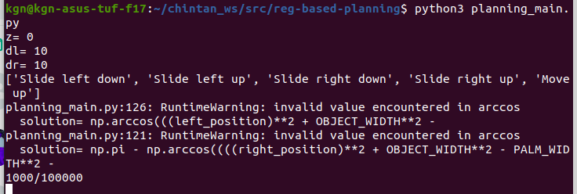

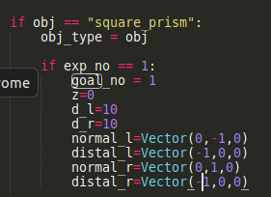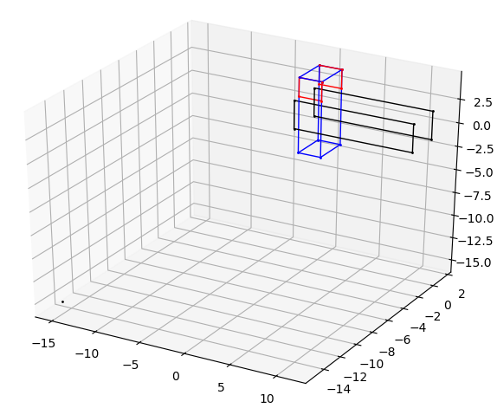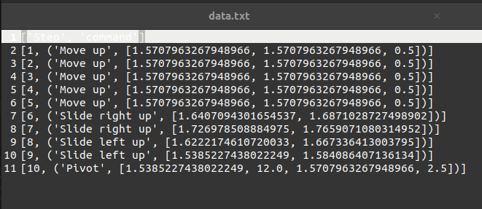

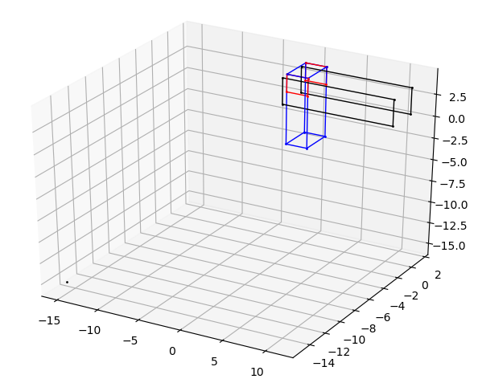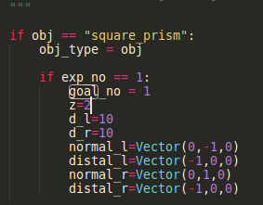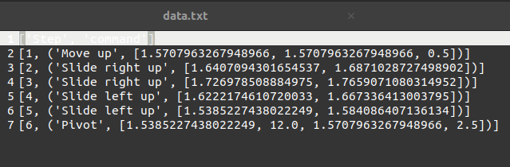

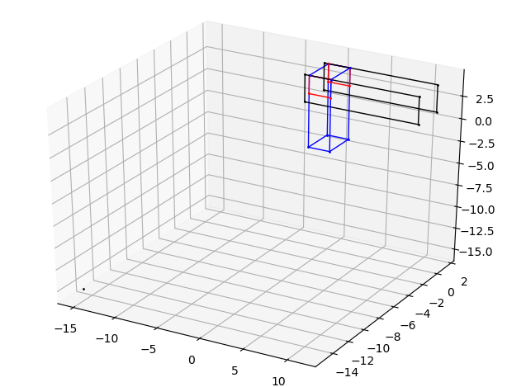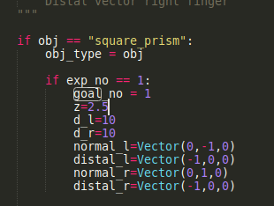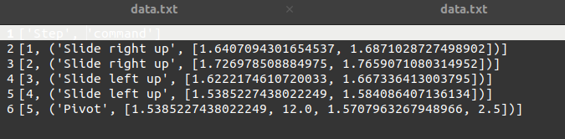

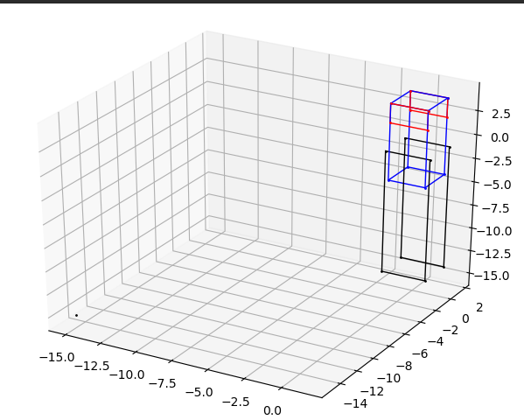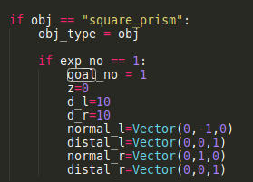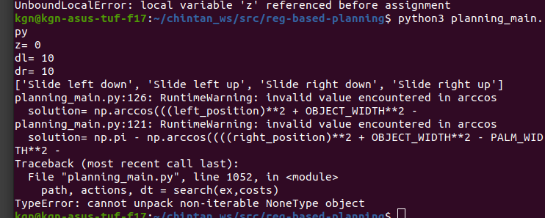

returned empty data

