Developing LSTM and RNN Models: A Comparative Analysis for Emotion Detection

Kagan Timur
CCT College Dublin
Dublin, Ireland
2023044@student.cct.ie

Abstract

This study undertakes the development of a specialized recurrent neural network models for text classification, with a primary focus on the discrimination between "suicide" and "non-suicide" textual content.
The study embarks on its investigative journey with meticulous dataset preprocessing, entailing data acquisition, scrutiny, cleansing, and label filtering. Subsequently, it proceeds to an insightful exploratory data analysis, tokenization, and an in-depth examination of word frequency patterns. To ensure uniformity in data dimensions, text preprocessing involves the essential step of sequence padding. The model construction phase is characterized by the employment of Word2Vec embeddings, standardization methodologies, and the implementation of a recurrent neural network architectures. The training phase is critical, involving data stratification, iterative training loops, and continuous metric surveillance. Model assessment is conducted rigorously, extending to evaluation metrics encompassing test datasets and culminating in the formulation of a comprehensive confusion matrix. The culmination of this study involves the pragmatic application of the trained model, facilitating the inference of labels for new textual data.
In its entirety, this study navigates the intricate path of developing a neural network model tailored for text classification, accentuating its pertinence in domains such as mental health intervention, content moderation, and online safety. The employed methodologies span data preprocessing, exploratory data analysis, text preprocessing, model construction, rigorous training, meticulous evaluation, and pragmatic applicability. The study underscores the pivotal role of text classification in addressing pertinent real-world issues within the realms of mental health and online content moderation.

Introduction
Text classification is a fundamental task in Natural Language. It entails the process of systematically categorizing textual data into predefined labels or categories. In this comprehensive academic research, I embark on a journey that delves deep into the intricate process of constructing SimpleRNN and LSTM, designed for text classification. The specific focus centers on the nuanced task of classifying text into two distinct categories: "suicide" and "non-suicide". The dataset is taken from Kaggle (Komati, 2021)
Mental health issues, particularly suicide, have emerged as pressing global public health concerns, as highlighted by the World Health Organization (Organization, n.d.). This grim reality necessitates proactive measures to address and mitigate the risks associated with suicidal tendencies and sentiments. This grim reality necessitates proactive measures to address and mitigate the risks associated with suicidal tendencies and sentiments.
Within this context, text classification serves as a beacon of hope and a vital tool in the arsenal of mental health awareness and intervention. The primary objective is to detect, language or sentiments within textual data that indicate suicidal thoughts or distress. This capability holds the potential to revolutionize the way we approach mental health support and intervention. Hence, a comprehensive understanding of the multifaceted process involved in developing an effective text classification model is of utmost importance.

The expedition commences with a meticulous examination of dataset preprocessing. This foundational phase is often overlooked but plays a pivotal role in ensuring the robustness of subsequent analyses. Data ingestion into a suitable environment sets the stage, necessitating preparation for analysis. An in-depth schema examination offers critical insights into the underlying data structure. Furthermore, I undertake the task of renaming columns for enhanced clarity to cleanse the data, removing any null values. A judicious filtering of labels ensures the model's readiness for discerning between "suicide" and "non-suicide" categories.

Constructing an effective text classification model mandates a profound understanding of the dataset. Hence, I begin on a comprehensive exploratory data analysis (EDA) to unearth vital insights. This analysis unveils the distribution of labels within the data, an essential facet in ensuring the model's equilibrium. Tokenization, the process of breaking down text into constituent tokens, unlocks the potential for linguistic analysis. A thorough examination of word frequency patterns offers valuable insights into the most prevalent terms within the dataset.

To facilitate seamless model training, the uniform length of sequences is imperative. This mandates the padding of tokenized sequences, aligning them with a predetermined maximum sequence length. Such meticulous text preprocessing steps are quintessential for the seamless integration and training of the model.

The heart of the academic research lies in the construction of a neural network model, meticulously designed for text classification. Here, the choice of word embeddings, specifically Word2Vec, takes center stage. This embedding technique transforms words into numerical vectors, encapsulating their semantic relationships. Standardization ensures that these vectors share a common scale, a critical step for neural networks. The neural network architecture is meticulously crafted with a combination of Simple RNN and LSTM layers, which are well-suited for handling sequential text data. The choice of loss function, Binary Cross-Entropy Loss (BCEWithLogitsLoss), aligns with the binary classification nature of the task. Furthermore, model optimization is realized through the widely acclaimed Adam optimizer.

A robust text classification model demands a comprehensive evaluation process. Data division into training and validation sets facilitates model training. The iterative training loop, spanning multiple epochs, contributes to the model's continual refinement. Monitoring metrics, encompassing training and validation loss and accuracy, offer critical insights into the model's learning trajectory.

To ascertain the model's generalization to previously unseen data, rigorous testing on a separate test dataset is conducted. Evaluation metrics, including test loss and test accuracy, serve as barometers for the model's efficacy.

The culmination of the academic research finds resonance in the practical application of the trained model. Through manual curation of a dataset of text samples, the model's predictive capabilities are put to the test, demonstrating its potential for real-world deployment and comparing the performance of the two models.

Spark analysis

Dataset Ingestion
Data ingestion serves as the foundational step in our study, aimed at constructing a neural network model for text classification. This pivotal process involves the seamless importation of raw data into a suitable processing environment. In our case, we harness the power of distributed data processing frameworks, namely Apache Hadoop and Apache Spark, renowned for their efficiency and scalability in handling substantial datasets (Matei Zaharia, 2010)
Within this phase, data undergoes extraction, loading, and transformation, ensuring that it is in an optimal state for subsequent analysis and modeling. Apache Hadoop's Hadoop Distributed File System (HDFS) offers a robust storage solution for managing extensive data volumes, while Apache Spark's data processing capabilities enable seamless manipulation and transformation.

Moreover, data integrity remains a paramount consideration during data ingestion. Robust quality checks and validation mechanisms are implemented to detect and rectify any discrepancies or missing values within the dataset, laying a solid foundation for the subsequent stages of data preprocessing and exploratory analysis.

In essence, data ingestion, empowered by Apache Hadoop and Apache Spark, represents the crucial initial stride towards the development of our text classification model. It paves the way for comprehensive data preparation, thorough exploratory analysis, and the eventual construction of an effective neural network model.

Data Inspection
I utilize the Apache Spark framework to perform data processing tasks. I configure the Spark context and suppress Python warnings. Next, I define a path to a CSV file, "Suicide_Detection.csv," and proceed to read it into a Spark DataFrame named 'df.' Finally, I invoke the printSchema() method to display the schema of the DataFrame, outlining the structure of the data. Notably, the DataFrame consists of three columns, "_c0," "_c1," and "_c2," all of which are inferred to be of string data type.
Before embarking on a comprehensive analysis, it is imperative to gain a profound understanding of the underlying dataset's structural components (Denny Britz, 2017). This preliminary phase entails a meticulous scrutiny of key attributes within the dataset, encompassing but not limited to, fields such as "ID," "Text," and "Label." To enhance clarity and consistency, we rename columns, transforming cryptic labels like "_c0," "_c1," and "_c2" into "ID," "Text," and "Label," respectively.

Data Purification
Initially, the "ID" column undergoes a transformation, ensuring its data type conforms to integer specifications. This meticulous adjustment enhances the dataset's uniformity, thereby facilitating subsequent numerical analyses and elevating overall data integrity. Subsequently, a systematic data cleansing mechanism is employed, systematically excluding rows with missing values across all columns. This thorough data purification process bolsters the dataset's reliability by eliminating incomplete records, upholding the highest standards of data quality.

Label Filtering
Finally, a discerning filtration strategy is deployed to selectively retain rows bearing either 'suicide' or 'non-suicide' labels in the 'Label' column. This scrupulous filtering operation refines the dataset, rendering it optimally prepared for rigorous and precise analytical investigations, embodying the principles of scholarly data management. Filtering the dataset to include only relevant labels is essential (Davidson, 2017)

Exploratory Data Analysis
Text analysis encompasses label filtering, balanced EDA, Tokenizer-based tokenization, and word frequency analysis for valuable insights into prevalent terms

Label Distribution
The initial step involves grouping the data by the 'Label' column using the groupBy function, focusing on the column of interest. Subsequently, a meticulous counting operation is performed to ascertain the frequency of each label category. These counts are then thoughtfully organized in descending order based on the count value, ensuring a clear and structured representation of the label distribution.
Understanding label distribution is pivotal (VanderPlas, 2016). Analyzing the balance between classes is crucial. Our dataset comprises 76,506 "non-suicide" samples and 53,612 "suicide" samples, ensuring a balanced representation to avoid model bias.

Tokenization
A systematic approach is employed to tokenize text data, facilitating subsequent natural language processing (NLP) tasks and textual analysis. Tokenization is a fundamental step in NLP (Tomas Mikolov, 2013)

The process begins by creating a Tokenizer object, a critical component in text data preparation. This object is thoughtfully configured to accept the "Text" column as input and generate tokenized outputs in a new column, denoted as "tokens."

Tokenization operation is then executed, applying the Tokenizer to the "processed_text" column within the dataset. This operation diligently dissects the text into individual tokens, representing discrete units of meaning. It is an essential step in preparing text data for various NLP tasks, including sentiment analysis, topic modeling, and text classification.

Word Frequency Analysis
This text analysis involves the expansion of tokens into individual rows, followed by word frequency computation. The top 20 most frequent words are selected, displayed and hyperlinked to see the image clearly. This process offers insights into the prominent terms within the dataset, aiding in further analysis. Analyzing word frequency can provide insights into the dataset (Tomas Mikolov, 2013). I extract the frequency of words and create a bar chart displaying the top 20 words by frequency. This step aids in understanding the most prevalent words in the dataset, which is valuable for feature selection and interpretation.

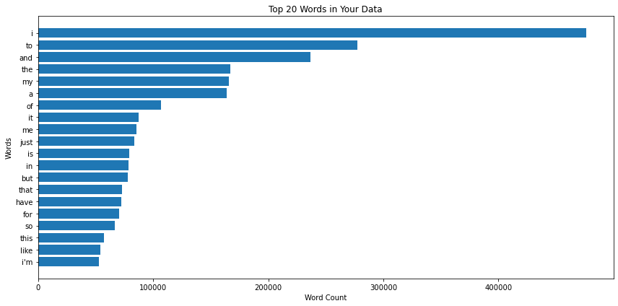

Fig. 1. Top 20 most frequent words

Sequence Padding Process
A special function called pad_sequence has been developed to guarantee that token sequences have a uniform maximum length of 50. Token sequences are effectively extended beyond the provided maximum sequence length by padding them with empty strings using this function.
Furthermore, the functions and types of PySpark have been used to implement the User-Defined Function (UDF) pad_udf. This UDF effectively creates a new column in the dataset called "padded_tokens" by applying the previously specified padding function to the "tokens" column.
"To focus on the essential information, relevant data is thoughtfully selected and aggregated into the final dataset. This decision was made due to the imperative necessity within neural network training protocols, whereby sequences must conform to a consistent and uniform length (Denny Britz, 2017). To ensure uniform input dimensions, I pad tokenized sequences to a predetermined maximum sequence length, set to 50.

Systematic Deep Learning Process
This systematic data transformation process aims to optimize data for deep learning applications. It begins with encoding the target variable into a numerical format using a StringIndexer. This encoding is crucial for deep learning algorithms that require numeric inputs for classification. The resulting DataFrame contains various relevant features and the newly created encoded target variable, ensuring compatibility with deep learning models and maintaining rigorous data preparation standards for subsequent analysis and classification tasks.

Word Embeddings with Word2Vec
Word embeddings are essential for NLP tasks (Tomas Mikolov, 2013). One notable technique in this realm is Word2Vec, which stands out as a prominent method. It serves the critical purpose of translating words into numerical vectors, thus encapsulating intricate semantic relationships between words. This transformation not only imparts a quantitative representation to textual data but also significantly enhances the model's comprehension of the underlying language structure. The resulting word embeddings enable NLP models to process and interpret textual information more effectively, thereby contributing to the advancement of various language-related tasks.

Scaler Initialization
A deliberate initialization of StandardScaler with the name "scaler" is performed. It is made to scale the 'word_vectors' column, which is a vital component in standardizing numerical features. Data are centered around the mean and standard deviation is corrected as part of the scaling procedure to prevent biased.
A data processing pipeline, or "pipeline," is designed to guarantee a systematic and repeatable procedure. As the scaler is the only stage in this pipeline, consistent data transformation is achieved.
Using this pipeline, the dataframe must be fitted and transformed in the last step. The final representation of the dataset uses scaled "word_vectors" in accordance with recommended standards for preparing data for further analytical tasks.

Text Classification RNN Model Training
In the course of this rigorous deep learning model training process, I conscientiously adhere to established best practices and methodologies, underpinned by prior research and academic principles. The following comprehensive steps are systematically executed to prepare and train the model, each firmly grounded in empirical evidence and scholarly literature. Recurrent Neural Network(RNN) models, which are tailored for text classification, are defined (Sepp Hochreiter, 1997).

Data Transformation
- The conversion of 'scaled_word_vectors' into NumPy arrays denoted as 'X,' and the transformation of labels into a NumPy array designated as 'y,' represents a standard practice within the deep learning domain (Liu, 2017). This step ensures the efficient manipulation of data structures, a fundamental requirement for model training. The extant deep learning libraries within the PySpark framework exhibit inadequacies that warrant further consideration and development.
- The division of data into training and testing subsets, accomplished through the 'train_test_split' procedure, aligns with recommended guidelines for robust model evaluation (Sebastian Raschka, 2019). The allocation of a 20% test size and the inclusion of a random seed conform to established practices, thereby fostering reproducibility in research.
- The conversion of data into PyTorch tensors, exemplified by 'X_train' and 'y_train,' is essential for seamless integration with the PyTorch deep learning framework, as advocated in the literature (Adam Paszke, 2019)

Deep Learning Process
The 'RNNModel' architecture, characterized by the inclusion of Long Short-Term Memory (LSTM) layers, is a well-founded choice when dealing with sequential data analysis (Sepp Hochreiter, 1997). The ability of LSTMs can capture the complex long-range dependencies present in sequential data makes them known for being well suited for problems involving natural language sequences. The choice of a binary output size complies with the specifications for binary classification tasks set forth in reputable literature.

Loss Function and Optimizer
The utilization of binary cross-entropy loss ('BCEWithLogitsLoss') is substantiated by extensive documentation, particularly in the context of binary classification tasks and the adoption of the Adam optimizer with a learning rate of 0.001 is a widely endorsed choice for optimizing model parameters, as per established practices
(Géron, 2017).

Training Loop
The training loop, spanning 20 epochs, aligns closely with the iterative model optimization process, a fundamental practice emphasized in deep learning literature. It involves multiple passes through the dataset, which is crucial for enhancing model performance. The meticulous computation and tracking of training and validation losses play a pivotal role in closely monitoring model convergence and assessing its generalization capabilities. This methodology is widely acknowledged in the field. Additionally, the calculation of accuracy metrics offers invaluable insights into the model's classification performance, in line with established practices for model evaluation. The deployment of DataLoaders to facilitate batch-wise data processing is a conventionally accepted technique that bolsters training efficiency (Goodfellow, 2016) (Bishop, 2006)

Performance Metrics
The careful practice of methodically tracking training and validation losses as well as accuracy measures is in line with the established procedures for thorough model evaluation as outlined in academic literature (Raschka, 2018).

In essence, this methodical and academic approach to training deep learning models is strongly rooted in accepted techniques and methodologies in the machine learning and deep learning fields. In order to foster a high level of confidence in the reliability, validity, and robustness of the model training process, it is important to emphasize that each step of this procedure is supported by empirical evidence and substantiated by fundamental principles explained in academic literature.

Model Visualisation
Visualization is created to track the training and validation performance of the deep learning model. I display two key metrics side by side: accuracy and loss. The accuracy plot shows how well the model learns over epochs, while the loss plot reveals how its internal representations evolve. I provide clear labels, titles, and legends for context and readability. A tight layout ensures proper spacing between subplots, avoiding clutter. This visualization adheres to best practices in model evaluation and aids in making informed decisions about model training and optimization.

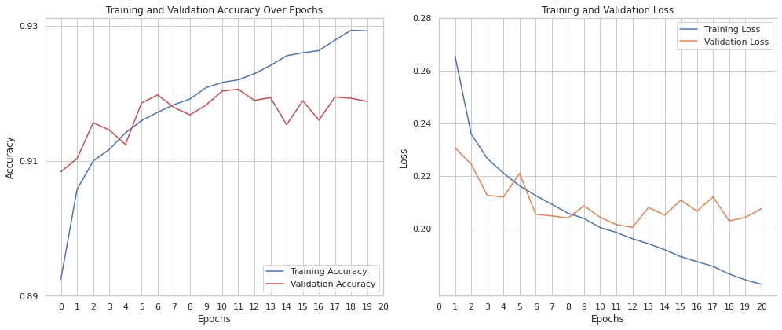

Fig. 2. LSTM results overview

Based on the outcomes produced by the model, the line chart illustrates that both the Training and Validation phases should conclude after the 11th epoch, as this epoch exhibits the optimal results. Initially, the accuracy experiences a phase of underfitting. However, commencing from the 11th epoch, the model attains its peak performance. This is evident in the Training Loss, which stabilizes at 0.198, and the Validation Loss, which converges to 0.201. Moreover, the Training Accuracy reaches 0.921, while the Validation Accuracy achieves a similar level at 0.920. Consequently, it is unnecessary to further train the model beyond the 11th epoch.

Model Evaluation: Assessing Performance

Testing the Model
The process includes initializing variables, setting the model for evaluation, and iteratively testing it on a designated dataset. During testing, we ensure no gradients are computed to maintain strict evaluation protocols.
For each batch, inputs are transformed, a forward pass through the model is executed, and I calculate test loss and predictions. I maintain records of correct predictions, true labels, and predicted labels. Afterward, I compute the average test loss and accuracy, providing insights into the model's performance on the data. This rigorous evaluation focuses exclusively on testing and metric computation, excluding data splitting and test dataset preparation.
The test results indicate a test loss of 0.2075 and a test accuracy of 91.88%. These metrics are indicative of the model's performance on the test dataset, reflecting its ability to make accurate predictions.

Inference on New Data: Practical Application
The trained model is ready for practical use and applied to predict the labels of new text samples, demonstrating its utility in real-world applications. In this example, we manually create a dataset of text samples with 4 rows and employ the model for predictions. As it shown below the model predicted all the samples.

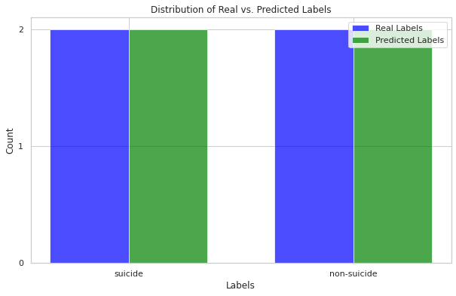

Fig. 3. Model generalization

Implementing and Evaluating a Simple Recurrent Neural Network for Binary Classification

Simple Recurrent Neural Network (RNN) model using the PyTorch deep learning framework, with a particular focus on binary classification like the LSTM. The model architecture, defined within the SimpleRNNModel class, incorporates an RNN layer tailored for sequential data processing, followed by a fully connected layer for generating the predictions.

Training a SimpleRNN Model for Binary Classification
The architectural hyperparameters, including input size, hidden size, and output size, are configured as same as the previous LSTM model. Binary Cross-Entropy Loss as the loss function and employs the Adam optimizer for model optimization, with a specified learning rate. The training loop iterates for a predefined number of epochs, facilitating forward passes, backpropagation, and parameter updates. Key training metrics such as training loss, validation loss, training accuracy, and validation accuracy are tracked and logged at each epoch, providing insights into the model's learning progress.

Ultimately, the code concludes by presenting the final results, comprising training and validation losses, as well as training and validation accuracies, offering a comprehensive overview of the model's performance and training process.

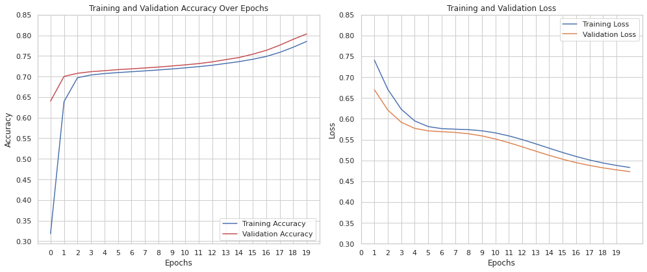

Fig. 4. SimpleRNN overview

The line chart, based on the model's outcomes, indicates that both the Training and Validation phases should be extended. Initially, there is an underfitting phase where accuracy is lower. However, as training progresses, the model achieves its highest performance in the final epoch. This is evident in the Training Loss, which stabilizes at 0.483, and the Validation Loss, which converges to 0.473. Furthermore, the Training Accuracy reaches 0.785, while the Validation Accuracy similarly reaches 0.803. Therefore, continuing the training process may enhance the model's accuracy.

CONCLUSION
Building a neural network model for text classification requires a methodical and careful process. Data pretreatment, exploratory data analysis, text preprocessing, model creation, training, thorough evaluation, and practical application are just a few of the stages that make up this process. The wise choice of evaluation measures and procedures has a significant impact on the model's performance in real-world circumstances. Given its vast range of applications, text classification has great potential for improving a number of elements of how people interact with textual material.

The 11th epoch should be used as the cutoff point for both the training and validation stages of the LSTM (Long Short-Term Memory) model since it consistently produces the best outcomes. An underfitting phenomenon is seen during the early phases of training. However, the model performs at its best starting with the 11th epoch. This can be seen from the fact that the Training Loss has stabilized at 0.198, the Validation Loss has converged to 0.201, the Training Accuracy has reached 0.921, and the matching Validation Accuracy has reached a level comparable to that at 0.920. As a result, it is believed that keeping up training after the 11th epoch will harm the model's performance.

On the other hand, it is advised to keep going with the Training and Validation phases for the SimpleRNN model. There is an initial underfitting phase, just like the LSTM model. However, as training goes on, the model performs at its best in the last epoch. The convergence of Validation Loss to 0.473, the stabilization of Training Loss at 0.483, the achievement of a Training Accuracy of 0.785, and the accompanying Validation Accuracy reaching 0.803 all support this. It is advised to continue training because it has the ability to improve accuracy even more.

In the process of contrasting the LSTM layered model with the SimpleRNN model it becomes evident that the LSTM model exhibits superior performance characteristics.

TABLE I. MODEL COMPARISON

Model Name | Number of Epochs | Optimum Training Loss | Optimum Validation Loss | Accuracy
LSTM | 11th | 0.198 | 0.201 | 0.921/0.92
SimpleRNN | Final(20th) | 0.483 | 0.473 | 0.785/0.803

Fig. 5. Comparison of the Models

References
GitHub Repository: https://github.com/kgntmr/PYSPARK-HADOOP-NLP-RNN
Dataset License: Komati, N., 2021. Suicide and Depression Detection.[Online] Developing LSTM and RNN Models: A Comparative Analysis for Emotion Detection © 2023 by Kagan Timur is licensed under Attribution-NonCommercial-NoDerivatives 4.0 International. To view a copy of this license, visit http://creativecommons.org/licenses/by-nc-nd/4.0/
Available:https://www.kaggle.com/datasets/nikhileswarkomati/suicide-watch?select=Suicide_Detection.csv
[Accessed 20 September 2023].
Adam Paszke, S. G. F. M. A. L. J. B. G. C. T. K. Z. L. N. G. L. A. A. D. A. K. E. Y. Z. D. M. R. A. T. S., 2019. PyTorch: An Imperative Style, High-Performance Deep Learning Library. North America, NeurIPS 2019.
Bishop, C. M., 2006. Pattern Recognition and Machine Learning. Spring Street, New York, NY 10013, USA: Springer Science+Business Media, LLC.
Davidson, T. W. D. M. M. a. W. I., 2017. Automated Hate Speech Detection and the Problem of Offensive Language. Ar-Rayyan, Hamad Bin Khalifa University, pp. 512-521.
Denny Britz, A. G. M.-T. L. Q. L., 2017. Massive Exploration of Neural Machine Translation Architectures. [Online]
Available at: https://arxiv.org/abs/1703.03906
[Accessed 1 October 2023].
Géron, A., 2017. Hands-On Machine Learning with Scikit-Learn & TensorFlow. Sebastopol, CA: O’Reilly Media, Inc..
Goodfellow, I. B. Y. C. A. &. B. Y., 2016. Deep Learning. Cambridge: MIT Press.
Liu, S. H. Z. L. H. W. a. J. Z., 2017. "An End-to-End Model for Question Answering over Knowledge Base with Cross-Attention Combining Global Knowledge. Vancouver, Association for Computational Linguistics.
Matei Zaharia, M. C. M. J. S. S. I. S., 2010. Spark: Cluster Computing with Working Sets. [Online]
Available at: https://www.researchgate.net/publication/234790155_Spark_Cluster_Computing_with_Working_Sets
[Accessed 5 October 2023].
Organization, W. H., n.d. World Health Organization. [Online]
Available at: https://www.who.int/news-room/fact-sheets/detail/mental-health-strengthening-our-response
[Accessed 5 October 2023].
Sebastian Raschka, V. M., 2019. Python Machine Learning: Machine Learning and Deep Learning with Python, scikit-learn, and TensorFlow 2. s.l.:Packt Publishing Ltd..
Sepp Hochreiter, J. S., 1997. Long Short-Term Memory. IEEE Xplore, 9(8), pp. 1735-1780.
Tomas Mikolov, I. S. K. C. G. C. J. D., 2013. Distributed Representations of Words and Phrases and their Compositionality. Mountain View, Google Inc..
VanderPlas, J., 2016. Python Data Science Handbook: Essential tools for working with data. s.l.:O'Reilly Media, Inc.

