LS ASIC – Version 2 – IC77

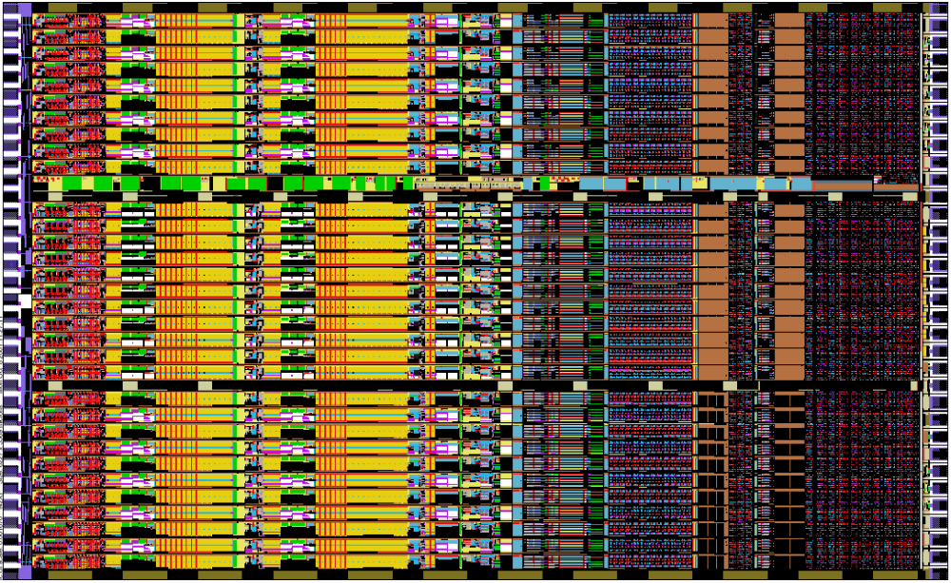

Technology : CMOS 0.35µm 2-poly, 4-metal

Channels : 32
preamplifier / high order shaper
settable gain: 1V/fC, 2V/fC
settable peaking time: 0.5µs, 1µs, 2µs, 4µs
dual window comparators / threshold comparator
comparator thresholds individually adjustable (6-bit DAC)
24-bit counter for each comparator

Power per channel : ≈ 8mW

SPI compatible logic

Expected resolution : < 300 eV @ 1µs, 100kHz/pixel

LOGIC

Chip select via CS
Chip is selected when CS (chip select) is high.
Transition high to low of CS resets the counters (internal control CRST) and sets ELK and EAN (internal control SAN).

Chip select via token
Chip selection can also be performed via token by connecting TO (token out) to CS of the next chip.

Enabling Counters and data SDI/SDO interface
Counters are enabled/disabled through EN.
Read/write mode is selected through WR.
In write mode (WR=0) SCK and SDI are enabled through internal control WE (write enable).
In read mode (WR=1) SCK and SDO (tristated) are enabled through internal control RE (read enable).
If CS is low, WE and RE are forced to low.

SUPPLIES

Vdd +3.3V analog
Vddb +3.3V analog common bias
Vddp +3.3V analog input MOSFET
Vddd +3.3V digital

Vss 0V analog
Vssb 0V analog common bias
Vssd 0V digital
Vsubd 0V substrate digital

ANALOG INPUTS

CAL calibration input

VL0 low threshold, window 0
VL1 low threshold, window 1
VH1 high threshold, window 1
VL2 low threshold, window 2
VH2 high threshold, window 2

ANALOG OUTPUTS

OAN analog output
OLK leakage current monitor

ANALOG CONTROLS (self biasing)

BLK internal leakage current control
BLN output baseline control
BDAC DAC range control

DIGITAL INPUTS

SCK clock input positive edge shifts in write mode
negative edge shifts in read mode (latch on positive edge)
clock must be idling high

SDI 904 bit serial input; first bit written at first clock (positive edge), ending to Ch31
0,0,0,0,EBLK,T1,T2,G,[ECH,ECAL,ELK,EAN,D0-D5/VL1,D0-D5/VH1,D0-D5/VL2,D0-D5/VH2]x32,
first bit of data stream is D5/VH2 of Ch31, last bit of data stream is 0.

CS chip select 1 active
CS transition 1 to 0 resets the counters and sets EAN and ELK

EN counters enable/disable EN=1 enables the counters
EN=0 disables the counters

WR write/read mode WR=1 read mode
WR=0 write mode

RST global reset 0 active
OR-ed to internal power-on reset

TO token output, to be connected to CS of the next chip

TCK token clock input positive edge shifts token

DIGITAL OUTPUTS (clocked)

SDO 2304 bit counter serial output; first bit available before first clock, starting from Ch31
[C23-C0/W0, C23-C0/W1, C23-C0/W2]x32,
first bit of data stream is C23/W0 of Ch31, last bit of data stream is C0/W2 of Ch0.

DIGITAL CONTROLS

EBLK internal bias leakage enable 0 enable
1 disable

T2,T1 peaking time controls 00 4.0µs
01 2.0µs
10 1.0µs
11 0.5µs

G gain control 0 1500mV/fC
1 750mV/fC

ECH channel enable 0 enable
1 disable

ECAL calibration input enable 1 enable
0 disable

ELK leakage current monitor enable 1 enable
0 disable

EAN analog output enable 1 enable
0 disable

E4 ch.4 EAN, ECAL, ELK enable 1 enable
0 disable

DIE SIZE / PADS

Layout size 6197µm x 3568µm
Requested max die cut size 6500µm x 3800µm
Confirmed die cut size 6384µm x 3788µm
Pads 34 left + 34 right, none top or bottom
Pad opening Input: 60µm x 70µm – Output 70µm x 100µm
Pad pitch 106µm
Fabrication TSMC 0.35µm through MOSIS multi-project, $27,420

Vddp | Vdd
I31 | Vss
I30 | CS
I29 | SDI
I28 | SCK
I27 | TCK
I26 | WR
I25 | EN
I24 | RST
I23 | Vddd
I22 | Vssd
I21 | Vdd
I20 | Vss
I19 | VH2
I18 | VL2
I17 | VH1
I16 | VL1
I15 | VL0
I14 | BDAC
I13 | BLN
I12 | BLK
I11 | OAN
I10 | OLK
I9 | Vss
I8 | Vdd
I7 | CAL
I6 | Vsubd
I5 | SDO
I4 | TO
I3 | E4
I2 | Vddd
I1 | Vssd
I0 | Vss
Vddp | Vdd

COMPONENTS / STATIC POWER

Bias, Global Settings + Pads:

MOSFETs 708
BJTs 5
Capacitors 28
Resistors 34
Static power 3.25mW
Bias area 5854µm x 102µm

Channel (Analog+Windows+Settings+Counters):

MOSFETs 359 (analog) + 1986 (windows) + 200 (settings) + 3176 (counts) = 5721
Capacitors 87 (analog) + 17 (windows) = 104
Resistors 32 (analog) + 10 (windows) = 42
Static Power 5.68mW (analog) + 1.53mW (windows) + 0.85mW (DACs) = 8.06mW
Channel area 5854µm x 102µm

Total ASIC

MOSFETs 183780
BJTs 5
Capacitors 3356
Resistors 1378
Static Power 261.2mW
Chip area 6280µm x 3568µm

